Shortest Path Calculator
A hardware implementation of Dijkstra’s algorithm

Dagan Martinez
CPE 527
November 25th 2019

https://github.com/Property404/dijkstra-verilog

Design
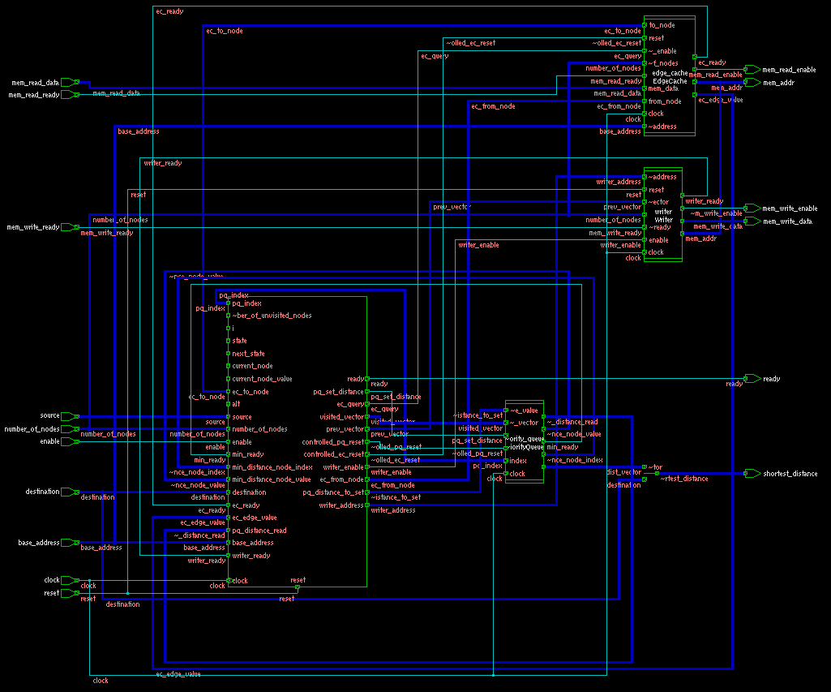Illustration 1: Top level design, pre-synthesis

This is the top level diagram for the shortest path calculator.
The non-memory input signals are: reset, clock, enable, source, destination, number_of_nodes, and base_address
The non-memory output signals are: shortest_distance and ready
The mem_* signals are intended to be attached to some kind of memory. The testbenches uses block ram implemented in Verilog.
base_address is a pointer that points to the graph in memory that the module is attempting to solve. Source and destination are the index of the source and destination nodes. The size of the graph is determined by number_of_nodes
Calculations begin after reset and when enable is high.
The actual shortest path will be written immediately after the graph in memory. The distance of the shortest path is returned as the signal shortest_distance
A 4-node graph would look like this:
NODE | 0 | 1 | 2 | 3
0 | 0 | 13 | 5 | 3
1 | 13 | 0 | 52 | 1
2 | 5 | 52 | 0 | 67
3 | 3 | 1 | 67 | 0
PATH | -1 | -1 | -1 | 0

This means that, for example, the edge weight between nodes 2 and 3 is 67. Note that the graph doesn’t have to be symmetric; the weight between 2 and 3 can be different from 3 and 2.
The last row of the graph is a list of previous nodes, as determined by the module. For example, 3 has a previous node of 0, which is indeed shows the shortest path from 0 to 3. -1 means there is no previous node. Note that there may be multiple correct results in some cases.
The graph is contiguous in memory. It should look like this:
0 | 13 | 5 | 3 | 13 | 0 | 52 | 1 | 5 | 52 | 0 | 67 | 3 | 1 | 67 | 0 | -1 | -1 | -1 | 0

Customization
The module can be figured to use different sized edges, different sized node indexes, and for different memory configurations. The configuration used in this report looks like this:
`define DEFAULT_MAX_NODES 32
`define DEFAULT_INDEX_WIDTH 8
`define DEFAULT_VALUE_WIDTH 8
`define DEFAULT_MADDR_WIDTH 16
`define DEFAULT_MDATA_WIDTH 8
This means we expect to work with a memory with a 16-bit address bus and 8-bit data bus. We are also limiting the number of nodes to 32. The design has been shown to simulate correctly with a much higher number of nodes, but synthesis was much slower.

Pre-synthesis Submodules

EdgeCache
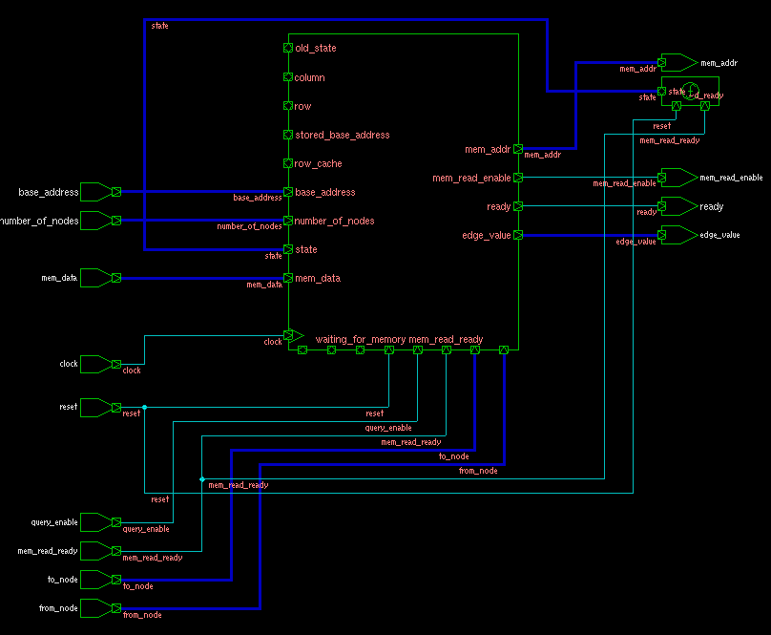Illustration 2: EdgeCache
The EdgeCache module is use to retrieve edge weights from memory. Unless the top-level design/controller requires an edge weight not yet retrieved, the edge-cache will perform this task concurrently with the calculation logic. For area considerations, it only stores one row at a time.

PriorityQueue and MinHeap
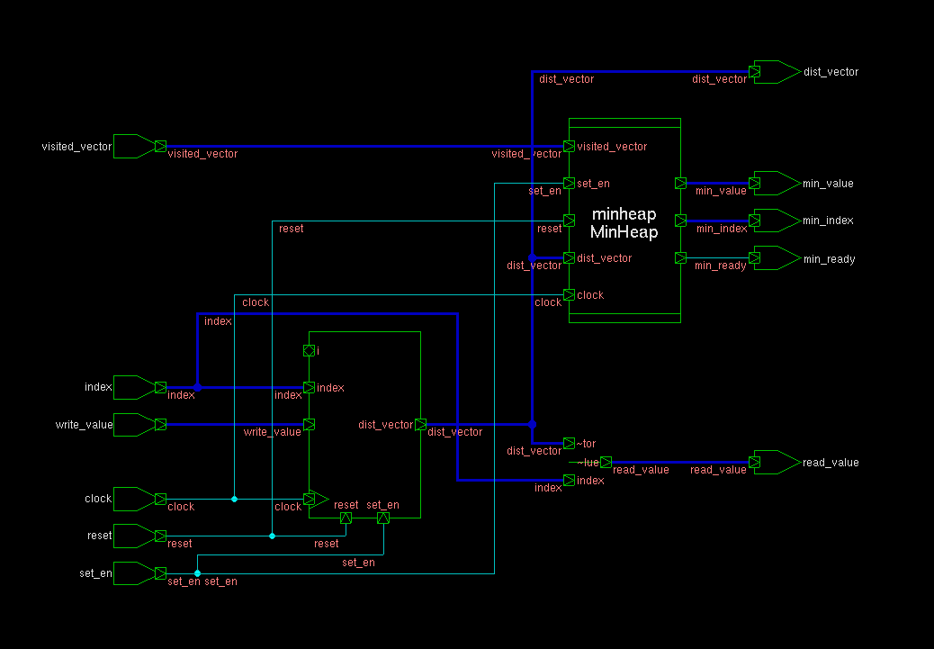Illustration 3: PriorityQueue
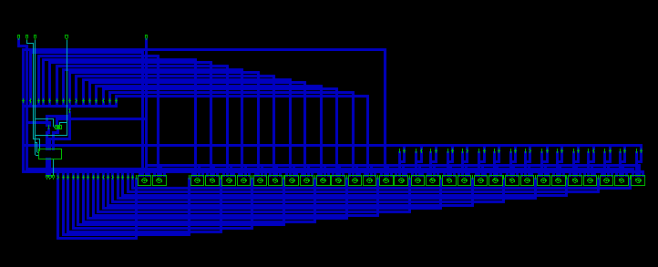Illustration 4: MinHeap

The tightly-coupled modules PriorityQueue and MinHeap have been separated for schematic-viewing purposes. From this point on, they shall collectively be referred to as PriorityQueue.
The PriorityQueue is the module that decides the next node to visit, by pointing to the node with the current shortest path, that has not yet been visited.
It does so according to the following logic:
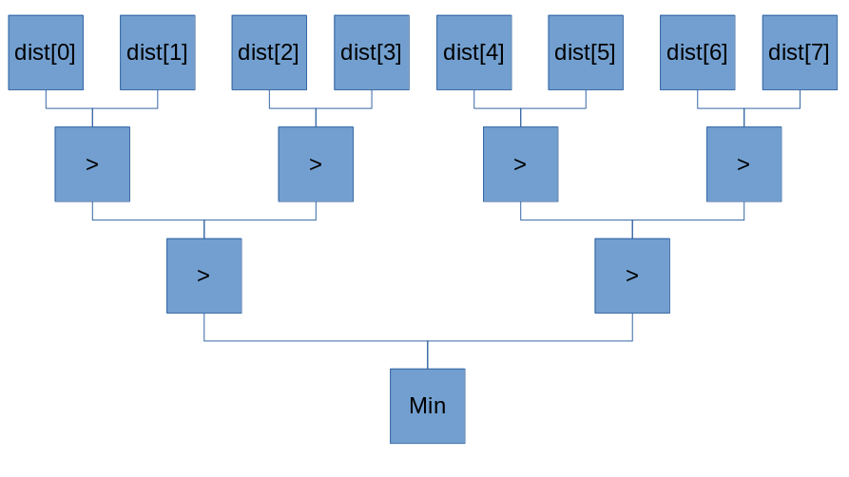
“>” means “choose the greater of the two. If one has been visited, consider it to have a value of -infinity”

Writer
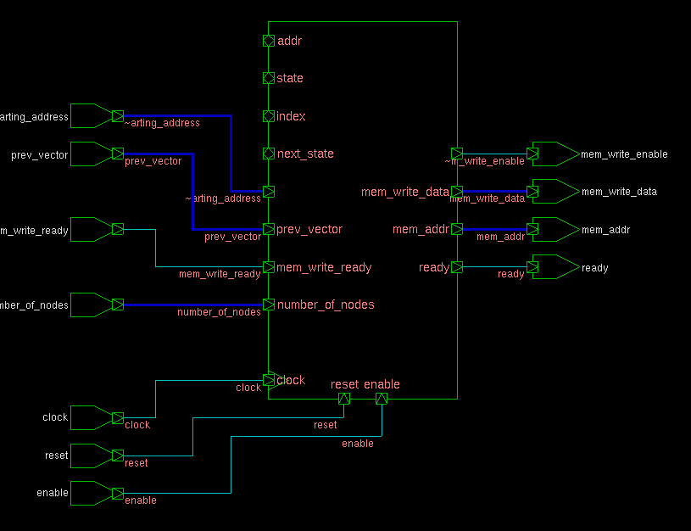Illustration 5: Writer
Writer is tasked with writing the final results to memory, sequentially.

Testing
There are 5 testbenches: one primary testbench, three module-level testbenches, and one meta testbench for the block ram. The code for these testbenches can be seen in the appendix, along with all the other code. Only the primary testbench , top_tb.sv, will be discussed in this section

Test Vectors
Each test vector was generated with a C++ program (see appendix), and created in this format:
4 22048
0 13 5 3
13 0 52 1
5 52 0 67
3 1 67 0
-1 -1 -1 0
3
The first number is the size of the graph. The second number is the random seed used to generate the graph(for reproducibility, not actually used in the testbench). The graph is next, followed by the path, followed by the distance of the shortest path.
As mentioned before, and is worth reiterating, there can be multiple correct solutions for the path(but only one correct solution for the distance). So we can not simply check to see if the path matches. Instead we only check the distance, use the path for debugging, and issue a warning when the path does not match.
A list of test vectors were generated in the following manner(excerpt from bash script):
# Make vectors
for size in $(seq $MIN_SIZE 1 $MAX_SIZE)
do
for j in $(seq 1 1 $TESTS_PER_SIZE)
do
./$EXECUTABLE -mi -n $size -s $((RANDOM%65536)) >> $OUTPUT
done
done
MAX_SIZE was set to 32, to reflect our earlier decided max number of nodes.
There are also some additional checks to make sure resetting works.

90nm node

Selecting a configuration
54 different configurations were tried in the 90nm node. Only some are shown in this table.

Setting | CriticalPathSlack | CriticalPathClkPeriod | TotalNegativeSlack | DesignArea
medium map, low area | -0.02 | 59.00 | -0.18 | 123474.895793
medium map, medium area | 0.00 | 59.00 | 0.00 | 111350.473233
medium map, high area | -0.06 | 59.00 | -1.03 | 107472.567424
high map, low area | 0.00 | 59.00 | 0.00 | 108444.028577
high map, medium area | -0.02 | 59.00 | -0.14 | 107159.588610
high map, high area | 0.01 | 59.00 | 0.00 | 108272.438981
medium map, low area | 0.00 | 58.00 | 0.00 | 108424.594126
medium map, medium area | -0.23 | 58.00 | -6.68 | 108254.965431
medium map, high area | -0.38 | 58.00 | -19.57 | 107664.664630
high map, low area | -0.20 | 58.00 | -2.43 | 107108.039357
high map, medium area | -0.24 | 58.00 | -5.51 | 107919.076997
high map, high area | -0.50 | 58.00 | -11.30 | 108251.772997
medium map, low area | -0.18 | 57.00 | -6.39 | 107717.901296
medium map, medium area | -0.27 | 57.00 | -10.86 | 109229.061070
medium map, high area | -0.08 | 57.00 | -2.48 | 108225.650649
high map, low area | -0.24 | 57.00 | -8.13 | 108284.918407
high map, medium area | -0.13 | 57.00 | -1.64 | 109711.834068
high map, high area | -0.16 | 57.00 | -3.37 | 108429.682897

We will select a clock period of 58 with a medium map optimization and low area optimization.

For this configuration, our critical path is from priority_queue/dist_vector to priority_queue/minheap/sc_min_value. This is to be expected, since MinHeap contains the most complex combinational logic.

