

**รายงาน**

เรื่อง Idioms Quiz

**เสนอ**

อาจารย์กุลวดี สมบูรณ์วิวัฒน์

**ผู้จัดทำ**

นางสาวปรมาภรณ์ สังข์ปิติกุล 6130300514

รายวิชา Programming Fundamentals II 03603112 หมู่เรียน 801/831

คณะวิศวกรรมศาสตร์ศรีราชา สาขาคอมพิวเตอร์และสารสนเทศศาสตร์

มหาวิทยาลัยเกษตรศาสตร์ วิทยาเขตศรีราชา

คำนำ

รายงานฉบับนี้เป็นส่วนหนึ่งของวิชา Programming Fundamentals II มีเนื้อเกี่ยวกับรายละเอียดของโครงงานเกี่ยวกับรายวิชาวิชาที่ได้เรียน ผู้จัดทำได้ทำเกมเพื่อทดสอบทักษะภาษาอังกฤษเกี่ยวกับสำนวน ที่ผู้จัดทำสนใจ คือ เกม Idioms Quiz

ผู้จัดทำคาดหวังว่ารายงานฉบับนี้จะเป็นประโยชน์กับผู้อ่าน หากมีข้อผิดพลาดประการใด ผู้จัดทำขอน้อมรับและขออภัยมา ณ ที่นี้ด้วย

ผู้จัดทำ

สารบัญ

|  |  |
| --- | --- |
| เรื่อง | หน้า |
| คุณสมบัติของเกม | 1 |
| หลักการออกแบบเกม | 1 |
| ตัวอย่างการรันโปรแกรม | 2 |
| Source Code | 4 |

Idioms Quiz

**คุณสมบัติของเกม**

เกมนี้เป็นเกมที่สร้างขึ้นเพื่อทดสอบทักษะภาษาอังกฤษ ที่เกี่ยวกับสำนวน ซึ่งตัวเกมจะประกอบไปด้วย ส่วนคำถาม และส่วนคำตอบอีก 3 อัน ผู้เล่นมีโอกาสในการตอบผิดได้เพียง 2 ครั้ง เมื่อถึงครั้งที่ 3 เกมจะจบ หลังจากนั้นผู้เล่นสามารถเลือกที่จะเล่นอีกครั้ง หรือจะออกเกมเลยก็ได้ ตัวคำถามและคำตอบจะเป็นสุ่มขึ้น คำตอบ จะมีรูปคำตอบที่ถูกอยู่ 3 ที่ซึ่งจะเป็นการสุ่มเช่นกัน คำถามของเกมนี้จะมีเพียง 49 คำถามเมื่อผู้เล่นสามารถเล่นได้ครบและหัวใจยังไม่หมดจะขึ้นหน้า win game

**หลักการออกแบบเกม**

- **การสุ่ม** จะมีสุ่ม 2 อย่าง คือ การสุ่มรูปแบบของคำตอบ และ การสุ่มตำแหน่ง เพื่อนำตำแหน่งมาใช้ในส่วนการสร้างคำถาม และ คำตอบ

- **การใส่คำถามและคำตอบ** ในที่นี้ผู้จัดทำ ได้ใช้อาร์เรย์ลิสต์ ในการใส่รูปของคำถามและคำตอบซึ่งมีทั้งหมด 4 อาร์เรย์ลิสต์ ประกอบด้วย คำถาม คำตอบที่ถูก และ คำตอบที่ผิดอีก 2 อาร์เรย์ลิสต์

- **หัวใจ** เมื่อเริ่มเกมผู้เล่นจะมีหัวใจ 3 ดวง และทุกการกดจะมีการเช็คว่ากดผิดหรือไม่ ถ้ากดผิดหัวใจจะลดลง แต่ถ้าถูกหัวใจจะเท่าเดิม

- **การกด** เมื่อผู้เล่นกดปุ่มใดๆ อีเว้นท์ในปุ่มแต่ละปุ่มจะมี ดังนี้

- เช็คว่าผู้เล่นกดถูกหรือไม่ ถ้าถูกแล้วจะทำการสุ่มรูปแบบ และ ตำแหน่งของข้อต่อไปเลย แต่ถ้าผิดหัวใจของผู้เล่นจะลดลง

- เมื่อสุ่มตำแหน่งของข้อถัดไปเสร็จแล้ว จะทำการใส่รูปใน Label ที่เป็นส่วนของคำถาม และ Button ทั้ง 3 อันที่เป็นส่วนคำตอบ

**ตัวอย่างการรันโปรแกรม**

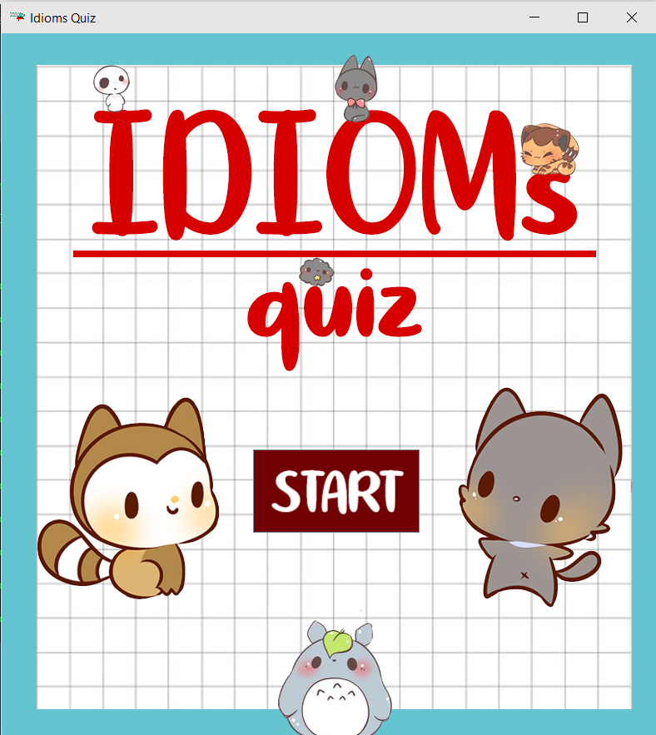

หน้าเริ่มเกม

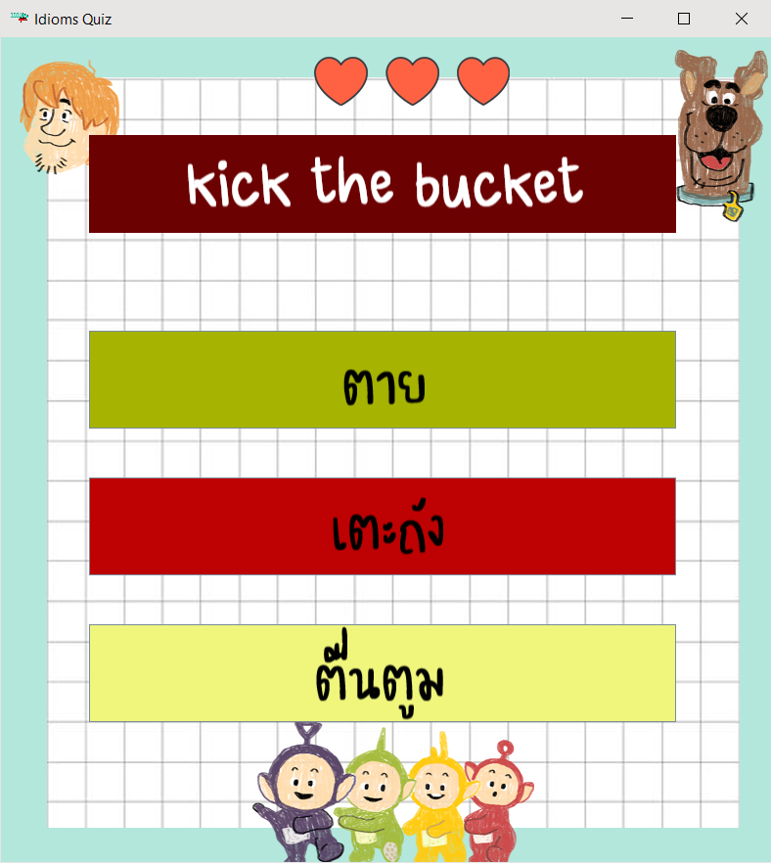

หน้าเกม

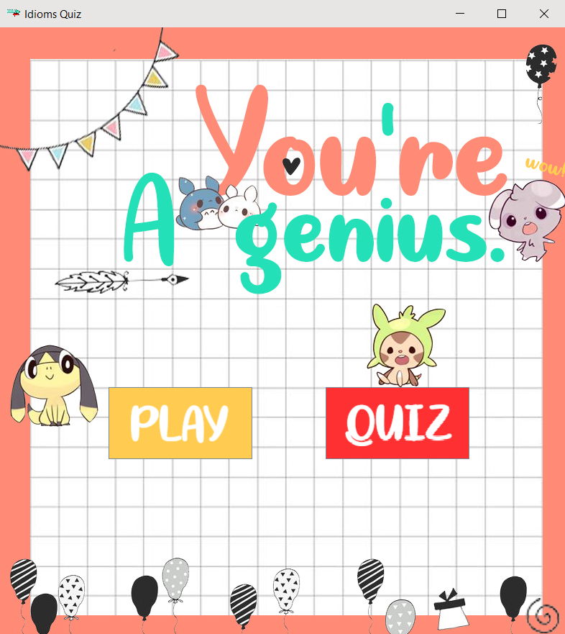

หน้านี้จะแสดงเมื่อผู้เล่นตอบครบทุกคำถาม

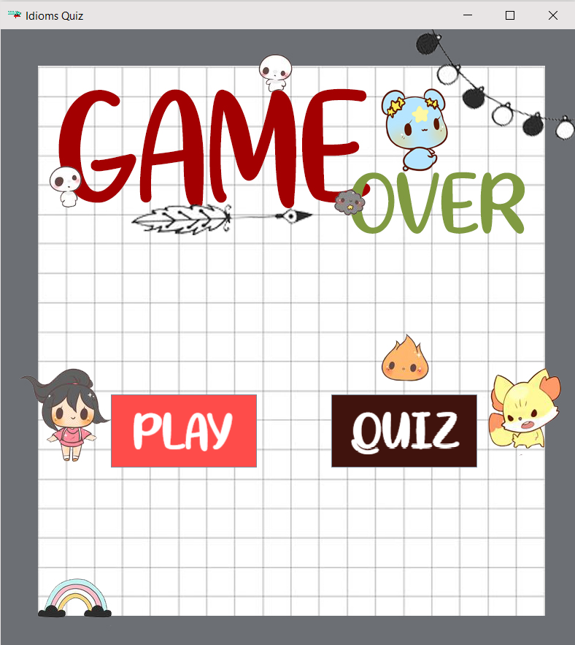

หน้านี้จะแสดงเมื่อผู้เล่นตอบผิดจนหัวใจหมด

**Source Code**

**File : Game.java**

public class Game{

public static void main(String[] args) {

new GUIGame();

}

}

**File : GUIGame.java**

import java.util.Random;

import java.util.ArrayList;

import java.awt.*;

import java.awt.event.*;

import javax.swing.*;

import java.io.*;

import java.net.URL;

import javax.sound.sampled.*;

public class GUIGame{

private JFrame f = new JFrame("Idioms Quiz");

private int heart = 2;

private int choice;

private int pos;

private int choose;

private ImageIcon imgicon = new ImageIcon("Resources/Logo/logo2.png");

private ArrayList<String> questionList = new ArrayList<String>();

private ArrayList<String> answer1List = new ArrayList<String>();

private ArrayList<String> answer2List = new ArrayList<String>();

private ArrayList<String> answer3List = new ArrayList<String>();

private ArrayList<Integer> use = new ArrayList<Integer>();

private ArrayList<Integer> used = new ArrayList<Integer>();

private JLabel backGround = new JLabel();

private JLabel Heartt = new JLabel();

private JLabel Question = new JLabel ();

private JButton Answer1 = new JButton ();

private JButton Answer2 = new JButton ();

private JButton Answer3 = new JButton ();

private Clip onGame;

private Clip right;

private Clip wrong;

public GUIGame() {

f.setIconImage(imgicon.getImage());

f.setSize(805, 890);

f.setLocation(500, 50);

f.setDefaultCloseOperation(JFrame.EXIT_ON_CLOSE);

f.setLayout( null );

playMusicGame();

//set Background

backGround.setLocation(0,0);

backGround.setSize(850,850);

backGround.setIcon(new ImageIcon ("Resources/Background/bg11.jpg"));

Heartt.setLocation(320,20);

Heartt.setSize(200,50);

Heartt.setBackground(Color.BLACK);

//create button question

Color c0 = new Color(108,1,2);

Question.setLocation ( 90, 100 );

Question.setSize (600,100);

Question.setBackground (c0);

Question.setOpaque(true);

//create button answer1

Color c1 = new Color(166,180,1);

Answer1.setLocation ( 90, 300 );

Answer1.setSize (600,100);

Answer1.setBackground (c1);

//create button answer2

Color c2 = new Color(190,1,2);

Answer2.setLocation ( 90, 450 );

Answer2.setSize (600,100);

Answer2.setBackground (c2);

//create button answer3

Color c3 = new Color(239,246,123);

Answer3.setLocation ( 90, 600 );

Answer3.setSize (600,100);

Answer3.setBackground (c3);

uselist();

fillQuestionList();

fillAnswerList1();

fillAnswerList2();

fillAnswerList3();

//startMenu();

f.add(Heartt);

f.add(Question);

f.add(Answer1);

f.add(Answer2);

f.add(Answer3);

f.add(backGround);

drawHeart(heart);

choice = ranPattern();

pos = ranPos(use);

drawQuestion(pos,questionList);

drawAns(choice,pos,answer1List,answer2List,answer3List);

f.setVisible(true);

//action button answer 1

Answer1.addActionListener(new ActionListener() {

public void actionPerformed(ActionEvent evt) {

//answer is Right

choose = 1;

if(choose == choice){

playMusicOnClickRight();

drawHeart(heart);

removerQues(pos,questionList);

removerAns1(pos,answer1List);

removerAns2(pos,answer2List);

removerAns3(pos,answer3List);

choice = ranPattern();

pos = ranPos(use);

drawQuestion(pos,questionList);

drawAns(choice,pos,answer1List,answer2List,answer3List);

}

else{

playMusicOnClickWrong();

if(heart != 0){

heart -= 1;

drawHeart(heart);

}

else{

drawHeart(heart);

if (onGame.isRunning()) onGame.stop();

new overState();

f.dispose();

}

removerQues(pos,questionList);

removerAns1(pos,answer1List);

removerAns2(pos,answer2List);

removerAns3(pos,answer3List);

choice = ranPattern();

pos = ranPos(use);

drawQuestion(pos,questionList);

drawAns(choice,pos,answer1List,answer2List,answer3List);

}

}

});

//action button answer 2

Answer2.addActionListener(new ActionListener() {

public void actionPerformed(ActionEvent evt) {

//answer is Wrong

choose = 2;

if(choose == choice){

playMusicOnClickRight();

drawHeart(heart);

removerQues(pos,questionList);

removerAns1(pos,answer1List);

removerAns2(pos,answer2List);

removerAns3(pos,answer3List);

choice = ranPattern();

pos = ranPos(use);

drawQuestion(pos,questionList);

drawAns(choice,pos,answer1List,answer2List,answer3List);

}

else{

playMusicOnClickWrong();

if(heart != 0){

heart -= 1;

drawHeart(heart);

}

else{

drawHeart(heart);

if (onGame.isRunning()) onGame.stop();

new overState();

f.dispose();

}

removerQues(pos,questionList);

removerAns1(pos,answer1List);

removerAns2(pos,answer2List);

removerAns3(pos,answer3List);

choice = ranPattern();

pos = ranPos(use);

drawQuestion(pos,questionList);

drawAns(choice,pos,answer1List,answer2List,answer3List);

}

}

});

//action button answer 3

Answer3.addActionListener(new ActionListener() {

public void actionPerformed(ActionEvent evt) {

choose = 3;

if(choose == choice){

playMusicOnClickRight();

drawHeart(heart);

removerQues(pos,questionList);

removerAns1(pos,answer1List);

removerAns2(pos,answer2List);

removerAns3(pos,answer3List);

choice = ranPattern();

pos = ranPos(use);

drawQuestion(pos,questionList);

drawAns(choice,pos,answer1List,answer2List,answer3List);

}

else{

playMusicOnClickWrong();

if(heart != 0){

heart -= 1;

drawHeart(heart);

}

else{

drawHeart(heart);

if (onGame.isRunning()) onGame.stop();

new overState();

f.dispose();

}

removerQues(pos,questionList);

removerAns1(pos,answer1List);

removerAns2(pos,answer2List);

removerAns3(pos,answer3List);

choice = ranPattern();

pos = ranPos(use);

drawQuestion(pos,questionList);

drawAns(choice,pos,answer1List,answer2List,answer3List);

}

}

});

}

public void drawHeart(int heart){

if(heart == 2){

Heartt.setIcon(new ImageIcon ("Resources/Heart/h1.png"));

}

else if(heart == 1){

Heartt.setIcon(new ImageIcon ("Resources/Heart/h2.png"));

}

else if(heart == 0){

Heartt.setIcon(new ImageIcon ("Resources/Heart/h3.png"));

}

}

//method random pattern of answer

public int ranPattern(){

Random rand = new Random();

return choice = rand.nextInt(100)%3+1;

}

//method random position of Question,Answer1,Answer2,Answer3

public int ranPos(ArrayList<Integer> use){

Random rand = new Random();

if(use.size() != 0){

pos = rand.nextInt(100)%(use.size());

use.remove(pos);

}

else{

if (onGame.isRunning()) onGame.stop();

new winState();

f.dispose();

}

return pos;

}

//add value of use 1-50

public ArrayList<Integer> uselist(){

for (int i=0;i <= 3 ;i++ ) {

use.add(i);

}

return(use);

}

//add image of Question in questionList and getImage of questionList

public ArrayList<String> fillQuestionList(){

for (int i=1;i<=5;i++ ) {

questionList.add("Resources/Question/q" +String.valueOf(i)+ ".png");

}

return(questionList);

}

public void drawQuestion(int pos,ArrayList<String> questionList){

Question.setIcon ( new ImageIcon (questionList.get(pos)));

}

// add image of Answer1 in answer1List

public ArrayList<String> fillAnswerList1(){

for (int i=1;i<=5;i++ ) {

answer1List.add("Resources/Answer/an1" +String.valueOf(i)+ ".png");

}

return(answer1List);

}

// add image of Answer2 in answer2List

public ArrayList<String> fillAnswerList2(){

for (int i=1;i<=5;i++ ) {

answer2List.add("Resources/Answer/an2" +String.valueOf(i)+ ".png");

}

return(answer2List);

}

// add image of Answer3 in answer3List

public ArrayList<String> fillAnswerList3(){

for (int i=1;i<=5;i++ ) {

answer3List.add("Resources/Answer/an3" +String.valueOf(i)+ ".png");

}

return(answer3List);

}

public void drawAns(int choice,int pos,ArrayList<String> answer1List,ArrayList<String> answer2List,ArrayList<String> answer3List){

if(choice == 1){

Answer1.setIcon ( new ImageIcon (answer1List.get(pos)));

Answer2.setIcon ( new ImageIcon (answer2List.get(pos)));

Answer3.setIcon ( new ImageIcon (answer3List.get(pos)));

}

else if(choice == 2){

Answer2.setIcon ( new ImageIcon (answer1List.get(pos)));

Answer1.setIcon ( new ImageIcon (answer2List.get(pos)));

Answer3.setIcon ( new ImageIcon (answer3List.get(pos)));

}

else if(choice == 3){

Answer3.setIcon ( new ImageIcon (answer1List.get(pos)));

Answer1.setIcon ( new ImageIcon (answer2List.get(pos)));

Answer2.setIcon ( new ImageIcon (answer3List.get(pos)));

}

}

public ArrayList<String> removerQues(int pos,ArrayList<String> questionList){

questionList.remove(pos);

return (questionList);

}

public ArrayList<String> removerAns1(int pos,ArrayList<String> answer1List){

answer1List.remove(pos);

return (answer1List);

}

public ArrayList<String> removerAns2(int pos,ArrayList<String> answer2List){

answer2List.remove(pos);

return (answer2List);

}

public ArrayList<String> removerAns3(int pos,ArrayList<String> answer3List){

answer3List.remove(pos);

return (answer3List);

}

public void playMusicGame() {

try {

// Open an audio input stream.

URL url = this.getClass().getClassLoader().getResource("Resources/Music/onGame.wav");

AudioInputStream audioIn = AudioSystem.getAudioInputStream(url);

// Get a sound clip resource.

onGame = AudioSystem.getClip();

// Open audio clip and load samples from the audio input stream.

onGame.open(audioIn);

FloatControl gainControl = (FloatControl) onGame.getControl(FloatControl.Type.MASTER_GAIN);

gainControl.setValue(-40.0f);

onGame.start();

onGame.loop(5);

} catch (UnsupportedAudioFileException e) {

e.printStackTrace();

} catch (IOException e) {

e.printStackTrace();

} catch (LineUnavailableException e) {

e.printStackTrace();

}

}

public void playMusicOnClickRight() {

try {

// Open an audio input stream.

URL url = this.getClass().getClassLoader().getResource("Resources/Music/right2.wav");

AudioInputStream audioIn = AudioSystem.getAudioInputStream(url);

// Get a sound clip resource.

right = AudioSystem.getClip();

// Open audio clip and load samples from the audio input stream.

right.open(audioIn);

right.start();

} catch (UnsupportedAudioFileException e) {

e.printStackTrace();

} catch (IOException e) {

e.printStackTrace();

} catch (LineUnavailableException e) {

e.printStackTrace();

}

}

public void playMusicOnClickWrong() {

try {

// Open an audio input stream.

URL url = this.getClass().getClassLoader().getResource("Resources/Music/wrong2.wav");

AudioInputStream audioIn = AudioSystem.getAudioInputStream(url);

// Get a sound clip resource.

wrong = AudioSystem.getClip();

// Open audio clip and load samples from the audio input stream.

wrong.open(audioIn);

wrong.start();

} catch (UnsupportedAudioFileException e) {

e.printStackTrace();

} catch (IOException e) {

e.printStackTrace();

} catch (LineUnavailableException e) {

e.printStackTrace();

}

}

}

**File : startState.java**

import java.awt.*;

import java.awt.event.*;

import javax.swing.*;

import java.io.*;

import java.net.URL;

import javax.sound.sampled.*;

public class startState{

private JFrame f = new JFrame("Idioms Quiz");

private ImageIcon imgicon = new ImageIcon("Resources/Logo/logo2.png");

private JLabel backGround = new JLabel();

private JButton Go = new JButton();

private boolean stopMusic = false;

private Clip clip;

private Clip click;

public startState(){

f.setIconImage(imgicon.getImage());

f.setSize(805, 890);

f.setLocation(500, 50);

f.setDefaultCloseOperation(JFrame.EXIT_ON_CLOSE);

f.setLayout( null );

playMusic();

backGround.setLocation(0,0);

backGround.setSize(850,850);

backGround.setIcon(new ImageIcon ("Resources/Background/startback7.jpg"));

Color c1 = new Color(112,0,1);

Go.setLocation ( 302, 500 );

Go.setSize (200,100);

Go.setBackground (c1);

Go.setIcon(new ImageIcon ("Resources/Picbutton/start.png"));

f.add(Go);

f.add(backGround);

f.setVisible(true);

Go.addActionListener(new ActionListener() {

public void actionPerformed(ActionEvent evt) {

playMusicOnClick();

if (clip.isRunning()) clip.stop();

//answer is Right

new GUIGame();

f.dispose();

}

});

}

public void playMusic() {

try {

// Open an audio input stream.

URL url = this.getClass().getClassLoader().getResource("Resources/Music/start.wav");

AudioInputStream audioIn = AudioSystem.getAudioInputStream(url);

// Get a sound clip resource.

clip = AudioSystem.getClip();

// Open audio clip and load samples from the audio input stream.

clip.open(audioIn);

FloatControl gainControl = (FloatControl) clip.getControl(FloatControl.Type.MASTER_GAIN);

gainControl.setValue(-40.0f);

clip.start();

clip.loop(5);

} catch (UnsupportedAudioFileException e) {

e.printStackTrace();

} catch (IOException e) {

e.printStackTrace();

} catch (LineUnavailableException e) {

e.printStackTrace();

}

}

public void playMusicOnClick() {

try {

// Open an audio input stream.

URL url = this.getClass().getClassLoader().getResource("Resources/Music/right.wav");

AudioInputStream audioIn = AudioSystem.getAudioInputStream(url);

// Get a sound clip resource.

click = AudioSystem.getClip();

// Open audio clip and load samples from the audio input stream.

click.open(audioIn);

click.start();

} catch (UnsupportedAudioFileException e) {

e.printStackTrace();

} catch (IOException e) {

e.printStackTrace();

} catch (LineUnavailableException e) {

e.printStackTrace();

}

}

}

**File : winState.java**

import java.awt.*;

import java.awt.event.*;

import javax.swing.*;

import java.io.*;

import java.net.URL;

import javax.sound.sampled.*;

public class winState{

private JFrame f = new JFrame("Idioms Quiz");

private ImageIcon imgicon = new ImageIcon("Resources/Logo/logo2.png");

private JLabel backGround = new JLabel();

private JButton play = new JButton();

private JButton quit = new JButton();

private Clip clip;

private Clip playag;

private Clip quitt;

public winState(){

f.setIconImage(imgicon.getImage());

f.setSize(805, 890);

f.setLocation(500, 50);

f.setDefaultCloseOperation(JFrame.EXIT_ON_CLOSE);

f.setLayout( null );

playMusic();

backGround.setLocation(0,0);

backGround.setSize(850,850);

backGround.setIcon(new ImageIcon ("Resources/Background/winback2.jpg"));

Color c1 = new Color(255,204,81);

play.setLocation ( 151, 500 );

play.setSize (200,100);

play.setBackground (c1);

play.setIcon(new ImageIcon ("Resources/Picbutton/play.png"));

Color c2 = new Color(255,48,49);

quit.setLocation ( 453, 500 );

quit.setSize (200,100);

quit.setBackground (c2);

quit.setIcon(new ImageIcon ("Resources/Picbutton/quit.png"));

f.add(play);

f.add(quit);

f.add(backGround);

f.setVisible(true);

play.addActionListener(new ActionListener() {

public void actionPerformed(ActionEvent evt) {

playMusicClickplay();

//answer is Right

if (clip.isRunning()) clip.stop();

new GUIGame();

f.dispose();

}

});

quit.addActionListener(new ActionListener() {

public void actionPerformed(ActionEvent evt) {

playMusicClickQuit();

//answer is Right

if (clip.isRunning()) clip.stop();

System.exit(0);

}

});

}

public void playMusic() {

try {

// Open an audio input stream.

URL url = this.getClass().getClassLoader().getResource("Resources/Music/congregation.wav");

AudioInputStream audioIn = AudioSystem.getAudioInputStream(url);

// Get a sound clip resource.

clip = AudioSystem.getClip();

// Open audio clip and load samples from the audio input stream.

clip.open(audioIn);

FloatControl gainControl = (FloatControl) clip.getControl(FloatControl.Type.MASTER_GAIN);

gainControl.setValue(-40.0f);

clip.start();

clip.loop(5);

} catch (UnsupportedAudioFileException e) {

e.printStackTrace();

} catch (IOException e) {

e.printStackTrace();

} catch (LineUnavailableException e) {

e.printStackTrace();

}

}

public void playMusicClickplay() {

try {

// Open an audio input stream.

URL url = this.getClass().getClassLoader().getResource("Resources/Music/play.wav");

AudioInputStream audioIn = AudioSystem.getAudioInputStream(url);

// Get a sound clip resource.

playag = AudioSystem.getClip();

// Open audio clip and load samples from the audio input stream.

playag.open(audioIn);

playag.start();

} catch (UnsupportedAudioFileException e) {

e.printStackTrace();

} catch (IOException e) {

e.printStackTrace();

} catch (LineUnavailableException e) {

e.printStackTrace();

}

}

public void playMusicClickQuit() {

try {

// Open an audio input stream.

URL url = this.getClass().getClassLoader().getResource("Resources/Music/right.wav");

AudioInputStream audioIn = AudioSystem.getAudioInputStream(url);

// Get a sound clip resource.

quitt = AudioSystem.getClip();

// Open audio clip and load samples from the audio input stream.

quitt.open(audioIn);

quitt.start();

} catch (UnsupportedAudioFileException e) {

e.printStackTrace();

} catch (IOException e) {

e.printStackTrace();

} catch (LineUnavailableException e) {

e.printStackTrace();

}

}

}

**File : overState.java**

import java.awt.*;

import java.awt.event.*;

import javax.swing.*;

import java.io.*;

import java.net.URL;

import javax.sound.sampled.*;

public class overState{

private JFrame f = new JFrame("Idioms Quiz");

private ImageIcon imgicon = new ImageIcon("Resources/Logo/logo2.png");

private JLabel backGround = new JLabel();

private JButton play = new JButton();

private JButton quit = new JButton();

private Clip clip;

private Clip playag;

private Clip quitt;

public overState(){

f.setIconImage(imgicon.getImage());

f.setSize(805, 890);

f.setLocation(500, 50);

f.setDefaultCloseOperation(JFrame.EXIT_ON_CLOSE);

f.setLayout( null );

playMusic();

backGround.setLocation(0,0);

backGround.setSize(850,850);

backGround.setIcon(new ImageIcon ("Resources/Background/overback.jpg"));

Color c1 = new Color(254,76,74);

play.setLocation ( 151, 500 );

play.setSize (200,100);

play.setBackground (c1);

play.setIcon(new ImageIcon ("Resources/Picbutton/play.png"));

Color c2 = new Color(64,19,13);

quit.setLocation ( 453, 500 );

quit.setSize (200,100);

quit.setBackground (c2);

quit.setIcon(new ImageIcon ("Resources/Picbutton/quit.png"));

f.add(play);

f.add(quit);

f.add(backGround);

f.setVisible(true);

play.addActionListener(new ActionListener() {

public void actionPerformed(ActionEvent evt) {

playMusicClickplay();

//answer is Right

if (clip.isRunning()) clip.stop();

new GUIGame();

f.dispose();

}

});

quit.addActionListener(new ActionListener() {

public void actionPerformed(ActionEvent evt) {

playMusicClickQuit();

//answer is Right

if (clip.isRunning()) clip.stop();

System.exit(0);

}

});

}

public void playMusic() {

try {

// Open an audio input stream.

URL url = this.getClass().getClassLoader().getResource("Resources/Music/sadly.wav");

AudioInputStream audioIn = AudioSystem.getAudioInputStream(url);

// Get a sound clip resource.

clip = AudioSystem.getClip();

// Open audio clip and load samples from the audio input stream.

clip.open(audioIn);

FloatControl gainControl = (FloatControl) clip.getControl(FloatControl.Type.MASTER_GAIN);

gainControl.setValue(-40.0f);

clip.start();

clip.loop(5);

} catch (UnsupportedAudioFileException e) {

e.printStackTrace();

} catch (IOException e) {

e.printStackTrace();

} catch (LineUnavailableException e) {

e.printStackTrace();

}

}

public void playMusicClickplay() {

try {

// Open an audio input stream.

URL url = this.getClass().getClassLoader().getResource("Resources/Music/play.wav");

AudioInputStream audioIn = AudioSystem.getAudioInputStream(url);

// Get a sound clip resource.

playag = AudioSystem.getClip();

// Open audio clip and load samples from the audio input stream.

playag.open(audioIn);

playag.start();

} catch (UnsupportedAudioFileException e) {

e.printStackTrace();

} catch (IOException e) {

e.printStackTrace();

} catch (LineUnavailableException e) {

e.printStackTrace();

}

}

public void playMusicClickQuit() {

try {

// Open an audio input stream.

URL url = this.getClass().getClassLoader().getResource("Resources/Music/right.wav");

AudioInputStream audioIn = AudioSystem.getAudioInputStream(url);

// Get a sound clip resource.

quitt = AudioSystem.getClip();

// Open audio clip and load samples from the audio input stream.

quitt.open(audioIn);

quitt.start();

} catch (UnsupportedAudioFileException e) {

e.printStackTrace();

} catch (IOException e) {

e.printStackTrace();

} catch (LineUnavailableException e) {

e.printStackTrace();

}

}

}