# Login Page Project

This repository contains a simple and responsive login page built using HTML, CSS, and JavaScript. It is designed to be easy to use, customizable, and suitable for integration into web applications.

## Features

* **Responsive Design**: The login page is fully responsive and works seamlessly on all devices (desktop, tablet, and mobile).
* **User-Friendly Interface**: Clean and intuitive UI for a smooth user experience.
* **Form Validation**: Basic client-side validation for email and password fields.
* **Customizable**: Easily modify the design and functionality to suit your needs.

## Technologies Used

* **HTML5**: For structuring the login page.
* **CSS3**: For styling and responsiveness.
* **JavaScript**: For form validation and interactivity.

## Screenshots

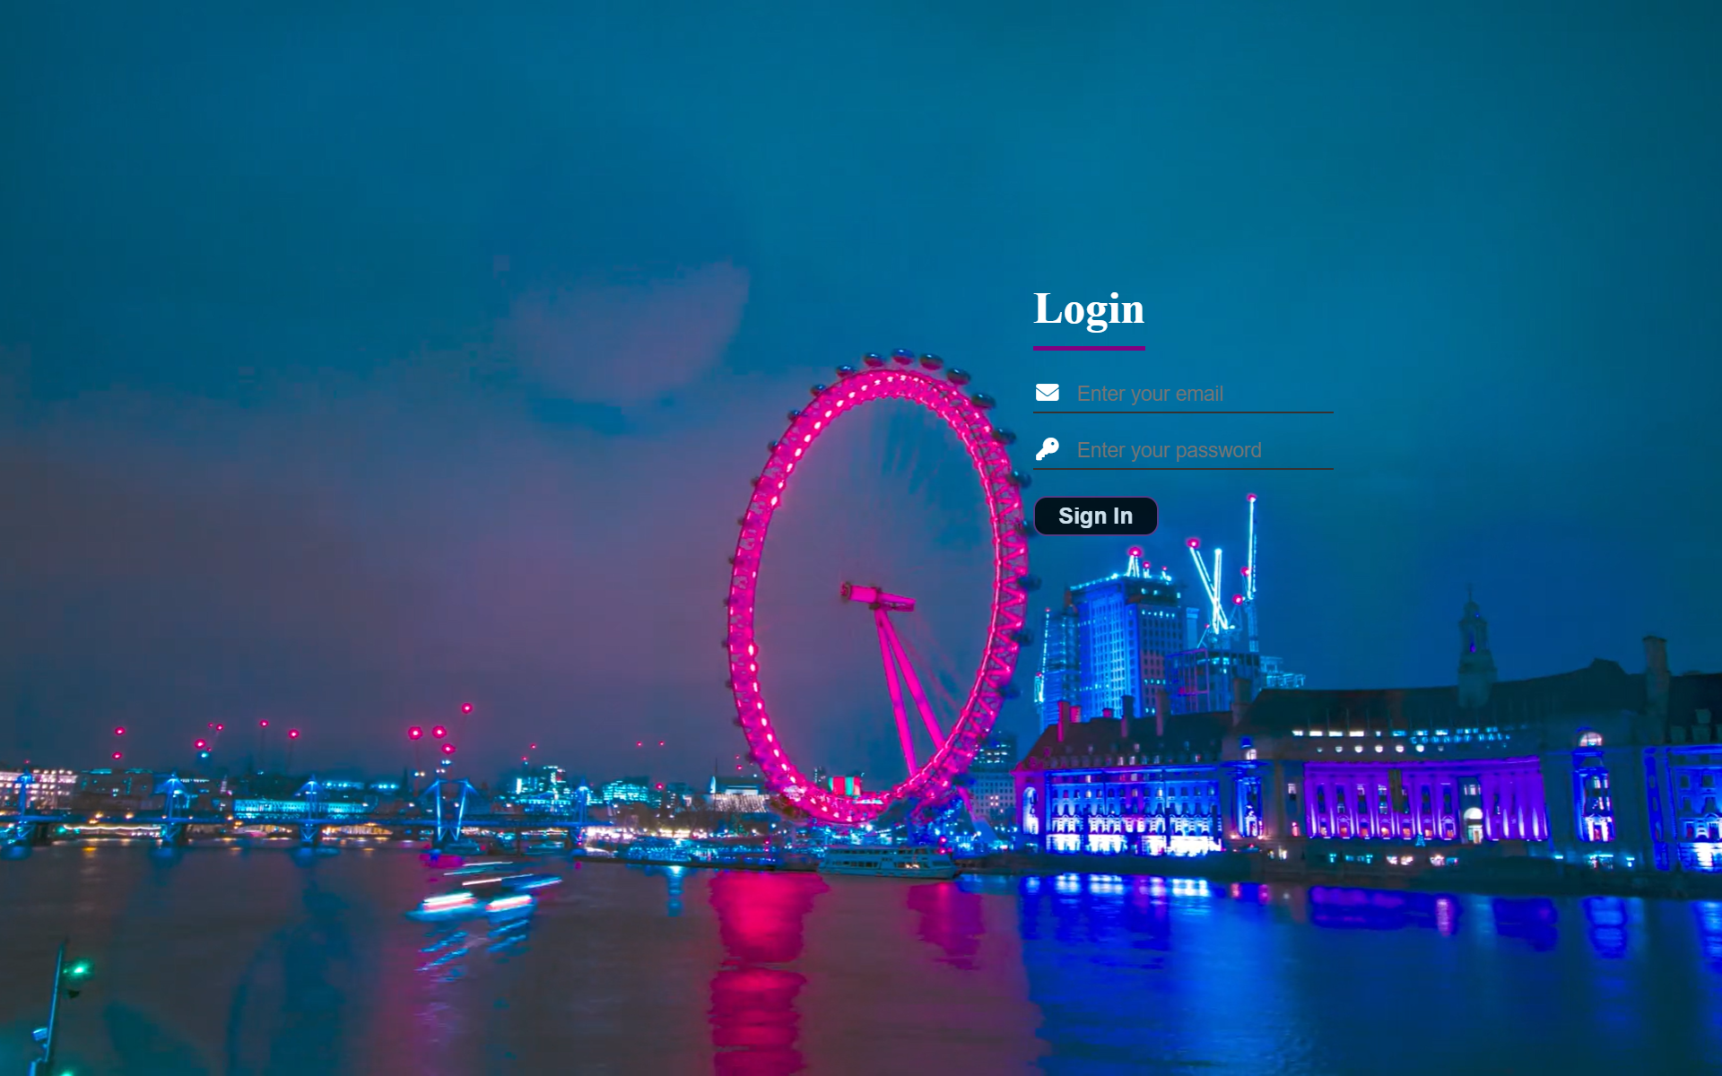

## How to Use

1. **Clone the Repository**:

bash

Copy

git clone https://github.com/Prorudrajit23/Login-page.git

cd Login-page

1. **Open the Project**:
   * Open the index.html file in your browser to view the login page.
2. **Customize**:
   * Modify the index.html, styles.css, and script.js files to customize the login page according to your requirements.

## Folder Structure

Copy

Login-page/

├── index.html # Main HTML file for the login page

├── styles.css # CSS file for styling

├── script.js # JavaScript file for form validation

├── README.md # Project documentation

└── screenshot.png # Screenshot of the login page

## License

This project is licensed under the MIT License. See the [LICENSE](https://chat.deepseek.com/a/chat/s/LICENSE) file for details.

## Author

* **Rudrajit Dutta**  
  GitHub: [Prorudrajit23](https://github.com/Prorudrajit23)  
  Email: rudrajitdutta9@gmail.com