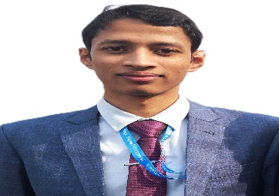

**Projects:**

**Graph Visualizations**

https://github.com/Prosenjit-Mondol/GraphCraft

**Blood Bank**

<https://github.com/Prosenjit-Mondol/Blood_Bank_Project>

**Nagad App**

<https://github.com/Prosenjit-Mondol/Nagad_App_Project>

**Ardiuno UNO**

https://github.com/Prosenjit-Mondol/Ardiuno_UNO_Project

**Work Experience:**

<https://www.linkedin.com/in/prosenjit-mondol-615342266//> 

https://github.com/Prosenjit-Mondol 

<https://prosenjit-mondol.github.io/Personal-Portfolio/> 

**Prosenjit Mondol**

🏠︎ Rajshahi , Dhaka

➤ [prosenjit1156@gmail.com](mailto:prosenjit1156@gmail.com)

01315-747034



**Certifications:**

* The 2023 ICPC Asia Dhaka Regional
* AutoCAD Electrical from Beginner to Expert

**Skills:**

Problem solving expert in c, c++, java, python languages

Database (MySQL, Oracle), Data Structures, Data Communications and Networking,

Expert in AutoCAD Electrical, HTML, CSS, JavaScript

**Objective:**

Highly motivated and dedicated fresher Computer Science Engineer with a strong academic background and a passion for innovation and problem-solving. Seeking a challenging and rewarding opportunity to use and grow my coding skills.

**Education:**

**Patuakhali Science and Technology University –** B.Sc.Engg. CSE

January 2023 – current Dumki, Patuakhali, Barishal

**Naogaon Govt. College –** HSC, Science

2019 – 2020 Naogaon, Rajshahi