a software:

with speaking command everything can do all tasks.

doesn't need any keyboard.

For example:

If i wanna open an a editor create a new .py file. So how can do that?

Answer: first check in my desktop current window whether there is that editor suppose "pycharm", or check software package where all software installed. if not then will show "not found "Pycharm"". Now if found: open this first and now i wanna create .py file. So in this case i have to command "create pagla python file or pagla.py file and open it". Now i wanna write something code. So command will be such as "Write ......................................." until command will be " Stop Write" or "run" this code.

The above explanation will be such like for every software or every mechanism for every devices.

Details:

Every Language will have there asif anybody or from country people any devices can run it.

?????????

I wanna copy or cut or remove a file from a directory to c directory.

How to do this?

??????????????


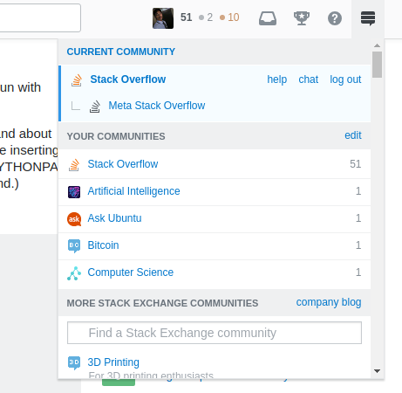

The above 2 images we can show there has some icons Quadrilateral, star cup, question’s mark, menubar

