Exploratory Test Charter

<https://en.wikipedia.org/w/index.php?search>

1. check search line for max and min characters

2. check search line the auto-selection for the first few characters

3. check search line for special characters

4. check case insensitivity for search line

5. check the filters in the search line

6. check the correctness of the transition through links and buttons

7.check scalability and window resizing

What was revealed:

**1.** **bug with processing a large number of characters in the search line**

Algorithm:

1. go to https://en.wikipedia.org/wiki/War_and_Peace

2. copy all page content

3. return to the search line

4. paste the copied text

Result:

after a few seconds of waiting, the page became unresponsive and had to be reloaded.

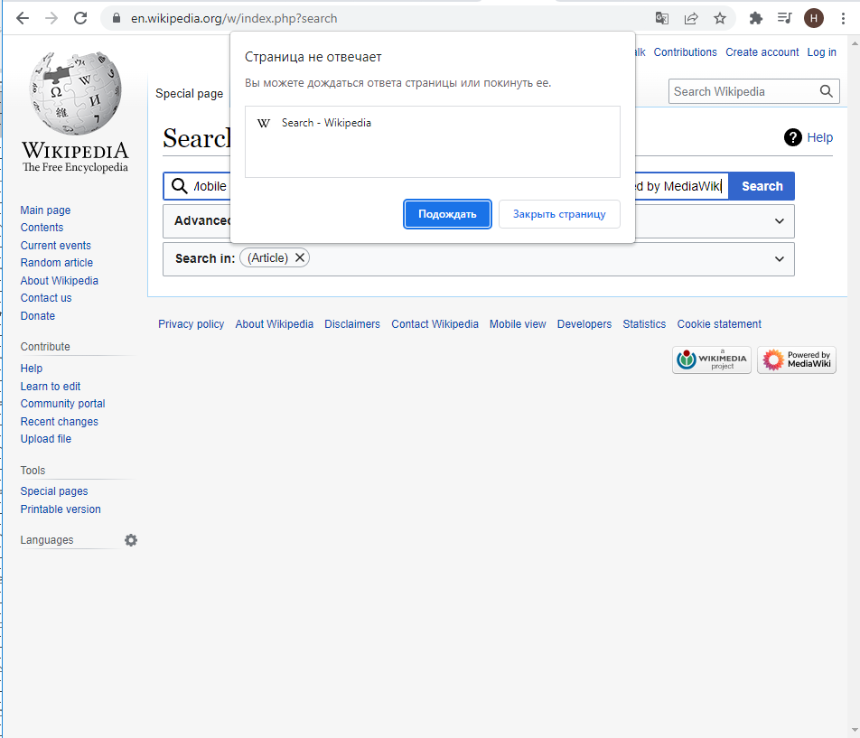

(The user does not know the cause of the failure, does not know how to fix this error and will repeat this algorithm until he guesses what the problem is.)

Expected Result:

The user saw an informational message about exceeding the maximum number of characters in the line. (He understands how to fix this error and knows how to fix it, he will no longer use such long queries.)

**2. bug with search with special characters**

Algorithm:

1. in the search line, enter the word "cat"

2. press "search"

3. the user sees articles related to topics about cats

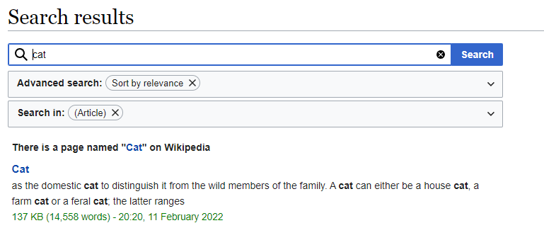

4. update the search string

5. enter the word "~cat~"

6. click "search"

Result:

The user sees articles that have nothing to do with cats.

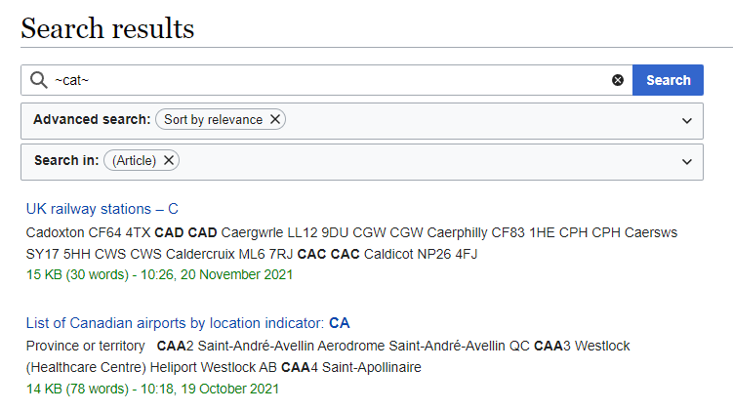

Expected Result:

If the work of the search string does not imply searching for special characters, then the user should have seen the corresponding informational message.

If the work of the search line involves searching for special characters, then the user must understand how this works. (At the moment, the search algorithm for queries with special characters is completely unclear, the user will spend time understanding this)

Automationscenarios

**T**est 1. Happy flow.

1. send a valid request

2. compare the expected result with the actual one

Test 2. Check for errors

1. send an incorrect request, for example with a very large number of characters

2. compare the received error text with the expected one

Explanation: Automatic scripts should always contain cases of positive work and work with errors.