Philip Prososki

Game Production Project 1

Ryan Rosenthal Fall Quarter 2017 – Game Design Document Submission

**Game Concept:**

The overall concept of Legends of Asmundur is a journey of finding out who you are through game play and trials. The player will follow in the path of two childhood friends Celica and Noct as they follow the path of a Legendary hero of the Horos clan sorceress Isha. The player will learn about who Celica is supposed to be and learn the identity of her mysterious friend Noct as he is not initially born into the Horos clan. Fight through various trials, meet the Deities who created the world of Asmundur and take down a corrupted empire who seeks to rule over the world through calamity and destruction.

**Game Foundations:**

**Artificial Intelligence: These are NPCs and enemy encounters that will all be controlled by the AI**

Demons – The spawn of the Dark Deity that plagues Asmundur

Dragons – Descendants of the 7 great deities themselves they protect their Legendary weapons

Slimes – a commonly found enemy throughout the world

Gargoyles – an uncommonly found enemy in the world – they attack with great strength and magic

Dark Mages – Corrupted mages who have been forced into fighting for the Othello

Genetically altered Human – An ordinary human being that has been turned into a super solider.

Othello military – Members of Xaber’s military.

Wild beast variations – Roaming beasts of the world of Asmundur who have been corrupted by the Dark Deity’s return

Xena – Xaber’s daughter

Xaber – Emperor of the Othello.

Zid – Assassin hired by the Othello to kill Celica and Noct before they interfere with the Empire’s plans.

**Characters of the game** (This section will have a description of the characters and then a character fully character model selected and referenced along with changes I would make to the model to fit my game):

Celica - a young sorceress with unique talent. She can call on all elements of the world around her, and even combine the elements to create even more powerful magic. She is a descendant of Isha, the strongest sorceress known among the Horos.

Isha – The legendary sorceress who once battled an evil Deity who desired to destroy the realm of Asmundur that he helped create along with several other great deities.

Noct – childhood friend of Celica. Noct has mysterious powers and extreme strength. He can use a wide variety of weapons and even combine magic into his weapons to help give him an edge in battle.

Zid – An assassin belonging to the Othello Clan. He can deliver silent deadly strikes without being detected and fights with daggers, short swords, shuriken, swords, and bows.

Fiora – A mysterious elf with magical knowledge that is even unknown to members of the Horos clan. She excels in support and curative magicks to aid those she fights alongside. Where she is initially from and what hidden clan, she belongs to she keeps to herself.

Xaber – Emperor of the Othello clan he leads his nation with brute military force. Any who oppose him are cut down and made an example of him and his power. His greed fuels his desire to rule more than just the main continent of Asmundur.

Xena – Daughter of Xaber and leader of several specialist forces she sets out under Xaber’s orders to go to new continents, and crush anyone they find that oppose and refuse to obey the Othello’s order. She is feared for being stronger than any man in the military force aside from her father.

**Characters Continued with Models and changes I would make:**

Celica - 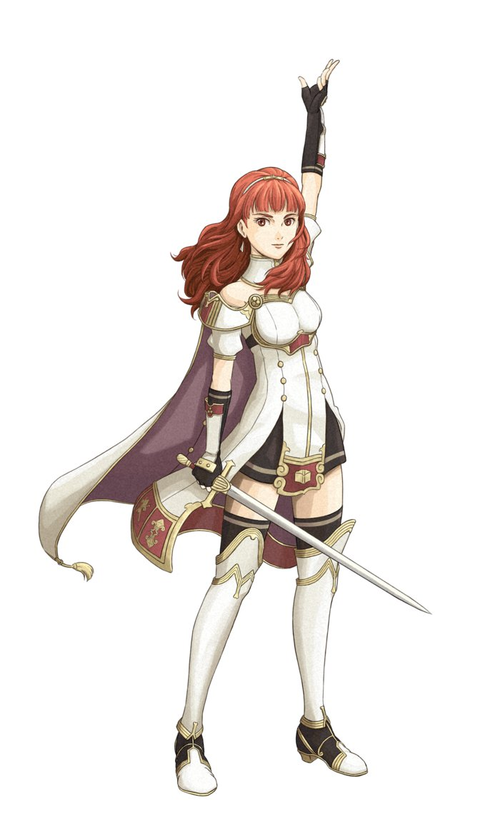 This image was drawn by “Marthur” on deviant art. Image credit goes to him.

This is Celica from the game Fire Emblem Echoes: Shadows of Valentia. There are many changes I would incorporate with this base model. First – I would have her wardrobe color changed to black with red trim instead of white. Since she is a sorceress I would have her wearing robes along with a hood that could be used to hide her identity. Her hair I would have blonde with some flares of pink in it to give her a more fantasy feel. Instead of carrying a sword she would carry a wand and sacred tome of the Horos.

Isha – 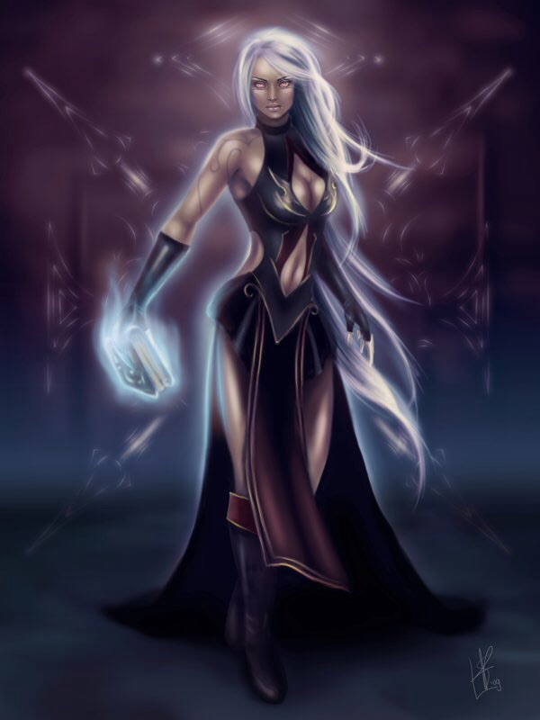 A sorceress who once battled the Dark Deity. I’m a major fan of this image I found. There are a few things I would have to change. I would make her sorceress wardrobe into the Horos tribe colors which are black with red trim. She would have her face partially covered by her hood, and wielding a tome of the Horos along with some Goddess-like wand that she battled with. I would keep her hair the same because I really like the way this woman’s hair is. **this image is owned by playbuzz all rights to it belong to them**

Noct – 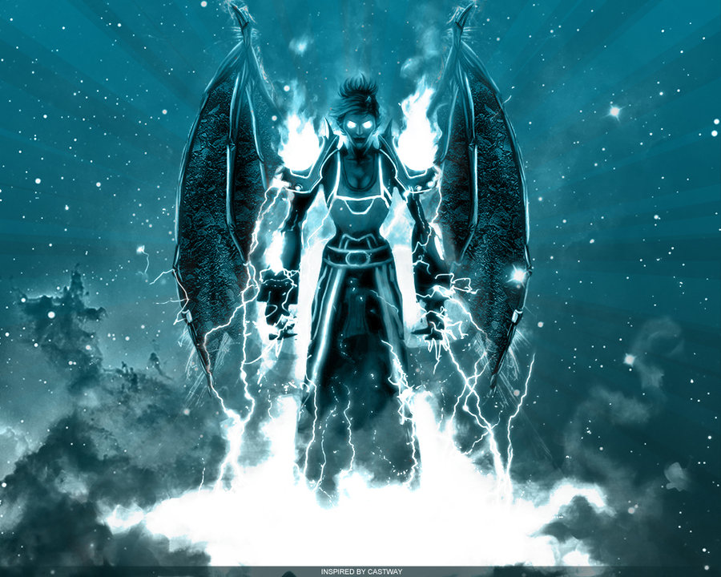A mysterious youth among the Horos. This picture captures the mysterious part that I want to have for Noct. There is a lot to change about this art piece starting with removing the wings. I would keep the hair style and body type for my character. I would change his wardrobe into fighter/mercenary gear with the traditional tribe colors. He also, would need a weapon that captures just how strong he is such as a heavy glaive. Image created by “Castway” on DeviantArt. All rights belong to the artist.

Zid - 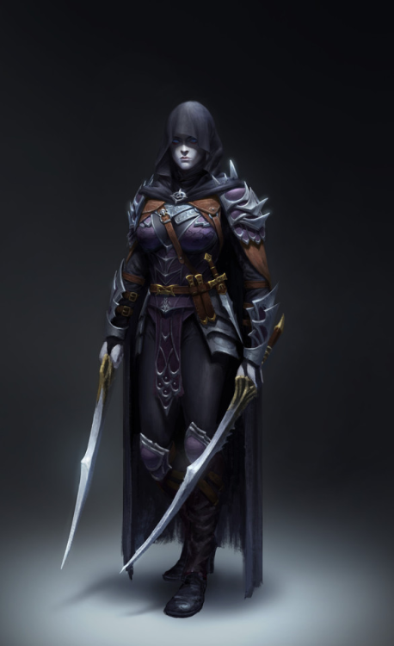 **Image found on Tumblr. I do not own the rights to this image nor do I claim to have created it** I really like how this character looks. If possible, I would hope to find the artist and ask to use this character in my game and just change the weapons to something such as a short sword and dagger that he uses. Although, you can clearly see a small dagger on his belt. I would however, change the color scheme of the armor to colors that represent the Othello, which would be blue with black skulls on the chest.

Fiora - 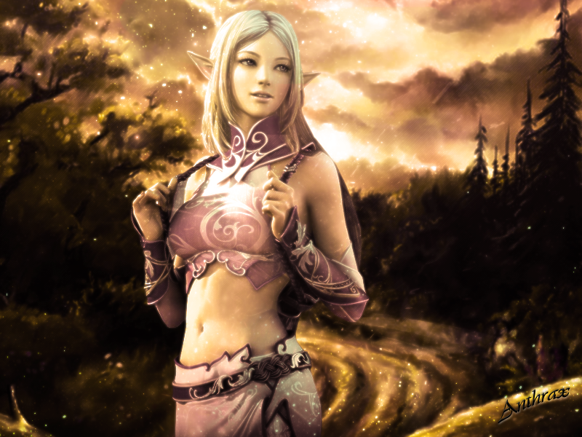 This image is brilliant and could easily be used as concept for this character. Since nobody really knows the age of this elf is she truly as young as she looks, or is she hundreds of years old but still retains a physical look of youth? I would have to change the color of the wardrobe of this character to a lighter green color to follow the trend of what color an “elf” would wear. I would also give her a staff to show her prowess as a healer. I also feel that I would cover her torso when re-drawing the character. **Found on Pinterest – I do not own the rights to this drawing nor do I claim it as my own. **

Xaber - 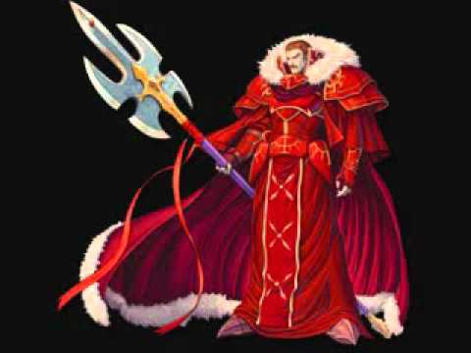 **Image credit belongs to Square Enix and all artists there. I do not own this image** Things I would change about this image, the color of the wardrobe to Blue with black skulls on it. The white fur area I would change that to red to represent the “blood” of all those Xaber has conquered. I am a fan of the kind of weapon this character has so I would change just the color scheme of it and maybe add a few small changes such as two more spikes going up and down on the sides to make it look even more brutal. This captures what an emperor would look like

Xena - 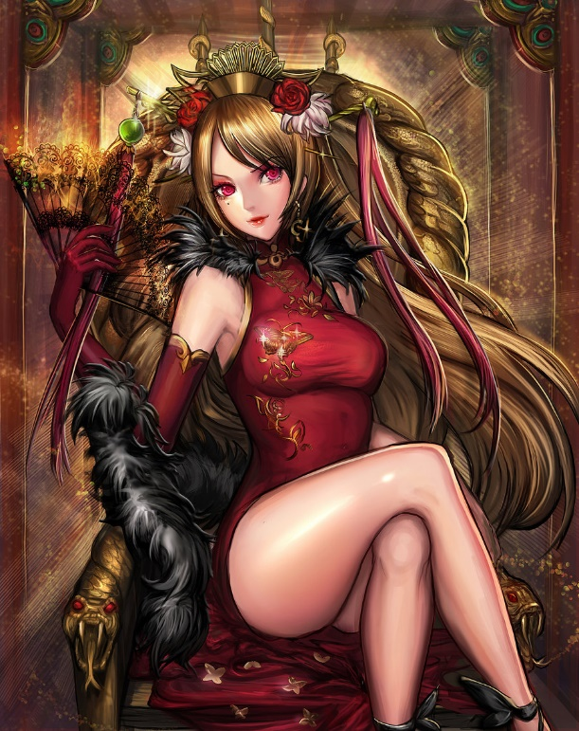 This artist captured the idea of what a potential future empress would look like. In my game, I want Xena to be a beautiful but feared warrior and conqueror, so I could use this design to my advantage. I would change the color scheme to match the Othello colors and design, I would also give her a wardrobe of a more military feel rather than casual and “sexy” as shown here. She also would need several weapons to show how cruel she can be so I’m thinking a bladed whip, a short rapier, and a hidden dagger that she could use to kill foes she has tricked into trusting her and her motives. **Drawn by “Sangrde” on DeviantArt, all rights go to the artist who drew this**

**Gameplay Elements:**

There are many different elements of gameplay within Legends of Asmundur. Being it is an RPG there are many different things players can expect to find. These are some of the things the player may find. The player character they control, the controls in which to control them on the overworld map and in battle and statistics about them in the menu and in battle such as health, mana, status, experience to level, level, etc. Items that can be collected for use or key items for missions such as potions, antidotes, eye drops, magick components, keys, remedies, etc. Non-playable characters (NPCs) such as Celica’s father, the chieftain, Isha, Xaber, Xena, Deities, etc. Game rules and how to determine when the game ends such as dying in battle, or running out of time during a mission.

**Essence of Gameplay:**

Legends of Asmundur offers a unique gameplay experience through the world of Asmundur. The world is filled with magic and was created by 7 elemental Deities who each gave birth to a piece of the world. The player will follow the lives of Celica and Noct who belong to the Horos clan, a group of people long forgotten to the world who live in total isolation. Both Celica and Noct have no idea what is in store for their lives when a sudden calamity comes back from many centuries ago when their ancestor Isha once lived. These two adolescents will end up following in their great ancestors’ footsteps and find out who they truly are.

**Game Features:**

Legends of Asmundur features co-op playability, leader boards for mission time completions, and how many missions you have completed. There is also an online feature that allows players to play together on their own console using our server and Nintendo’s soon to be launched online service system.

**User Interface (Navigational Chart, Functional Reqs, Objects of the UI):**

All components of the UI will be created within Unreal Engine. This includes the world map, the cursor so players know what part of game menus they are on, and all other objects found in the game. The world map will be able to be accessed from the in-game menu or on the overworld screen by press of a button. The map will then populate and take over the current screen to show the layout of the land, where you are, and where towns are that you have visited along with information about them such as name, what can be found there, and if any quests can be started or continued there. The cursor will be a gold or silver colored arrow whose point is pointing at what menu option you are on from the left-hand side. The main menu will consist of the following sub menus to be accessed: Items, Gear, Status, Save, Magick, Abilities, Skills, and Settings.

**Graphics and Video (Graphics and Animations, Animated Insertions):**

All my graphics would be created within 3DS Max and animations would be partially created with credit to Mixamo pre-made animations. Any special animations or effects that would need to be made would also be created within 3DS Max using its animation tools within the software itself. For example: Spells casted by Celica would have a unique starting animation depending on the element of the spell that is cast.

**Sounds and Music (General Description, Sound Effects, Music):**

Players can expect to hear a wide variety of sounds, and music throughout their adventures in Asmundur. My plan is to create a wide range of music that ranges from calming and relaxing music in towns and areas of tranquility to upbeat and heart pounding music that are to be triggered when critical and bad situations are happening. An example of this is in the beginning of the game you start your adventure off on the Isolated Island of the Horos clan where everything is calm and in sync. Then, upon the summoning of the Dark Deity when things start going into chaos there will be a dramatic musical and sound change that occurs. Sound effects will be the sounds of metal clanking against metal and piercing through objects as war breaks out. For the various magic in the game I would attempt to capture some of nature’s sound effects such as fires burning or being lit, lightning striking the ground, water rushing and winds gusting.

**Plot:**

The major conflict that occurs in Legends of Asmundur is the leader of the Othello clan Xaber becomes consumed by greed and corrupted by the military power he holds and sets out to seize control of the entire world. His actions of taking over several continents by force upsets the balance set in the world by the 7 great deities and eventually leads to the re-awakening of the Dark Deity who was defeated by Isha in centuries past. After noticing this disruption in the world Celica and her childhood friend Noct of the Horos clan leave their isolated home and journey into the world to restore balance and stop the Dark Deity from destroying all Asmundur.

**Level Description (The graph of the Positional Relationship of the Levels, Queue of the New Objects Implementation, General Level Design Description):**

Here is a graph and flow chart I made in Visio that shows how to do the very first level within the game which also happens to be the tutorial. It shows one interpretation of mine for how the village would be setup along with the forgotten forest. Along with a legend of how to decipher this map.

**Legend to Decipher my map**

Grey Arrows = General path to follow to find quests or new areas

Red arrows: Critical path to start quests / find quest objectives

Blue arrows: Critical path to get to quest area

Trees: Decoration for creating the Forgotten Forest

Buildings: Represent villager, heroes, key NPC homes.

Black lines: Represent roads

Cautionary Signs: Quest battles / Boss battles

Do not Enter Sign: Spawn in point for new area

Rail roads: Represents gate leading into forgotten forest

**Description of my first level:**

Here is my idea for the first level of the game which is a tutorial to help the player learn how to play. In the tutorial, the player will learn how about the world around them, how to use magic, what types of weapons there are and how they can be used to one’s benefit in battle, how to move around on the world map etc. Celica and Noct are then tasked with hunting creatures in the forest to bring back food for the Horos clan. They must bring back 3 pieces of meat, 1 bear, and 2 boars. After they have finished hunting and defeating the grizzly bear they end up finding out that their great forest is starting to die. This is a bad omen and they rush back home to their village to inform the elders and chieftain what has happened. Upon completion of the tutorial an event is triggered that sets the main storyline into action and begins the next level.



References:

References:

<https://www.google.com/url?sa=i&rct=j&q=&esrc=s&source=images&cd=&cad=rja&uact=8&ved=0ahUKEwi5wY7U1qfVAhXJyoMKHQMSCD8QjB0IBg&url=http%3A%2F%2Ftalesofwiki.wikia.com%2Fwiki%2FDesolation&psig=AFQjCNHJT7rGc4-Mys0JsNPJMpl69perTw&ust=1501183546881078> – First image

<https://www.google.com/url?sa=i&rct=j&q=&esrc=s&source=images&cd=&cad=rja&uact=8&ved=0ahUKEwis7tbl36fVAhVG74MKHeKyCtUQjB0IBg&url=http%3A%2F%2Fmarthur.deviantart.com%2Fart%2FCelica-Fire-Emblem-Echoes-667601270&psig=AFQjCNGw9BJDTbFfLUGe6_U5rpNRajYzGw&ust=1501185998656755> – Second image

<https://www.google.com/url?sa=i&rct=j&q=&esrc=s&source=images&cd=&cad=rja&uact=8&ved=0ahUKEwih6PjX36fVAhUlyoMKHfRdCOIQjB0IBg&url=http%3A%2F%2Fwww.playbuzz.com%2Fgabbyj13%2Fwhat-magic-user-are-you&psig=AFQjCNEFw0HgB8XsV_h060_4YK-6O2Vt_A&ust=1501185935281852> – Third image

<https://www.google.com/url?sa=i&rct=j&q=&esrc=s&source=images&cd=&cad=rja&uact=8&ved=0ahUKEwj8v9Tz4KfVAhXh64MKHeQICXsQjB0IBg&url=http%3A%2F%2Fcastway.deviantart.com%2Fart%2FMysterious-fantasy-warrior-201462114&psig=AFQjCNGFHKsRWKpk15T1kYvJOSbDlYqWLg&ust=1501186294260744> – Fourth image

<https://www.google.com/url?sa=i&rct=j&q=&esrc=s&source=images&cd=&cad=rja&uact=8&ved=&url=https%3A%2F%2Fwww.tumblr.com%2Ftagged%2Ffantasy-assassin&psig=AFQjCNFP3BDsMvRe-zG1lo4ZShuMlb3p9A&ust=1501186574921425> – Fifth image

<https://www.google.com/url?sa=i&rct=j&q=&esrc=s&source=images&cd=&cad=rja&uact=8&ved=0ahUKEwixxN2B46fVAhWH64MKHemfCXgQjB0IBg&url=https%3A%2F%2Fwww.pinterest.com%2Fatimeinplace%2Felfs%2F&psig=AFQjCNEAnTxaMnTfjr1JBLtev7aN0vHYzw&ust=1501186862894386> – Sixth image

<https://www.google.com/url?sa=i&rct=j&q=&esrc=s&source=images&cd=&cad=rja&uact=8&ved=0ahUKEwirxb3M5KfVAhVs2IMKHUjUAjIQjB0IBg&url=https%3A%2F%2Fwww.youtube.com%2Fwatch%3Fv%3DynPE7gHN3io&psig=AFQjCNGwZV7e-RKXwOOU6vVtYNE6v4eBBg&ust=1501187096753111> – Seventh image

<https://www.google.com/url?sa=i&rct=j&q=&esrc=s&source=images&cd=&cad=rja&uact=8&ved=0ahUKEwjQjNzw5KfVAhXM24MKHYmwCckQjB0IBg&url=http%3A%2F%2Fsangrde.deviantart.com%2Fart%2FEmpress-WIP-453824767&psig=AFQjCNH2GMVkBi3EDbjZ2ScJi9ClxlcqNg&ust=1501187351060069> – Eight image

<https://www.google.com/url?sa=i&rct=j&q=&esrc=s&source=images&cd=&cad=rja&uact=8&ved=0ahUKEwiCubSP56fVAhWj0YMKHWQMCicQjB0IBg&url=https%3A%2F%2Febgames.com.au%2Fnintendo-switch-217630-Nintendo-Switch-Pro-Controller-Switch&psig=AFQjCNE1jm-g0lR_Yq3xFKDYfvqZG1Owqw&ust=1501187967882087> – Ninth image