Diabetes Prediction
A Comparative Analysis of Logistic Regression and K-Nearest Neighbors
Dataset: Pima Indians Diabetes Dataset

Executive Summary
This project builds and compares two classification models — Logistic Regression and K-Nearest Neighbors (KNN) — to predict whether a patient has diabetes, using the Pima Indians Diabetes dataset. Because a missed diabetic diagnosis (a false negative) is far more costly than an unnecessary follow-up test (a false positive), the project deliberately prioritizes Recall over Precision or Accuracy throughout model tuning and threshold selection.
After cleaning physiologically impossible values, performing exploratory data analysis, and tuning both models with GridSearchCV, each model's decision threshold was optimized independently on a held-out validation set. On the final, previously untouched test set, the two models performed closely: Logistic Regression achieved a stronger overall ranking ability (AUC 0.84 vs. 0.83), while KNN — once its threshold was tuned as aggressively toward Recall as Logistic Regression's — actually caught slightly more diabetic cases in practice (Recall 0.81 vs. 0.78).
The key finding of this project is not simply "which model is better," but that threshold selection can matter as much as model choice for the practical, real-world outcome a project is optimizing for.

1. Introduction & Objective
Diabetes is a chronic condition where early detection meaningfully improves patient outcomes. This project frames diabetes prediction as a binary classification problem and asks two questions:
- Can patient measurements (glucose, BMI, blood pressure, etc.) reliably predict diabetes status?
- Between a linear model (Logistic Regression) and a non-parametric, distance-based model (KNN), which is better suited to this dataset and this project's specific goal of minimizing missed diagnoses?
Given the asymmetric cost of errors in a medical screening context — a missed diagnosis carries real health consequences, while a false alarm simply triggers a low-risk follow-up test — Recall on the positive (Diabetic) class was chosen as the primary metric to optimize throughout this project, rather than Accuracy.

2. Dataset Description
The Pima Indians Diabetes dataset contains 768 records of female patients, each with 8 numeric features and a binary Outcome label (1 = Diabetic, 0 = Non-Diabetic).
Column | Description
Pregnancies | Number of times pregnant
Glucose | Plasma glucose concentration (mg/dL)
BloodPressure | Diastolic blood pressure (mm Hg)
SkinThickness | Triceps skinfold thickness (mm)
Insulin | 2-Hour serum insulin (mu U/ml)
BMI | Body mass index
DiabetesPedigreeFunction | Diabetes likelihood based on family history
Age | Age of the patient (years)
Outcome | Target variable (0 = Non-diabetic, 1 = Diabetic)

The class distribution is moderately imbalanced: roughly 65% Non-Diabetic and 35% Diabetic. This informed both the choice of evaluation metrics (Accuracy alone would be misleading) and the decision to use class_weight and recall-based tuning during modeling.

3. Data Cleaning
Several columns use 0 to silently represent a missing measurement rather than a genuine value — a 0 mm skin thickness or 0 mg/dL glucose reading is not physiologically possible. Each affected column was cleaned according to its own physiological logic:
Column | Treatment | Reasoning
Glucose | 0 -> NaN -> median | Only a handful of missing rows; median is a safe, simple fill
BloodPressure | 0 -> NaN -> median | Same reasoning as Glucose
BMI | 0 -> NaN -> median | Imputed before SkinThickness, since SkinThickness's fix depends on clean BMI tiers
SkinThickness | Cap >60 at 60; 0 -> NaN -> random value within +/-10 of the BMI-tier median | Caps respect the physical limit of clinical calipers. Bounded random imputation (rather than plain median) avoids an artificial spike in the distribution while staying grounded in the physiological link between skinfold thickness and body fat (BMI)
Insulin | 0 -> NaN -> random value within +/-30 of the Glucose-tier median | Insulin release is directly triggered by blood glucose level, so grouping by Glucose tier reflects real physiology. A wider +/-30 band accounts for Insulin's larger numeric scale
Age, Pregnancies, DiabetesPedigreeFunction | No cleaning needed | 0 is a valid value for these columns

Raw feature distributions (before cleaning), showing the 0-value outliers that motivated this approach:
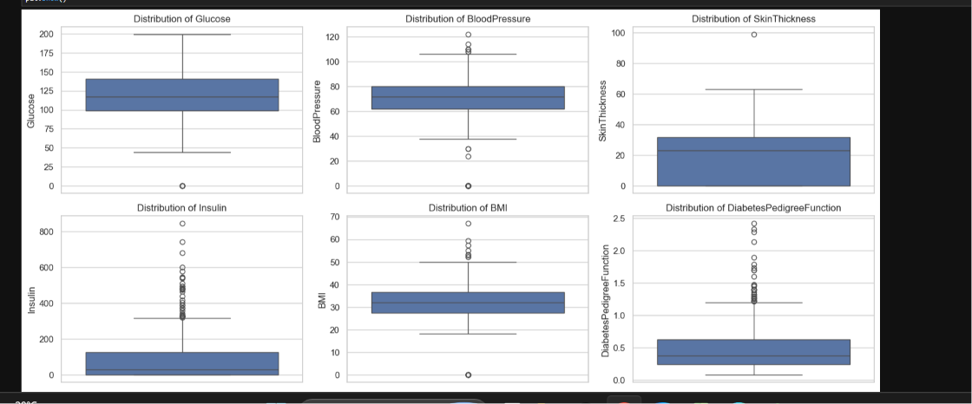
Figure 1. Raw distributions showing impossible zero-value outliers in Glucose, BloodPressure, SkinThickness, Insulin, and BMI.
Distributions after cleaning:
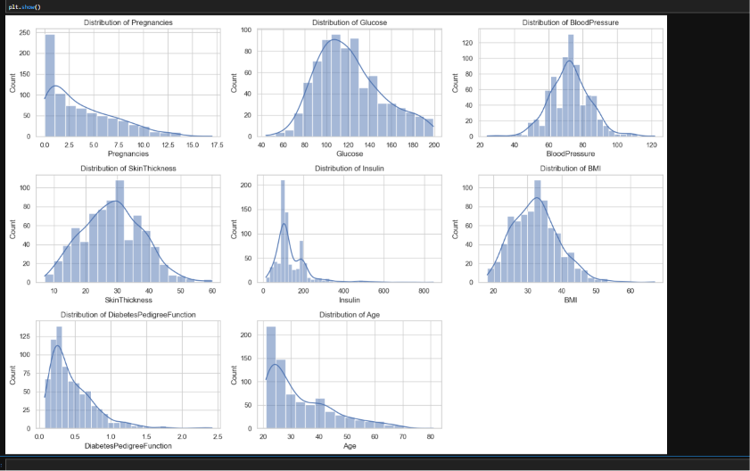
Figure 2. Feature distributions after cleaning and imputation.

4. Exploratory Data Analysis

4.1 Feature Separation by Outcome
Boxplots of each feature, split by Outcome, reveal which features individually separate diabetic from non-diabetic patients:
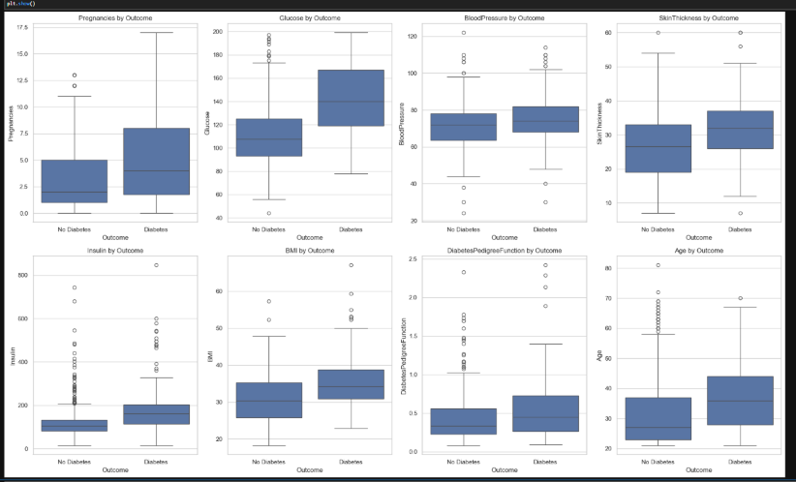
Figure 3. Feature distributions split by Outcome.
- Strong separation: Glucose (clearest predictor), Pregnancies, BMI, Age
- Moderate separation: Insulin, SkinThickness
- Weak separation: BloodPressure, DiabetesPedigreeFunction

4.2 Correlation and Multicollinearity
A correlation heatmap was used to check relationships between features and with the target:
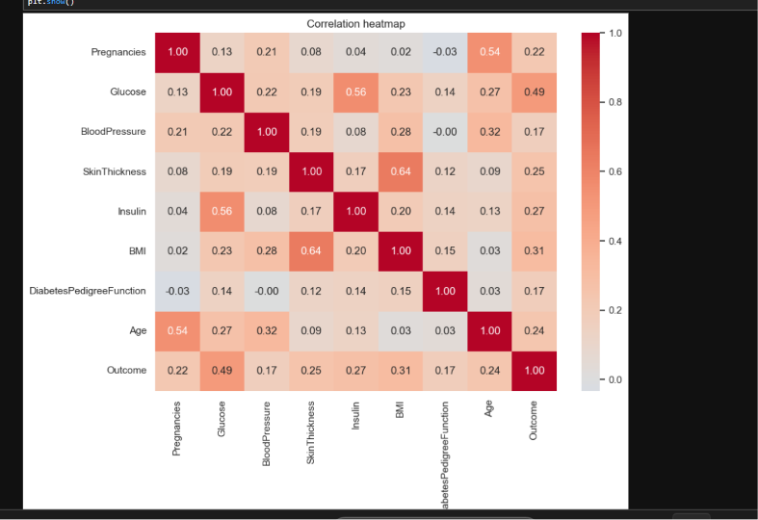
Figure 4. Correlation heatmap of all features and Outcome.
Glucose showed the strongest correlation with Outcome (0.49). Two feature pairs stood out for correlating with each other: SkinThickness/BMI (0.64) and Glucose/Insulin (0.56) — both reflecting genuine physiological relationships (adiposity, and glucose-triggered insulin release) rather than redundant measurements.
A Variance Inflation Factor (VIF) check confirmed this correlation does not translate into problematic multicollinearity: all VIF values fell between 1.05 and 1.85, well below the conservative threshold of 5. No features were dropped.

4.3 Pairwise Relationships
A pairplot of the four strongest predictors shows no single pair of features cleanly separating the two classes — the diabetic and non-diabetic groups overlap substantially in every 2D projection, confirming that a model needs to combine signal across all features rather than relying on any simple rule.
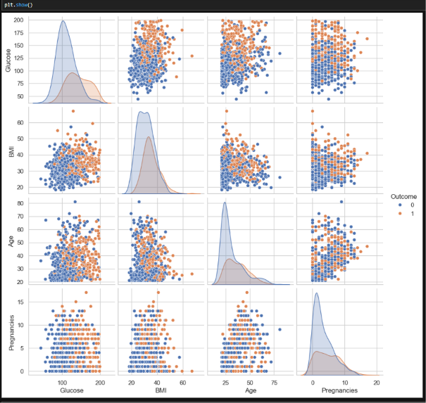
Figure 5. Pairplot of Glucose, BMI, Age, and Pregnancies, colored by Outcome.

5. Preprocessing for Modeling
The data was split into stratified Train (56%), Validation (14%), and Test (30%) sets, preserving the Outcome class ratio in each. The validation set was used exclusively for hyperparameter and threshold selection; the test set was held out and evaluated only once, at the very end.
Features were scaled using StandardScaler, fit only on the training set and applied (never re-fit) to validation and test data, to avoid any leakage of information from the held-out sets.

6. Model 1: Logistic Regression
Logistic Regression was tuned using GridSearchCV over C (regularization strength), penalty (L2), and class_weight, optimizing for Recall on 5-fold cross-validation. The best configuration was C=0.1, class_weight='balanced', penalty='l2'.
Train and validation accuracy were nearly identical (75.5% vs. 75.0%), indicating the model generalizes well and is not overfitting.

6.1 Threshold Optimization
The default 0.5 classification cutoff was compared against alternatives by scanning Precision and Recall across the full threshold range on the validation set.
Threshold | Recall | Precision | F1 | Accuracy | False Negatives
0.50 (default) | 0.74 | 0.62 | 0.67 | 0.75 | 10
0.45 (chosen) | 0.84 | 0.60 | 0.70 | 0.75 | 6
0.35 | 0.87 | 0.51 | 0.64 | 0.66 | 5

Threshold 0.45 was chosen as the final operating point: it substantially improves Recall over the default (74% to 84%, catching 4 more diabetic cases) while leaving Accuracy unchanged and even improving F1 — a strictly better choice than the default 0.5.

6.2 Model Evaluation
ROC and Precision-Recall curves summarize the model's overall discriminative ability, independent of any single threshold. The chosen 0.45 threshold is marked on both curves.
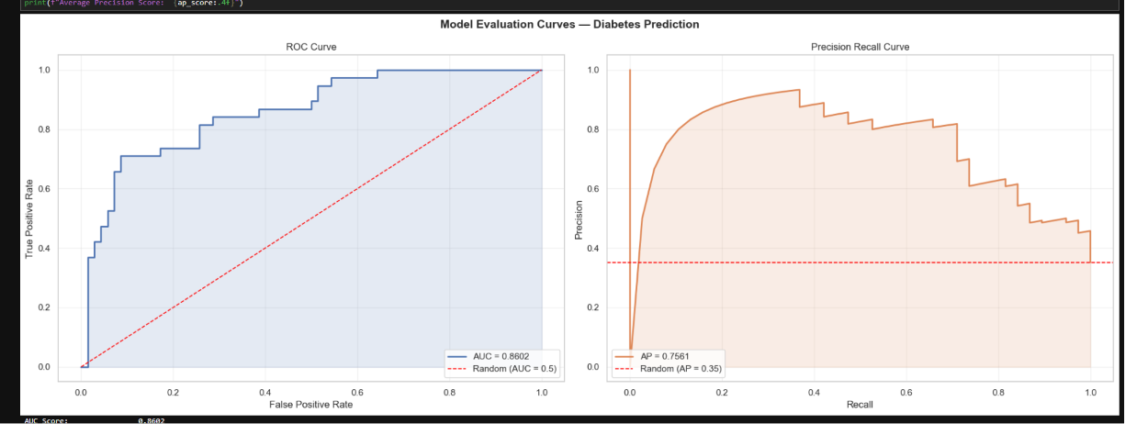
Figure 6. ROC and Precision-Recall curves for Logistic Regression (AUC = 0.86, AP = 0.76).

7. Model 2: K-Nearest Neighbors
KNN was tuned with the same methodology as Logistic Regression — GridSearchCV optimizing for Recall over n_neighbors, weights, and distance metric. The best configuration was n_neighbors=9, weights='distance', metric='euclidean'.

7.1 Threshold Optimization
The same threshold-scanning process used for Logistic Regression was applied to KNN:
Threshold | Recall | Precision | F1 | Accuracy | False Negatives
0.50 (default) | 0.55 | 0.62 | 0.58 | 0.72 | 17
0.45 | 0.61 | 0.61 | 0.61 | 0.72 | 15
0.35 | 0.71 | 0.56 | 0.63 | 0.70 | 11
0.30 (chosen) | 0.82 | 0.52 | 0.63 | 0.67 | 7

Threshold 0.30 was chosen: moving from 0.35 to 0.30 raised Recall substantially (71% to 82%) while F1 held essentially flat, meaning the move traded Precision for Recall without hurting overall balance — consistent with the project's stated priority of minimizing missed diagnoses.

7.2 Model Evaluation
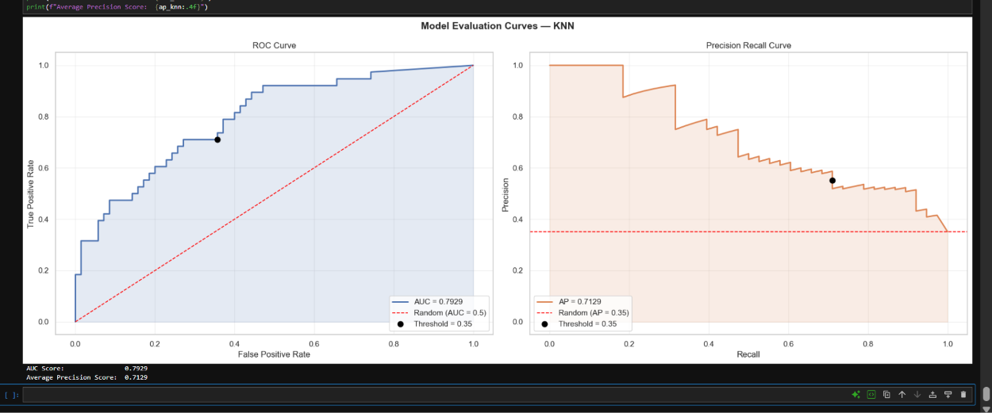
Figure 7. ROC and Precision-Recall curves for KNN (AUC = 0.79, AP = 0.71).
KNN's overall ranking ability (AUC 0.79, AP 0.71) is comfortably better than random, but lower than Logistic Regression's. This is likely because the pairplot showed heavy class overlap in feature space (KNN relies on locally class-pure neighborhoods to perform well), the imputed Insulin and SkinThickness values introduce some synthetic noise that distance calculations are more sensitive to, and KNN has no direct equivalent to Logistic Regression's regularization for handling the moderately correlated feature pairs identified earlier.

8. Final Model Comparison — Held-Out Test Set
Both models were evaluated once, at their independently chosen thresholds (Logistic Regression: 0.45, KNN: 0.30), on the test set that had not been used in any prior tuning or threshold decision.
Metric | Logistic Regression (0.45) | KNN (0.30)
Recall (Diabetes) | 0.78 | 0.81
Precision (Diabetes) | 0.59 | 0.59
F1 (Diabetes) | 0.67 | 0.68
Accuracy | 0.74 | 0.74
AUC | 0.8374 | 0.8263
Average Precision | 0.7170 | 0.6936
False Negatives (missed cases) | 18 | 15

The result is closer, and more nuanced, than the validation-set comparison suggested. Once KNN's threshold was tuned as aggressively toward Recall as Logistic Regression's, KNN actually overtook Logistic Regression on Recall (0.81 vs. 0.78, missing 15 diabetic cases instead of 18) and F1 (0.68 vs. 0.67), while matching it exactly on Precision and Accuracy. Logistic Regression retained the edge on AUC and Average Precision — the threshold-independent measures — meaning its underlying probability estimates are somewhat better calibrated across the full range of possible cutoffs, even though KNN's specific chosen operating point performed slightly better in practice.

9. Conclusion & Limitations

9.1 Which Model Is "Better"?
The answer depends on what is being optimized for. If the priority is the single number this project cares about most — Recall at the chosen operating threshold — KNN narrowly wins. If the priority is a model with stronger, more reliable probability estimates in general — useful if the threshold might need to shift later, or if predicted probabilities are reported directly to a clinician — Logistic Regression is the safer choice, given its stronger AUC/AP and simpler, more interpretable coefficients.
Given how close the two models ended up, either is a defensible final choice for this project. This outcome also demonstrates a broader lesson: threshold selection can matter as much as model choice for the practical result a project is trying to achieve.

9.2 Limitations
- Small dataset (768 rows total, ~429 used for training) limits how much signal any model can learn, especially for the minority (Diabetic) class.
- SkinThickness and Insulin required substantial imputation; while physiologically-informed and randomized to avoid distribution artifacts, a meaningful portion of those two columns is synthetic rather than measured.
- The dataset lacks some clinically important diabetes predictors (e.g. HbA1c, fasting glucose test results), which likely caps how separable the two classes can ever be with this feature set.
- Results are based on a single train/validation/test split; repeating this analysis across multiple random splits would give a more robust estimate of each model's true performance and variance.

