Previous requirement estimate report for Action Impact Workspace 310

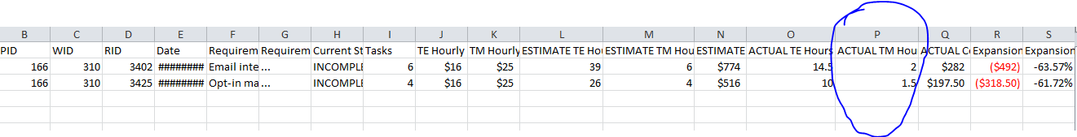

Here I am calculating Actual TM Hours = round(((0.15\*Actual TE Hours )/0.5),0)\*0.5

For eg. round(((0.15\*14.5)/0.5),0)\*0.5 = 2

Previous Daily work journal for Action Impact Workspace 310

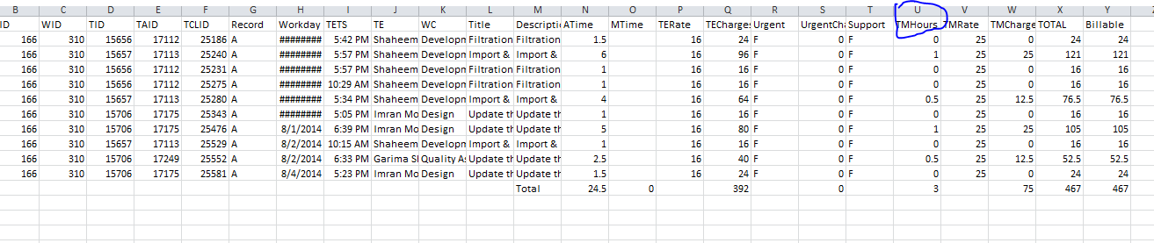

Here I am calculating TM Hours = round(((0.15\*ATime )/0.5),0)\*0.5

For eg. round(((0.15\*1.5)/0.5),0)\*0.5 = 0

I have created new reports for both with decimal values

Requirement estimate report for Action Impact Workspace 310

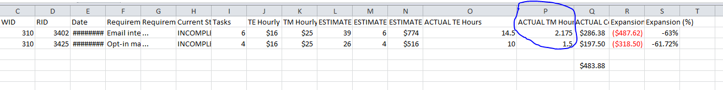

Here I am calculating Actual TM Hours = ((0.15\*Actual TE Hours ) /0.5) \*0.5

For eg. ((0.15\*14.5)/0.5)\* 0.5 = 2.175 Not rounding the value

Daily work journal for Action Impact Workspace 310

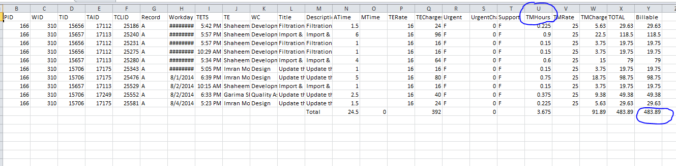

Here I am calculating TM Hours = ((0.15\*ATime )/0.5)\*0.5 For eg. ((0.15\*1.5)/0.5)\*0.5 = 0.225