Classes used

Main Class

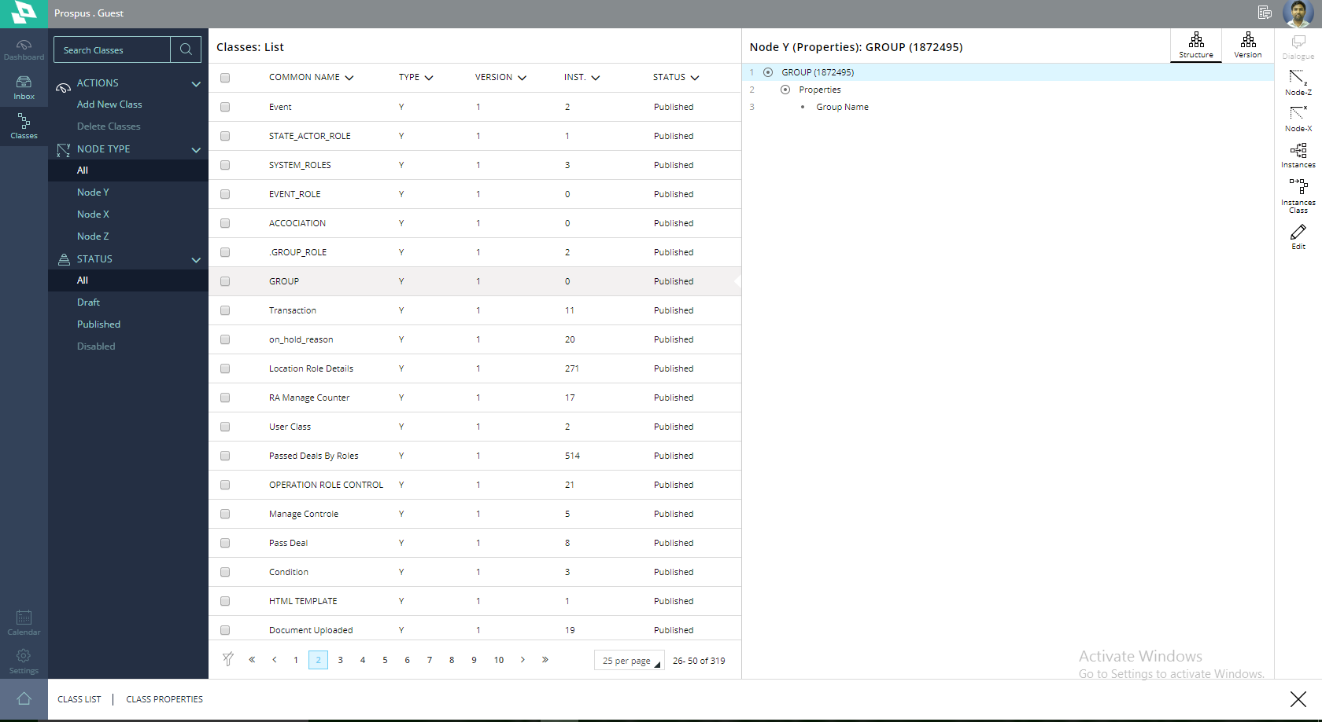

Instance Class

We have created this class to so that we can inherit the changes from the main class, where Group is Main Class.

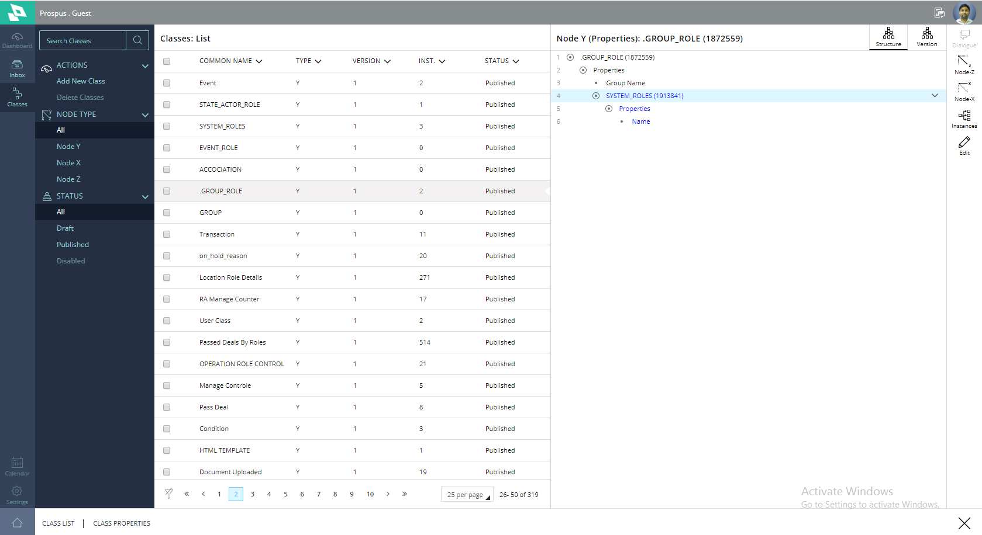

Class

SYSTEM_ROLES

Here we can add the roles for the system. For e.g., BM,RM etc

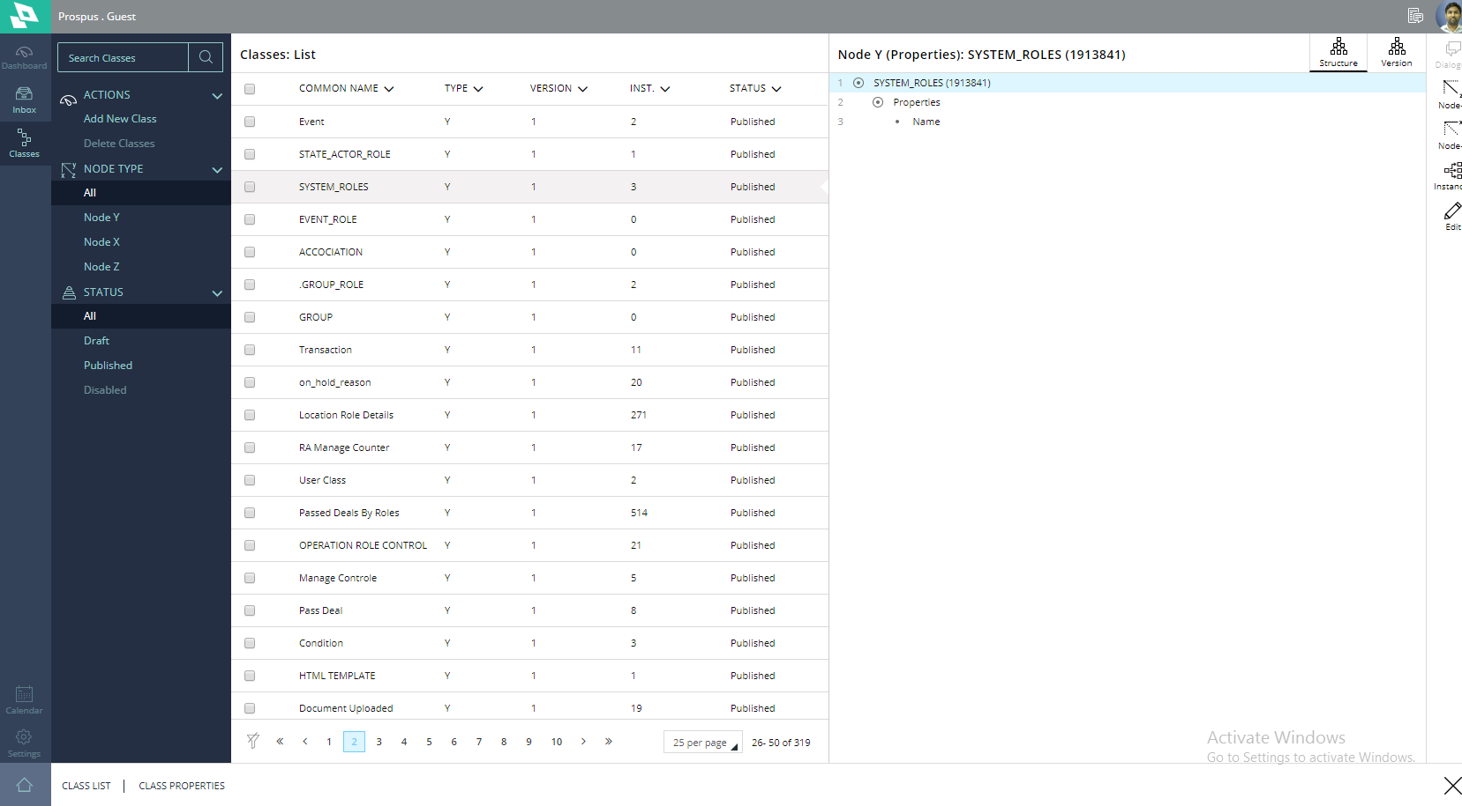

Association Class

Group_role is sub-class

Timestamp:

Type:

Actor:

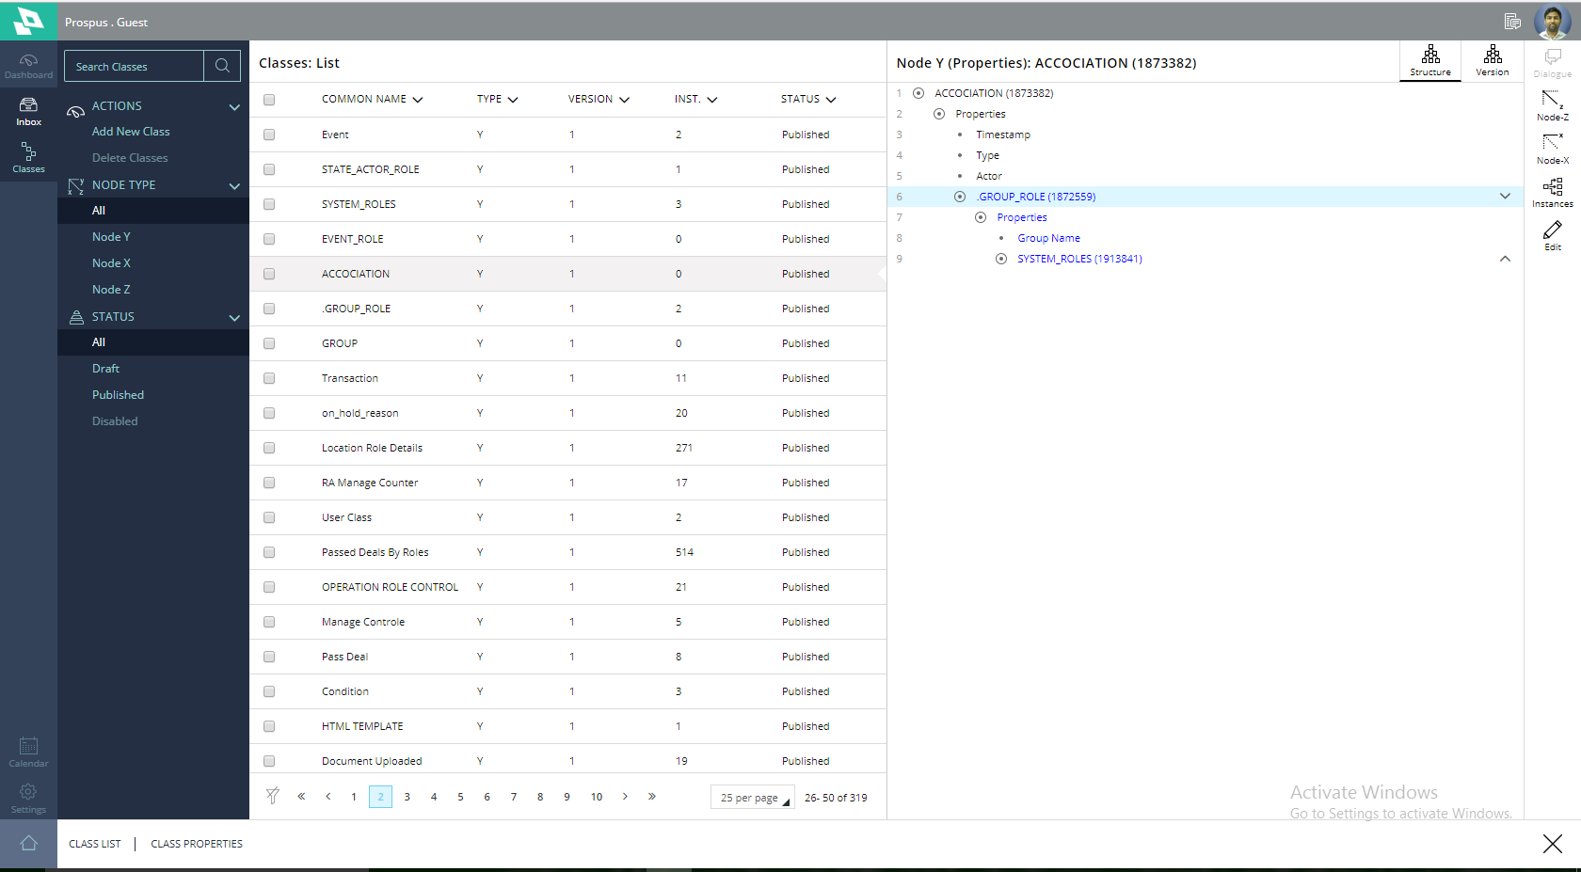

STATE_ACTOR_ROLE

Table used to get the information of user at any time for their role in groups. By using the Actor id we can get the complete Role information of the Actor.

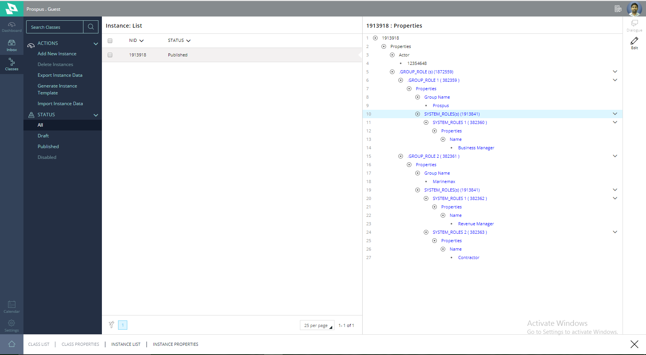

Event Class  
 This class created for storing the event information whenever role is assigned or Un-assigned to the actor with timestamp. Also group information and role information.

