**COVID-19 Detection in Chest X-ray Images Using Swin-Transformer and Transformer in Transformer**

The 2019 Coronavirus Disease (COVID-19) has spread around the world and done significant harm. An X-ray of the chest are frequently employed to diagnose COVID-19, and the inclusion of artificial intelligence can improve productivity and precision. We presented a method that combined Swin Transformer and Transformer in Transformer to classify chest X-ray images as three classes: COVID-19, Pneumonia, and Normal (healthy) and achieved 0.9475 accuracies on the test set in the Ethics and Explainability for Responsible Data Science (EE-RDS) conference 2021.

COVID-19, chest X-ray images, SwinTransformer, Transformer in Transformer, model ensemble, and image classification are some of the terms used in the index.

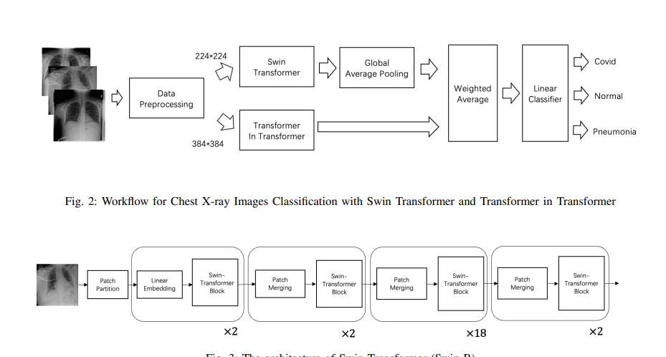

In the challenge of Chest XR COVID-19 detection, we used Swin Transformer and Transformer in Transformer to classify the chest X-ray pictures in this work. Utilizing the weighted average technique, we created an ensemble of models. On the test set, we had an accuracy of 0.9475, placing eight on the scoreboard.