// serial time 8.803 seconds

// parallel time 0.353 seconds the speed up is s=tserial/tparallel = 8.803/0.353 = 24.94

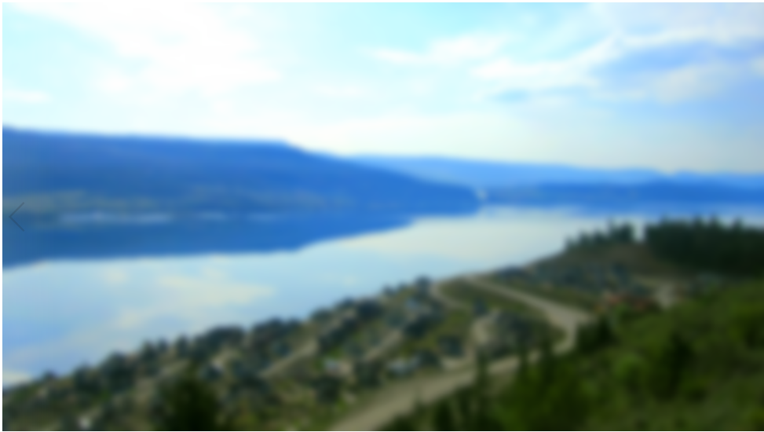

Custom filter 1:

More black pixels results in a blurrier and distorted image and a longer time to process

//1.278

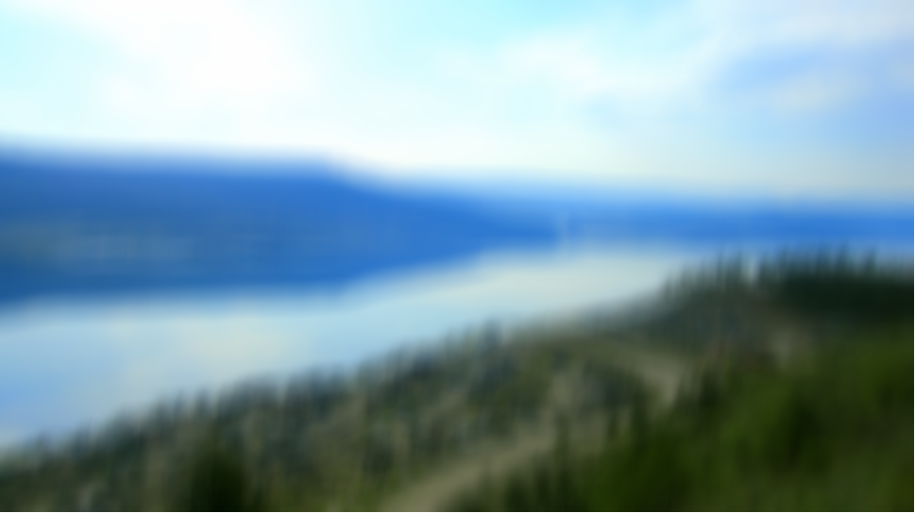

Custom filter 2:

Using more white pixels, results in just a blurrier image

1.294 seconds

