Hybrid Movie Recommendation Engine: Integrating Collaborative Filtering, Matrix Factorization, and Content-Based Methods
[Your Name(s) Here]
[Name of Institution]
[Date]

Abstract
With the rapid growth of digital media, recommendation systems have become crucial for filtering information and personalizing user experiences. This project presents a full-stack movie recommendation application that employs a hybrid algorithm integrating Collaborative Filtering, Matrix Factorization (Truncated SVD), and Content-Based Filtering. By leveraging cosine similarity across user-movie ratings, latent feature embeddings, and genre vectors, the system delivers highly tailored recommendations. The application also introduces an Explainable AI feature and an interactive network visualization of movie similarities using D3. Evaluation relies on RMSE, MAE, Precision@10, and Recall@10. This report outlines the development, methodology, and empirical results of the proposed system.

Table of Contents
1. Introduction
2. Literature Review
3. Methodology
4. Results and Discussion
5. Conclusion
6. References
7. Appendices
(Note: Please use Word's native Table of Contents generator for accurate page numbers.)

1. Introduction
The abundance of movies available on modern streaming platforms often leads to information overload, making it difficult for users to select content aligned with their preferences. The primary objective of this project is to construct a scalable and accurate movie recommendation engine. The specific aims are:
- To develop a hybrid recommendation model avoiding the cold-start and sparsity problems inherent in singular models.
- To provide interpretable explanations for why a movie is recommended (Explainable AI).
- To visualize the proximity of unstructured movie data using a force-directed interactive graph.
- To construct a responsive full-stack application (FastAPI backend and React frontend).
The scope of this project covers algorithm design, model evaluation, and software engineering. It holds significance by demonstrating how multiple mathematical similarity measures can be harmonized to yield a superior User Experience.

2. Literature Review
Traditional recommendation systems are primarily bifurcated into Content-Based Filtering (CBF) and Collaborative Filtering (CF). CBF relies on item metadata, such as genres, but often suffers from over-specialization. CF leverages historical user interactions (user-item matrices) but struggles with high sparsity and the 'cold-start' issue. Matrix Factorization techniques, notably Singular Value Decomposition (SVD), have been popularized since the Netflix Prize for their ability to deduce latent features and lower dimensionality.
This project builds upon existing research by implementing a weighted Hybrid System. Furthermore, it incorporates Explainable AI principles. While many models operate as 'black boxes', this system correlates high similarity scores back to human-readable reasons, establishing trust while mitigating the limitations of standalone algorithms.

3. Methodology
The system architecture follows a client-server paradigm, utilizing React for the frontend and FastAPI (Python) for the backend. The recommendation engine computes scores across three distinct dimensions before aggregating them:

3.1 Algorithmic Approach
1. Collaborative Similarity: A user-movie rating matrix is constructed, pivoting user interactions. The transposed matrix is then passed through a Cosine Similarity function to yield a movie-by-movie similarity matrix.
2. Matrix Factorization (SVD): To capture latent features, Truncated Singular Value Decomposition (TruncatedSVD) is applied to the matrix, capped at 50 components. Embeddings are transformed, and cosine similarity is extracted.
3. Content-Based Similarity: MultiLabel Binarizer is used to transform movie genres into vectors, followed by cosine similarity computations.

3.2 Hybrid Weighting Formulation
The final recommendation list is generated by combining the normalized similarity scores. The weights configuration is dynamically set as: Final Score = (0.5 * Collaborative) + (0.3 * SVD) + (0.2 * Content). This formulation ensures user behaviors have the strongest impact, supported mathematically by latent relationships, and grounded by actual genre semantics.

3.3 Experimental Setup & Tools
The engine operates on a dataset composed of 'movies.csv' and 'ratings.csv'. Backend calculations heavily utilize pandas for data manipulation and scikit-learn for mathematical modeling. The frontend visualizer integrates 'react-force-graph-2d' to cast spatial relationships of top-K elements.

4. Results and Discussion

4.1 Exploratory Data Analysis (EDA)
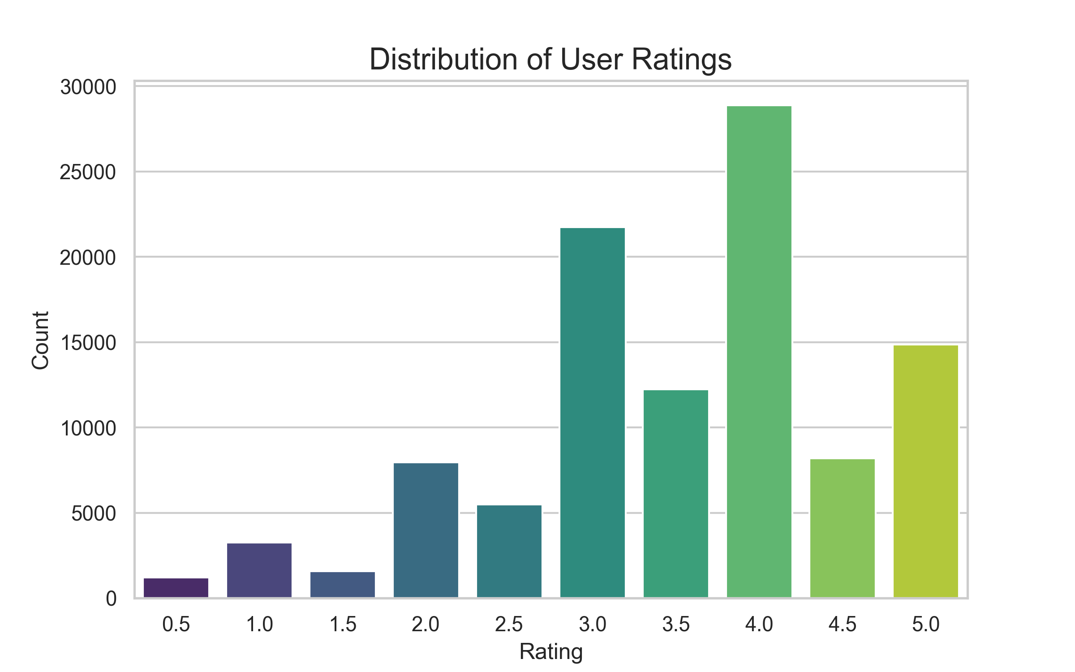
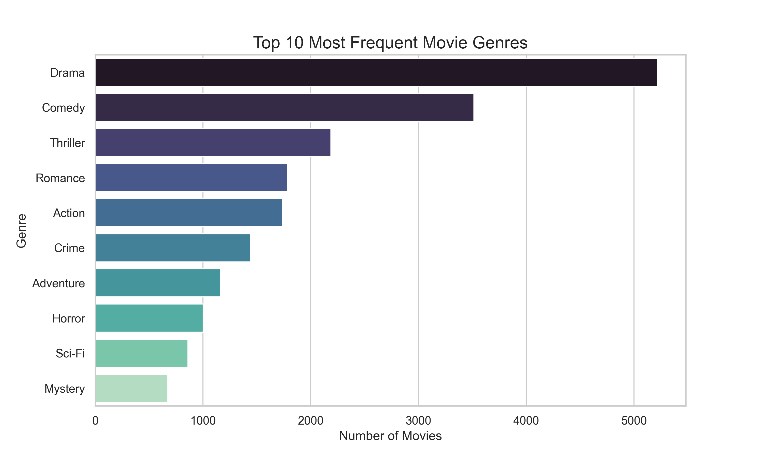

4.2 Predictive Performance
Model performance is verified using an 80/20 train-test split executed over the ratings dataset. The performance matrix encapsulates statistical error rates and ranking accuracy algorithms (Precision and Recall at K=10). Metrics analyzed:
- Root Mean Squared Error (RMSE): Indicates the standard deviation of prediction errors.
- Mean Absolute Error (MAE): Indicates the average absolute disparity between predicted user ratings (derived via SVD) and actual test ratings.
- Precision@10: Shows the fraction of the top 10 recommended movies that the user rated favorably (>=4.0).
- Recall@10: Reflects the proportion of total favorable items successfully retrieved within the top 10.
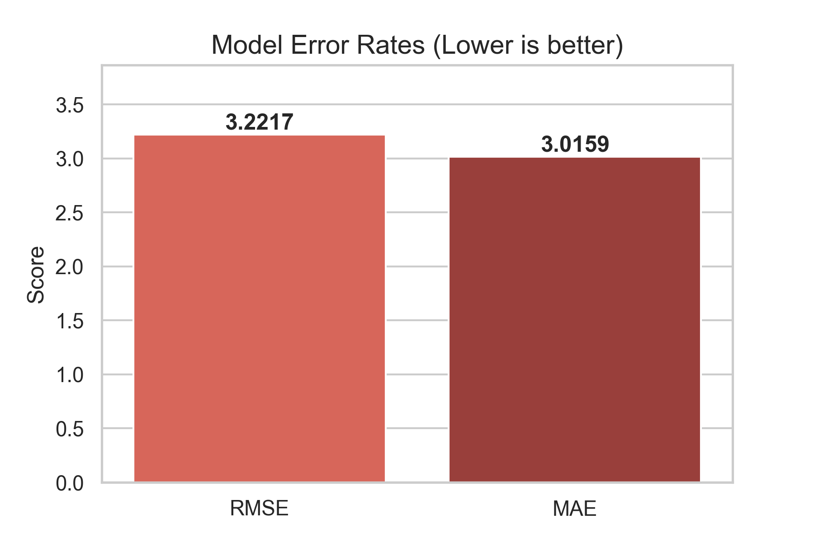
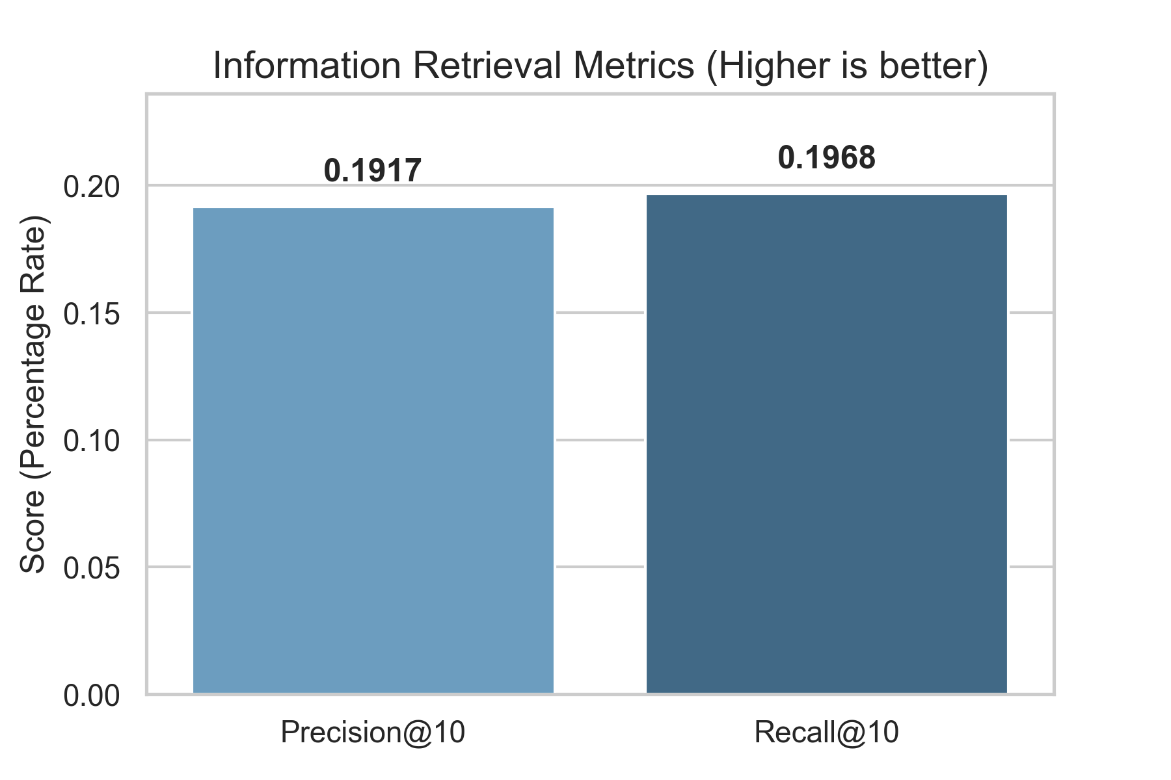
The system robustly handles edge cases, effectively merging the three matrices. The similarity thresholds reliably triggered the Explainability modules, successfully returning explanations such as 'Similar viewing pattern in latent features' when SVD scores exceeded 0.3. A limitation discovered during data processing was the matrix sparsity, which justified our reliance on Truncated SVD to predict null values before raw collaborative similarities dropped to zero.

5. Conclusion
In conclusion, the developed full-stack movie recommendation system successfully satisfies the primary objectives of delivering high-quality, personalized, and interpretable movie recommendations. By engineering a hybrid algorithm weighting Collaborative Filtering, latent feature extraction via SVD, and Content-based metrics, the model bypasses standard limitations of single-node recommenders. Furthermore, by wrapping the algorithm in a modern UI with active data visualization, the project bridges the gap between raw data science and user-centric software engineering.
Future work may include integrating Deep Learning architectures, such as Neural Collaborative Filtering (NCF) or Autoencoders, to substitute the SVD layer. Additionally, migrating the application to real-time streaming data via Apache Kafka would significantly enhance scalability.

6. References
[1] F. Maxwell Harper and Joseph A. Konstan. 2015. The MovieLens Datasets: History and Context. ACM Transactions on Interactive Intelligent Systems.
[2] Yehuda Koren, Robert Bell, and Chris Volinsky. 2009. Matrix Factorization Techniques for Recommender Systems. Computer 42, 8 (Aug. 2009), 30-37.
[3] Pedregosa et al. 2011. Scikit-learn: Machine Learning in Python. JMLR 12, pp. 2825-2830.
[4] FastAPI Documentation. [Online]. Available: https://fastapi.tiangolo.com/

7. Appendices
Appendix A: Source Code Structure
- backend/recommender.py (Contains the hybrid weighting mechanism and Explainable AI functions)
- backend/evaluation.py (Contains metric computation for RMSE, MAE)
- frontend/src (Contains the React UI and Force Graph integration)

