Quantum-yields Blog

MPWR – Monolithic Power
Quick Thesis: Long track record of efficient operations and customer-centric innovative solutions are what enable this company to consistently deliver quality double-digit returns. Stock price recently dipped due to “near-term outlook” concerns, but long-term growth and value remain.

10-year return: 1,625%
5-year return: 374%
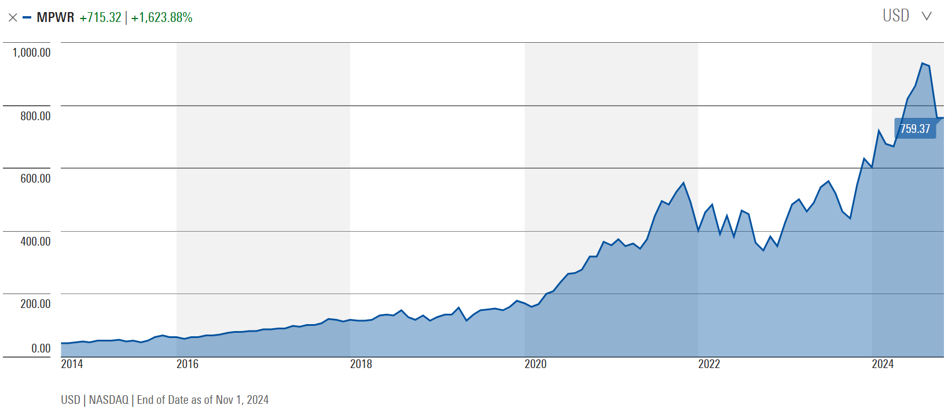

Biz Overview
As stated from their 10k, Monolithic Power Systems Inc. (MPS) is a “fabless global company that provides high-performance, semiconductor-based power electronics solutions.”. This essentially means they design the semiconductors that their customers buy but they outsource the manufacturing to a third party. This has both advantages and disadvantages but the key advantage is that MPS has lower capital expenditures and can focus on R&D and delivery innovative solutions to their customers. Many other companies like NVIDIA, Qualcomm, AMD, and Broadcom also follow this approach.
MPS’ mission is to “reduce energy and material consumption to improve all aspects of quality of life and create a sustainable future” and they differentiate themselves by “offering solutions that are more highly integrated, smaller in size, more energy-efficient, more accurate with respect to performance specifications and, consequently, more cost-effective than competing solutions.”.
MPS focuses on the analog and mixed-signal integrated circuit markets which differs from digital integrated circuit markets but the markets are wide and diverse. Below MPS’s revenue by end market and applications as of end of 2023:

End Market | Applications | 2023 % of Total Revenue
Storage and computing | Storage applications, commercial notebooks, and graphics cards | 27%
Automotive | Advanced driver assistance systems, infotainment digital cockpit, USB connectors, body electronics, and lighting applications | 21.7%
Enterprise Data | Cloud-based CPU server applications and server artificial intelligence (AI) applications | 17.7%
Consumer | Home appliances, gaming, smart TVs, lighting, monitors, and stereos | 12.9%
Communications | 4G and 5G infrastructure, satellite communications, and other wireless applications | 11.3%
Industrial | Power sources, industrial meter, security applications, and other industrial equipment | 9.4%

Its competitors include: Analog Devices, Infineon Technologies, NXP Semiconductors, ON Semiconductor, Power Integrations, Renesas Electronics, ROHM Semiconductor, Semtech, STMicroelectronics and Texas Instruments.

Growth Metrics
Here are some of the key metrics to consider. In general, I like to look for management’s ability to increase return on equity and invested capital, rely little on debt, and have ample liquidity to handle volatile times. Though this snapshot is over the past 5 years, if you go back further in time you’ll see improvement across all these metrics since the beginning of MPS’ formation.
I can’t say I like any single thing here the most, but I do like to see that management is disciplined about managing debt and cash and being able to consistently return value to shareholders year after year.

Metric | 2023 | 2022 | 2021 | 2020 | 2019
Revenue [$ MM] | 1,821 | 1,794 | 1,207 | 844 | 628
ROE [%] | 22.99 | 30.05 | 21.9 | 18.89 | 15.4
ROIC [%] | 21.86 | 29.23 | 20.96 | 17.80 | 14.36
Cash flow / Net income | 1.36 | .43 | .93 | 1.29 | 1.1
Net Margin [%] | 23.47 | 24.39 | 20.04 | 19.47 | 17.33
Debt / Equity | .002 | - | - | .003 | .002
Quick ratio | 5.78 | 3.58 | 3.75 | 4.60 | 5.26

Moat
MPS is very clear about their value proposition AND it’s in their name! Monolithic circuits refer to integrated circuits where all components (transistors, resistors, capacitors, etc.) are fabricated onto a single piece of semiconductor. They do this through their proprietary bipolar-CMOS-DMOS (BCD) process technology which is now in its sixth generation. The combination of these three components results in a product with higher power density and configurability than a three-component solution. Monolith focuses on highly integrated power management chips which provides superior levels of reliability and convenience for their customers which subsequently results in high switching costs.

Risks
The greatest risk to MPS is its exposure to China. A third of their revenue comes from Chinese customers and a portion of their manufacturing relies on Chinese foundries (with the remaining in Taiwan, South Korea, and Singapore). Given Donald Trump has won the most recent Presidential election, one can expect increased pressure on Chinese imports which could raise the cost of Chinese imported products as well as put pressure on Chinese consumers. Beijing, however, has been watching U.S. elections closely and recently revealed a $1.4 trillion financial package to boost the economy. It’s also worth noting that MPS stock price performed well even during Trump’s first term, gaining approximately 300%.

Sustained Alpha
What really makes MPS so attractive is the company’s consistently high return on equity and invested capital, extremely low debt levels, and high customer switching costs. The current CEO is Michael Hsing and he’s been with the company for 27 years. Unless there is a dramatic change in leadership, I expect MPS to continue to generate above average returns.

DIS – Disney what’s working

Biz Update

Growth and Operational Efficiency

Moat

Risks

Sustained Alpha

TPL – Texas Pacific Land Corporation: An interesting fossil fuel play with no debt

Biz Overview
Texas Pacific Land Corporation (TPL) is probably the fastest growing O&G stock that doesn’t produce a drop of oil. They own land from which they derive royalties from oil, gas, and NGL production (57% of 2023 revenues) as well as produced water (18%), easements and surface leases (11%) and land sales (1%). They own approximately 868,000 surface acres in WTX which were previously owned by the Texas and Pacific Railway Company who was granted land by the government to incentivize rail infrastructure expansion.
In the two graphs below you can see how TPL’s stock price has appreciated over the past year and has outperformed the S&P 500 (which they are expected to join in the next year) by a wide margin. In this blog I’ll talk more about what’s driving this and call out some price targets and risks.
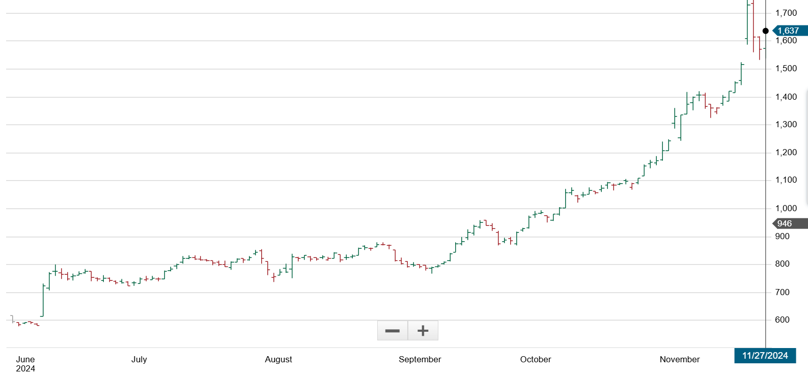
Figure 1: TPL 1-year price movement

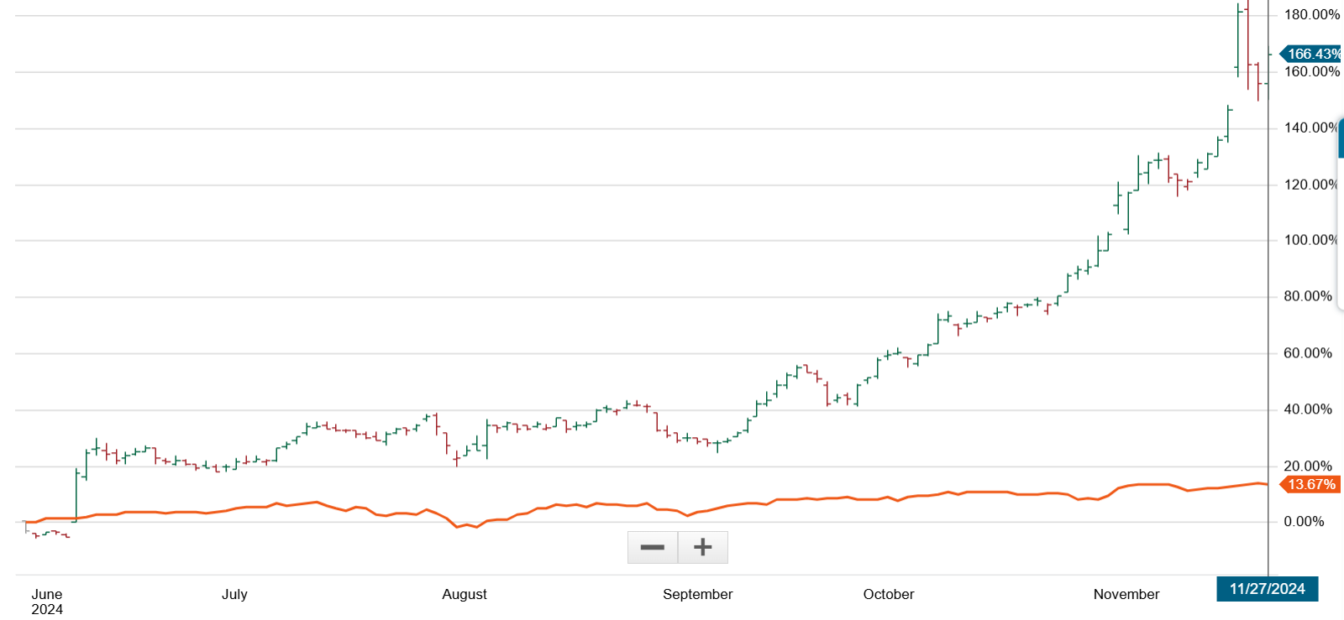
Figure 2: TPL vs S&P500 over 1 year

Growth and Operational Efficiency
TPL’s asset is land ownership and mineral rights. Oil & gas companies lease their land and pay a portion of their revenues to TPL in the form of royalties. TPL spends very little capital to maintain their asset and in turn receives royalties which are quickly turned into cash as there is no inventory and they have no debt to repay. Their cash conversion and return on assets and equity is otherworldly and they have been consistently carrying a heavy, growing cash balance every year. At the end of 2023 they held $725MM in cash.
Looking at profitability metrics:
- Gross profit margins: 93.6%
- Net profit margins: 65%
- Return on assets: 39.8%
- Return on equity: 44.5%
- Total debt: 0
No matter who you compare against, these are impressive operational metrics.

Moat and Competitors
Their moat is quite obvious – they own 868,000 surface acres in the Permian is the most productive oil, gas, and NGL plays in the country. Oil half-cycle break evens are extremely low and there is ample infrastructure to move product and if there isn’t sufficient pipeline, well, it is TX so building or expanding pipe is not really a bottleneck. Second, TX export infrastructure continues to grow so even if there is lack of demand in the U.S., export markets are a safe outlet. Lastly, WTX irradiation is also amongst the best in the country so TPL could hedge their oil royalties with solar capacity buildout.
I briefly looked up other similar “trusts” and came up with several including:
- Permian Basin Royalty Trust (PBT)
- Sabine Royalty Trust (SBR)
- North European Oil Royalty Trust (NRT)
- San Basin Royalty Trust (SJT)
- Cross Timbers Royalty Trust (CRT)
- VOC Energy Trust (VOC)
If any turn out to be interesting I’ll follow up in another blog, but just sharing these for the intrigued reader.

Risks and Opportunities
The risks are quite low for a non-operating company. The biggest risk is a collapse in oil prices but even a collapse in oil prices would be brief. The U.S. is now a large exporter of all these commodities and under Trump we’re likely to see few restrictions, if any, on exporting these products. Lack of infrastructure could constrain growth, but this is TX we’re talking about, and constructing supporting infrastructure (gas processing plants, fractionators, pipelines, etc.) is unlikely to be a significant barrier to growth.
Weather could be a factor but likely only short-lived. It is not uncommon now for WTX to experience arctic-like temperatures that cause well head freeze-offs, but those are only a blip on the radar at worst.
Given the abundance of supply in the Permian and relatively weak natural gas prices, I could see a scenario where data centers and accompanying gas-fired power plants get developed in this region. AI is driving exponential need for data centers and clean energy and the Permian produces an astounding amount of natural gas which, if paired with carbon capture, could be a perceived as both a sustainable and cost-effective energy production pathway. TPL could directly benefit from this trend directly through its surface and easements leases or indirectly through increased production of natural gas.

Sustained Alpha and Valuation
A growth rate is difficult to project here because they haven’t really spent any capital expanding their asset base.
Based on today’s current price and a discounted cash flow model we can infer the market is assuming the following on TPL :
- Discount rate: 7% (10-year treasuries are ~ 4.2% so I added a small risk premium which is inline with many real estate companies who act as lessors)
- FCF of $415MM growing annually 11%-12% with a terminal growth rate of 5%
- Annual cash on balance of $600MM
- Assuming 23MM outstanding shares with no future dilution or incremental dividends paid
- 0 debt

Of course, these are just assumptions but the two things I see with most variability would be the assumed annual cash on hand and the growth rates. Based on historical company operating data and what we know about the business (and ignoring drilling rig counts and oil & gas prices) I believe these are very conservative assumptions. Let’s look a slightly more optimistic scenario to estimate what this stock could be worth.
Assume the following:
- Discount rate: 7%
- FCF of $415MM growing annually over 10 years at 20% with a terminal growth rate of 5%
  - Historically the CAGR of their FCF over the past 8 years is 34% with the past two years at 22%
- Annual cash balance of $700MM
- Assuming 23MM outstanding shares with no future dilution or increase in dividend payout ratio
- 0 debt
We get a price of $3,367/share.
Taking the last set of assumptions and now estimating 30% growth, we get $6,709/share.

Thoughts on Portfolio and Risk Management and Returns
I’ve been investing for almost 20 years now and worked professionally in commodity fundamentals and risk management for 15 of those years. For anyone who’s worked in commodity trading, you know how cutthroat it is and how critical the need is to make right calls with appropriate hedging mechanisms in place. Being a fundamentals analyst has served me well and I am able to view a position holistically without any bias, but of course that took years of learning and many mistakes until I could confidently hone it. In this blog I will talk about how I approach optimizing my portfolio to reduce risk and reach for above-average returns.

Portfolio Optimization

Target Assets
The number and type of assets available to invest in is extremely large and can overwhelm investors. I don’t like to get into exotic investments or assets I don’t understand well. There may be exceptions such as cryptocurrencies or blockchain technologies as they tend to drive efficiencies and there should probably be some room in one’s portfolio to invest in these, as I have learned, it is imperative to keep an open mind when it comes to investing.
For the sake of this blog and my own portfolio, I will limit the world of assets to U.S. equities only. Why is that? It’s simple. The U.S. has hundreds of years of entrepreneurial history evidenced by the fact that the U.S. is the largest contributor to global economic value added. There is a long, rich history of American companies solving problems fast and at scale and no other country, including China, has measured up to the amount of value the U.S. has created. Some may debate this point but as along as the Chinese Communist Party is in power and attempts to control their markets with a heavy hand, this is unlikely to change anytime soon. The figure below illustrates this point perfectly.

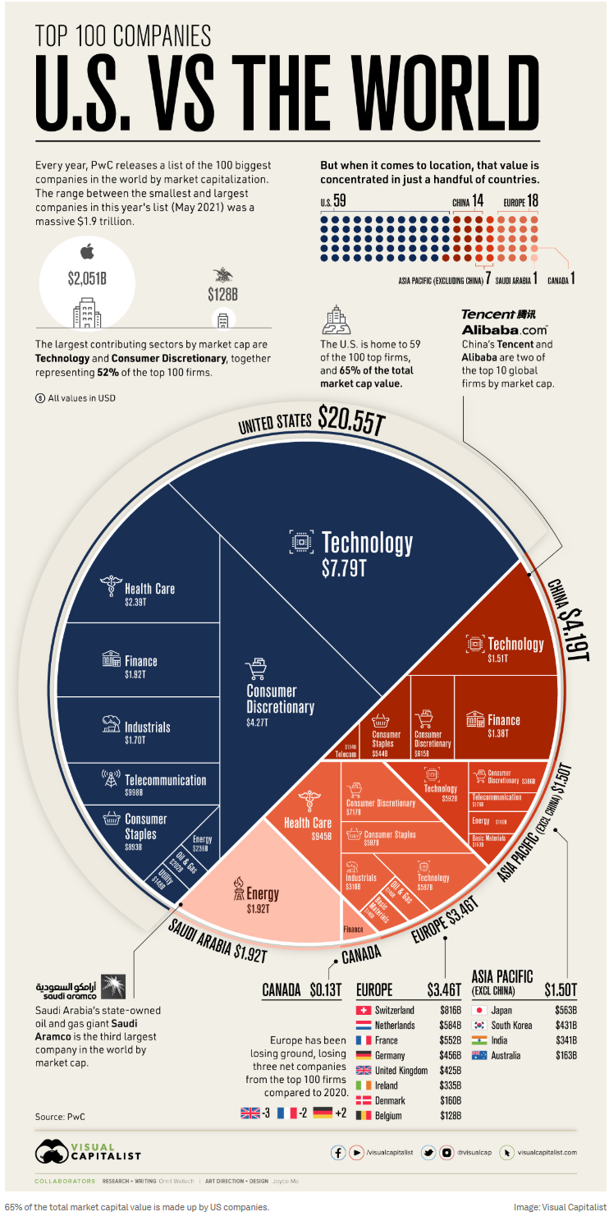

Target Returns
In my portfolio, I look for companies with asymmetric risk/reward profiles over the long-term (5+ years). I would rather spend a significant amount of time finding 10 companies that could return $3 for every $1 invested knowing I could lose $0.20 per dollar rather than investing in 100 companies that could return $1.20 for every $1 invested. I prefer to spend my time learning deeply about a few companies or industries and leveraging my expertise than to reach outside my sphere of knowledge. Healthcare companies are a great example of a type of equity I will never add to my portfolio simply because it is just outside the realm of what I read everyday.

Risk Calculation
Knowing your risk exposure is important. Taking too much risk for insufficient return is not an acceptable strategy. The goal of every investor is to maximize returns while taking as little risk as possible. In the table below I’ve outlined some key metrics for both TPL and MPWR in comparison to each other as well as in comparison to an equity benchmark, SPY using price data from January 18th 2024 to January 17th 2025.

 | Metric | TPL | MPWR | SPY
1 | Price correlation to SPY | .927 | .107 | n/a
2 | Price correlation to each other | -0.123 |  | n/a
3 | Standard deviation of returns | 0.0296 | 0.034 | 0.0081
4 | Covariance of daily returns to SPY | 0.000068 | 0.000169 | n/a

Some key takeaways from this table include:
- Sufficient diversification in the portfolio as TPL and MPWR have nearly 0 correlation.
- There is still some price correlation with SPY as TPL is an oil & gas equity so will naturally move in correlation with respect to health of the economy which is largely underpinned by commodity prices.
- We are taking on more risk than what is experienced by buying an index ETF, SPY but at the same time the portfolio’s volatility is limited to 3%-4% daily. This is sufficient risk to take on in return for double digit returns.
- Covariance of daily returns of each of these equities compared to SPY are not correlated.

Last Thoughts
This short blog highlights how I’ll be thinking of the portfolio going forward but that doesn’t mean I won’t necessarily be adjusting throughout the year as market dynamics change. The most interesting things to watch this year include:
- Interest rates and inflation
- Deregulation
- Geopolitics and how the U.S. positions itself compared to the rest of the world
- Impacts of machine learning, AI, and LLMs
- Infrastructure spending (data centers, energy, etc.)

Alternative Asset Investment Opportunities – A Closer Look at KKR

Thesis

The new U.S. Administration shows promise of boosting the economy. As Trump has stated, he’s pro deregulation, AI infrastructure, energy infrastructure, and set on reducing business friction in the U.S. However, he also has vowed to place tariffs on foreign goods and deport illegal immigrants, which, if executed unthoughtfully, could actually result in an increase in prices or inflation and completely derail the economy. As of today, it’s not exactly clear how these factors will play into overall inflation and interest rates but let’s simplify the analysis for now and just assume he will be a rational businessman at the end of the day and he and his cabinet will ultimately act rationally in their policies and support economic growth.
This infrastructure growth is being fueled by advancements in AI and machine learning. If you’ve been paying attention, folks like Jensen Huang are calling these the early days of AI with many making comparisons to the early days of the internet. We have entered a new growth era and looking for ways to ride this wave with as little risk as possible.
This is what brings me to data centers. All the large tech companies (Google, Meta, Microsoft, Amazon, etc.) are spending billions on data centers and there is just not enough energy available to support the demand. This is why alternative asset companies look highly attractive. They do invest in data center operations but their portfolios are generally much larger and wider than that and that’s what we’ll discuss in this blog and see if we can identify an investment opportunity in KKR or other alternative asset investment companies.

Alternative Asset Players
This class of companies brings an interesting approach to infrastructure investments. They themselves are typically highly diverse as they invest in a range of diverse assets and asset classes such as private equity, real estate, infrastructure, credit, and hedge funds. What’s attractive about them is their long-term thinking which aligns well with my investment style. Not only are they seeking long-term, low risk investments, but they’re looking for ones that will also generate excess returns over their lifetimes.
The chart below highlights five alternative investment companies:
- Brookfield (BN)
- Carlyle Group (CG)
- KKR & Co. (KKR)
- BlackRock (BLK)
- Blackstone (BX).

All of them have done relatively well, beating the S&P 500, but one in particular stands out and that is KKR which returned 93% over the past year, significantly higher than the S&P’s ~23%.
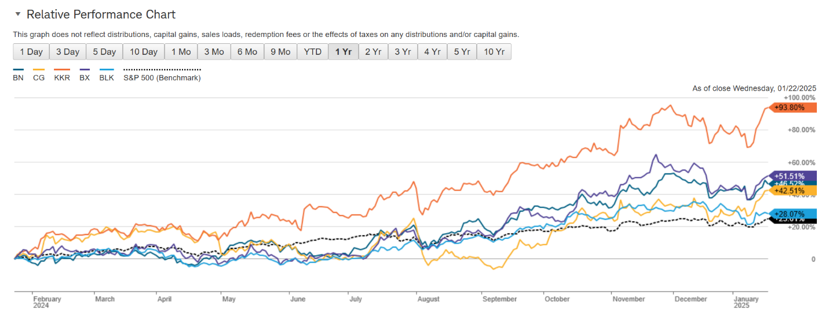

This performance by KKR is eye-catching so let’s talk about what has changed in 2024 and why their stock has done so well and whether we can be sufficiently confident this will extend into future years.

KKR Overview
KKR, as an asset management firm, generates revenue from multiple methods. I won’t go into detail on all these but will talk about the ones that are the main drivers of revenues and growth. The five business lines consist of:
- Private equity (59% of total holdings)
  - $176B in AUM
- Real assets (21% which includes real estate, infrastructure, and energy)
  - $130B in AUM
- Credit and liquid strategies (12%)
  - $245B in AUM
- Capital markets
- Principal activities
Private equity (PE) consists of core equity, traditional equity, and growth equity. Core equity represents assets that are lower risk and leverage but expected to continue to generate consistent returns over the long term. The IRR since inception of core equity is 19%. It’s difficult to know exactly what assets these (PE) funds are investing in but what’s key to know is KKR’s investing process which is described in their 10K and invest in a diverse set of assets. Some key points on their investment philosophy that give me confidence in their long-term investment decision making:
- “…focuses on achieving multiples of invested capital and attractive risk-adjusted IRRs..”
- “…applying rigorous standards of due diligence when making investment decisions, implementing strategic and operational changes that drive growth and value creation…”
- “We have access to significant opportunities for making private equity investments as a result of our sizable capital base, global platform, and relationships with leading executives…”
- “Private equity fund’s general partner is generally entitled to a carried interest that allocates to it 20% of net profits realized…”
- “…our private equity fund documents generally require the general partners of the funds to make minimum capital commitments to the funds.”
Their geographic focus is primarily the Americas at 70% with 15% allocated to Asia-Pacific and the remainder spread between Europe and the Middle East. I generally prefer this as America’s entrepreneurial spirit and general preference towards deregulation does not limit investment opportunities or stranglehold returns.
Lastly, in addition to these business lines, they own a majority stake in an insurance business operated by Global Atlantic which accounts for a large portion of the fees (or revenue) generated for KKR. Below is a summary of fees collected by KKR over the past several years.
Line Items | 2024 | 2023 | 2022
Total Management Fees | Not yet available | 3,030,325 | 2,656,487
- Private Equity |  | 1,286,062 | 1,188,463
- Real Assets |  | 825,735 | 679,890
- Credit and Liquid Strategies |  | 918,528 | 788,134
Total Insurance Revenues | Not yet available | 8,692,006 | 5,383,062

KKR now relies heavily on these fees to produce consistent revenue. This is one differentiating factor of KKR compared to their peers and over the past few years they’ve built a strong pipeline of fee collections which gives investors better insight into cash flows. However, they are also heavily reliant on carried interest which, if you observe their “other liabilities” section of the balance sheet, you’ll see how large this number is. In volatile times, this large exposure to carried interest will make earnings and cash flow much less predictable.

Historical Analysis
The table below highlights a few financial metrics that highlight the growth KKR has experienced over the past several years. Most notably, they’ve grown their total assets sixfold since 2019.
 | 2024 | 2023 | 2022 | 2021 | 2020 | 2019 | 2018 | 2017 | 2016
Debt/Equity | .82 | .85 | .82 | .68 | .82 | .89 | .88 | 1.03 | 1.08
Cash & Equivalents | 14.46 | 20.35 | 12.82 | 10.09 | 6.51 | 3.16 | 2.45 | 3.68 | 4.13
Total Assets | 360.66 | 317.29 | 277.08 | 264.29 | 79.81 | 60.90 | 50.74 | 45.83 | 39.00
Book Value per share | 27.14 | 25.83 | 19.29 | 27.64 | 21.15 | 18.44 | 15.27 | 13.79 | 12.06

Comparing KKR’s financials to their competitors, we see below that they have outpaced pretty much all of their competitors with the exception of Blackstone.
Total assets growth over 8 years:
- KKR: 824%
- BN: 218%
- CG: 126%
- BX: 61%
- BLK: -40%
Free Cash Flow per Share (FY24 / 8-year growth):
- BN: -2.68 / -443%
- CG: -0.58 / 60%
- BX: 5.19 / 405%
- BLK: 28.36 / 142%
- KKR: 8.56 / 300%
The reason KKR has outpaced its peers is because 2024 was the first year in 8 years they’ve reported positive free cash flow. This is primarily due to the fees they’ve been able to generate from investment funds, infrastructure projects, and real estate holdings. They’ve been able to do this by utilizing large amounts of debt over the past several years to strategically acquire or invest in long-term assets and in 2024 their efforts became evident in their financial statements.
The amount of long-term debt they have is significant. At the end of 2023, they were holding more than $49,187 MM in long-term debt. Compare that to Blackrock who is the largest in this group in terms of AUM and only has $7,918 MM in long-term debt. Only BN has taken on more long-term debt but this is do to their business model which focuses on real infrastructure assets. Over the past several years KKR has set itself up nicely to strategically invest in a diverse set of assets which are expected to generate long-term, consistent revenue

Efficiency
Given we’re talking about alternative asset companies whose core responsibility is to invest in assets, we could look at a few different efficiency metrics. The table below has four metrics: sales per employee, net profit margin, ROIC, and long-term debt to equity.

Ticker | Sales per Employee  [MM USD] | Net Profit Margin  [%] | ROIC  [%] | LT Debt / Equity  [%]
BLK | .902 | 31.91 | 11.3 | .19
BN | .705 | 5.36 | 5.41 | 1.05
BX | 1.68 | 36.9 | 22.8 | .62
CG | .954 | 3.64 | 1.25 | .56
KKR | 3.18 | 21.21 | 3.85 | .84

These were chosen as I wish to measure how efficiently they operate, how well they manage investments, and how much debt compared to equity they are trying to put to work. Some key things that stand out include:
- KKR is extremely efficient is its employee impact with a gross revenue per employee at $3.18MM. No one else is even close. Secondly, they are carrying a very large amount of long-term debt with respect to equity, demonstrating their dedication to long-term investments.
- BN also has a large LT debt to equity ratio, but they are more focused on real infrastructure which tends to be more capital-intensive, so their ratio is misleading to a degree. It does not necessarily signal aggressive long-term growth.
- BLK and BX are both strong capital allocators, however their revenue strategy is much less PE focused but more focused on generating stables feeds from ETFs/Alladin (BLK) and dominance in real estate (BX).

Current Valuation and Conclusion
The table below illustrates current valuation of each of these companies.
Ticker | Price / Book | Price / Cash Flow | EV/AUM
BLK | 3.86 | 39.31 | 1.45%
BN | 2.18 | 9.49 | 48.53%
BX | 16.58 | 26.31 | 14.34%
CG | 3.62 | 183.15 | 6.32%
KKR | 6.16 | 29.11 | 20.45%

However, these aren’t exactly apples-to-apples comparisons as all these companies generate revenue in different fashions. Here’s a quick summary on these valuation metrics for each company and which one may be more appropriate:

Company | Best Valuation Metric | Reasoning
KKR | P/CF & EV/AUM | Relies on performance fees & insurance cash flows; AUM-based valuation is key.
Blackstone (BX) | P/CF & EV/AUM | Driven by carried interest and real estate AUM monetization.
BlackRock (BLK) | P/B & P/CF | Asset-light business with stable fee revenue; book value relevant.
Carlyle Group (CG) | P/CF & EV/AUM | Private equity-based revenue; exits drive cash flow; AUM metric relevant.
Brookfield (BN) | P/B & P/CF | Owns hard assets; book value matters, but cash flow from operations is key.

Given KKR is most similar to CG and BX, let’s look at P/CF and EV/AUM for these three firms. KKR is clearly trading at a premium to these two on an EV/AUM basis. The market has fallen in love with this stock and it looks to be relatively expensive.
On a P/CF basis, it is on-par with BX but far cheaper than CG. Again, this is still not a perfect apples-to-apples basis given slightly differing business models but we can still deduce that at least on an EV/AUM basis, these firms are currently aggressively-priced.
Research indicates that 10-16% EV/AUM is more “normal” for high-fee PE firms. Given this, KKR continues to look like a decent buy, however, the downside remains probable given its exposure to carried interest and high valuation. Furthermore, the Trump administration is issuing new tariffs on China, Mexico, and Canada which presents uncertainty around inflation and interest rates. I would put KKR on a watchlist and if the broader market weakens while interest rates remain stable, I’d be interested in buying KKR with least 20% discount to have a sufficient margin of safety.

Update since earnings call on 2/4/25:
KKR dropped about 8.5% after their earnings was released on 2/4 to $149/share. Since then KKR bounced back about 3% to $154. This looks to be about as good a buying opportunity we will get. Furthermore, KKR pointed out some encouraging notes on their call that point to a continued long-term, Berkshire Hathaway-ish type of growth:
- Raising its stake in three existing holdings under its Strategic Holdings group which should support the group’s earnings.
- Annual profit was lower YOY, though earnings did beat analyst expectations.
- CEO Scott Nuttall described 2024 as a “good year, not a great year” as they are still figuring things out internally, even though the stock’s price is up nearly 90% over the past year. Nuttall describes 2025 as a year where things are expected to go relatively well or as he describes it in runner terms “the sun is out” and they’re “running on flat roads”. He also notes the dividend scaling opportunity is real and that the pipelines are opening up with more possible exits and opportunities globally across asset classes.

