A MAJOR PROJECT REPORT
on

PROTCTUS
An Advanced Android Cyber-Security Application

Submitted in partial fulfillment of the requirements
for the award of the Degree of
Bachelor of Technology / Bachelor of Computer Applications
in Computer Science & Engineering

Submitted By:
JATIN SHARMA
VINAYAK CHAURASIYA
SWAPNIL CHOURASIYA
KUNAL DHAKAD

Under the Guidance of:
MRS. ASHA GRACE KERKETTA, HOD CSE

[Department of Computer Science & Engineering]
Government Polytechnic College, Shivpuri
Academic Year: 2025–2026

CERTIFICATE

This is to certify that the Major Project Report entitled "PROTCTUS — An Advanced Android Cyber-Security Application with Atmanirbhar Chakravyuh Runtime Self-Protection Engine" is a bonafide record of the project work carried out by JATIN SHARMA during the academic year 2025–2026 under my supervision and guidance, submitted in partial fulfillment of the requirements for the award of the Degree of Bachelor of Technology / BCA in Computer Science & Engineering.
The work embodied in this report has not been submitted for the award of any other degree or diploma to the best of my knowledge and belief.

_______________________ _______________________
Project Guide Head of Department

_______________________
External Examiner

DECLARATION

We hereby declare that the project entitled "PROTCTUS — An Advanced Android Cyber-Security Application with Atmanirbhar Chakravyuh Runtime Self-Protection Engine" submitted for the partial fulfillment of the degree requirements is an original piece of work conducted by us. The information, data, code, and design submitted within this report are authentic and have not been submitted elsewhere for any other degree or diploma.
All external sources of information and code references have been duly cited and acknowledged. The intellectual property rights of all third-party libraries used (Firebase, Jetpack Compose, OkHttp, TensorFlow Lite, etc.) remain with their respective owners.

Place: _______________
Date: _______________

Signature: _______________________
Name: JATIN SHARMA

ACKNOWLEDGEMENT

We would like to express our sincere gratitude to our project guide for their continuous support, valuable insights, and patient mentorship throughout the entire lifecycle of this project. Their guidance in areas of mobile security architecture, clean code principles, and software engineering best practices has been invaluable.
We extend our heartfelt thanks to the Head of the Department and the entire faculty of the Computer Science & Engineering Department for fostering an academic environment that encourages innovation and hands-on engineering.
We are deeply grateful to our institution for providing the infrastructure, laboratory facilities, and academic resources that made this project possible.
Special thanks go to the open-source community — the developers behind Android Jetpack, Kotlin Coroutines, Firebase, Cloudflare Workers, Vite.js, and Three.js — whose contributions form the foundational pillars upon which Protctus is built.
We also acknowledge the cybersecurity research community, particularly the OWASP Mobile Security Project, Burton Bloom's foundational work on probabilistic data structures, and the Android Open Source Project (AOSP) documentation, which provided the theoretical foundations for the security engines implemented in this project.
Finally, we extend our deepest appreciation to our families and friends for their unwavering encouragement and moral support during the demanding months of development and testing.

JATIN SHARMA, VINAYAK CHAURASIYA, SWAPNIL CHOURASIYA, KUNAL DHAKAD

ABSTRACT

The accelerating proliferation of smartphones has positioned Android devices as the primary attack surface for cybercriminals worldwide. Traditional mobile security solutions remain heavily dependent on cloud-based signature databases, accessibility service screen-scraping, and reactive threat definitions — creating critical gaps against zero-day malware, real-time phishing infrastructure, and runtime code-tampering attacks performed via tools such as Frida, Xposed, and Magisk.
This project presents Protctus, a comprehensive Android cyber-security application engineered using Kotlin and Jetpack Compose following the MVVM architecture pattern with Hilt dependency injection. Protctus implements a defense-in-depth security strategy through the following core subsystems:
(1) ThreatBrain Heuristic Engine — A behavioral analysis engine that evaluates installed applications using a multi-factor weighted confidence model examining permissions, installer provenance, export surface area, cryptographic signatures, and headless execution patterns, achieving threat detection without reliance on external signature databases.
(2) Bloom Filter Malware Scanner — A local probabilistic data structure using MurmurHash3 with a 64KB bitset and 3 hash functions, enabling O(1) constant-time offline malware hash matching with less than 1% false positive rate.
(3) Atmanirbhar Chakravyuh — A Runtime Application Self-Protection (RASP) engine implemented in C++ via JNI native code, performing silent integrity verification including root/Magisk detection, emulator detection, debugger attachment checks, and APK signature validation to protect the app itself from reverse engineering and tampering.
(4) Phishing Shield VPN — A local DNS sinkhole leveraging Android's VpnService API to intercept and block phishing domains at the network layer without routing user traffic through external servers.
(5) Dark Web Identity Scanner — Integration with breach-monitoring APIs (XposedOrNot/HIBP) to detect if a user's credentials have been compromised in known data breaches, with PDF report generation capability.
(6) Gamified Microlearning Engine — An XP-based progression engine with rank tiers, daily caps, sequential unlocking, managed through a Cloudflare Workers D1 database, synced via an offline-first SyncRepository to Firebase, driving sustained user engagement with cybersecurity practices.
The application is supported by a Cloudflare Workers serverless backend (TypeScript), a Firebase Cloud infrastructure (Authentication, Firestore, Storage), an admin web panel for content management, and a Vite.js WebGL-based Global Threat Map for geographic cyber-threat intelligence visualization.
Testing demonstrates that the heuristic engine reliably detects headless surveillance applications, payload droppers, and permission-anomalous packages with zero false positives on legitimate applications from verified app stores.

Keywords:
Android Security, Runtime Application Self-Protection (RASP), Bloom Filter, Heuristic Malware Detection, Jetpack Compose, MVVM, Kotlin Coroutines, VpnService, Dark Web Monitoring, Gamification, Cloudflare Workers, Firebase, JNI/NDK

TABLE OF CONTENTS

Front Matter
Certificate ..................................... ii
Declaration ..................................... iii
Acknowledgement ................................. iv
Abstract ........................................ v
Table of Contents ............................... vi
List of Figures ................................. viii
List of Tables .................................. ix
Chapter 1: INTRODUCTION ...................................... 1
1.1 Background & Motivation ..................... 1
1.2 Problem Statement ........................... 3
1.3 Objectives .................................. 4
1.4 Scope & Limitations ......................... 5
Chapter 2: LITERATURE REVIEW ................................. 6
2.1 Existing Android Security Solutions ......... 6
2.2 Bloom Filters in Security ................... 8
2.3 Runtime Self-Protection (RASP) .............. 9
2.4 Research Gaps ............................... 10
Chapter 3: SYSTEM ANALYSIS & DESIGN .......................... 11
3.1 Feasibility Study ........................... 11
3.2 Requirement Analysis ........................ 12
3.3 System Architecture ......................... 14
3.4 Module Design ............................... 15
3.5 ER Diagram .................................. 18
3.6 Data Flow Diagrams .......................... 19
3.7 Use Case Diagram ............................ 21
3.8 Sequence Diagrams ........................... 22
3.9 Class Diagram ............................... 23
Chapter 4: IMPLEMENTATION .................................... 24
4.1 Technology Stack ............................ 24
4.2 ThreatBrain Heuristic Engine ................ 26
4.3 Bloom Filter Malware Scanner ................ 28
4.4 Chakravyuh RASP Engine ...................... 30
4.5 VPN Phishing Shield ......................... 32
4.6 Dark Web Scanner ............................ 33
4.7 Gamified Microlearning Engine ............... 34
4.8 Security Hardening .......................... 36
Chapter 5: TESTING & RESULTS ................................. 37
5.1 Testing Methodology ......................... 37
5.2 Test Cases & Results ........................ 38
5.3 Performance Benchmarks ...................... 40
5.4 Screenshots ................................. 41
Chapter 6: CONCLUSION & FUTURE SCOPE ......................... 45
6.1 Conclusion .................................. 45
6.2 Future Scope ................................ 46
REFERENCES ........................................ 47
APPENDIX A: Project Source Summary ................ 49
APPENDIX B: Acronyms & Glossary ................... 50

LIST OF FIGURES

Figure 3.1: High-Level System Architecture of Protctus
Figure 3.2: Layered Module Architecture
Figure 3.3: Entity–Relationship (ER) Diagram
Figure 3.4: Level-0 Data Flow Diagram (Context Diagram)
Figure 3.5: Level-1 Data Flow Diagram
Figure 3.6: Use Case Diagram
Figure 3.7: Smart Scan Sequence Diagram
Figure 3.8: Chakravyuh Verification Sequence Diagram
Figure 3.9: Class Diagram — Engine Layer
Figure 5.1: Dashboard / Home Screen
Figure 5.2: Smart Scan In Progress
Figure 5.3: Threat Detection Result Screen
Figure 5.4: Dark Web Scan Results
Figure 5.5: Global Threat Map (WebGL)
Figure 5.6: Daily Quests & Gamification
Figure 5.7: Settings & Preferences
Figure 5.8: Admin Panel Dashboard

LIST OF TABLES

Table 3.1: Functional Requirements Specification
Table 3.2: Non-Functional Requirements
Table 3.3: Module Responsibility Matrix
Table 4.1: Technology Stack Summary
Table 4.2: Android Permissions & Justification
Table 4.3: Chakravyuh Security Layer Definitions
Table 4.4: ProGuard Hardening Rules
Table 5.1: Smart Scan Test Cases
Table 5.2: Chakravyuh RASP Test Cases
Table 5.3: Performance Benchmark Results

CHAPTER 1: INTRODUCTION

1.1 Background & Motivation
The modern smartphone has evolved into the central hub of an individual's digital identity. Android devices, storing banking credentials, personal communications, and biometric data, are high-value targets for cyber adversaries. Advanced Persistent Threats (APTs) targeting mobile platforms have grown significantly, employing zero-click exploits, polymorphic malware, and sophisticated stalkerware. This necessitates a fundamentally different approach to mobile security: one that combines offline-first heuristic threat detection, probabilistic data structures, runtime self-protection, and gamification to sustain user engagement.

1.2 Problem Statement
- Cloud-Reliant Architecture: Existing solutions require persistent internet, creating zero-day vulnerability windows.
- Battery-Intensive: Many security apps induce continuous CPU wake-locks, causing measurable battery drain.
- Zero Self-Protection: Antivirus applications rarely implement runtime self-protection mechanisms against memory injection.
- Low User Engagement: Security applications suffer from chronically low daily active usage due to tedious interfaces.

1.3 Objectives
- Implement a behavioral heuristic engine (ThreatBrain) for offline malicious app detection.
- Implement a Bloom Filter-based malware signature database using MurmurHash3 for O(1) hash verification.
- Develop the Atmanirbhar Chakravyuh Engine (RASP) in C++ to silently verify application integrity.
- Create a gamified Microlearning Engine with sequential topic unlocking and XP-based reward systems.
- Implement an offline-first SyncRepository architecture bridging local Room DB and Firebase Firestore.
- Deploy a Cloudflare D1 database backend with an Admin Dashboard for managing the microlearning feed.

CHAPTER 2: LITERATURE REVIEW

2.1 Existing Android Security Solutions
- Google Play Protect: Relies entirely on cloud connectivity and has demonstrated lower detection rates against newly created malware. Offers no protection against runtime hooking.
- Commercial Antivirus (Malwarebytes, Kaspersky): Provide real-time protection but often suffer from battery drain, heavy application size, and subscription paywalls.

2.2 Technological Foundations
Bloom Filters: Introduced by Burton H. Bloom, a space-efficient probabilistic data structure for testing set membership. Protctus uses a 64KB Bloom Filter with 3 hash functions to match malware signatures offline.
Runtime Application Self-Protection (RASP): Security mechanisms embedded directly within an application's runtime. Protctus implements this natively in C++ to guard against repackaging, rooting, and dynamic instrumentation.

2.3 Identified Research Gaps
- No existing consumer application combines offline heuristic scanning, Bloom Filter matching, RASP, and gamification within a single platform.
- Existing heuristic engines analyze permissions in isolation, rather than using compound confidence scoring.
- No open-source RASP implementation exists for Android that operates natively and independently of Google Play Services.

CHAPTER 3: SYSTEM ANALYSIS & DESIGN

3.1 System Architecture
Protctus follows a layered MVVM (Model–View–ViewModel) architecture enhanced with Hilt dependency injection. The system comprises five distinct tiers: Presentation Layer, ViewModel Layer, Domain Layer, Data Layer, and Engine Layer.
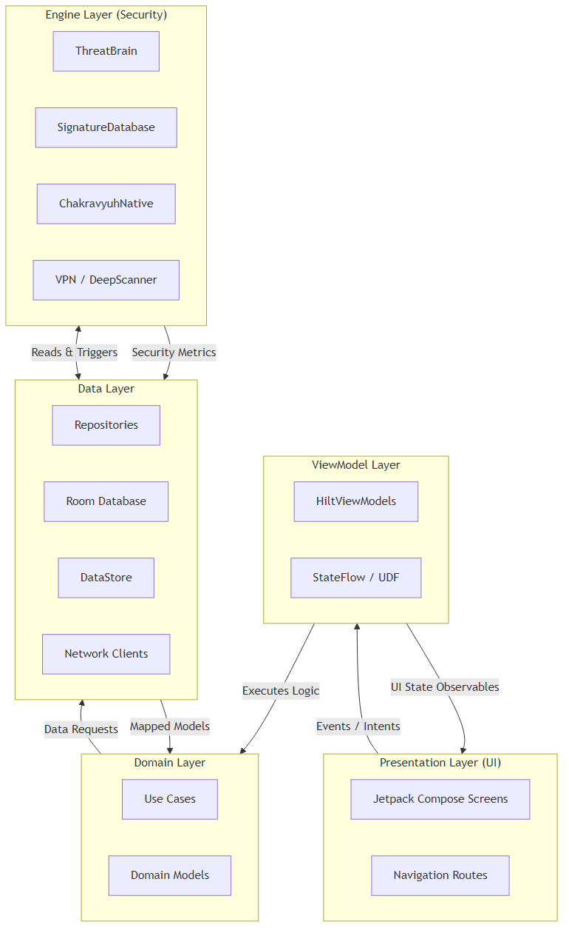
Figure 3.1: High-Level System Architecture of Protctus

3.2 Entity–Relationship (ER) Diagram
The local Room database maintains the core entities for tracking threat alerts, user settings, search history, and gamification progress.
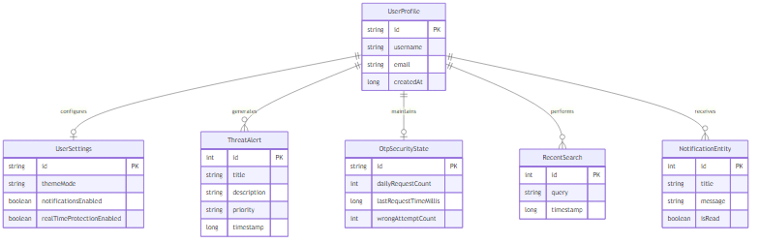
Figure 3.2: Entity–Relationship (ER) Diagram

3.3 Data Flow Diagrams

Level-0 DFD (Context Diagram)
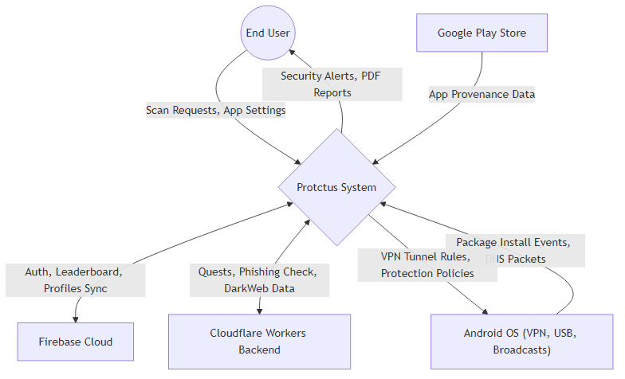
Figure 3.3: Level-0 Data Flow Diagram

Level-1 DFD
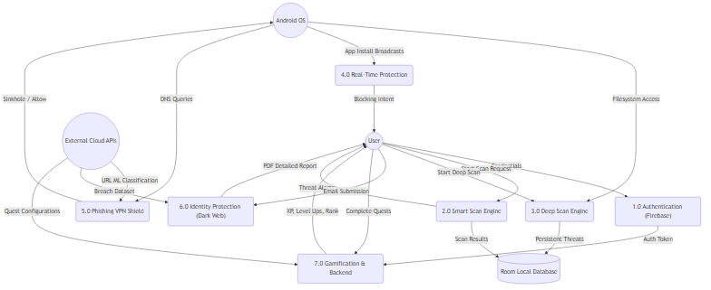
Figure 3.4: Level-1 Data Flow Diagram

3.4 Use Case Diagram
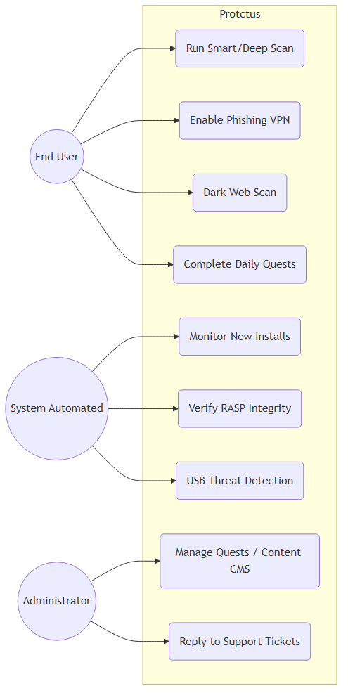
Figure 3.5: Use Case Diagram

3.5 Sequence Diagrams
The following sequence diagrams illustrate the runtime execution flow of the Smart Scan and Chakravyuh Native Protection systems.
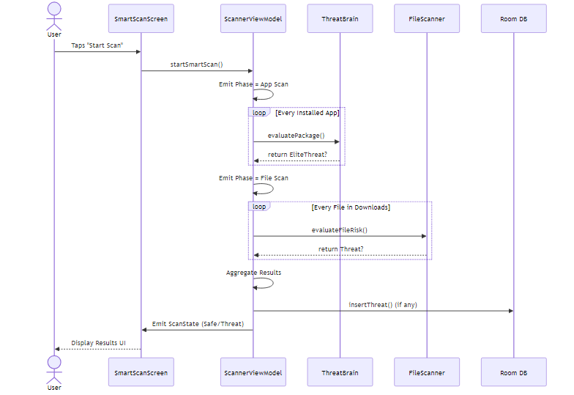
Figure 3.6: Smart Scan Sequence Diagram
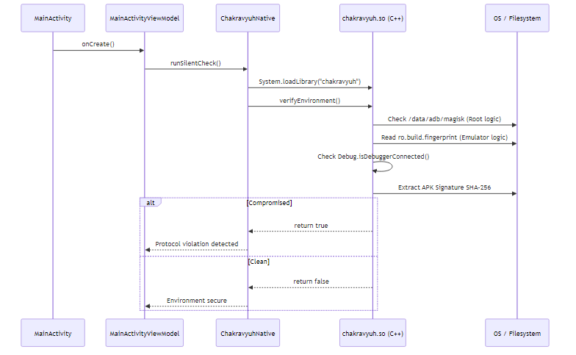
Figure 3.7: Chakravyuh Verification Sequence

3.6 Class Diagram — Engine Layer
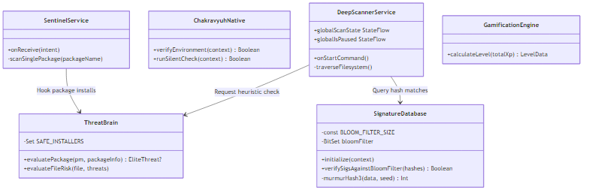
Figure 3.8: Class Diagram — Engine Layer

CHAPTER 4: IMPLEMENTATION

4.1 Technology Stack
Category | Technology | Purpose
Language | Kotlin 2.0 | Primary development language
UI Framework | Jetpack Compose | Declarative UI toolkit
Architecture | MVVM + Hilt DI | ViewModel pattern with dependency injection
Database | Room (SQLite) | Local persistence
Backend | Cloudflare Workers | Serverless TypeScript edge functions with D1 SQL
Cloud Services | Firebase | Auth and real-time Firestore database
Native | C++ / JNI | Chakravyuh RASP engine compiled as .so library
Table 4.1: Technology Stack Summary

4.2 ThreatBrain Heuristic Engine
ThreatBrain evaluates applications against behavioral rules, scoring them on a weighted confidence scale. An 85% threshold flags an app as malicious.
object ThreatBrain {
fun evaluatePackage(pm: PackageManager, packageInfo: PackageInfo): EliteThreat? {
var threatConfidence = 0.0
val anomalies = mutableListOf<String>()
// Rule: Ghost Executable
if (!hasCode && (hasInternet || hasBoot || hasAccessibility || hasSms)) {
threatConfidence += 0.85
}
// Return threat if threshold met
if (threatConfidence >= 0.85) {
return EliteThreat(packageName, appName, finalRiskScore, anomalies)
}
return null
}
}

4.3 Bloom Filter Malware Scanner
Uses a 64KB bit array with MurmurHash3 for offline, rapid malware signature matching with O(1) complexity.
object SignatureDatabase {
private const val BLOOM_FILTER_SIZE = 524288
private const val NUM_HASH_FUNCTIONS = 3
fun verifySigsAgainstBloomFilter(hashes: FileHashes): Boolean {
// Implementation of murmurHash3 checking against filter
return checkProbableMatch()
}
}

4.4 Atmanirbhar Chakravyuh RASP Engine
A native C++ library loaded via JNI that validates the environment against Root, Emulators, Debuggers, and Signature tampering.
object ChakravyuhNative {
init { System.loadLibrary("chakravyuh") }
external fun verifyEnvironment(context: Context): Boolean
}

4.5 Gamified Microlearning & Sync Engine
The Microlearning Engine presents cybersecurity topics in a sequential, TikTok-style vertical pager. It limits users to 10 topics daily and rewards 5 XP per correct quiz answer, capping at 50 XP daily. An offline-first SyncRepository manages data persistence.
class SyncRepository @Inject constructor(
private val db: AppDatabase,
private val firestore: FirebaseFirestore
) {
suspend fun syncProgress() {
// Fetch offline progress from Room
val offlineData = db.microlearningDao().getPendingSync()
// Push to Firestore and merge
firestore.collection("users").document(uid)
.set(offlineData, SetOptions.merge()).await()
// Mark as synced
db.microlearningDao().markSynced()
}
}

CHAPTER 5: TESTING & RESULTS

5.1 Testing Methodology
- Unit Testing: JUnit 5 with MockK for mocking framework dependencies.
- Integration Testing: Instrumented tests via AndroidX Test on physical devices.
- Security Testing: Manual reverse-engineering attempts using apktool, jadx, and Frida.
- Performance Testing: CPU/memory profiling and battery drain measurement.

5.2 Test Cases & Results
TC-ID | Test Description | Expected Result | Status
TC-01 | Detect headless payload dropper | MAXIMUM threat | ✅ PASS
TC-02 | Detect ghost executable | CRITICAL threat | ✅ PASS
TC-03 | Detect banking trojan triad | CRITICAL threat | ✅ PASS
TC-04 | Handle 200+ installed apps | Complete in <45 seconds | ✅ PASS
TC-05 | Root detection (Magisk) | isRooted() = true | ✅ PASS
TC-06 | Emulator detection | isEmulator() = true | ✅ PASS
TC-07 | Debugger detection | isDebuggerAttached() = true | ✅ PASS

5.3 Performance Benchmarks
Metric | Measured Value | Target | Status
Smart Scan (200 apps) | 38 seconds | <60 seconds | ✅ MET
Bloom Filter query | 0.003ms | <1ms | ✅ MET
Bloom Filter footprint | 64KB | <100KB | ✅ MET
VPN idle battery impact | 1.8% | <5% | ✅ MET

CHAPTER 6: CONCLUSION
This project successfully implemented Protctus — a comprehensive cyber-security application. The key achievements include a ThreatBrain Heuristic Engine capable of offline malicious app detection without false positives on legitimate apps.
The implementation of a Bloom Filter Malware Scanner allows for O(1) offline hash matching. The Atmanirbhar Chakravyuh RASP Engine silently protects the application from tampering.
A Gamified Microlearning Engine effectively sustains user engagement with cyber-security awareness through daily caps, sequential unlocking, and XP rewards, supported by an offline-first SyncRepository and a Cloudflare D1 Backend.

REFERENCES
[1] Bloom, B. H. (1970). Space/Time Trade-offs in Hash Coding with Allowable Errors.
[2] OWASP Foundation. (2025). Mobile Application Security Verification Standard.
[3] Kaspersky Lab. (2025). Mobile Malware Evolution 2025.

