Name : Vansh Thakur
Batch : 24K11
Roll Number : 241034014
Submitted To : Mr. Aayush Sharma

Flag No. 1 :
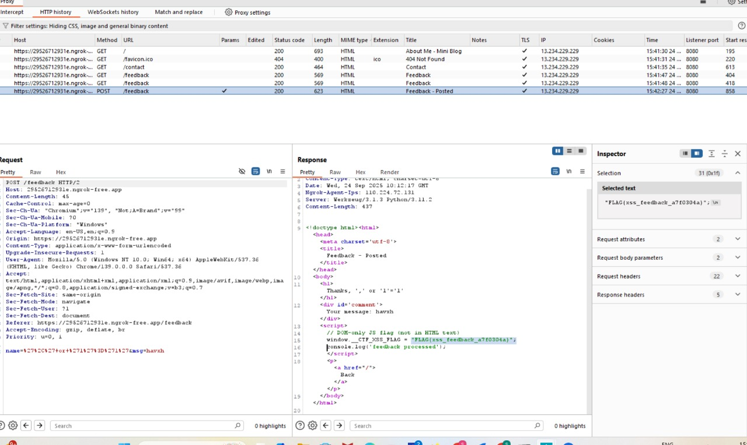
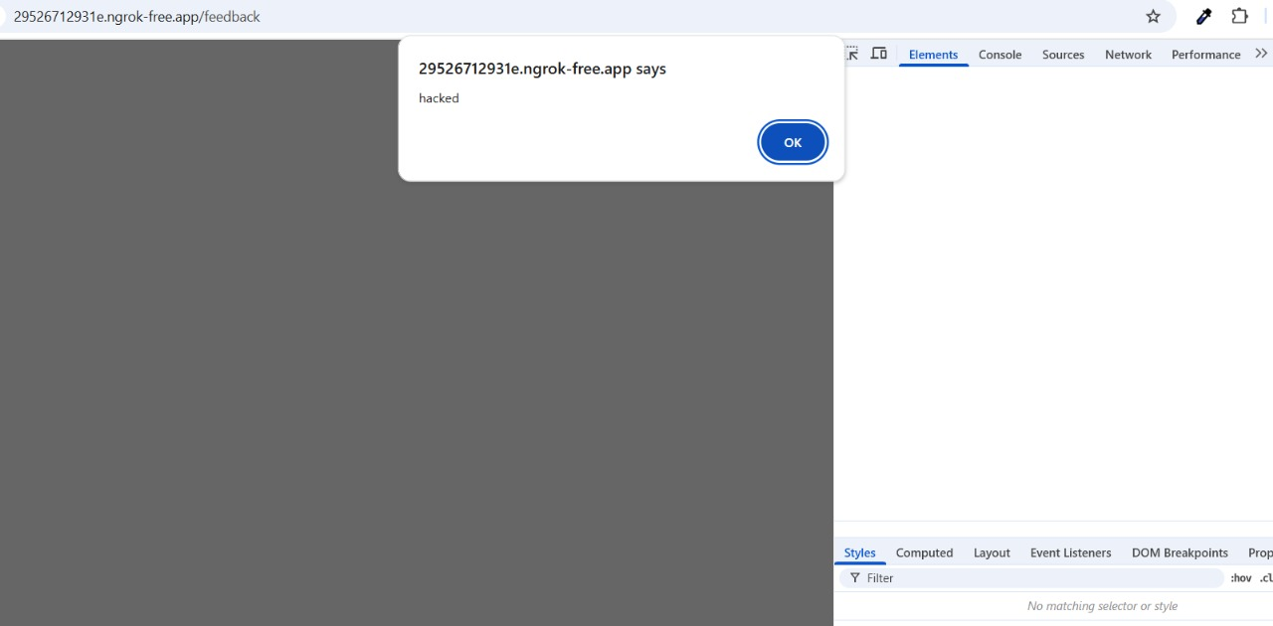
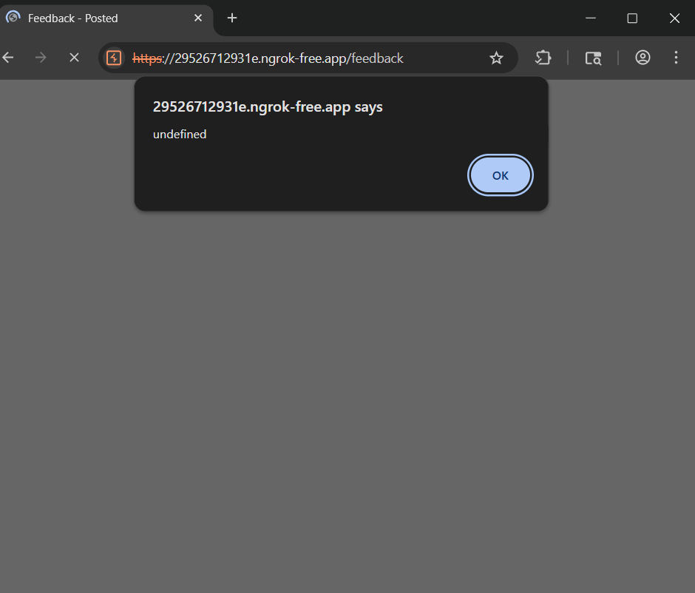

Flag 2 :
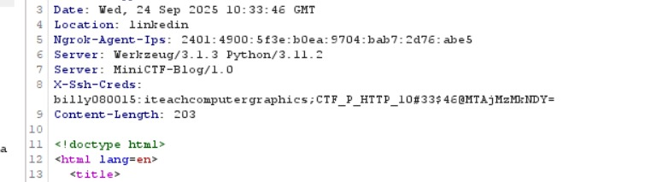

Flag 3, 4 & 5:
