Name: Vansh Thakur
Batch: 24K11
Roll Number: 241034014
Submitted To: Mr. Pankaj Dhiman

Practical Even Roll Number :
Ques. 1 & 2 :
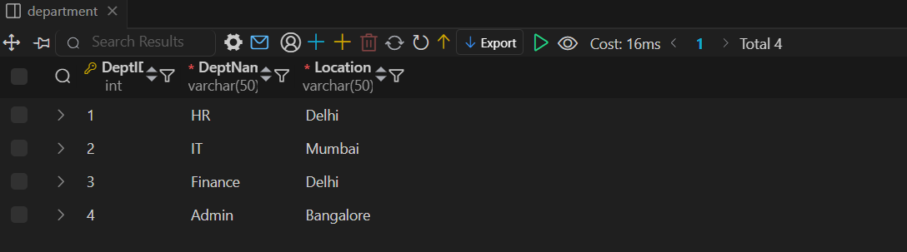
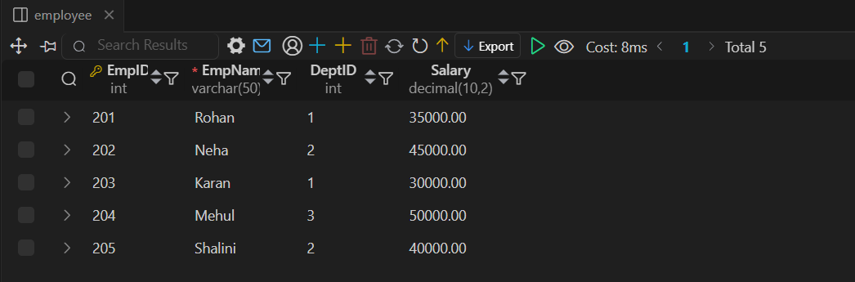
Ques. 3:
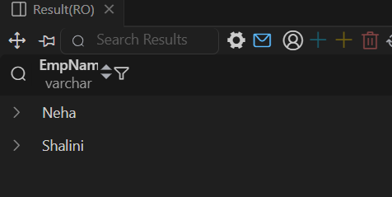


Ques. 4:
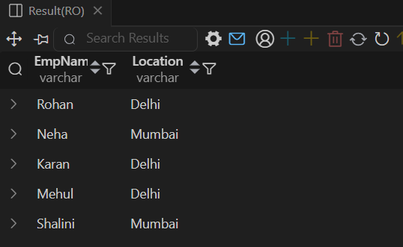
Ques. 5:
