Name : Vansh Thakur
Batch : 24K11
Roll Number : 241034014
Submitted To : Mr. Pankaj Dhiman

Assignment Number : 5

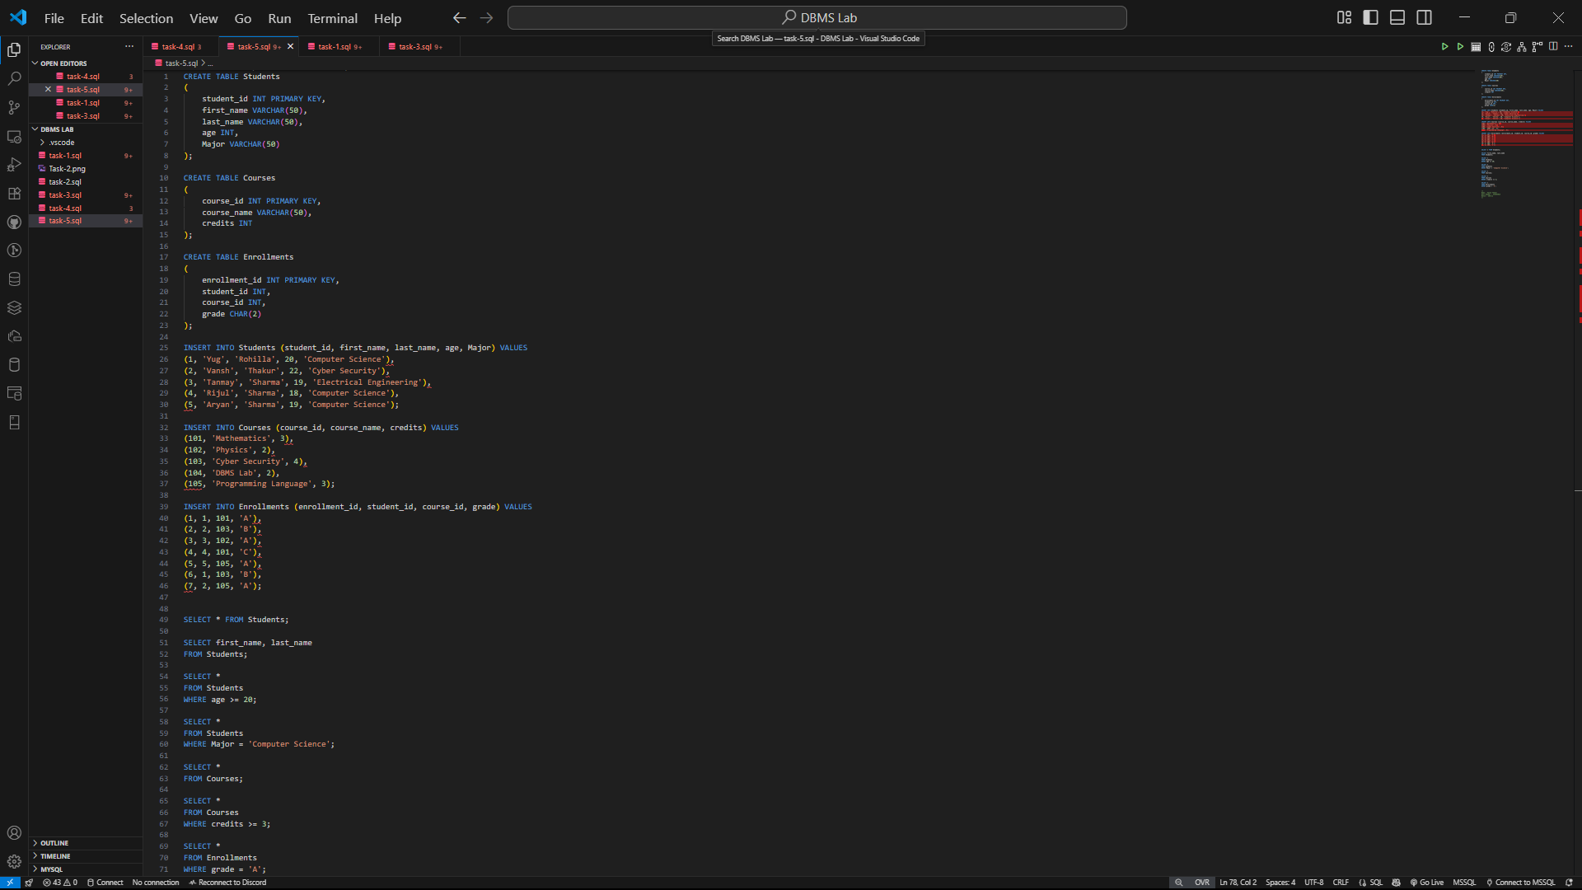

OUTPUTS :

