Name: Vansh Thakur
Batch: 24K11
Roll Number: 241034014
Submitted To: Mr. Pankaj Dhiman
Assignment Number: 8

Task 1 :
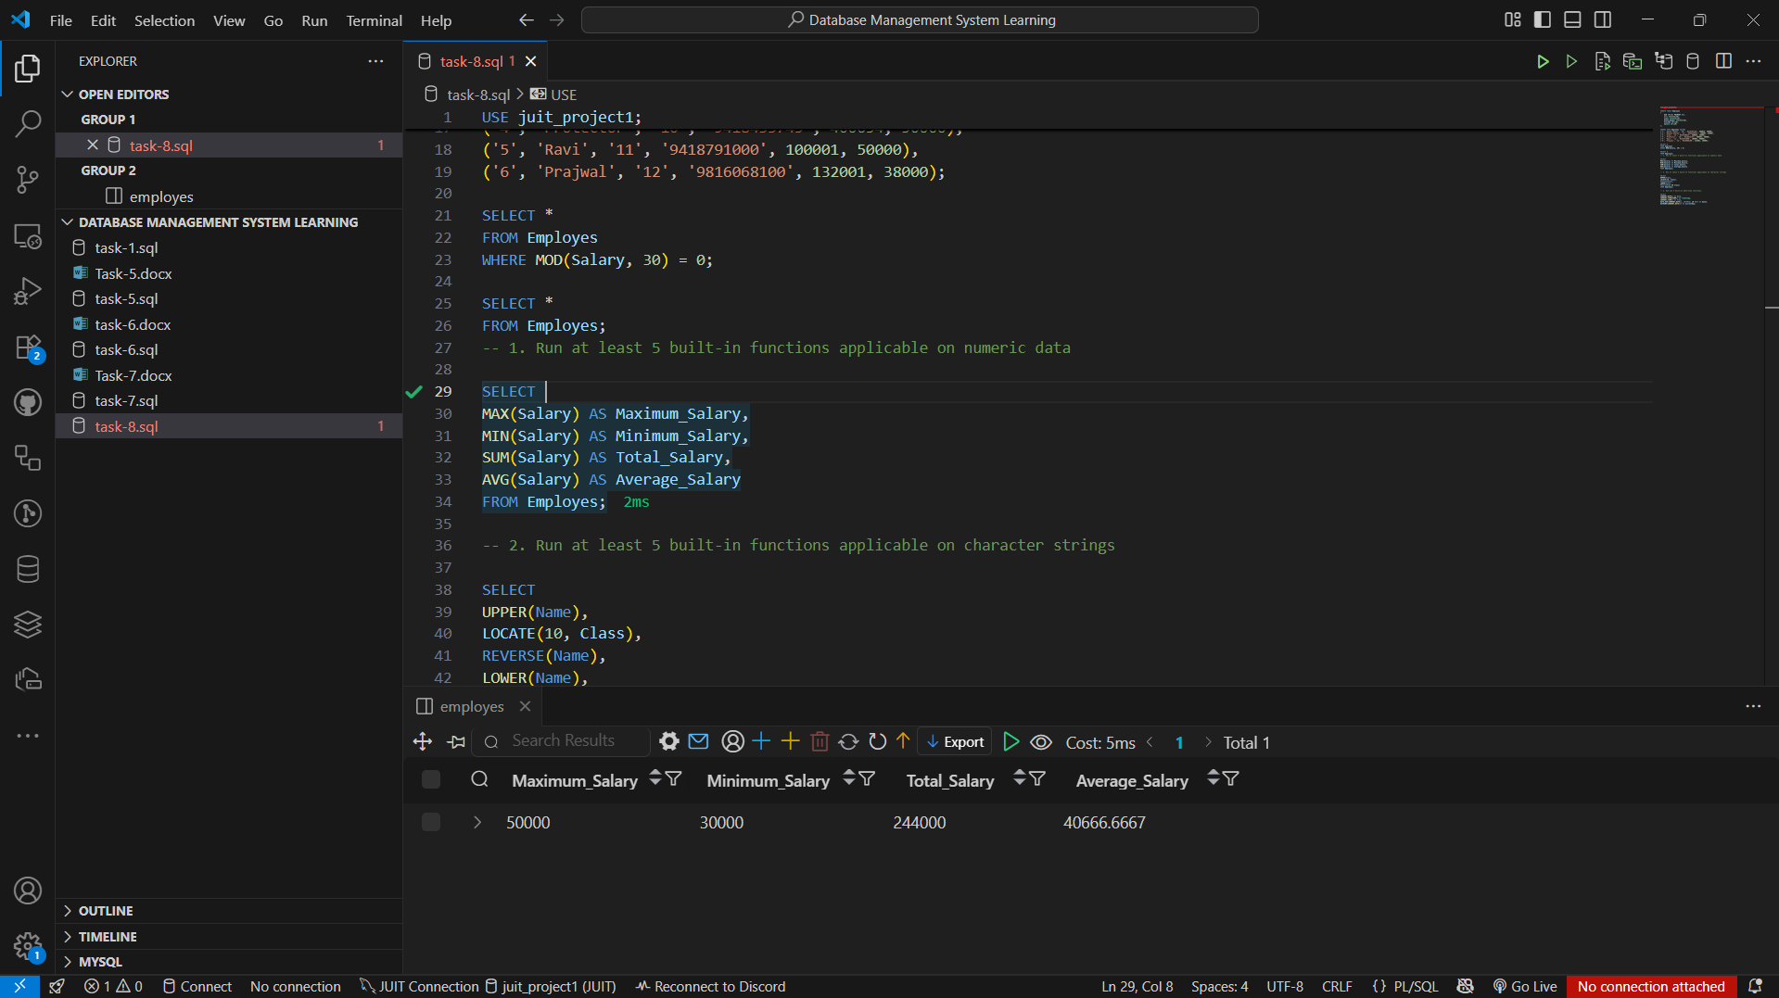

Task 2 :
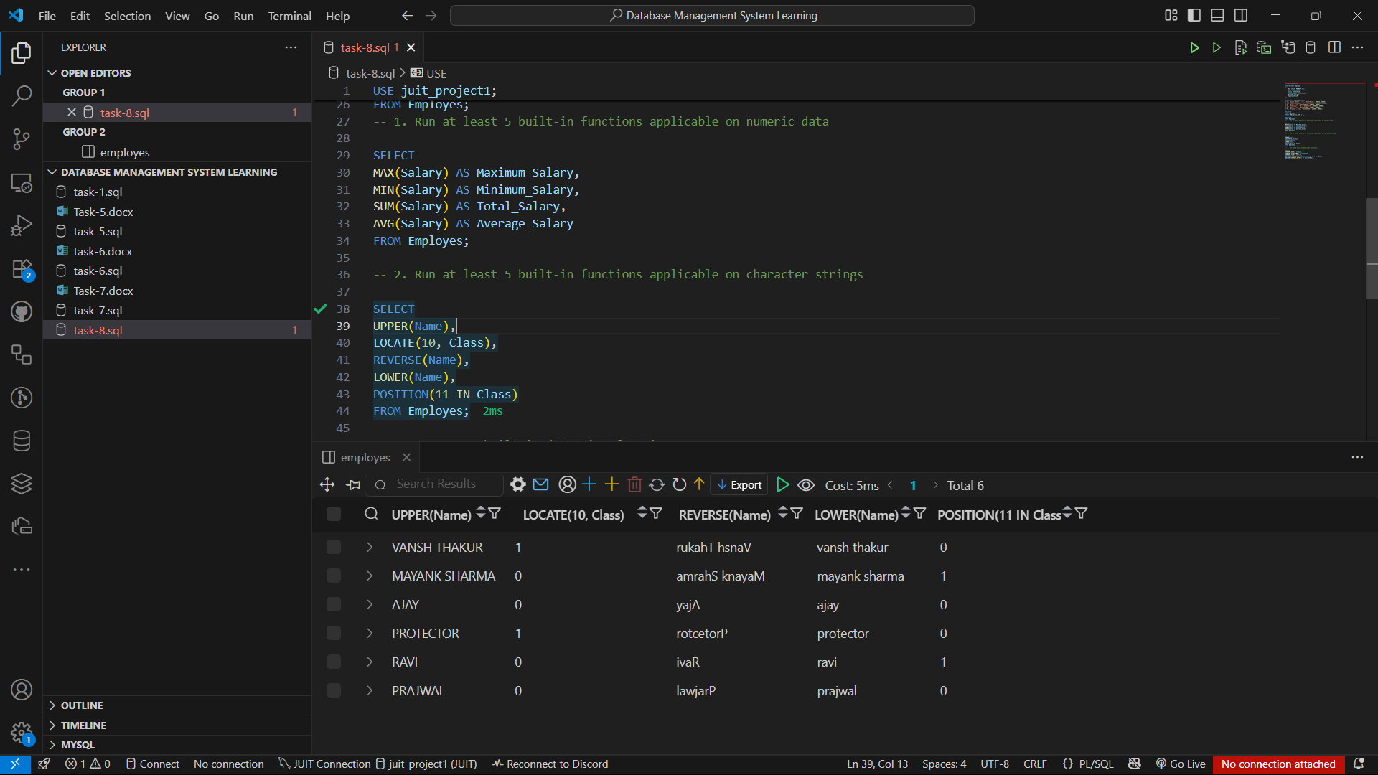

Task 3 :
