Using Skyline Batch in Webinar 14

This tutorial covers how to use Skyline Batch to replace the batch scripts in Webinar 14.

**Getting Started**

Install the latest Skyline Batch from:

[Skyline Batch: /home/software/Skyline](https://skyline.ms/wiki/home/software/Skyline/page.view?name=skyline-batch)

To start this tutorial, visit the Webinar 14 page:

[Start Page: /home/software/Skyline/events/2017 Webinars/Webinar 14](https://skyline.ms/project/home/software/Skyline/events/2017%20Webinars/Webinar%2014/begin.view?)

From there, download the following zipped folders:

* Scripts
* DIA Data
* Documents

Create a “Webinar14” folder somewhere on your computer, like:

C:\Users\alimarsh\Documents\Webinar14

When each zip file has finished downloading, extract it to your “Webinar14” folder.

When all 3 zip files have been extracted, the Webinar14 folder should look like this:

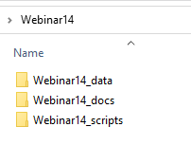

|  |
| --- |
| *Note: Once you have downloaded and extracted Webinar14_scripts.zip to the Webinar14_scripts subfolder, you may skip ahead to the “Setting Up R” section below, and return to this point later when the larger ZIP files have finished downloading. |

* Double-click the Webinar14_docs folder in the Windows File Explorer.
* Right-click the TTOF_64w.sky.zip file and click **Extract All**.
* Delete 2 levels of the path suggested under **Files will be extracted to this folder** to specify the Webinar14 folder you created.

The **Extract Compressed (Zipped) Folders** form should look like this:

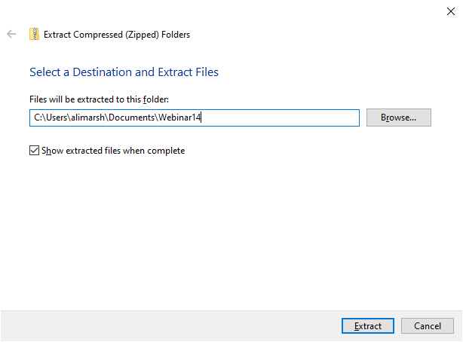

* Click the **Extract** button.

A new File Explorer should open presenting the following files:

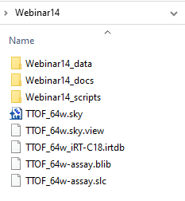

|  |
| --- |
| *Note: When running a configuration in Skyline Batch, the Skyline template document must be located inside a parent of the analysis folder. Our analysis folder will be inside Webinar14, therefore the template document needs to be in Webinar14. |

* Double-click the “TTOF_64w.sky” file.

You will see a progress bar as Skyline opens it.

* Go to **Settings** > **Transition Settings**.
* Click on the **Full**-**Scan** tab.
* Change the **Product mass analyzer** to **Centroided**

Your transition settings should now look like this:

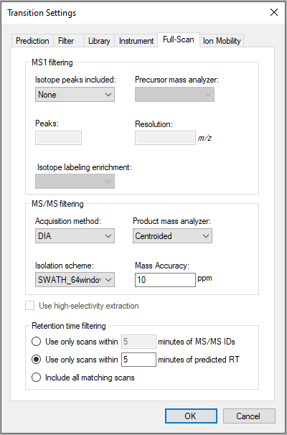

* Click the **OK** button.
* Save the document. (Ctrl-S)
* Close Skyline when it is finished saving. (Alt-F4)

**Setting Up R**

Check if you have a “C:\Program Files\R\ R-3.6.3” folder. If you do not, go to:

[Download R-3.6.3 for Windows. The R-project for statistical computing. (r-project.org)](https://cran.r-project.org/bin/windows/base/old/3.6.3/)

*Note: You can use an R-3.6.3 installation located somewhere else on your computer. However, you will have to add your R directory to Skyline Batch.

Install R-3.6.3 from the link at the top of the page. When it is done downloading, the setup installer will open.

* Click the **Next** button until you see a green Installing progress bar.
* Click the **Finish** button.

Go to the Rtools website:

[Building R for Windows (r-project.org)](https://cran.r-project.org/bin/windows/Rtools/history.html)

* Click on “Rtools35.exe” to begin downloading the correct version of Rtools.
* Click the **Next** buttonuntil you reach **Install** to accept the default settings.
* Click the **Install** button.
* Click the **Finish** button.

If you do not have Rstudio, download it here:

[Download the RStudio IDE – Rstudio](https://rstudio.com/products/rstudio/download/#download)

* Install it, accepting the default settings.
* Open RStudio.
* Go to **Tools** and click **Global Options**.
* Select the **General** tab on the left-hand side.
* Check if **R version** is showing R-3.6.3
  + If it is:
    - Click **OK**
  + If it is not:
    - Click **Change**
    - Select **R-3.6.3**
    - Click **OK** twice
    - Restart RStudio

You are now ready to start downloading packages in R-3.6.3

* Navigate to “Webinar14\Webinar 14_scripts\lfqbench\install_R_packages_fresh.R”
* Open this file in RStudio.
* Select lines 1-8, then click the **Run** toolbar button. (Ctrl-Enter)

You will be asked if you want to install packages from sources which need compilation.

* Click **Yes** and wait for them to finish installing.
* Select lines 10-13, then click the **Run** toolbar button. (Ctrl-Enter)

In the console, you will be asked if you would like to update all, some, or none of the packages.

* Type “n” in the console and press Enter.
* Select lines 15-20, then click the **Run** toolbar button. (Ctrl-Enter)

You will be asked if you want to install packages from sources which need compilation.

* Click **Yes** and wait for them to finish installing.

This will install devtools and look for your installation of Rtools. When this has finished running, you should see “TRUE” in the console, indicating Rtools has been found.

* Select lines 22-23, then click the **Run** toolbar button. (Ctrl-Enter)

In the console, you will be asked which packages you would like to update.

* Type “3” in the console and press Enter.

When this has finished running, you should see “DONE (LFQbench)” in the console.

**Importing a Configuration**

* Navigate to “Webinar14\Webinar 14_scripts\lfqbench”
* Double-click on Webinar 14_configuration.bcfg to open Skyline Batch

Skyline Batch looks for Skyline when you open it the first time. If it does not find it, you will see a form to specify the path to the Skyline directory. Do that.

The main window will appear, with a dialog asking if you want to import configurations from Webinar 14_configuration.bcfg:

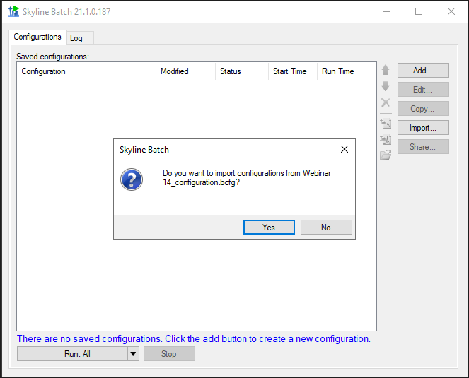

* Click **Yes**.

*Note: If your R-3.6.3 is not located in “C:\Program Files\R,” a dialog will appear asking if you would like to add an R installation directory. Do that now.

The main window will now display your imported configuration:

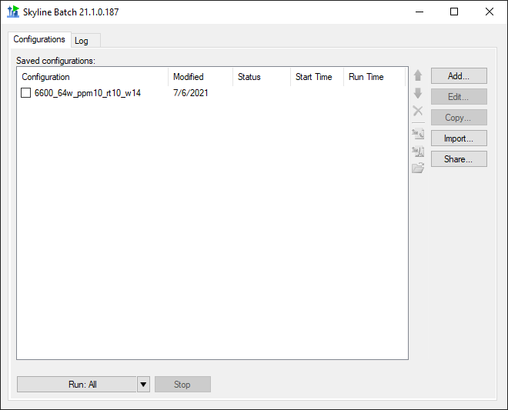

If you set everything up using the file format in the **Getting Started** section, the configuration should appear in black.

If the configuration appears in red, double-click it to fix the missing information in the **Configuration Set Up Manager**.

**Running a Configuration**

* Check the checkbox next to “6600_64w_ppm10_rt10_w14”

The main window should now look like this:

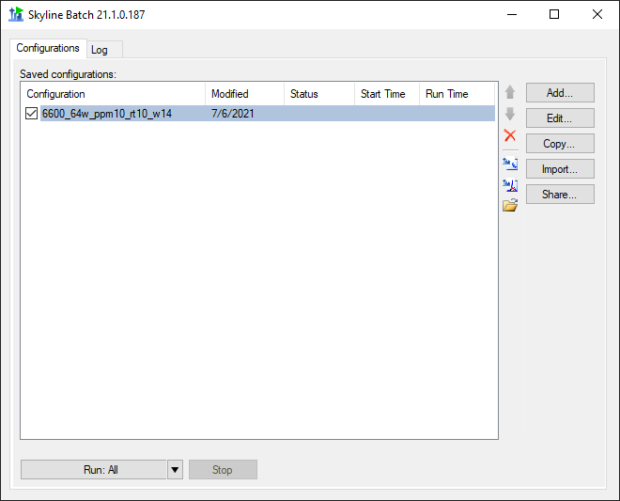

* Click the **Run: All** button.

Skyline Batch brings you to the **Log** tab to show the output of running your configurations.

Switching back to the **Configurations** tab, you can see the status of your configuration. Wait until the status is **Completed** (this takes around 30-50 minutes on a fast Intel i7 computer with plenty of memory):

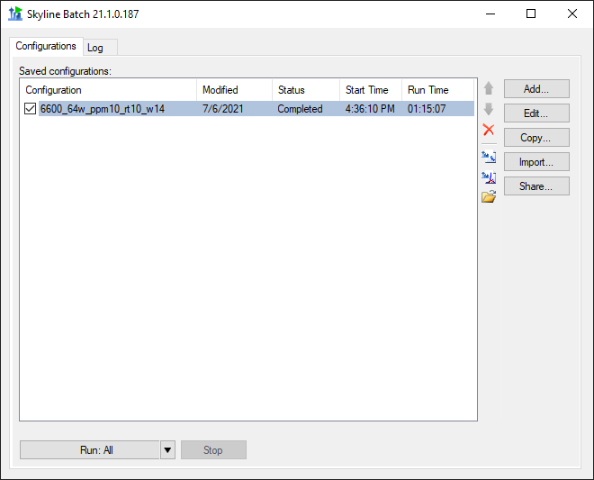

* Click on “6600_64w_ppm10_rt10_w14”
* Click the Open Folder icon.

This opens the configuration’s analysis folder.

In the “plot” subfolder, you will find PDF files with the familiar plots from the Navarro, Nature Biotech 2016 paper:



If you want to learn more about Skyline Batch, visit the documentation at:

[Microsoft Word - SkylineBatchDocumentation (washington.edu)](https://skyline.gs.washington.edu/software/SkylineBatch/SkylineBatchDocumentation.pdf)