Using Skyline Batch in Webinar 15

This tutorial covers how to use Skyline Batch to replace the batch scripts in Webinar 15.

**Getting Started**

Install the latest version of Skyline Batch from:

[Skyline Batch: /home/software/Skyline](https://skyline.ms/wiki/home/software/Skyline/page.view?name=skyline-batch)

To start this tutorial, visit the Webinar 15 page:

[Start Page: /home/software/Skyline/events/2017 Webinars/Webinar 15](https://skyline.ms/project/home/software/Skyline/events/2017%20Webinars/Webinar%2015/begin.view?)

From there, download the following zipped folders:

* New Documents
* Scripts
* DIA Demux 1
* DIA Demux 2

For each zipped folder, extract the files to an existing folder on your computer, like:

C:\Users\alimarsh\Documents

This will create a “Webinar15” folder with four new subfolders inside it.

When all the folders have been unzipped, the “Webinar15” folder should look like this:

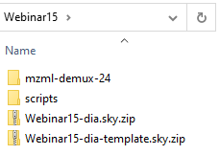

*Note: When running a configuration in Skyline Batch, the Skyline template document must be located inside a parent of the analysis folder. Our analysis folder will be inside Webinar15, therefore the template document (Webinar15-dia-template.sky.zip) needs to be in Webinar15.

**Setting Up R**

Check if you have a “C:\Program Files\R\R-4.0.3” folder. If you do not, go to:

[Download R-4.0.3 for Windows. The R-project for statistical computing. (r-project.org)](https://cran.r-project.org/bin/windows/base/)

*Note: You can use an R-4.0.3 installation located somewhere else on your computer. However, you will have to add your R directory to Skyline Batch.

* Install R-4.0.3 from the link at the top of the page.

When it is done downloading, the setup installer will open.

* Click the **Next** button until you see a green Installing progress bar.
* Click the **Finish** button.

**Importing a Configuration**

* Navigate to “Webinar15\scripts”
* Double-click on Webinar 15_configuration.bcfg to open Skyline Batch

Skyline Batch looks for Skyline when you open it the first time. If it does not find it, you will see a form to specify the path to the Skyline directory. Do that.

The main window will appear, with a dialog asking if you want to import configurations from Webinar 15_configuration.bcfg:

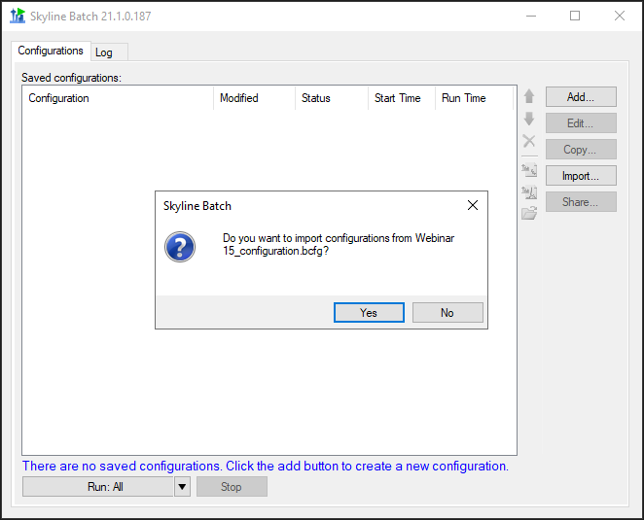

* Click **Yes**.

*Note: If your R-4.0.3 is not located in “C:\Program Files\R,” a dialog will appear asking if you would like to add an R installation directory. Do that now.

The main window will now display your imported configuration:

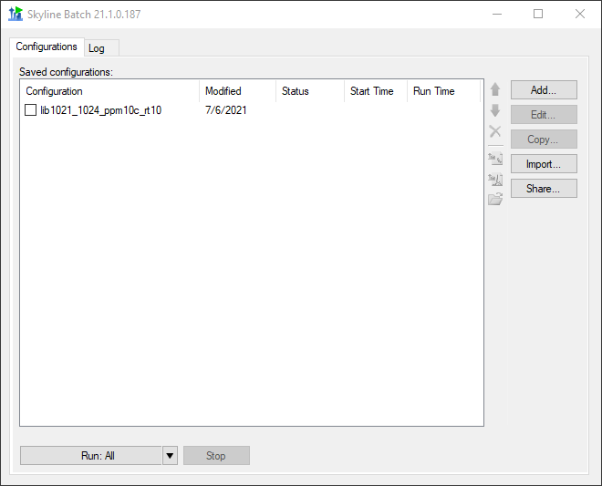

If you set everything up using the file format in the **Getting Started** section, the configuration should appear in black.

If the configuration appears in red, double-click it to fix the missing information in the **Configuration Set Up Manager**.

**Running a Configuration**

* Check the checkbox next to “lib1021_1024_ppm10c_rt10”

The main window should now look like this:

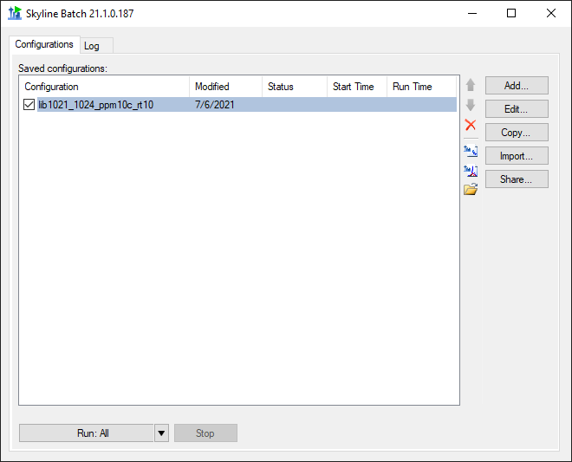

* Click the **Run: All** button.

Skyline Batch brings you to the **Log** tab to show the output of running your configurations.

Switching back to the **Configurations** tab, you can see the status of your configuration. Wait until the status is **Completed** (this takes around 30 minutes on a fast Intel i7 computer with plenty of memory):

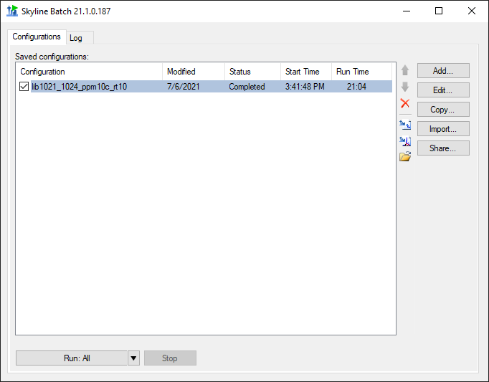

* Click on “lib1021_1024_ppm10c_rt10”
* Click the Open Folder icon.

This opens the configuration’s analysis folder.

You will find PeakAreasCvs.pdf with 7 familiar plots from Webinar 15:

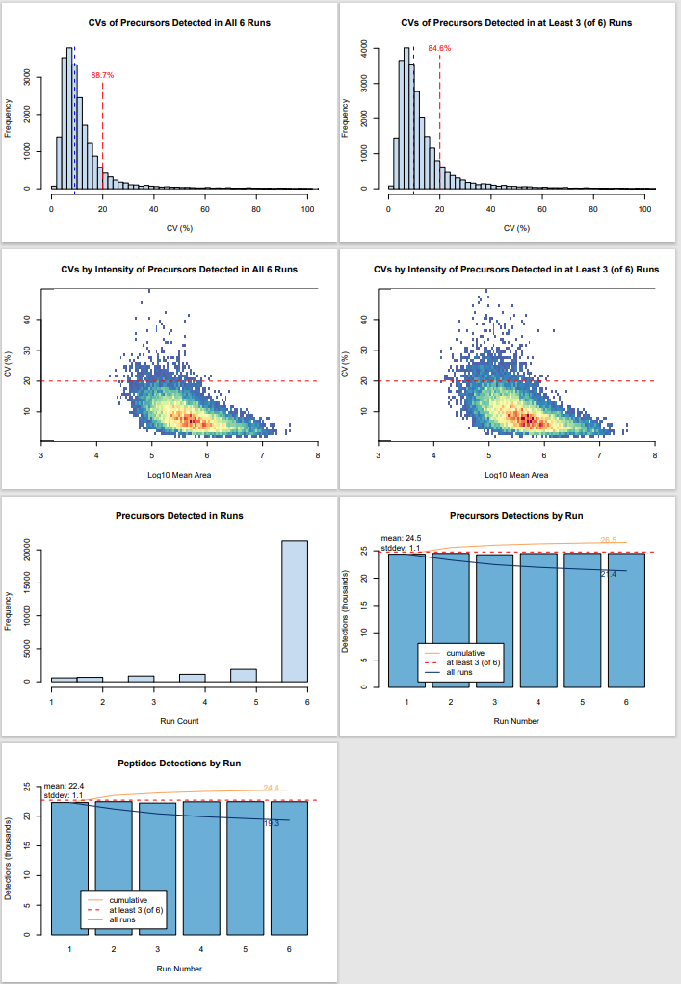

If you want to learn more about Skyline Batch, visit the documentation at:

[Microsoft Word - SkylineBatchDocumentation (washington.edu)](https://skyline.gs.washington.edu/software/SkylineBatch/SkylineBatchDocumentation.pdf)