**Mortenson VR Room Project**

**INSTALLATION**

1. **INSTALL UNREAL ENGINE FROM SOURCE**

Download Unreal Engine .zip at <https://github.com/Oculus-VR/UnrealEngine>

**MANDATORY: UNZIP/INSTALL TO A "SHALLOW" FOLDER (i.e. C:\UE4_422\)**

Unzip

Setup.bat

GenerateProjectFiles.bat

Open UE4.sln with VS2017

Build UE4

1. **MAKE SOME CHANGES**
2. Close VS2017
3. Replace the following folder with the one provided: \Engine\Plugins\Runtime\Oculus\OculusAvatar
4. **Build UE4 (again), build UnrealLightmass, Close VS2017. That's it**

Now you can right-click on Proteus.uproject, select Engine Version, then build Proteus.sln in VS or directly in explorer.

**The Control Panel in MainMenuPC**

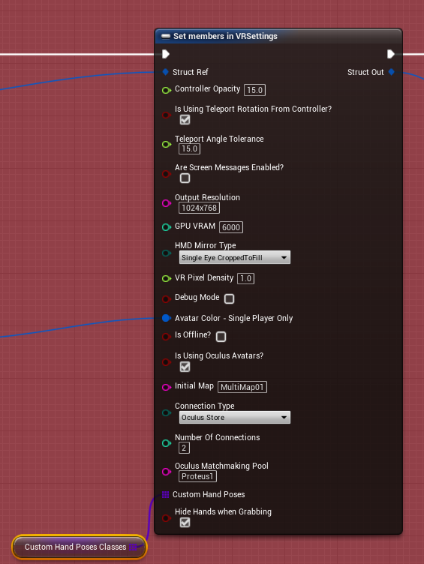

|  |  |
| --- | --- |
| **Setting** |  |
| Controller Opacity | 0 up to whatever, 1 is not entirely opaque, just 15 should be fine |
| Controller Scale | For the hands, the scale is 1:1 with Epic VR template. Reduce scale to approx. 0.75 to come close to real-life for the hands, 0.93 to Oculus Avatar Hands |
| Teleport Rotation from Controller | If unselected, rotation is from thumbstick / trackpad |
| Teleport Angle Tolerance | Safety feature to teleport only on surfaces under a certain inclination. Between 0 and 90 degrees. Put 90 degrees to disable it. |
| Enable Screen Messages | Yes / No (in development and editor mode) |
| Output Resolution | The resolution on your monitor. |
| GPU VRAM | GPU Video Memory, can be useful to tweak to stream large textures,  by default 4000 (MB). You should put it around 1GB under your GPU VRAM |
| HMD Mirror Mode | See below |
| VR Pixel Density | Use a higher number for better quality, and a lower one for better performance |
| Debug Mode | Enable debug mode (no VR – see below) |
| Avatar Color | Avatar color when not using the Oculus Avatars |
| Is Offline? | You will be logged in but will not accept any connections |
| Is Using Oculus Avatars? | Use in-house hands+head or Oculus Avatars system |
| Initial Map | The map you'll load into following entryMap |
| ConnectionType | LAN / Oculus Home. You need to be connected to Oculus Home to use the Oculus Avatars |
| Oculus Matchmaking Pool | Oculus Matchmaking Pool, as set in Developer Dashboard |
| Custom Hand Poses | See Custom Hand Poses section |

**HMD Mirror Modes**

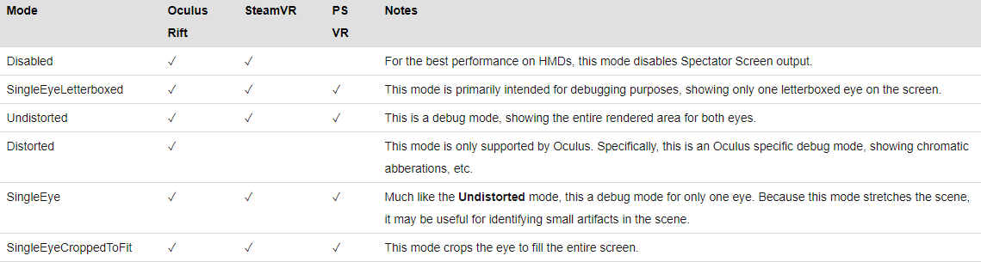

**To use custom hands (no internet necessary, works with Vive & Oculus)**

**Unselect Is Using Oculus Avatars**

**To use Oculus Avatars (must be connected to Internet, Oculus only)**

**Select Is Using Oculus Avatars**

**Mortenson features**

Laser beam / XRay Ping

Ensure you have Layered Materials ON in ProjectSettings

Example: Material_3459

Create / Duplicate a Material Layer like Material_3459 Material Layer. This is the canvas:

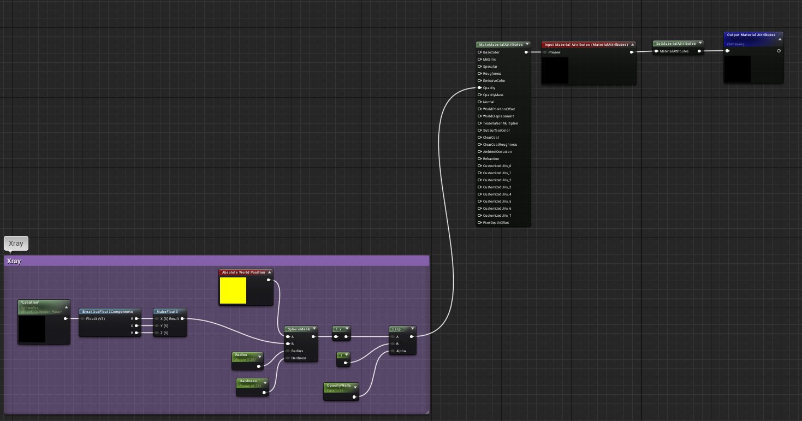

Copy / Paste and plug the target material nodes into “MakeMaterialAttributes”:

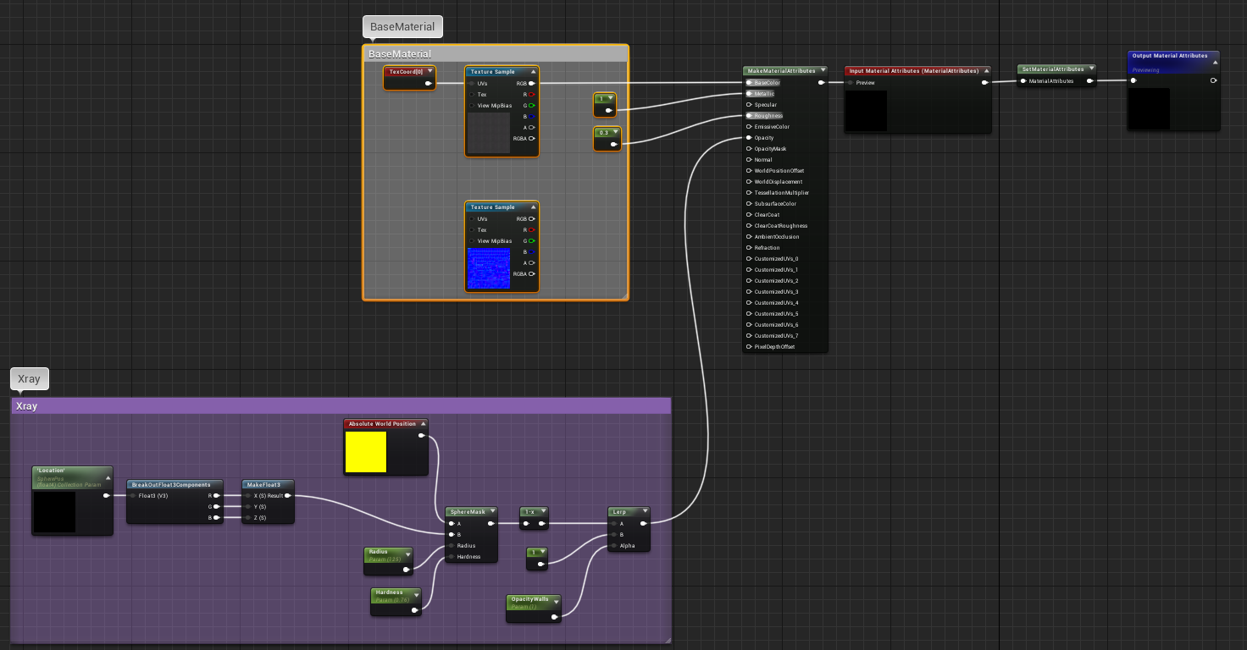

Open Original Material_3459 Material; delete everything

Set Material: 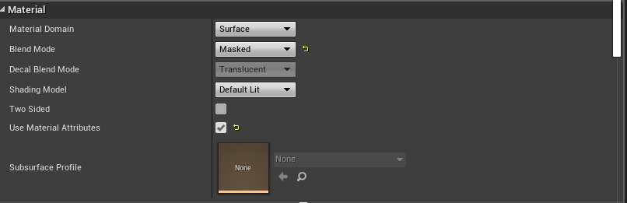

Copy / Paste this canvas:

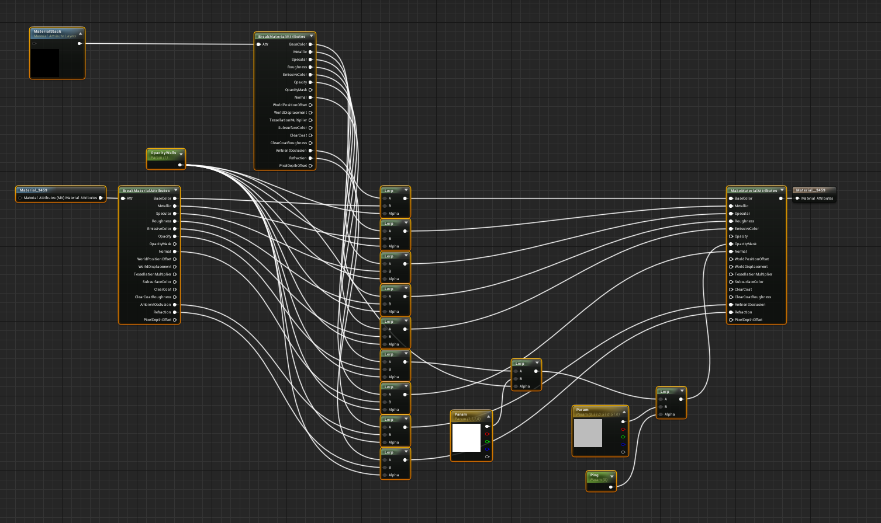

Set Material Function to previous Material Layer:

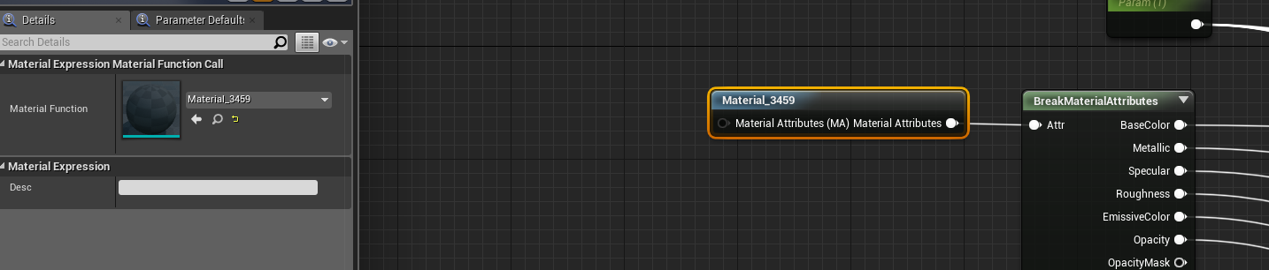

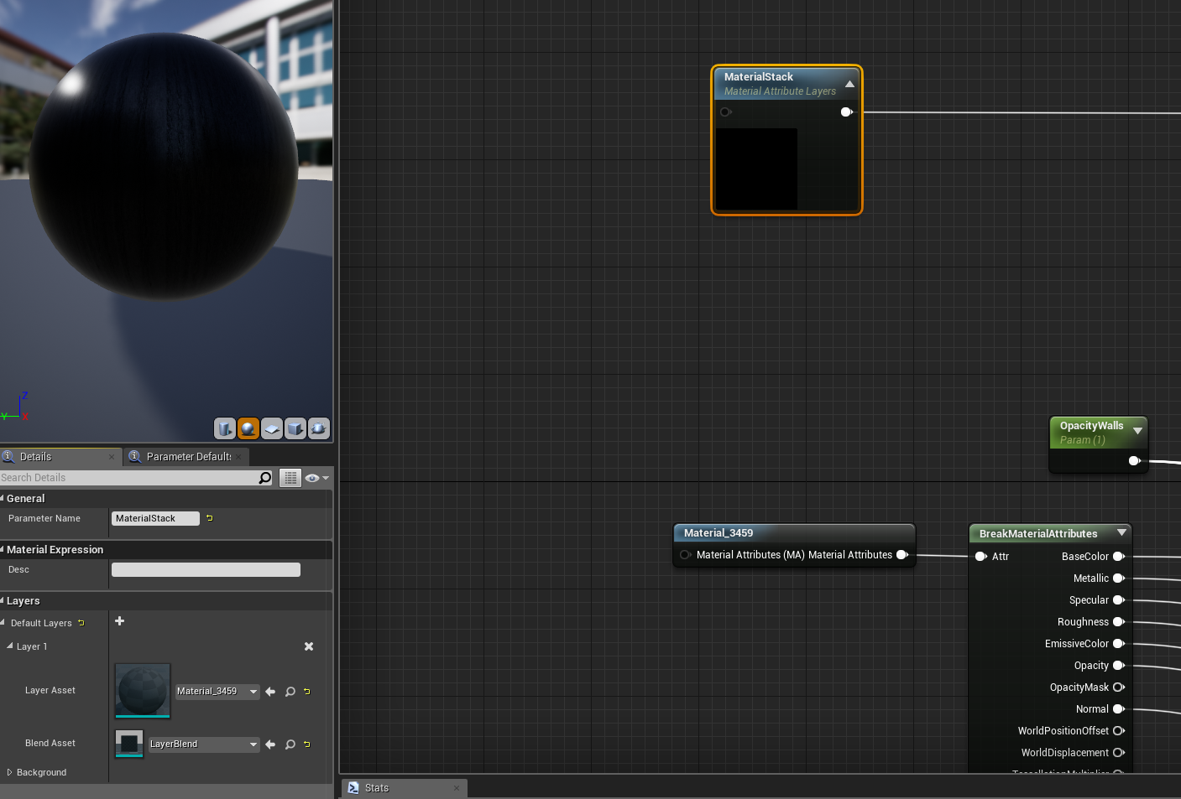In the Material Stack, set Layer 1 asset to previous Material Layer:

Ensure the mesh has Generate Overlap Events, and Collision Presets to WallPreset

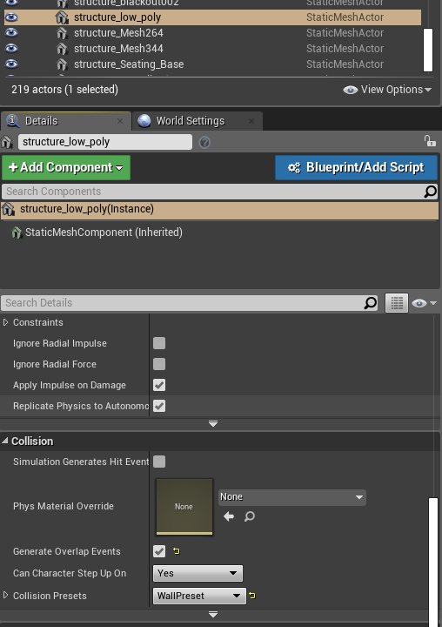

Adjust Ping time / slope:

Click on ProteusPawn/PingTimeline; there you can adjust time and slope (between 0,0) and (time x, 1)

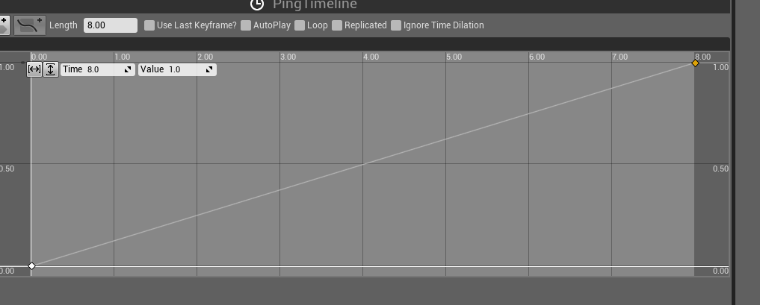

Changing Chamaleon PP

Connect the node to on/off the selected effect in ProteusPawn

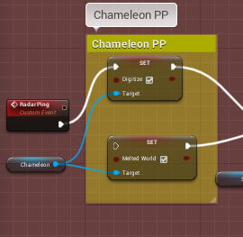 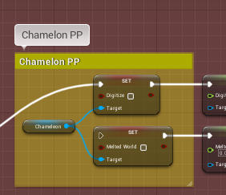

You can also adjust some properties of each effect. You can also scale the effect with the coefficient.

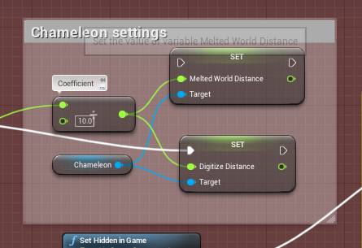

And bring them to initial values when ping is finished

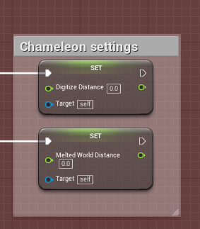

Ping Sphere

Toggle visibility in ProteusPawn/Sphere/Rendering/Visible

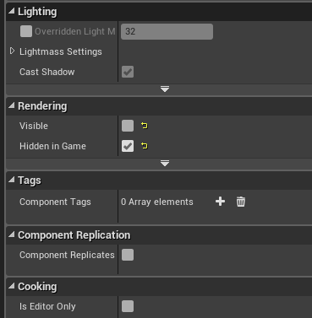

You can also select material at the same place

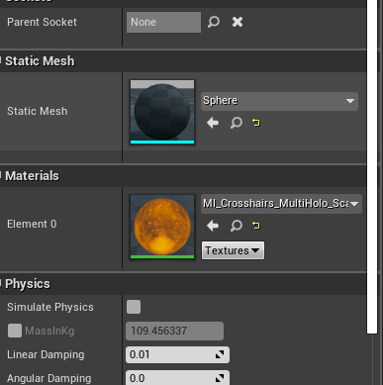

XRay Highlight

Duplicate conduit_branch+conduit00bp; change Static Mesh to target mesh

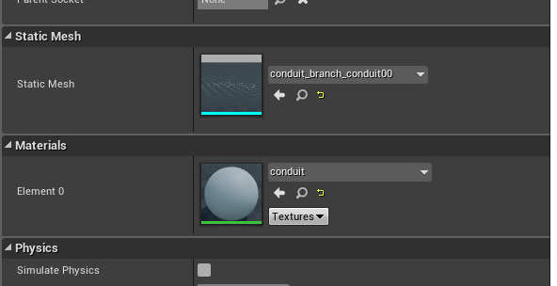

NOTE FOR XRAY AND HIGHLIGHT: YOU HAVE TO BE SURE YOUR MESH HAS A COLLISION BOX

To adjust the time during which the mesh will be highlighted, change value in ProteusPawn/HighlightDelay

Teleporting on the 3D model

You can put any number of Indicators on the model. You'll teleport at the base, where there is the little sphere:

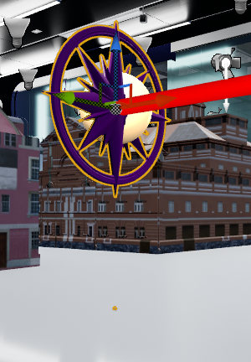

In the editor, when selecting each indicator, you can insert 2 cubemaps (.DDS) images, one for each eye, and select "CubeMap"

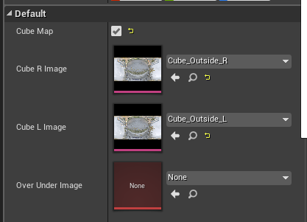

Or you can insert 1 over-under image, and uncheck "CubeMap"

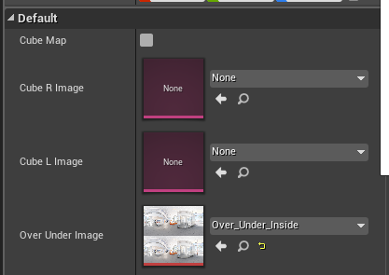

**Furniture swap**

Take example on one of the 3 FurnitureGroup

You can add each mesh in the Construction Script:

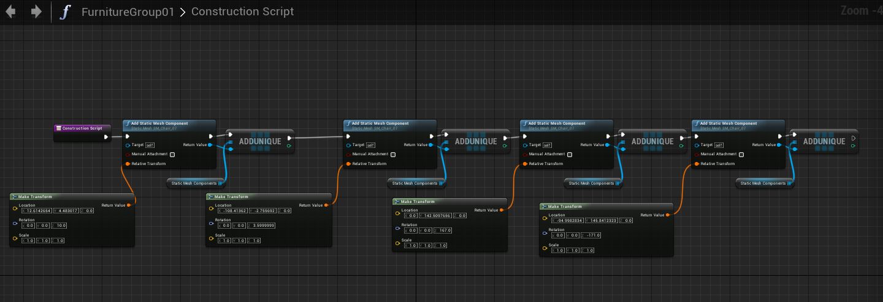

Be sure that each mesh has "Generate Overlap Events" and WallPreset

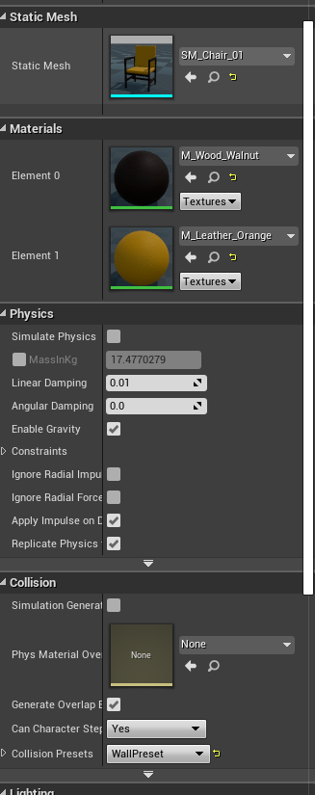

**Inputs**

|  |  |
| --- | --- |
| **HTC Vive** | **Oculus Touch** |
| L Vive Menu | L Touch Y Button |
| Radar Ping | |
| L / R Vive Trackpad | L Touch X Button / R Touch A Button |
| Teleport | |
| L Vive Trigger | L Touch Hand Trigger |
| Play Area Limits / L Grab | |
| L Vive Grip | L Touch Thumbstick Button |
| Teleport in Media Sphere (3D 360 pictures) | |
| R Vive Menu | R Touch B Button |
| X-Ray Flashlight / Indicator + Furniture Selector | |
| R Vive Trigger | R Touch Hand Trigger |
| Vive Camera (Vive only) / R Grab | |
| R Vive Grip | R Touch Thumbstick Button |
| Teleport in Mini-Model (if indicator selected) / Move Furniture if furniture selected | |
|  | R / L Touch Trigger |
| Unassigned | |