Book Exchange SEPM
Project Report
Focused on engineering lifecycle, architecture, security, testing, CI, deployment, and teamwork
Date: April 4, 2026

Stack: Java 17, Spring Boot 4, PostgreSQL, Thymeleaf, Spring Security, WebSocket, Docker, GitHub Actions, Render

Abstract

Book Exchange SEPM is a full-stack Spring Boot project built around a book exchange platform, but the real academic value of the project is broader than its features. The main purpose of the work was to practice how a complete software project should be designed, organized, secured, tested, and maintained using industry-oriented engineering habits. For that reason, this project was developed not only with user-facing functionality in mind, but also with careful attention to layered architecture, REST API structure, role-based security, project maintainability, testing strategy, collaborative GitHub workflow, CI support, and deployment readiness.

The project uses a realistic domain in which users can register, manage books, request exchanges, communicate through chat, and complete transactions in a controlled way. That domain is useful because it naturally requires authentication, authorization, database relationships, workflow transitions, and real-time communication. However, those features are mainly a vehicle for demonstrating stronger engineering ideas such as modular structure, design pattern usage, secure request handling, reproducible environments, and codebase clarity for a two-person team.

This report therefore explains the project from an engineering lifecycle perspective. It highlights the main objective of the work, the technical choices that support maintainability, the security and architecture model, the use of WebSocket and Thymeleaf in a full-stack monolith, the role of testing and CI, and the way Docker and Render support deployment. The goal is to show that Book Exchange SEPM is not only a functional application, but also a disciplined software engineering exercise that reflects how a maintainable real-world project should be approached.

1. Introduction

In many student projects, the main focus stays on visible features, while the engineering process behind those features receives much less attention. In real software development, that balance is reversed. A system is judged not only by what it can do, but also by how safely and sustainably it was built. A project with attractive functionality but weak structure, poor security, and no testing discipline quickly becomes difficult to maintain. Because of that reality, the core intention of Book Exchange SEPM was to build a project that feels like a real software product in terms of lifecycle thinking, not only in terms of output.

The selected domain, a book exchange platform, supports that goal well. It is simple enough to explain clearly, but rich enough to require meaningful engineering decisions. Once users can exchange books, the system must handle accounts, roles, ownership, requests, approvals, notifications, real-time chat, and completion rules. That makes it possible to practice several professional concerns within one repository while keeping the project understandable for presentation and academic review.

The team used this project to explore how a full-stack Spring Boot application should be structured. This included separating controllers from services, keeping data access in repositories, securing both HTTP and WebSocket interactions, organizing frontend pages with Thymeleaf and page-specific assets, and maintaining supporting documentation. The project also includes CI workflow, Docker support, deployment configuration, and multiple forms of testing, which together make the repository much closer to a real engineering workspace than to a one-semester demo script.

2. Main Objective of the Project

The main objective of Book Exchange SEPM was to practice the complete lifecycle of an industry-style software project. The visible features were important, but they were not the only target. The deeper target was to build a system that demonstrates how real engineering work should be organized from design to deployment.

More specifically, the project aimed to show:

- a maintainable backend structure
- secure authentication and role-based access control
- clearly organized REST APIs
- separation of business logic from controllers
- use of software design patterns where they add clarity
- integration of server-rendered frontend pages with backend logic
- real-time communication through WebSocket
- testing across unit, integration, and security levels
- GitHub-based workflow with automated checks
- deployment readiness through Docker and Render configuration

This objective matters because it changes how the project is evaluated. Instead of asking only whether a feature exists, the better question is whether the project was built in a way that another developer could understand, test, extend, review, and deploy. That is the perspective from which this report is written.

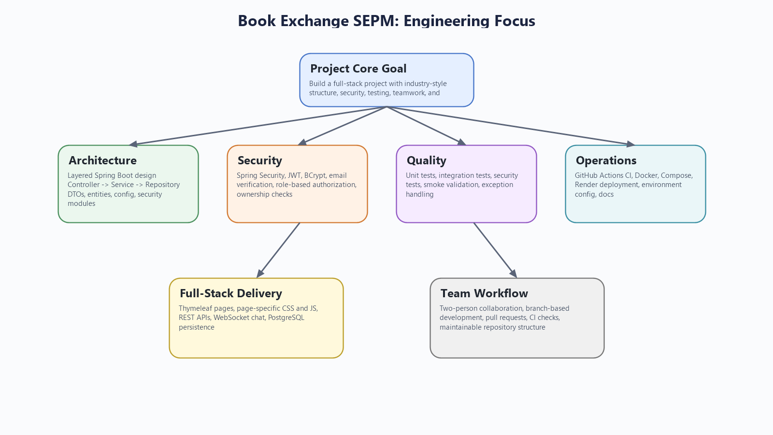
Figure 1. The project was designed around engineering quality, not only end-user features.

3. Technology Stack and Why It Was Chosen

The project uses a stack that supports full lifecycle development rather than isolated coding exercises. Java 17 provides a modern and stable language base, while Spring Boot 4.0.3 serves as the main framework for dependency management, application startup, web handling, persistence integration, and security configuration. PostgreSQL is used as the main runtime database so the application behaves like a realistic relational system instead of depending on temporary in-memory storage.

On the frontend side, Spring MVC and Thymeleaf were chosen to keep the UI and backend inside one maintainable monolith. This is a practical decision for a two-person team because it reduces the complexity of managing separate frontend and backend repositories. The static CSS and JavaScript files are organized per page, which improves clarity and keeps the frontend easier to maintain.

Security concerns are handled through Spring Security, JWT utilities, BCrypt password hashing, and Passay-based password validation. Real-time communication is supported through Spring WebSocket with STOMP and SockJS. Together, these tools allow the project to demonstrate both traditional request-response patterns and live interaction inside the same application.

The operational side of the stack is equally important. Docker and Docker Compose support local reproducibility, GitHub Actions provides automated CI verification, and Render deployment files show that the application was prepared for hosted execution. This selection of tools reflects the project's real goal: to cover development, testing, collaboration, and deployment as parts of one complete software workflow.

4. Architecture and Project Structure

One of the biggest strengths of the repository is its clean architectural organization. The project follows a layered structure in which controllers manage requests, services contain business rules, repositories handle persistence, and DTOs keep API contracts separate from JPA entities. This is a familiar and reliable pattern in Spring Boot applications because it improves readability and reduces the risk of mixing responsibilities.

The controller layer is responsible for page routing, REST endpoints, and WebSocket entry points. The service layer contains the most important application logic, including authentication flows, book handling, exchange validation, chat access, delivery processing, notification generation, and user-role operations. The repository layer uses Spring Data JPA interfaces to interact with the database. The entity layer represents the domain model, including users, books, exchanges, deliveries, chat rooms, messages, and notifications.

This project structure was not chosen only for neatness. It directly supports maintainability. Thin controllers are easier to understand. Service-layer rules are easier to test and reuse. Repository concerns remain separated from business logic. DTOs protect the system from exposing raw entity design to every client. Static assets and Thymeleaf templates are also clearly organized so frontend concerns do not become mixed with backend configuration.

The repository includes supporting documentation such as `README.md`, `TESTING_GUIDE.md`, `DESIGN_PATTERNS.md`, and `RENDER_DEPLOY.md`. These files make the codebase easier to onboard into and defend during academic review. In practice, documentation is part of maintainability, and this repository reflects that.

5. Security, Authentication, and Roles

Security was one of the main pillars of the project. The system uses Spring Security as the central place for controlling authentication and authorization, which is the correct approach for a project aiming to reflect real engineering standards. Instead of spreading security decisions across unrelated classes, the application keeps them in a clear configuration-driven model.

Authentication supports multiple use cases. Browser users can work through form login, while token-based API access is handled through JWT. Passwords are protected using BCrypt, and password quality is checked using Passay. The email verification flow adds another layer of realism because the system does not simply create an account and trust it immediately. That reflects a more production-aware user lifecycle.

Authorization is role-based. The project uses `ROLE_USER`, `ROLE_MODERATOR`, `ROLE_ADMIN`, and `ROLE_DELIVERY_MAN`. These roles shape access to endpoints and operations in meaningful ways. A normal user can manage books and requests, moderators can review exchange activity and remove inappropriate listings, admins can manage users and system sections, and delivery-role users can work with delivery assignments. The project also combines role checks with ownership validation, which is important because secure design must consider both who the user is and what resource they are interacting with.

Another strong point is that security is not limited to normal REST requests. Exchange chat is protected through both service-layer access checks and the WebSocket channel interceptor. That means the system treats real-time messaging as a secured feature, not as an unguarded side channel. For a student project, that is a strong and practical design decision.

6. REST API Design and Business Logic

The REST API is organized by domain rather than by generic technical grouping. Authentication, books, exchanges, users, wishlist subscriptions, notifications, and admin-related operations are separated into clear controller areas. That makes the project easier to understand and gives the frontend predictable interfaces to work with.

The more important part, however, is how logic is placed behind those endpoints. Business rules live in services such as `AuthenticationService`, `BookService`, `ExchangeRequestService`, `DeliveryService`, `ChatRoomService`, `UserService`, `WishlistService`, and `NotificationService`. This helps the project avoid one of the most common problems in student work: controllers becoming overloaded with all application logic.

Several examples show why this matters. Exchange creation validates ownership, availability, and duplicate-request rules. Approval and completion are not simple status updates; they are part of a controlled workflow. Delivery completion performs final ownership transfer. Wishlist notifications are triggered through an event-based path when book availability changes. These are signs that the backend was designed around process integrity, not only around database CRUD.

This approach gives the system stronger internal consistency. It also makes the project easier to test because the most important rules are concentrated in service classes rather than scattered throughout multiple pages or endpoints.

7. Use of Design Patterns

The project intentionally includes software design patterns where they improve clarity and maintainability. This is one of the aspects that supports its industry-oriented goal.

The Strategy pattern is used in the book search module. Different search behaviors such as keyword, title, author, and genre matching are implemented through dedicated strategy classes and selected through a resolver. This keeps search logic modular and makes it easier to add new search modes in the future.

The Factory pattern appears in controlled object creation, especially through `UserFactory` and `ExchangeRequestFactory`. This reduces repeated initialization logic and keeps creation rules centralized. It also improves readability because object creation becomes intention-revealing instead of being repeated in multiple places.

The Singleton pattern is used in the book event manager that supports the notification flow around book availability. The goal is to keep one central event hub for publishing and subscribing to those events. In the context of this project, that is a reasonable design because it creates clear event coordination without adding infrastructure complexity that would be unnecessary for the current scale.

These patterns are meaningful because they are connected to actual project behavior. They are not included only for theory. They improve extensibility, reduce duplication, and make the system easier to reason about.

8. Full-Stack Integration with Thymeleaf and WebSocket

Book Exchange SEPM is not only a backend API project. It is a full-stack monolith with integrated UI, server-side rendering, REST communication, and real-time chat. Thymeleaf is used to render pages such as the landing page, browse page, book page, profile page, exchange page, delivery page, wishlist page, and admin sections. Each page is supported by focused CSS and JavaScript files, which keeps the frontend organized and easier to maintain.

This choice fits the project well. For a team of two, keeping frontend and backend inside one Spring Boot application reduces overhead and makes local development more straightforward. It also makes deployment simpler because the UI and backend travel together.

WebSocket support adds another important engineering dimension. The project uses STOMP and SockJS to support exchange-specific live chat. This is especially valuable because it demonstrates that the system can handle both standard HTTP requests and real-time communication. The chat feature is also integrated into the broader workflow rather than being an isolated extra. It is tied to exchange participation, message history can be fetched through REST, and the security model remains active in the real-time channel.

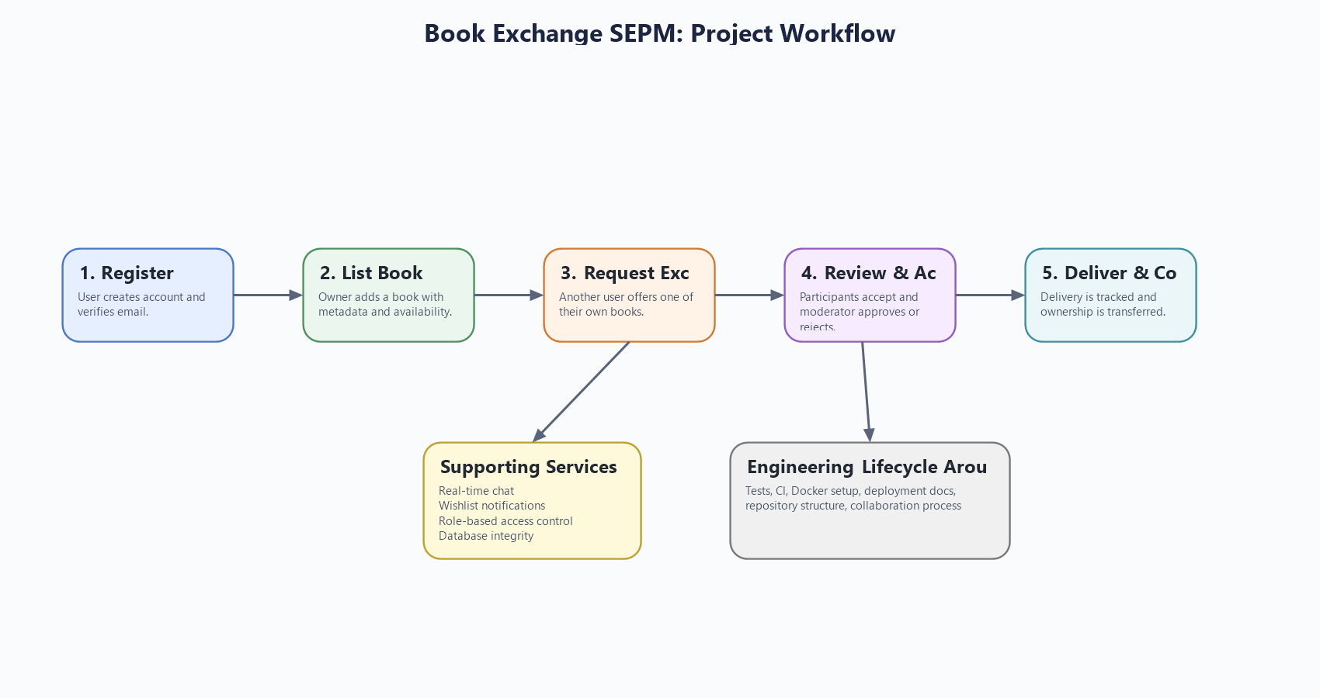
Figure 2. The system combines workflow handling with security, chat, notification, testing, and deployment support.

Together, Thymeleaf and WebSocket make the project much more representative of a real full-stack application.

9. Database Design and Workflow Thinking

The application's data model supports the project's workflow-heavy design. The most important entities include `User`, `Role`, `Book`, `ExchangeRequest`, `Delivery`, `ChatRoom`, `ChatMessage`, `WishlistSubscription`, and `UserNotification`. These entities are related in ways that support ownership tracking, moderated exchange, delivery handling, and notification generation.

This matters because the project is not just storing isolated records. The database supports a workflow in which books belong to users, exchanges connect multiple users and books, deliveries control completion, and chat is linked to a specific exchange context. That is much closer to a real process-driven application than to a flat CRUD table structure.

The project also includes compatibility and integrity initializers in the configuration layer. These classes help maintain schema consistency and repair evolving data assumptions. That is a thoughtful addition because it reflects the reality that software systems change over time and need help staying stable as the model evolves.

10. Testing and Quality Assurance

Testing is another major area where the project shows maturity. The repository contains unit tests, integration tests, security authorization tests, and smoke-level application validation. This is important because the project goal was never just to make the application appear functional during a demo. The stronger goal was to make its behavior verifiable and maintainable.

The Maven build is configured so that Surefire runs unit tests, while Failsafe handles integration tests and application-level verification. This separation is useful because fast feedback and deeper system validation serve different purposes. The test suite includes service-level checks and end-to-end style verification around security and workflow behavior.

The use of H2 in PostgreSQL compatibility mode supports fast automated testing while staying reasonably close to the production-style relational model. Error handling is also standardized through the global exception handler, which improves both client behavior and testability. Altogether, the testing strategy shows that quality assurance was treated as a core project concern rather than a last-minute addition.

11. GitHub Workflow, Team Collaboration, and CI

Because the project was completed by a two-person team, collaboration process mattered a great deal. A maintainable codebase is not only about good classes; it is also about how changes are introduced, reviewed, and verified. That is why the repository includes a GitHub Actions CI workflow that runs on both `push` and `pull_request`.

The CI workflow is separated into unit testing and integration testing jobs. This provides a good base for pull-request-based development and aligns well with branch protection thinking, even though branch protection settings themselves live in GitHub configuration rather than in the repository code. In practice, this means the team can use branches, submit pull requests, and rely on automated checks before merging. That is a much more professional workflow than editing directly on a shared branch without verification.

The repository also helps teamwork through its structure and documentation. Environment templates, deployment notes, testing instructions, and organized packages reduce confusion and make it easier for one collaborator to understand or continue the work of the other. For a project built by two people, that is a meaningful achievement.

12. Deployment, Docker, and Render Support

The project was prepared not just for coding and local presentation, but also for reproducible setup and deployment. Docker and Docker Compose make it easier to run the application together with PostgreSQL in a consistent environment. The `Dockerfile`, `docker-compose.yml`, and `.env.example` files support this process clearly.

Render deployment support is also included through `render.yaml` and `RENDER_DEPLOY.md`. These files show how the same project can move from local development to a hosted platform by using environment variables for database and runtime configuration. Even though the repository does not contain a full production CD pipeline, it is deployment-ready in a very practical sense because the main packaging and environment decisions are already documented.

This is important for the report because it shows the project was treated as something that should be runnable and maintainable beyond the IDE. That is one of the clearest signs of lifecycle awareness.

13. Conclusion

Book Exchange SEPM is best understood as an engineering-focused full-stack project rather than only as a feature-focused web application. Its importance comes from the way it brings together architecture, security, backend structure, full-stack integration, design patterns, testing, collaboration workflow, and deployment preparation within one coherent repository.

The project succeeds because it shows how a realistic domain can be used to practice real software engineering habits. Authentication and roles are handled carefully. Business logic is structured in services. REST APIs are organized clearly. WebSocket and Thymeleaf are integrated into the same maintainable system. Testing and CI are part of the workflow. Docker and Render support deployment readiness. Documentation supports maintainability and teamwork.

For these reasons, the project demonstrates more than implementation effort. It demonstrates engineering discipline. That is the main achievement of the work and the main reason it stands as a strong software engineering project.

