Book Exchange SEPM
Industry-Focused Project Report
Main emphasis: engineering lifecycle, security, architecture, testing, CI, deployment, and teamwork
Date: April 4, 2026

Stack: Java 17, Spring Boot 4, PostgreSQL, Thymeleaf, Spring Security, WebSocket, Docker, GitHub Actions, Render

Executive Summary

Book Exchange SEPM is a full-stack Spring Boot project built to demonstrate how a real software project should be structured, secured, tested, and deployed.

The project goal was not only to implement features.

The real goal was to practice:

- industry-style project structure
- secure authentication and role-based authorization
- clean REST API design
- maintainable architecture and design patterns
- real-time communication with WebSocket
- testing and verification
- GitHub workflow and team collaboration
- CI support and deployment readiness

Why this project stands out:

- It uses a realistic domain, book exchange, to show complete workflow handling.
- It includes backend, frontend, security, database, and deployment concerns in one repository.
- It reflects how a two-person team can work in an organized, review-friendly, maintainable way.

1. Project Objective

Main Objective

The main objective of this project was to build a software system using industry-level engineering practices from start to finish.

Instead of focusing only on visible features, the team focused on:

- how the code is organized
- how users are authenticated and authorized
- how modules are separated
- how changes can be tested safely
- how the app can run locally and in deployment
- how a small team can collaborate with less risk

Why Book Exchange Was Chosen

The book exchange domain is simple enough to explain but rich enough to demonstrate real engineering concerns.

It naturally requires:

- user accounts
- different roles
- secure access
- data relationships
- request workflow
- messaging
- notifications
- deployment and testing support

That made it a good domain for practicing full software lifecycle management.

2. What Makes This Project Industry-Oriented

This project was designed to look and behave like a serious maintainable product, not a classroom prototype.

Key engineering aspects implemented:

- Layered architecture using controller, service, repository, DTO, entity, config, and security packages
- Secure authentication flow with form login, JWT support, password hashing, and email verification
- Role-based authorization using `ROLE_USER`, `ROLE_MODERATOR`, `ROLE_ADMIN`, and `ROLE_DELIVERY_MAN`
- REST APIs grouped by clear business areas
- Thymeleaf frontend integrated with backend logic in one maintainable monolith
- WebSocket support for live exchange chat
- Design patterns used intentionally, not only theoretically
- Unit tests, integration tests, security tests, and smoke-style validation
- GitHub Actions CI workflow for automated verification
- Docker, Docker Compose, and Render deployment support
- Documentation and helper files that make team maintenance easier

Short takeaway:

This project is valuable because it covers software engineering process, not just screens and endpoints.

3. High-Level System View

The application is a full-stack monolithic web system built with Spring Boot.

Main layers:

- Presentation layer: Thymeleaf pages, CSS, JavaScript
- API layer: REST controllers and WebSocket controllers
- Business layer: service classes containing rules and workflow logic
- Data layer: JPA repositories and PostgreSQL entities
- Security layer: Spring Security, JWT utilities, filters, and role checks

Core modules:

- Authentication
- User profile and roles
- Book management
- Exchange workflow
- Delivery handling
- Chat
- Wishlist and notifications
- Admin and moderation

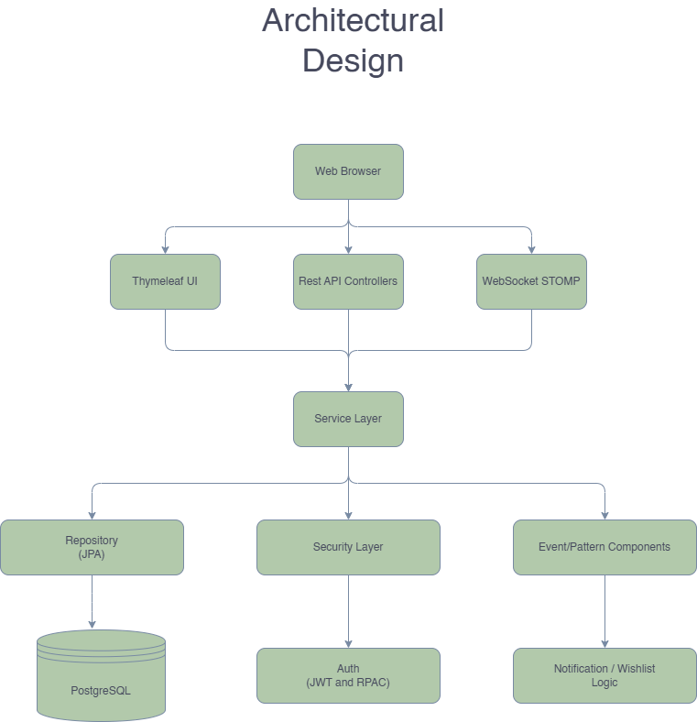
Figure 1. High-level architecture of the Book Exchange SEPM system

Why this architecture works well:

- easy to understand
- easy to test
- easier for two developers to divide responsibilities
- easier to maintain compared with mixing everything in one place

4. Project Structure and Maintainability

One of the main strengths of the project is its folder and package structure.

Important package responsibilities:

- `controller`: handles page routes, API endpoints, and request mapping
- `service`: contains business logic and workflow rules
- `repository`: handles database access
- `entity`: defines persistent domain models
- `dto`: shapes request and response payloads
- `config`: startup, seeders, security, and WebSocket configuration
- `security`: JWT, filters, and WebSocket access control
- `templates`: Thymeleaf pages
- `static/css` and `static/js`: page-specific frontend assets

Why this matters:

- business rules stay out of controllers
- database access stays separate from business logic
- APIs are easier to evolve
- frontend pages stay connected to backend cleanly
- onboarding is easier for another developer

Supporting repository files also help maintenance:

- `README.md`
- `TESTING_GUIDE.md`
- `DESIGN_PATTERNS.md`
- `RENDER_DEPLOY.md`
- `docs/FILE_EXPLANATIONS.md`

These files make the project easier to understand, present, and extend.

5. Security, Authentication, and Roles

Security was one of the main engineering priorities in this project.

Authentication Approach

The project supports multiple access styles:

- form login for browser-based usage
- JWT-based API authentication
- HTTP Basic in testing and compatibility scenarios

Main security elements used:

- Spring Security
- `JwtUtil`
- `JwtAuthenticationFilter`
- BCrypt password hashing
- Passay-based password strength validation
- email verification before normal login flow

Authorization Model

Roles implemented in the project:

- `ROLE_USER`
- `ROLE_MODERATOR`
- `ROLE_ADMIN`
- `ROLE_DELIVERY_MAN`

Why roles matter here:

- users manage their own books and requests
- moderators review exchanges and remove inappropriate content
- admins manage users and system sections
- delivery men handle assigned deliveries

Security Value of the Project

This project shows that security is not only login.

It also includes:

- ownership checks
- protected routes
- role-based permissions
- secured chat access
- validated error handling

That makes the system much closer to real application design.

6. REST API Design and Business Logic

The REST API is organized by domain instead of placing everything under one generic controller.

Main API areas:

- `/api/auth`
- `/api/books`
- `/api/exchange-requests`
- `/api/exchange`
- `/api/user`
- `/api/wishlist`
- `/api/notifications`
- moderator and admin routes

The more important engineering point is where the logic lives.

Core business rules are placed in services such as:

- `AuthenticationService`
- `BookService`
- `ExchangeRequestService`
- `DeliveryService`
- `ChatRoomService`
- `UserService`
- `WishlistService`
- `NotificationService`

Why this is important:

- controllers stay thin
- logic is easier to test
- reuse is easier
- workflow rules remain consistent

Examples of real business logic handled by services:

- preventing users from requesting their own books
- blocking duplicate pending exchange requests
- assigning delivery responsibility
- swapping ownership only after delivery completion
- generating wishlist notifications when a book becomes available

This is one of the reasons the project is more than a CRUD system.

7. Design Patterns Used

The project explicitly applies software design patterns to improve maintainability.

Strategy Pattern

Used in book search.

Classes involved:

- `BookSearchStrategy`
- `TitleSearchStrategy`
- `AuthorSearchStrategy`
- `GenreSearchStrategy`
- `KeywordSearchStrategy`
- `BookSearchStrategyResolver`

Benefit:

- search logic stays modular
- new search modes can be added with less modification

Factory Pattern

Used for controlled object creation.

Main classes:

- `UserFactory`
- `ExchangeRequestFactory`

Benefit:

- object creation rules stay centralized
- less duplicate setup logic
- cleaner initialization

Singleton Pattern

Used in event-based book availability notification flow.

Main class:

- `BookEventManager`

Benefit:

- one central event manager
- controlled publish-subscribe behavior
- easier event lifecycle management

Quick conclusion:

The patterns were used for practical maintainability, not only to satisfy theory.

8. WebSocket and Full-Stack Integration

The project includes real-time communication using WebSocket with STOMP and SockJS.

Where it is used:

- exchange-specific live chat between participants

Why this matters:

- adds real-time capability to the application
- demonstrates more advanced communication than normal REST
- shows security and access control in live messaging

Important implementation points:

- WebSocket endpoints configured in `WebSocketConfig`
- chat access guarded by `ChatChannelInterceptor`
- chat tied to exchange workflow instead of being globally open
- HTTP fallback and history retrieval also supported

The project also uses Thymeleaf for the frontend.

Frontend value:

- backend and frontend are integrated in one repository
- server-rendered pages are easy to deploy with the backend
- CSS and JS are separated by page, improving maintainability

Pages included:

- landing page
- browse page
- book page
- profile page
- exchange page
- delivery page
- wishlist page
- admin pages

This makes the project a real full-stack system, not only an API backend.

9. Database Design and Core Data Model

The application uses PostgreSQL for runtime persistence and H2 in PostgreSQL compatibility mode for testing.

Most important entities:

- `User`
- `Role`
- `Book`
- `ExchangeRequest`
- `Delivery`
- `ChatRoom`
- `ChatMessage`
- `WishlistSubscription`
- `UserNotification`

Why the data model is important:

- user roles control access
- books belong to owners
- exchanges connect users and books
- deliveries control completion
- chat stays linked to a specific exchange
- notifications are triggered by wishlist matches

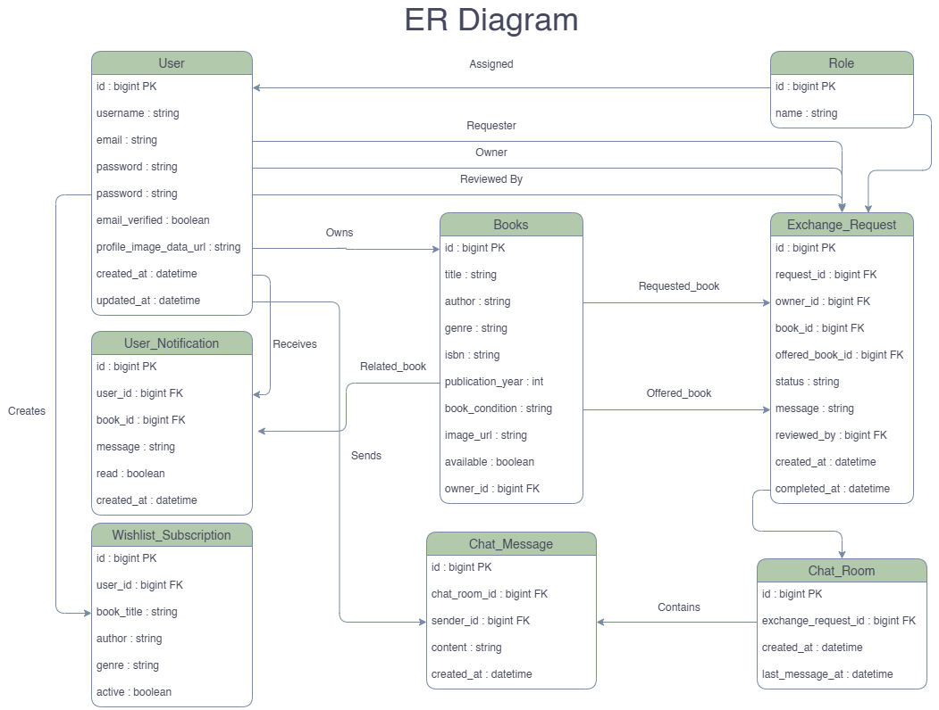
Figure 2. Core ER diagram showing users, books, exchanges, chat, delivery, and notifications

This data model supports a realistic workflow instead of isolated tables.

10. Testing and Quality Assurance

Testing was treated as a major part of the project lifecycle.

Types of testing present in the repository:

- unit tests
- integration tests
- security authorization tests
- smoke-style application tests

Important testing files include:

- `BookServiceTest`
- `ExchangeRequestServiceTest`
- `AuthenticationServiceTest`
- `SecurityAuthorizationIntegrationTest`
- `ServiceLayerSmokeIntegrationTest`

Build strategy:

- Maven Surefire runs unit tests
- Maven Failsafe runs integration tests and application-level verification

Why this is valuable:

- fast feedback for core logic
- deeper validation for end-to-end behavior
- safer collaboration for a two-person team
- better confidence before merging or deployment

The project also includes a detailed `TESTING_GUIDE.md`, which supports repeatable validation.

11. GitHub Workflow, Teamwork, and Branch Protection Thinking

This project was developed by a team of two, so collaboration quality was important.

Good teamwork in software engineering means:

- dividing responsibilities clearly
- working with manageable branches
- reviewing changes before merge
- running automated checks
- keeping the main branch stable

The repository includes a GitHub Actions CI workflow at `.github/workflows/ci.yml`.

What it does:

- runs on `push`
- runs on `pull_request`
- executes unit tests
- then runs integration tests

Why this supports branch protection workflow:

- pull requests can be checked automatically
- risky code can be detected early
- teamwork becomes process-driven, not informal

Even though branch protection settings themselves live in GitHub repository settings, this CI workflow provides the technical base for protected-branch collaboration.

This is a strong industry-style habit for a student project.

12. CI, Docker, and Render Deployment

The project also covers operational readiness.

CI Support

GitHub Actions is used for continuous integration.

Value:

- automatic verification on change
- healthier team workflow
- better confidence in repository stability

Docker Support

Files included:

- `Dockerfile`
- `docker-compose.yml`
- `.env.example`

Why Docker matters:

- easier local setup
- consistent runtime behavior
- simpler database and app startup

Render Deployment

Files included:

- `render.yaml`
- `RENDER_DEPLOY.md`

Why this matters:

- shows cloud deployment readiness
- documents required environment variables
- makes the project more realistic than local-only demos

Short summary:

This project was prepared not only to be coded, but also to be run, tested, and deployed properly.

13. Main Strengths of the Project

The strongest points of the project are:

- clear layered architecture
- security-aware design
- multiple user roles with real permission differences
- maintainable full-stack structure
- real-time WebSocket integration
- explicit design pattern usage
- organized testing strategy
- CI workflow for collaboration safety
- Docker and Render deployment readiness
- documentation that supports maintenance

Most important message:

The project shows software engineering maturity, not only implementation effort.

14. Conclusion

Book Exchange SEPM is best understood as an industry-oriented engineering project built around a realistic book exchange system.

Its biggest achievement is not simply the feature list.

Its biggest achievement is that the team applied:

- architecture
- security
- structured backend design
- maintainable frontend integration
- design patterns
- testing
- CI workflow
- deployment preparation
- teamwork discipline

That is what makes the project meaningful from a software engineering perspective.

Final conclusion:

The project successfully demonstrates how a two-person team can build a secure, structured, maintainable, and deployment-ready full-stack application using Spring Boot and related industry tools.

