**HW4 Screenshots Submission**

**(30 points in total; Due 11:59 PM Central Time, April 2, 2023)**

Requirements: This homework is open book, open slides, and open notes, but you are not allowed to collaborate nor discuss with anyone else before the due time. Any question about the homework should be addressed to the instructor. You are required to follow the instruction to complete all the questions and screenshots. This is an individual homework assignment, so sharing your RM process, screenshots, or answers with other students or parties is considered as cheating, which will be reported to the university authority. In addition, it is your responsibility to make your answers meet the required format; otherwise, you might lose points because of wrong format. Please read, understand, and comply with these requirements in this homework assignment by typing your name as below.

Your Name (First Last): Mehnaz Afrose

**Part 1: A Screenshot of Statement of Accomplishment (15 points).**

Your screenshot must meet the three requirements specified in the instruction.

**Part 2: Screenshots (15 points: 3 points for each). A screenshot without date and time will receive a 50% penalty.**

Screenshot 1: Step 3.5 Take a screenshot of your regression model (the one with regression coefficients and p values) with date and time.

Screenshot 2: Step 4.5 Take a screenshot of your prediction results (the one with predicted quality of the five new wines) with date and time.

Screenshot 3: Step 6.4 Take a screenshot of your decision tree model (the one with a tree graph) with date and time.

Screenshot 4: Step 7.4 Take a screenshot of your prediction results (the one with predicted quality of the five new wines) with date and time.

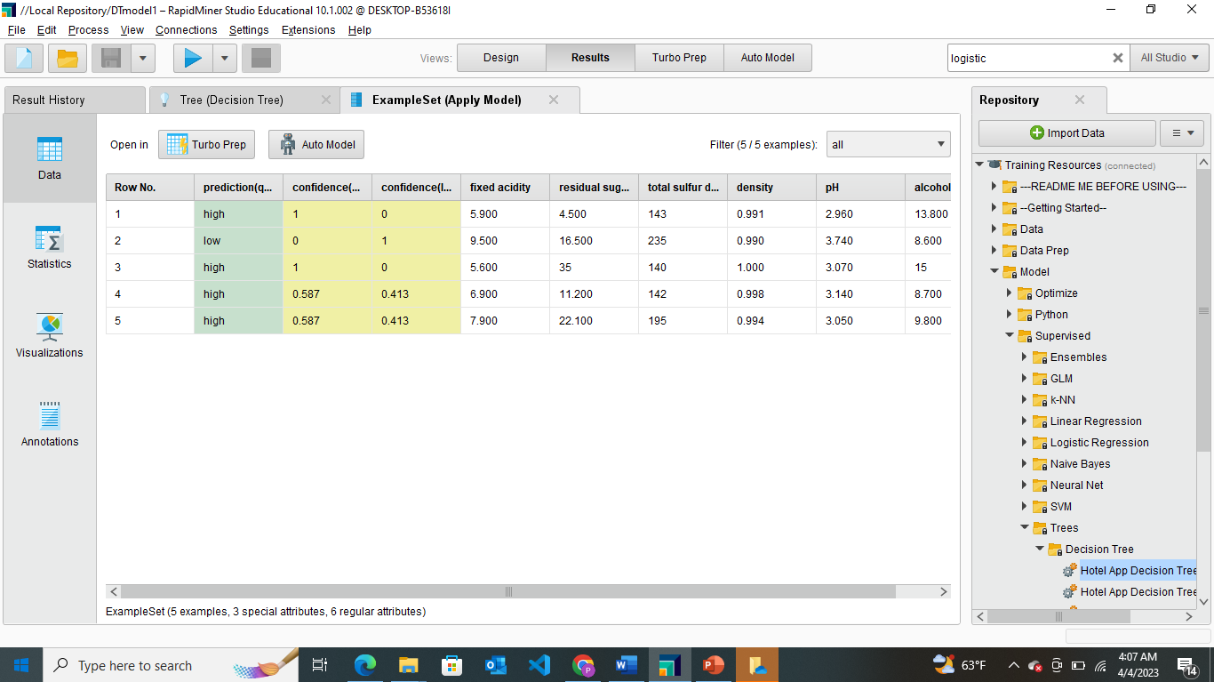

Screenshot 5: Step 9.6 Take a screenshot of your prediction results (the one with predicted quality of the five new wines) with date and time.

