Project Horizon

Test Scheme

# Written by:

Chaz Goddard

# Overview

The purpose of this document is to detail the criteria needed ascertain if the current iteration of project Horizon meets the intended function.

Furthermore it is in the interest of the development team to understand how actors not involved in development can navigate and utilise the application with little to no prompting.

# Hardware / software requirements for test

Testers will require the following to properly engage with the test scheme:

* Windows 10 software platform
* A PC or laptop with a web browser installed
* Xampp version 7.4.27 – supplied by C. Goddard
* Current version of project horizon PHP files – supplied by C. Goddard

# Tester demographic

The preferred demographic of testers would contain the following:

* Male and female
* Age range 18-60
* Both I.T and non I.T background
* Experience in Captec as an employee
* No Captec employment experience

# Functionality Testing - users

The key tests to ascertain functionality of the current iteration from the perspective of a user.

## Function to perform – User Login

Tester can use premade login credentials to access the application as production staff.

## Pass criteria

User successfully logs in and account information displayed at the bottom reads production.



## Fail criteria

User cannot login using premade credentials.

## Function to perform - New instruction request creation

User will select add instruction and create a request by filling out the form.

## Pass criteria

System will provide record inserted message.

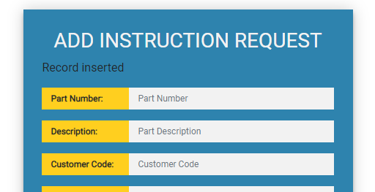

## Fail criteria

System will reset screen and no record will be created.

## Function to perform – Instruction updates requests

Search an existing instruction and submit an update request.

## Pass criteria

Instruction information is displayed and can be adjusted.

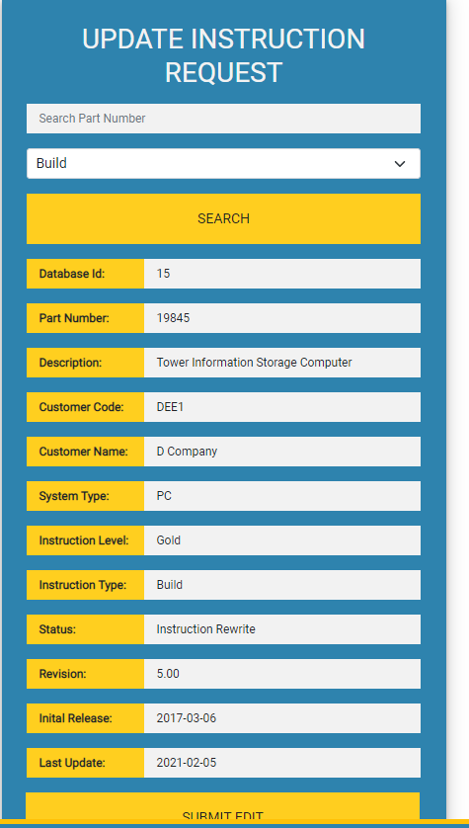

## Fail criteria

No information will display.

## Function to perform – Viewing the current work instruction list

Select to view current instruction list.

## Pass criteria

Instruction list will be displayed.

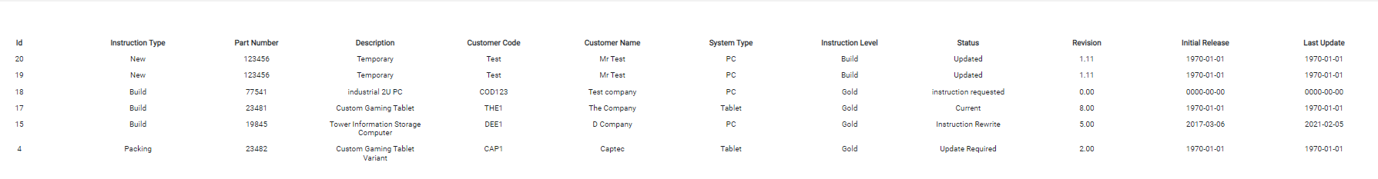

## Fail criteria

No list will appear.

## Function to perform – View existing requests

Attempt to view statistics regarding current requests.

## Pass criteria

Statistics object will be displayed.

## Fail criteria

No statistics will be displayed.

# Functionality Testing - Admins

The key tests to ascertain functionality of the current iteration from the perspective of an administrator.

## Function to perform – User Login

Tester can use premade login credentials to access the application as engineering staff.

## Pass criteria

User successfully logs in and account information displayed at the bottom reads engineering.



## Fail criteria

User cannot login using premade credentials

## Function to perform - New instruction request creation

User will select add instruction and create a request by filling out the form.

## Pass criteria

System will provide record inserted message.

## Fail criteria

System will reset screen and no record will be created.

## Function to perform – Instruction updates requests

Search an existing instruction and submit an update request.

## Pass criteria

Instruction information is displayed and can be adjusted.

## Fail criteria

No information will display.

## Function to perform – Viewing the current work instruction list

Select to view current instruction list.

## Pass criteria

Instruction list will be displayed.

## Fail criteria

No list will appear.

## Function to perform – View existing requests

Attempt to view statistics regarding current requests.

## Pass criteria

Statistics object will be displayed.

## Fail criteria

No statistics will be displayed.

## Function to perform – approve or deny requests from user accounts

View requests made and either approve or deny.

## Pass criteria

Record will be either inserted if accepted or removed from view if denied.

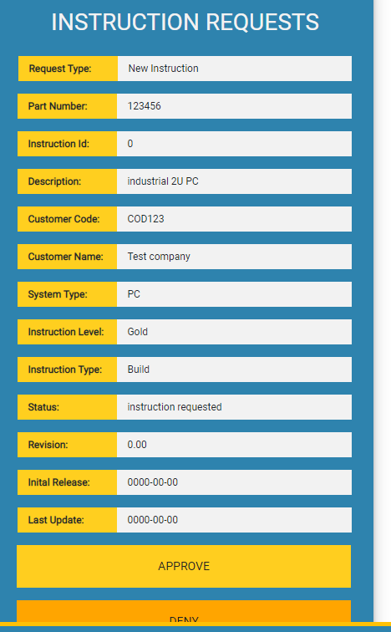

## Fail criteria

Instruction will not update and record screen will not change.

# Usability testing

## Function to perform – Site navigation

User can move from one functionality test to the other with little to no prompting from tester.

## Pass criteria

Users can execute functional tests in sequence.

## Fail criteria

Users must regularly ask for direction when moving between functional tests

## Function to perform – Form field check

Confirmation from users that all needed fields are available.

## Pass criteria

Qualitative agreement that no further fields are required

## Fail criteria

Data fields missing

## Function to perform – In app guidance

Application provides users with guidance and use within the app space

## Pass criteria

Personal judgment – the system provides the guidance required.

## Fail criteria

Personal judgement – the system doesn’t provide the guidance required

## Function to perform – form validation

App leads users and prevents inaccurate information being entered.

## Pass criteria

Only accurate information can be entered into required fields.

## Fail criteria

Any field can have any data entered into fields damaging information displayed.

## Function to perform – error communication

Are errors or inaccuracy’s clearly demonstrated and communicated to the user.

## Pass criteria

Personal judgment – the system is perceived to provide the guidance required.

## Fail criteria

Personal judgement – the system is perceived to provide the guidance required.

## Function to perform – Brand adherence

Does the site integrate (as best as feasibly possible) with the feel and design tone of the Captec brand?

Users to give impressions in a rating of 1-5 1 being lowest and 5 being highest

## Pass criteria

Users give score of 3 - 5

## Fail criteria

Users give score of 1 - 2