# Hands on assignment

Step 1) Data Loading

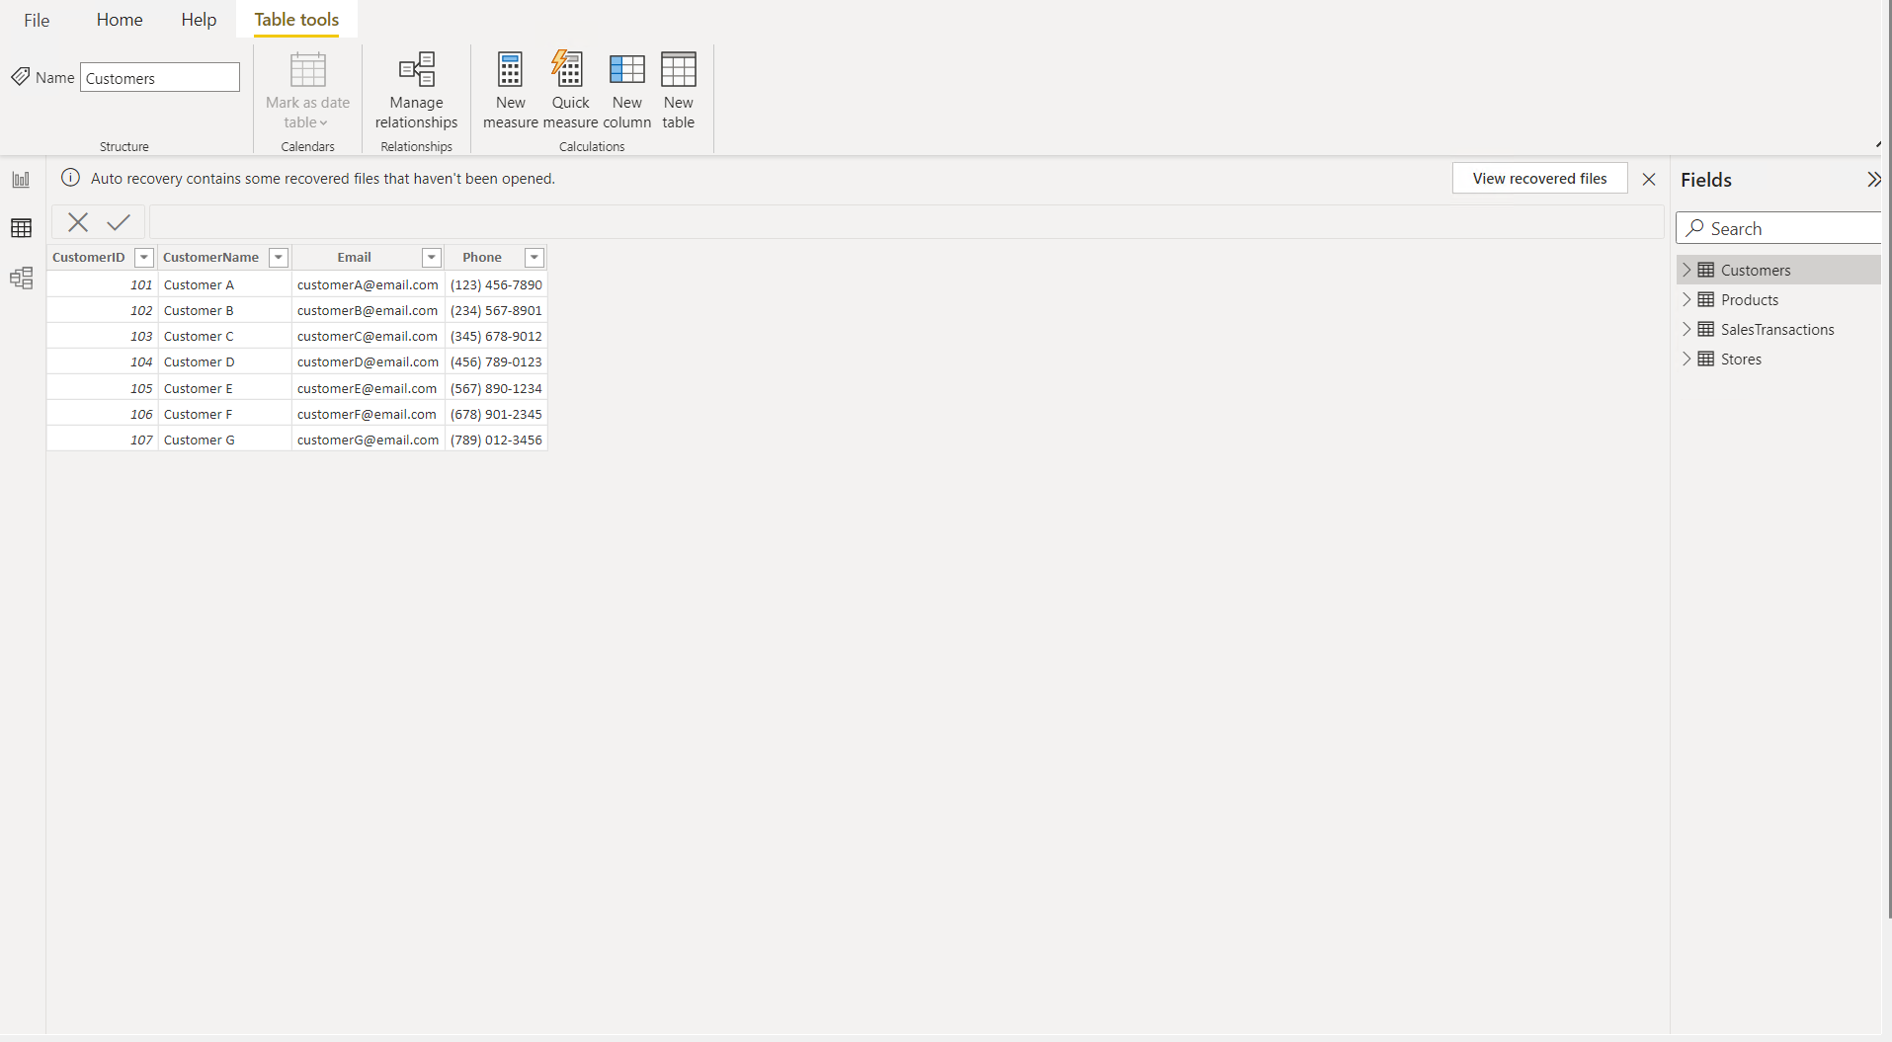

Step 2) Data Transformation

* 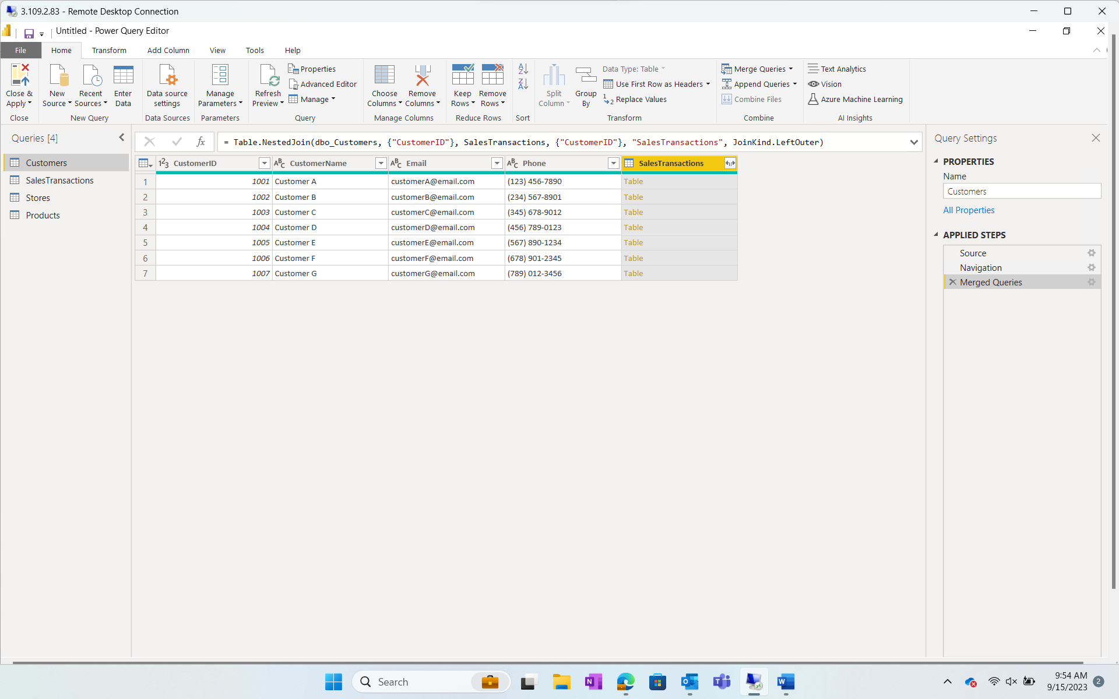
* 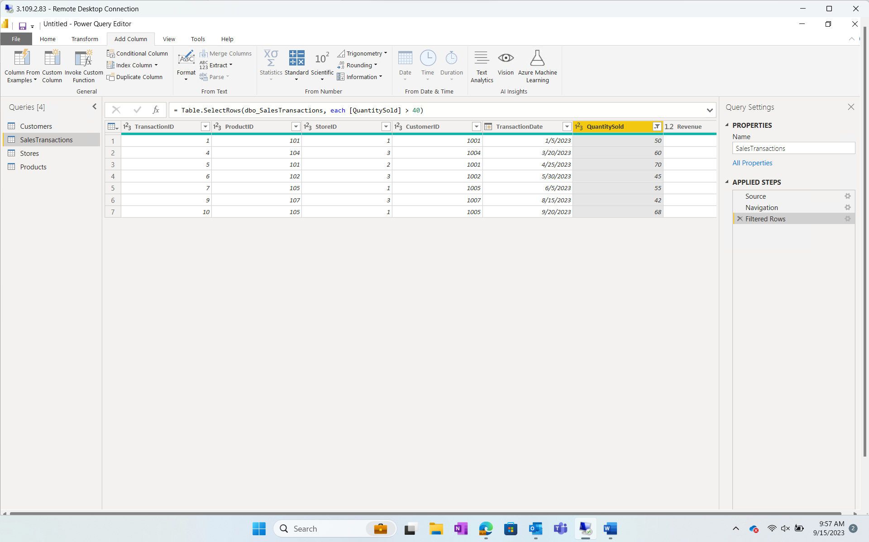
* 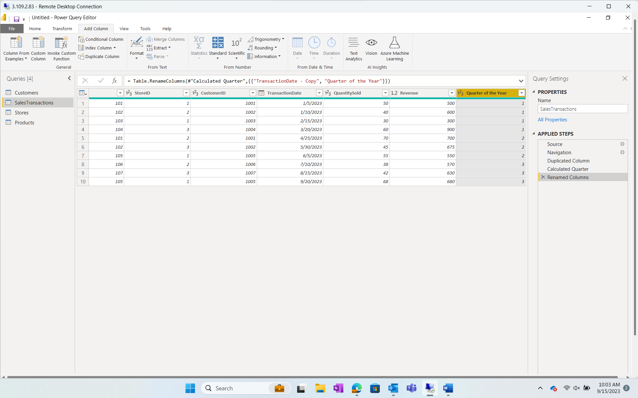

Step 3) Data Modelling

* 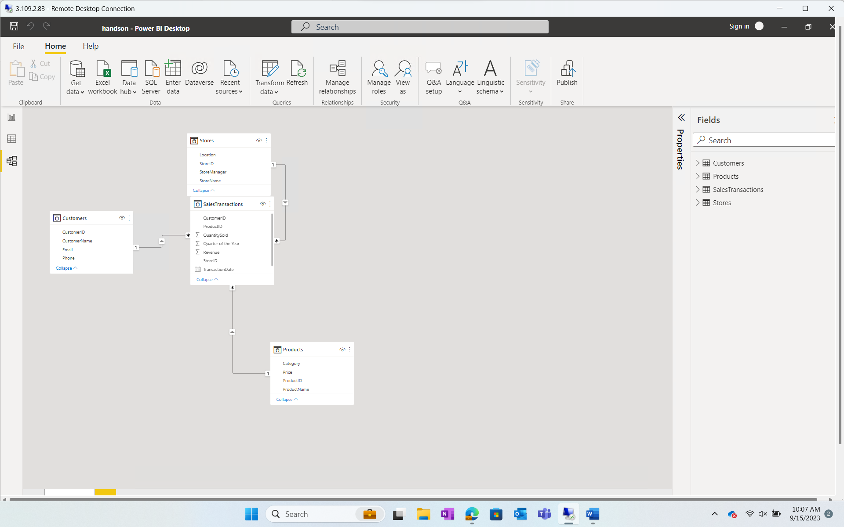
* 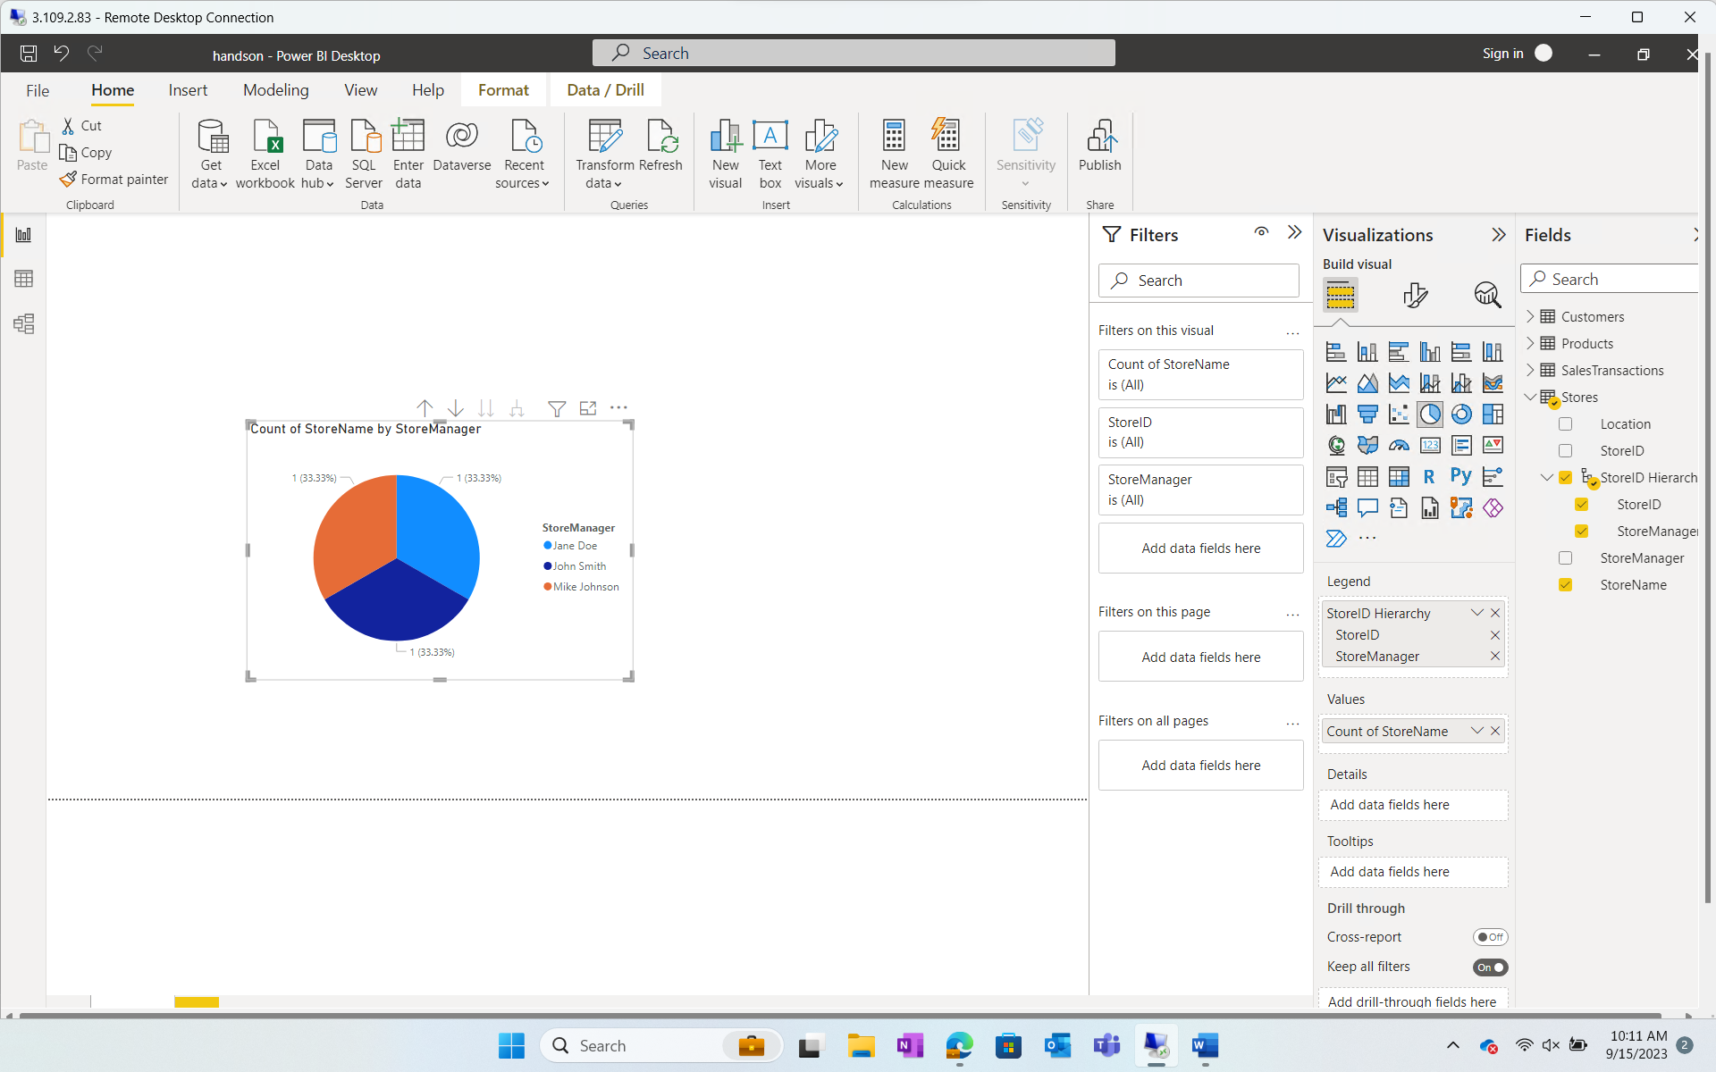

Step 4) Business Queries and Analysis

* 1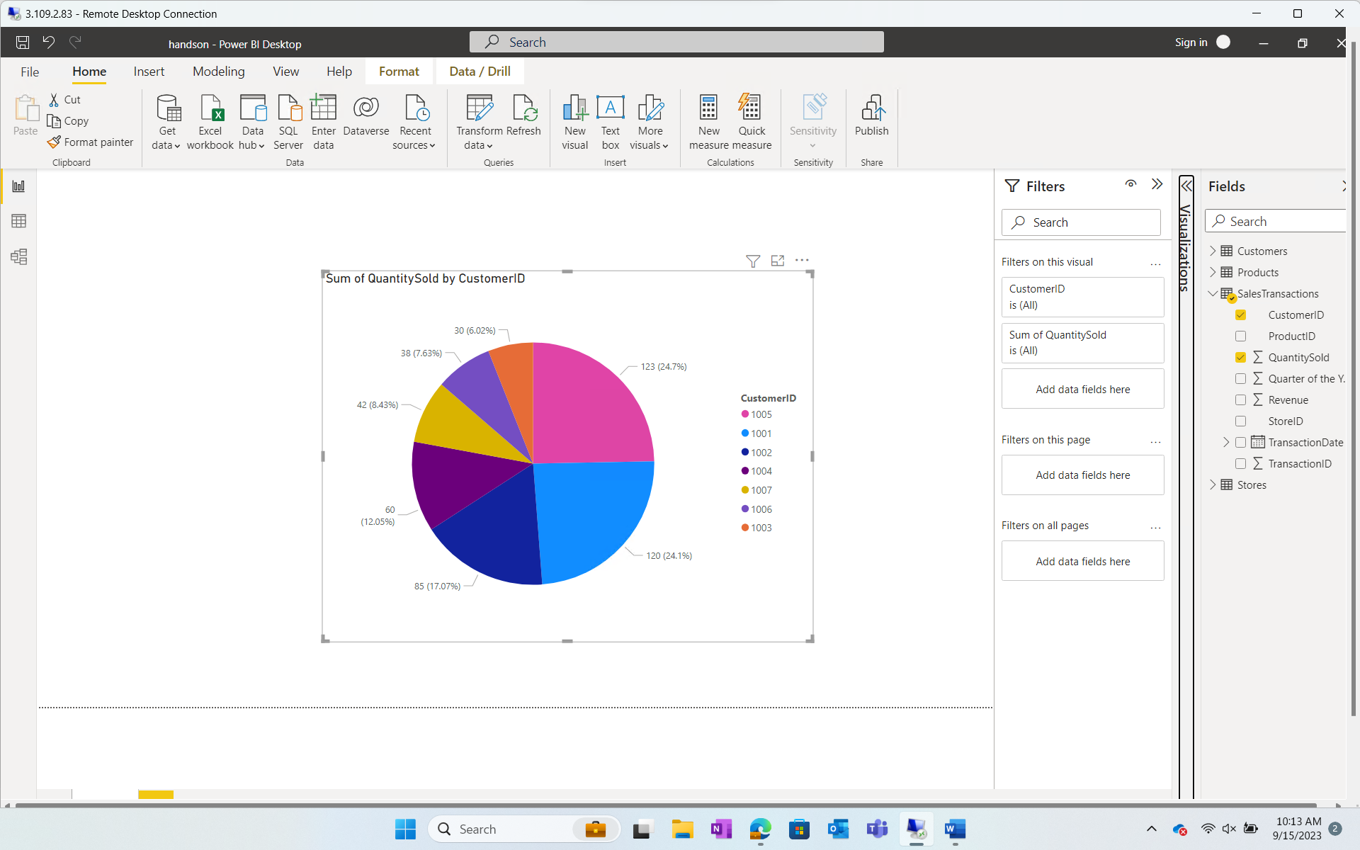
* 2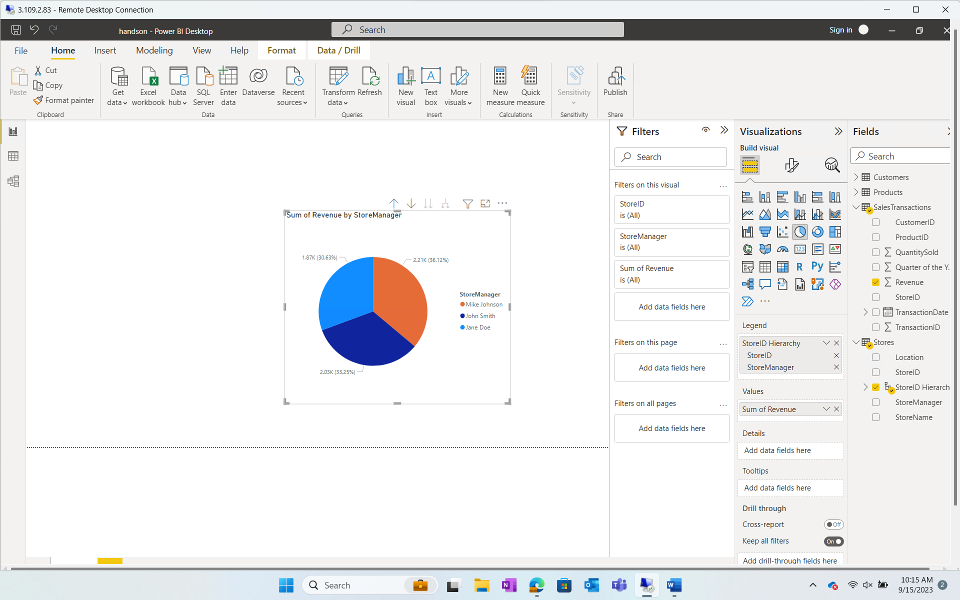
* 3,4,5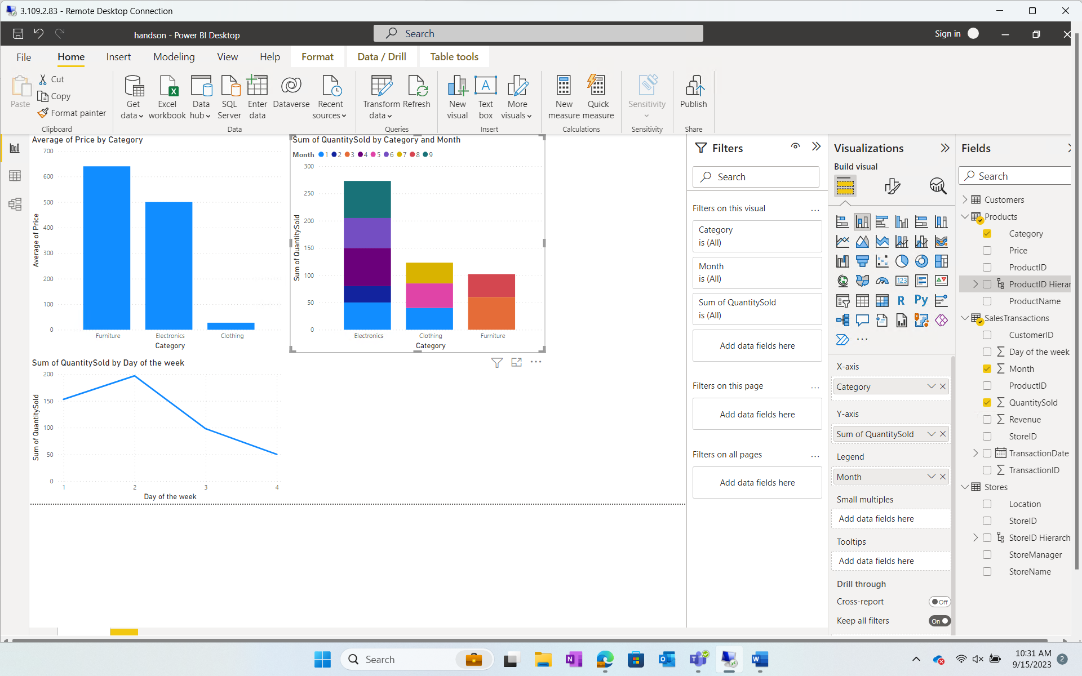
* 6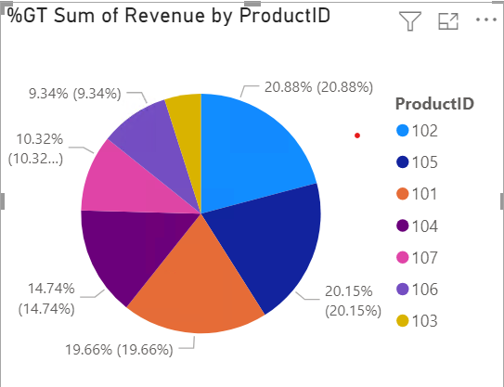
* 8 A pie chart with numbers and a pie chart

  Description automatically generated
* 9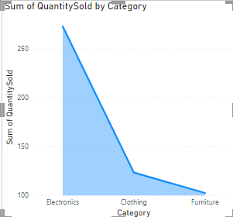
* 10A graph of a bar chart

  Description automatically generated

Step 5)

* Tuesday has the highest sale. 
* As the sales of electronics good are the highest, and customer buy the most between price ranges 15-800, the company should release more electronics products in that range.  
  there should be more sales on Tuesday and on the months when sales are the highest i.e. 4th and 9th months.

