MyHomeBase
Strategic Evaluation — Pivot Decision
Keep the marketplace · Pivot to a Home OS · or Hybrid
Independent analysis — 3 parallel agents + direct review, cross-evaluated. No bias, no ego, no sunk-cost reasoning.
BOTTOM LINE

Recommendation: Option C — but NOT the investor's version
Do not pivot the company. Keep the marketplace as the business and revenue engine. Take the investor's two genuinely valuable insights — that cold-start is your real risk, and that a 'what to fix' layer can generate demand — and apply them as a lightweight feature, not a new product sold to builders.
All three independent agents and the direct review converged on the same answer, separately. The decisive fact: the near-exact product the investor describes already existed (Centriq), won the homebuilder industry's 'Game Changer' award — the builder validation his thesis depends on — ran for a decade, and shut down in 2026. The experiment has already been run, with a known negative result.

What the investor gets RIGHT (take this)
- Cold-start liquidity is your true existential risk. He named it correctly — two founders building both supply and demand with little marketing budget is the hardest problem in startups.
- Builder-funded distribution is a real way to acquire homeowners at near-zero CAC. The distribution insight is genuinely good.
- A 'what to fix' layer is a legitimate demand-generation instrument for the marketplace — every 'your HVAC filter is due' is a qualified booking trigger.

What the investor gets WRONG (discard this)
- The exact product already died. Centriq (home-document ingestion + memory + reminders) won the NAHB builder award and still shut down in 2026, citing the home-services market. Surviving apps (HomeZada, Homer, Dwellin) are sub-scale with free tiers as the pricing floor — a market signalling low willingness-to-pay.
- The 'HOA-fee norm' is wishful. HOA fees are legally embedded in the deed and lien-enforceable; an app subscription is a discretionary opt-in. The honest analog is freemium-to-paid conversion (~2-5%, lower for consumer) — the year-2 'homeowner pays' moment is a churn cliff where the entire revenue thesis lives.
- Weak standalone moat. 'Chat with your home documents' is a thin RAG wrapper — cheap to copy. The builder channel is already owned by entrenched ERP vendors (Constellation, ECI — 'over half of the top 200 builders run on ECI'). A 2-person pre-revenue team can't win that enterprise motion.
- A full pivot discards most of what makes HomeBase differentiated (booking, check-in, trust, provider network) and keeps mostly commodity infrastructure.
- His incentives aren't neutral. PE values predictable, contracted recurring B2B revenue — the builder-SaaS framing is optimized for his return model. Take the insight; discount the revenue-model story.

THE THREE OPTIONS, SCORED

Option Scorecard
Scored across the factors that actually determine survival for a 2-person, pre-revenue, low-budget team.
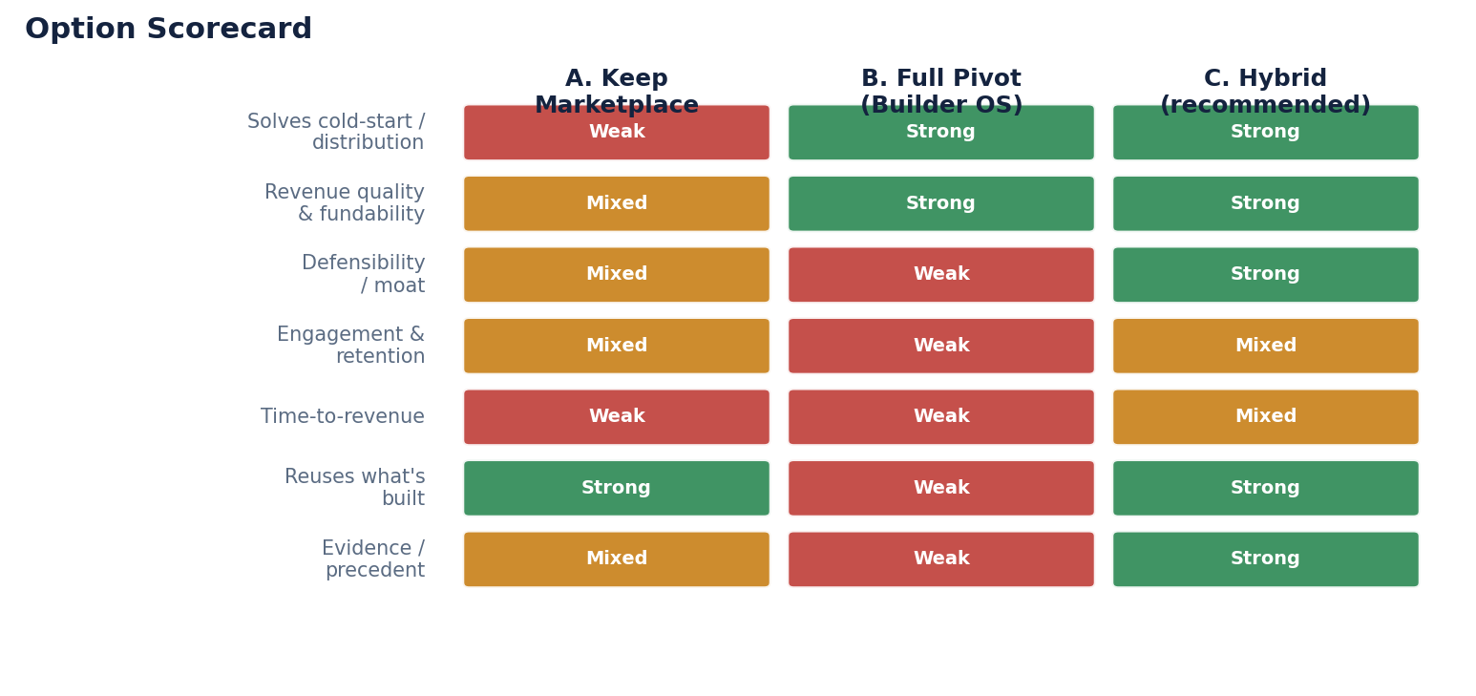
Read: Option A (keep marketplace) is strong on reuse but weak on the one thing that's killing it — distribution. Option B (full pivot) looks strong on revenue but is weak on defensibility, engagement, reuse, and — decisively — precedent. Option C captures B's distribution/revenue upside while keeping A's reuse and a real moat.

Option A — Keep the marketplace as-is
Pros: Differentiation that aligns with where the market is forced to go (Angi's 2025 shift to homeowner-choice). Recurring lawn/cleaning is the rare home-services niche with real repeat frequency and compounding LTV. 100% of engineering transfers.
Cons: Two-sided cold-start with no marketing budget is the documented killer. Take-rate revenue accrues slowly and trades at lower multiples than SaaS. The most likely failure mode is a slow death by liquidity.

Option B — Full pivot to builder-funded Home OS
Pros: Builder distribution solves consumer CAC on paper. SaaS revenue is more fundable, and signed builder LOIs are real pre-seed currency.
Cons: The exact product already failed (Centriq). Year-2 homeowner conversion is a cliff (~2-5%). Long enterprise builder sales (6-18 mo) against ERP incumbents burn runway before any revenue. Thin RAG moat. Builder concentration risk. Discards the differentiated build.

Option C — Hybrid (recommended)
Pros: Keeps the working, monetizable marketplace as the spine. Adds a 'home memory' layer built from STRUCTURED data you already capture (completed jobs, appliances serviced, history) — not messy-PDF RAG — sidestepping the hallucination/liability problem. Reuses the most. Feeds the data flywheel. Manufactures demand from existing users instead of buying it.
Cons: Splits a 2-person team's focus if done in parallel — so it must be sequenced, not simultaneous.

WHY C, NOT A OR B

The Risk Asymmetry
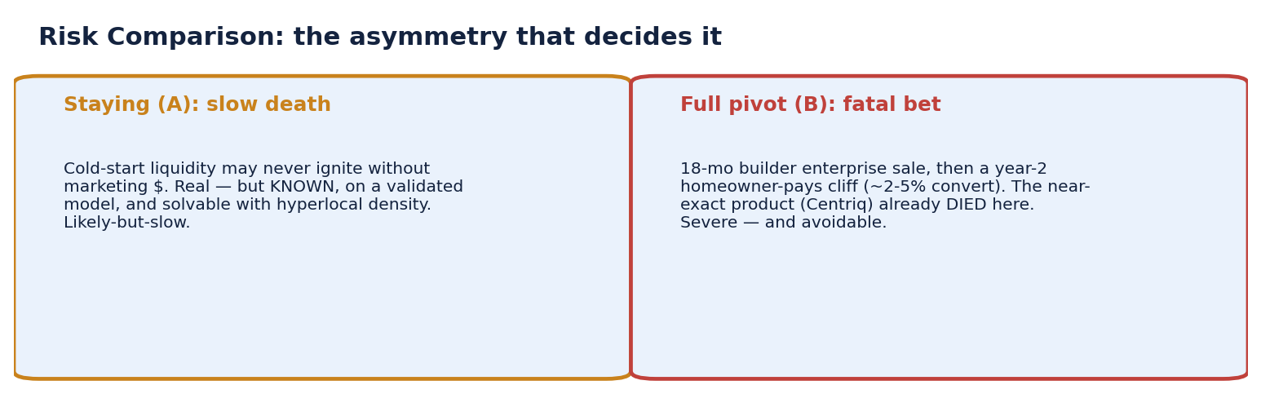
The decision in one line: staying risks a slow death on a validated model (solvable with hyperlocal density); the full pivot risks a fatal, avoidable bet on an assumption the market has already falsified. C neutralizes staying's risk (it manufactures demand) without taking on the pivot's risk (builder enterprise sales + the year-2 cliff).
THE PATH

Recommended Sequence
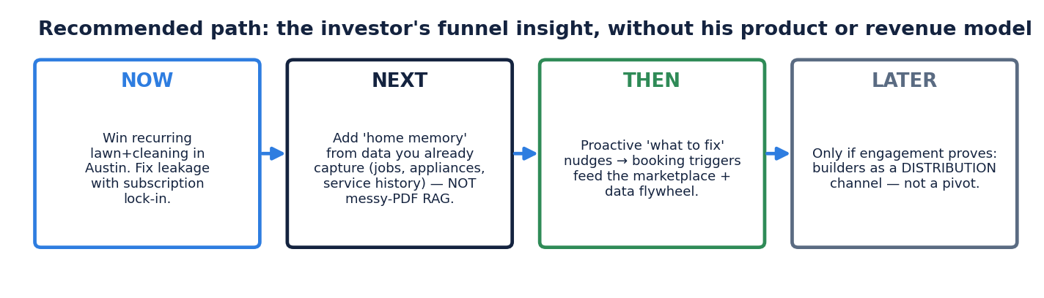

Concretely
- NOW: Double down on recurring lawn + cleaning in Austin. Solve cold-start with hyperlocal supply density and neighborhood distribution (Nextdoor/HOA partnerships as a CHANNEL — the one place 'HOA' is useful to you). Fix leakage with subscription lock-in and in-app payment stickiness.
- NEXT: Auto-build a lightweight home profile from data you already capture — services performed, appliances touched at check-in, photos, service history. Structured data, not document-ingestion RAG. Cheap, reuses storage + Haiku, no liability exposure.
- THEN: Turn proactive 'what to fix' nudges into booking triggers that feed the marketplace and the completion-data flywheel. This is the investor's funnel thesis taken to its defensible conclusion — demand-gen from your own users.
- LATER (only if engagement proves out): test builders as a DISTRIBUTION channel, and let users optionally add documents as enrichment — never as the gate to value. This is a Phase-4 experiment, not a Phase-1 pivot.

Honest note on sunk cost
This recommendation does not rest on sunk cost — it wins on forward economics. But for the record: under C, almost everything built transfers (Supabase/RLS, Stripe Connect, messaging, provider onboarding/verification, trust scores, crew accounts, and especially the check-in widget + completion-ledger/demand-events hooks). Under a full pivot (B), most of the differentiated, marketplace-specific build sits idle. C wastes the least — but the decision would be the same even if it wasted more.
METHOD

How this conclusion was reached
Three agents evaluated the decision independently and in parallel — one through a market/competition/GTM lens, one through business/economics/funding, one through product/behavior/technical feasibility — each fed full app context and instructed to research competitors and trends and to be critical of BOTH the existing idea and the pivot. A separate direct review ran alongside. All four arrived at Option C, and at the same load-bearing evidence (the Centriq precedent, the HOA-fee fallacy, the thin-RAG moat), without coordinating. Independent convergence on the same answer raises confidence it is right.
Sources: Centriq shutdown (TidyBoss; Real Estate Ledger; Dib). Angi Q3 2025 8-K (SEC). Frontdoor (Tracxn; BusinessWire). Builder portals (Constellation; ECI). Freemium conversion (Userpilot; FirstPageSage). SaaS vs. marketplace multiples (Aventis; Maxio). Home-app pricing/WTP (HomeZada; NewHomeSource).

