Overcoming roadway sensors

Date

## Gps

The Global Positioning System (GPS) is a space-based satellite navigation system that provides location and time information in all weather conditions, anywhere on or near the Earth where there is an unobstructed line of sight to four or more GPS satellites.

## Disadvantages of GPs vehicle tracking system

Location Inaccuracy & Drifting

GPS receivers rely on signals from at least four satellites. If they only connect with three, the positioning is not entirely accurate. When obstacles such as walls, buildings, skyscrapers, and trees obstruct a signal, problems can arise.

Geomagnetic storms and other extreme atmospheric conditions can also cause problems. Furthermore, the mapping technology used in conjunction with the GPS may be inaccurate or out of date, resulting in navigational errors.

Poor Signal & Battery Life Concerns

Relying solely on GPS can be problematic if there is a signal failure or you are using a battery-powered device that runs out of power (GPS devices are almost always power-hungry). Unless you have a backup plan, such as hard copy maps, you could easily get lost and have no idea which way to go.

Incorrect Routes

Another issue is that the position can be significantly off at times, especially when the number of satellites is limited. Satellites use atomic clocks, which are very precise, but there are sometimes discrepancies and thus time measurement errors. The satellites must preserve their predefined orbital positions, but gravitational pulls (from the earth, moon, and sun) do occur.

Unhappy Employees

One of the disadvantages of a GPS vehicle tracking system is that while many employees will understand the need for fleet management software or a vehicle tracking system, others may find it difficult to work with. Why? They may believe that their privacy is being infringed upon. But, in the workplace, keeping track of all events is beneficial in the long run, right?

That is precisely what some employees find difficult to believe and, as a result, resist using the GPS tracker. Although it is uncommon, they may perceive the devices as an incursion of their privacy or autonomy.

Distracted Driving

GPS devices are, by definition, distracting. In theory, they will relay audio instructions to you, and all you have to do is glance over at the map from time to time. In practice, however, you may end up fiddling with your smartphone or other devices while driving, attempting to change the destination, enter data, or change other settings. It’s a recipe for disaster.

Privacy & Data Concerns

Without their knowledge, GPS devices can be used to track people. A device, for example, can be installed in a car to track the victim’s location at all times. This method can also be used to aid in nefarious and criminal activities such as stalking, breaking and entering kidnapping, and even murder.

Over Dependency

When travelling, local knowledge is extremely valuable. If you rely solely on GPS technology, you may miss out on information that could be useful for your journey. For example, whether a stretch of road is prone to flooding or other hazards at certain times of day, whether there are any scenic views, or whether the road is closed for any reason, such as drawing bridges or railway crossings.

## Existing ROADWAY SENSORS

An effective (and often extensive) traffic surveillance and monitoring system is a pre-requisite for any intelligent traffic control system to keep track of prevailing conditions across the network. A wide range of different sensors are installed in, on and above the roadway for this purpose and to obtain the necessary geographical and critical time coverage. They include inductive loops, non-intrusive traffic detection devices, video cameras and video image processing. Each technology has its own advantages and shortcomings – so the choice of sensor type for any ITS application will depend on what performs well in the prevailing environmental conditions, and its cost.

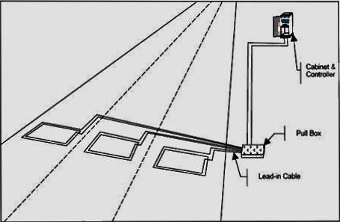

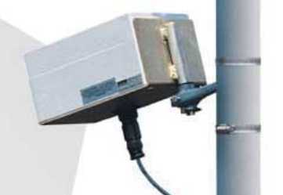

## Draw backs of road way sensors

This limitation makes it difficult to get a full picture of traffic flow in a particular area. 2. Weather Conditions: Vehicle detection systems can be affected by adverse weather conditions such as heavy rain, snow, and fog. This interference can affect the accuracy of the data collected.

## Overcoming Roadway Sensors Limitations with Proton's Road Mapping Technology

Google Maps is an excellent navigation tool, but it has limitations, particularly in areas with poor cellular service, high terrain roads, hairpins, and slanted roads. Moreover, Google Maps doesn't provide real-time road condition updates, which can change significantly over time due to weather conditions and infrastructure issues.

To address these challenges, Proton's road mapping sensors offer a comprehensive solution. These sensors include:

1. Depth sensors using ultrasonic sound waves to detect road banking and connections.

2. Moisture and weather sensors to monitor road conditions (wet, slippery, or dry).

3. Road railing connectivity sensors to detect obstacles or obstructions.

These sensors work in conjunction with a unit installed in each vehicle, providing real-time updates on road conditions, obstacles, and surrounding vehicles. This technology enhances safety by:

- Detecting blind spots, especially in hairpin turns

- Providing real-time soil moisture and movement indications, warning of potential landslides

- Enabling seamless navigation through challenging roads

To further improve this technology:

- Increase sensor accuracy and reliability

- Enhance data processing and transmission speeds

- Expand sensor coverage to more roads and areas

- Integrate with other safety features, such as emergency services and vehicle control systems

- Develop user-friendly interfaces for drivers to easily interpret sensor data

By advancing Proton's road mapping sensors, we can significantly enhance road safety, reduce accidents, and improve overall driving experiences.

By

PROTONS

S5 EEE