**DOCUMENTO DE MODELO**

**DE DATOS**

**TU APP RECICLA**

**John Alexander Pineda**

**Lina María Cortés**

**Historia de revisiones**

|  |  |  |  |
| --- | --- | --- | --- |
| **Fecha** | **Versión** | **Descripción** | **Autor** |
| **13/08/18** | **0.1** | **Descripción de requisitos funcionales y no funcionales** | **Lina Cortés** |

**MODELO ENTIDAD RELACIÓN**

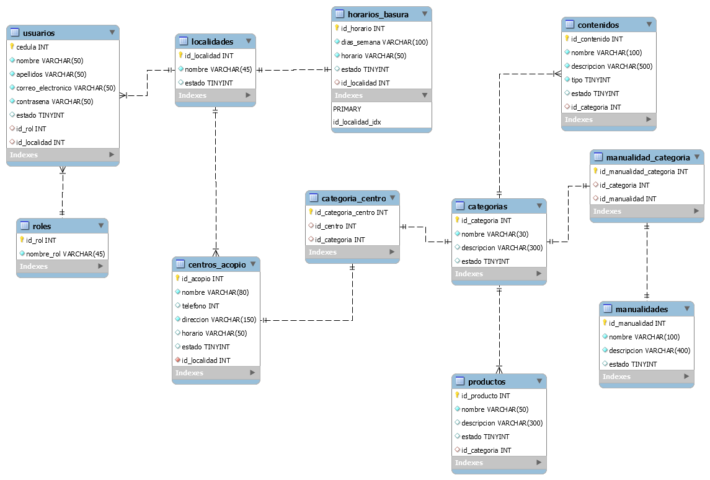

**DICCIONARIO DE DATOS**

## categoria_centro

|  |  |  |  |  |
| --- | --- | --- | --- | --- |
| Columna | Tipo | Nulo | Predeterminado | Comentarios |
| id_categoria_centro | int(11) | No |  |  |
| id_centro | int(11) | Sí | *NULL* |  |
| id_categoria | int(11) | Sí | *NULL* |  |

### Índices

|  |  |  |  |  |  |  |
| --- | --- | --- | --- | --- | --- | --- |
| Nombre de la clave | Tipo | Único | Columna | Cardinalidad | Cotejamiento | Nulo |
| PRIMARY | BTREE | Sí | id_categoria_centro | 0 | A | No |
| id_categoria | BTREE | No | id_categoria | 0 | A | Sí |
| id_centro | BTREE | No | id_centro | 0 | A | Sí |

## categorias

|  |  |  |  |  |
| --- | --- | --- | --- | --- |
| Columna | Tipo | Nulo | Predeterminado | Comentarios |
| id_categoria | int(11) | No |  |  |
| nombre | varchar(30) | No |  |  |
| descripcion | varchar(300) | Sí | *NULL* |  |
| color | varchar(50) | No |  |  |
| estado | tinyint(4) | Sí | 1 |  |

### Índices

|  |  |  |  |  |  |  |
| --- | --- | --- | --- | --- | --- | --- |
| Nombre de la clave | Tipo | Único | Columna | Cardinalidad | Cotejamiento | Nulo |
| PRIMARY | BTREE | Sí | id_categoria | 10 | A | No |

## centros_acopio

|  |  |  |  |  |
| --- | --- | --- | --- | --- |
| Columna | Tipo | Nulo | Predeterminado | Comentarios |
| id_acopio | int(11) | No |  |  |
| nombre | varchar(80) | No |  |  |
| telefono | int(11) | Sí | *NULL* |  |
| direccion | varchar(150) | No |  |  |
| horario | varchar(50) | Sí | *NULL* |  |
| estado | tinyint(4) | Sí | 1 |  |
| id_localidad | int(11) | No |  |  |

### Índices

|  |  |  |  |  |  |  |
| --- | --- | --- | --- | --- | --- | --- |
| Nombre de la clave | Tipo | Único | Columna | Cardinalidad | Cotejamiento | Nulo |
| PRIMARY | BTREE | Sí | id_acopio | 0 | A | No |
| id_localidad | BTREE | No | id_localidad | 0 | A | No |

## contenidos

|  |  |  |  |  |
| --- | --- | --- | --- | --- |
| Columna | Tipo | Nulo | Predeterminado | Comentarios |
| id_contenido | int(11) | No |  |  |
| nombre | varchar(100) | No |  |  |
| descripcion | varchar(500) | No |  |  |
| tipo | tinyint(4) | No |  |  |
| estado | tinyint(4) | Sí | 1 |  |
| id_categoria | int(11) | Sí | *NULL* |  |

### Índices

|  |  |  |  |  |  |  |
| --- | --- | --- | --- | --- | --- | --- |
| Nombre de la clave | Tipo | Único | Columna | Cardinalidad | Cotejamiento | Nulo |
| PRIMARY | BTREE | Sí | id_contenido | 0 | A | No |
| id_categoria | BTREE | No | id_categoria | 0 | A | Sí |

## horarios_basura

|  |  |  |  |  |
| --- | --- | --- | --- | --- |
| Columna | Tipo | Nulo | Predeterminado | Comentarios |
| id_horario | int(11) | No |  |  |
| dias_semana | varchar(100) | No |  |  |
| horario | varchar(50) | No |  |  |
| estado | tinyint(4) | Sí | 1 |  |
| id_localidad | int(11) | Sí | *NULL* |  |

### Índices

|  |  |  |  |  |  |  |
| --- | --- | --- | --- | --- | --- | --- |
| Nombre de la clave | Tipo | Único | Columna | Cardinalidad | Cotejamiento | Nulo |
| PRIMARY | BTREE | Sí | id_horario | 0 | A | No |
| id_localidad | BTREE | No | id_localidad | 0 | A | Sí |

## localidades

|  |  |  |  |  |
| --- | --- | --- | --- | --- |
| Columna | Tipo | Nulo | Predeterminado | Comentarios |
| id_localidad | int(11) | No |  |  |
| nombre | varchar(45) | No |  |  |
| estado | tinyint(4) | Sí | 1 |  |

### Índices

|  |  |  |  |  |  |  |
| --- | --- | --- | --- | --- | --- | --- |
| Nombre de la clave | Tipo | Único | Columna | Cardinalidad | Cotejamiento | Nulo |
| PRIMARY | BTREE | Sí | id_localidad | 0 | A | No |

## manualidad_categoria

|  |  |  |  |  |
| --- | --- | --- | --- | --- |
| Columna | Tipo | Nulo | Predeterminado | Comentarios |
| id_manualidad_categoria | int(11) | No |  |  |
| id_categoria | int(11) | Sí | *NULL* |  |
| id_manualidad | int(11) | Sí | *NULL* |  |

### Índices

|  |  |  |  |  |  |  |
| --- | --- | --- | --- | --- | --- | --- |
| Nombre de la clave | Tipo | Único | Columna | Cardinalidad | Cotejamiento | Nulo |
| PRIMARY | BTREE | Sí | id_manualidad_categoria | 0 | A | No |
| id_categoria | BTREE | No | id_categoria | 0 | A | Sí |
| id_manualidad | BTREE | No | id_manualidad | 0 | A | Sí |

## manualidades

|  |  |  |  |  |
| --- | --- | --- | --- | --- |
| Columna | Tipo | Nulo | Predeterminado | Comentarios |
| id_manualidad | int(11) | No |  |  |
| nombre | varchar(100) | No |  |  |
| descripcion | varchar(400) | No |  |  |
| estado | tinyint(4) | Sí | 1 |  |

### Índices

|  |  |  |  |  |  |  |
| --- | --- | --- | --- | --- | --- | --- |
| Nombre de la clave | Tipo | Único | Columna | Cardinalidad | Cotejamiento | Nulo |
| PRIMARY | BTREE | Sí | id_manualidad | 0 | A | No |

## productos

|  |  |  |  |  |
| --- | --- | --- | --- | --- |
| Columna | Tipo | Nulo | Predeterminado | Comentarios |
| id_producto | int(11) | No |  |  |
| nombre | varchar(50) | No |  |  |
| descripcion | varchar(300) | Sí | *NULL* |  |
| estado | tinyint(4) | Sí | 1 |  |
| id_categoria | int(11) | Sí | *NULL* |  |

### Índices

|  |  |  |  |  |  |  |
| --- | --- | --- | --- | --- | --- | --- |
| Nombre de la clave | Tipo | Único | Columna | Cardinalidad | Cotejamiento | Nulo |
| PRIMARY | BTREE | Sí | id_producto | 10 | A | No |
| id_categoria | BTREE | No | id_categoria | 10 | A | Sí |

## roles

|  |  |  |  |  |
| --- | --- | --- | --- | --- |
| Columna | Tipo | Nulo | Predeterminado | Comentarios |
| id_rol | int(11) | No |  |  |
| nombre_rol | varchar(45) | No |  |  |

### Índices

|  |  |  |  |  |  |  |
| --- | --- | --- | --- | --- | --- | --- |
| Nombre de la clave | Tipo | Único | Columna | Cardinalidad | Cotejamiento | Nulo |
| PRIMARY | BTREE | Sí | id_rol | 4 | A | No |

## usuarios

|  |  |  |  |  |
| --- | --- | --- | --- | --- |
| Columna | Tipo | Nulo | Predeterminado | Comentarios |
| cedula | int(11) | No |  |  |
| nombre | varchar(50) | No |  |  |
| apellidos | varchar(50) | No |  |  |
| correo_electronico | varchar(50) | No |  |  |
| contrasena | varchar(50) | No |  |  |
| estado | tinyint(4) | Sí | 1 |  |
| id_rol | int(11) | Sí | *NULL* |  |
| id_localidad | int(11) | Sí | *NULL* |  |

### Índices

|  |  |  |  |  |  |  |
| --- | --- | --- | --- | --- | --- | --- |
| Nombre de la clave | Tipo | Único | Columna | Cardinalidad | Cotejamiento | Nulo |
| PRIMARY | BTREE | Sí | cedula | 2 | A | No |
| id_rol | BTREE | No | id_rol | 2 | A | Sí |
| id_localidad | BTREE | No | id_localidad | 2 | A | Sí |