**User Manual**

1. Start Menu
   1. Upon starting the application the user will be directed to the Main Menu. In the Main Menu the user has four different options: play the game, quit the game, play in test mode, and read the manual.
   2. Clicking **Play** will direct the user to the Input Name scene.
   3. Clicking **Quit** will exit the application.
   4. Clicking **Test** will enter the test mode.
   5. Clicking **Manual** will open the manual.

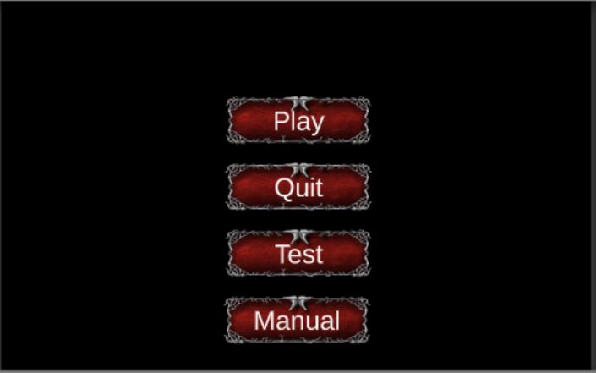

1. Input Name
   1. After clicking **Play** in the Start Menu, the user can input their name.
   2. Upon submitting a name, the user will be directed to the Player Selection scene.

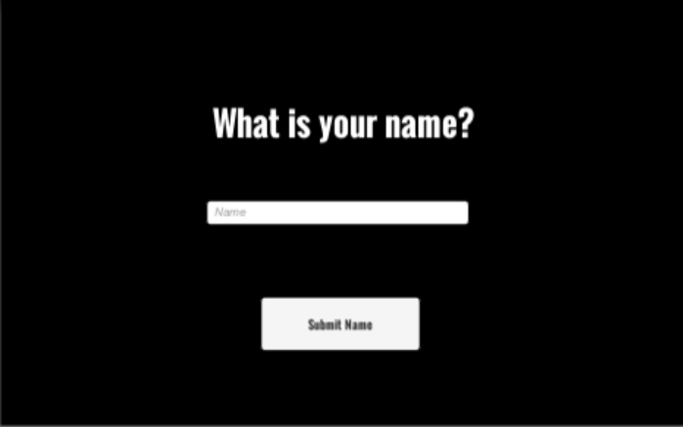

1. Player Selection
   1. The user can choose from two different characters to play the game as.
   2. Upon selecting a character, the game will start at Level 1.

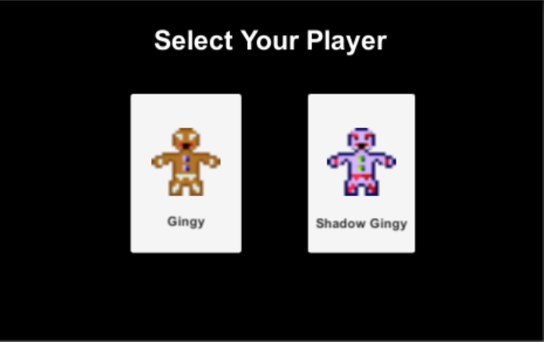

1. Enemies
   1. Muffin Man
      1. The main enemy in the game.
      2. The starting number of enemies is equal to the current level.
   2. Jack
      1. A stronger enemy that only appears once every five levels.
      2. The number of this enemy is equal to the current level divided by five.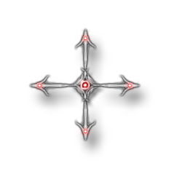
2. Joystick
   1. The user can move the joystick in any direction to move the character
3. Attack
   1. The attack button causes the user’s character to attack.
   2. If the character is in range of an enemy, the attack will deal damage.
4. Level Progression
   1. The level will end when all enemies on a level are defeated.
   2. The next level will automatically load upon completion of the previous level.
5. Items
   1. Health Item
      1. Health Items (red candy) will give OR take up to 50 health.
   2. Attack Item
      1. Attack Items (yellow candy) will give an attack bonus from 30% to 100% that lasts a duration from 10 to 30 seconds.
   3. Invincibility Item
      1. Invincibility Items (blue candy) will make the user’s character invincible for a duration from 10 to 30 seconds.
6. Game Over
   1. The game will end when the user’s character is defeated.
   2. The user will be directed to the Game Over scene and the Leaderboard.



1. Pause Menu
   1. Pressing the pause button will take the user to the pause menu.
   2. In the pause menu, the game is paused and the user can decide whether to resume the game or return to the Main Menu.

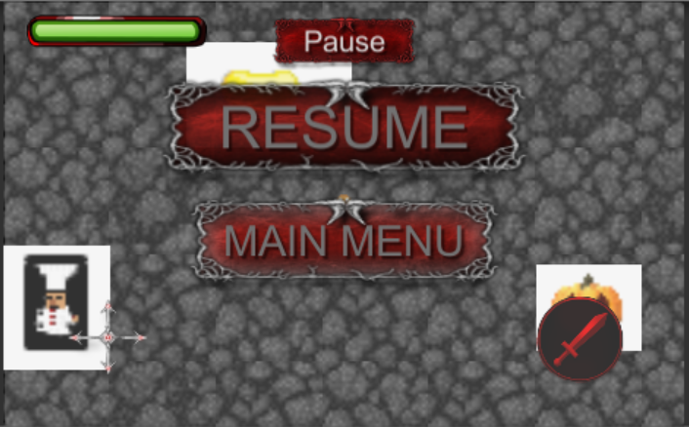

1. Test Mode
   1. Test Mode allows the user to freely test each aspect of the game.
   2. There are icons for each item and enemy that the character can run over.
   3. Upon doing so, the specific enemy/item will spawn randomly on the map.

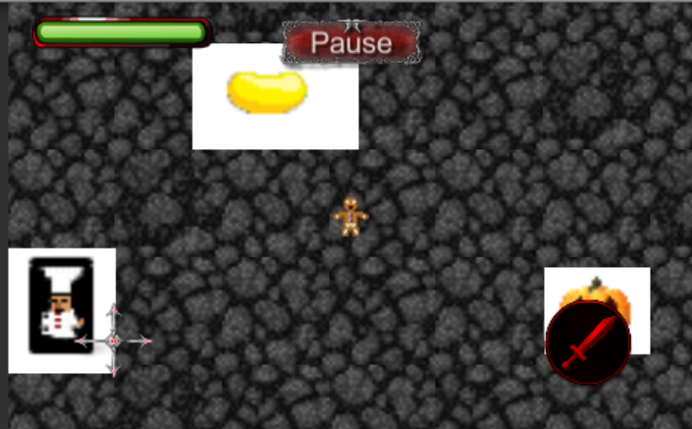

1. Manual
   1. The manual gives a brief description of each item and enemy in the game.
   2. The user can then use the back button to return to the main menu.

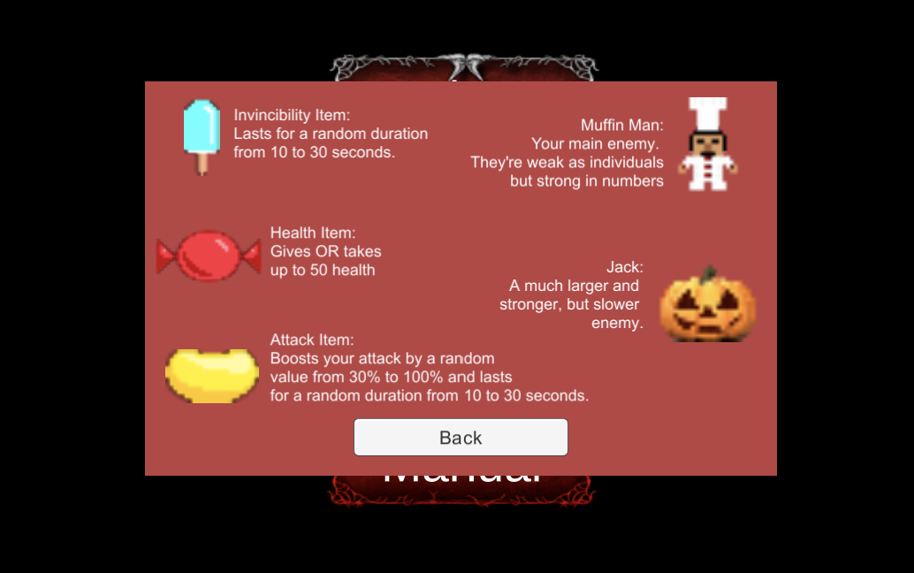

1. Leaderboard
   1. The leaderboard displays the top performances on the device.
   2. The leaderboard displays the rank, name of user, highest level, and duration of gameplay.
   3. The user can decide to return to the Main Menu or quit the application.

