Integrated information phi in flies reduces under anaesthesia

Angus Leung

Word Count:

A paper submitted in partial fulfilment of the requirements of the degree of

*Bachelor of Science (Honours)*

*School of Psychological Sciences, Monash University*

*[Month, 2017]*Table of Contents

Abstract 4

Statement of Contribution 5

CHAPTER 1: INTRODUCTION 6

The Integrated Information Theory of Consciousness 6

The Fly Model for Studying Consciousness 11

Aims and Hypotheses (in a separate section?) 12

CHAPTER 2: EXPERIMENTAL METHODS AND RESULTS 14

Method 14

Experimental Procedure 14

Animal preparation. 14

Electrode probe insertion. 14

Isoflurane delivery. 15

Experimental protocol. 15

Local field potential preprocessing. 15

Φ Computation 16

Discretisation. 16

Network Selection. 16

Transition Probability Matrix Construction. 16

Φ calculation. 17

Φ* Computation 18

Data Analysis 19

Phi-3. 19

Feedback. 19

Phi-*. 20

Results 21

Integrated information is reduced under isoflurane 21

Equal likelihood of feedback MIP cuts under isoflurane 22

Phi-star is moderately correlated with phi-3 23

CHAPTER 3: DISCUSSION AND CONCLUSION 25

CHAPTER 4: REFERENCES 26

# Abstract

Blardiblarblar

# Statement of Contribution

|  |  |
| --- | --- |
| Signed: |  |
|  | Angus Leung |

Date: /2017

# **CHAPTER 1: INTRODUCTION**

A key focus in neuroscientific research on consciousness has been to find how consciousness arises from neural activity in the brain. In this context, consciousness refers to subjective experience, or “what it is like to be” {Thomas Nagel}. The primary approach with which to tackle this question has generally been to search for neural activities and interactions which correlate with consciousness – to search for the neural correlates of consciousness (NCC; {Koch, 2016 #12}). However, correlates alone cannot provide an explanation as to how consciousness arises. In order to understand how consciousness comes to be, testable theories which address what consciousness is and what physical interactions it requires are needed. Integrated information theory (IIT; ) is one theory which has risen to provide a such a principled account of consciousness.

## The Integrated Information Theory of Consciousness

<Philosophical stuff>Consciousness is one hard problem. Conceptually, it is the capacity to have subjective experience, or, to paraphrase Thomas Nagel, it is “what it is like to be”. This idea of consciousness is distinct from other terms {from Klein 2016} which might also be termed consciousness, such as self-awareness/self-consciousness {}, high-order thoughts {}, or reportable access to one’s own experience {}. Thus, a system which is conscious has an experience “of itself”, and a system which is unconscious does not. Despite being just as prevalent as any other phenomenon (arguably more prevalent, as the only way to be experience any phenomenon is to, well, experience it), we still lack an understanding of how consciousness arises from physical neural activity.

<Prevalence of reductionism>The prevalent method with which to approach this question has been to search for and study the NCC. Within this approach, researchers focus either only on finding NCCs for levels of consciousness (the minimally sufficient conditions for a creature’s overall conscious level, such as wakefulness as opposed to dreamless sleep) or for contents of consciousness (the minimally sufficient conditions for a specific conscious perception, such as of that of a face or the colour red). This search has led to the proposal of numerous specific neural interactions as potential NCC, such as synchronous activation among neurons {Engel, 2001 #18}, 40 Hz oscillations in the cerebral cortex {Llinás, 1993 #58}, or feedback interactions {Lamme, 2010 #30} for the level of consciousness, and activation of the fusiform face area during face perception {Pierce, 2001 #57} for the contents of consciousness. However the reliability of these correlates as indicators of consciousness is debatable. For example, synchronous activity and feedback interactions both occur in the cerebellum {Person, 2012 #19;Witter, 2016 #29}, which likely does not contribute to consciousness {Yu, 2015 #20}, while the fusiform face area is activated during perception of non-face stimuli {see PSY4270 essay}. Additionally, these correlates lose relevance in contexts involving brain damage, non-human animals, and artificial systems. It is also increasingly clear that this split approach to studying consciousness has significant drawbacks. Namely, the search for content NCCs presumes consciousness in a system, and the search for level NCCs … {Hohwy, 2009 #32}. More critically, while informative as to the kind of structures and interactions which cause consciousness, correlates leave an explanatory gap between physical interactions and the rise of consciousness. In order to address this gap, a theory of consciousness which identifies the key principles of consciousness and how they are achieved through interactions is required.

<Discussion of other theories>… Though the search for correlates in this manner continues, given the limitations of NCCs there has recently been a stronger emphasis on approaching the problem using a more theoretical perspective in order to target both level and contents simultaneously {Hohwy, 2009 #32}. Accordingly, a number of theories of consciousness have been proposed, such as the global workspace theory {Baars, 1997 #4;Baars, 2002 #5}, cross-order integration theory {Kriegel, 2007 #59}, … A common concept in such theories is the concept of integration (whether it be between/across x in theory X, or between y in theory Y). A common approach in building these theories is to build from interactions which have been identified as potential NCCs. Thus, the limitation of specificity to vertebrates extends to these theories. Furthermore, though they provide predictions as to what kinds of biological systems may give rise to consciousness, they however provide no measure of consciousness itself.

<Intro to IIT>IIT stands out from the other theories by taking a different approach. Instead of building a theory from observed neural activities, IIT identifies fundamental aspects of consciousness, and from these reasons the necessary mechanisms for it. The fundamental properties it identifies are as follows: (a) intrinsic existence: an experience exists, and furthermore it exists from its own intrinsic perspective, independent of external observers; (b) composition: an experience is composed of multiple aspects (for example, the experience of watching a movie is composed of vision and audition, and the experience of a face is composed of eyes, a nose, etc.); (c) information: an experience rules out every other possible experience that could be occurring; (d) integration: an experience exists as a single whole which cannot be broken into parts; and (e) exclusion: an experience cannot be superposed with other experiences (consciousnesses cannot overlap). From these principles, it builds a measure, integrated information Φ, whose magnitude and structure are equivalent respectively to the level of consciousness in a system and its contents.

<Concept of phi>The raw concept of Φ can be understood from the principles of information and integration. Information (I) can be understood as a reduction in uncertainty. For example, a simple neuron at any time may have one of two states: firing or not firing. As the neuron can take one of multiple (two) states, there is inherent uncertainty (“entropy”) as to which state it is in at any time. However, if we were to consider a second simple neuron and its connection with the first (e.g. the first neuron fires at time *t* if the second neuron was firing at *t* - 1), knowing the state of the second neuron at time *t* - 1 would allow us to deduce the state of the first neuron at *t*, reducing the set of possible states it could take at that timepoint (from two states to one). Similarly, knowing the state of the first neuron at time *t* would reduce the possible states of the second neuron at time *t* - 1.This reduction in uncertainty is information. Integration (O) refers to what exists only when considering a system as a whole - in this example, the two neurons and their connection. If the system of two neurons is split into independent parts, each consisting of a single neuron, then the uncertainty as to the state of the first neuron at any time *t* increases to what it was before we considered the second neuron (and vice versa for the second neuron). Thus, the information gained from considering the second neuron only exists when considering the whole system, and is considered to be the result of integration.

<Intrinsic, past+future, large system level>In the novel example provided, information regarding one part of the system (neuron one) is gained when given knowledge about another part (neuron two). As consciousness is intrinsic to a system, IIT considers how a system generates information about itself. Thus, Φ would assess how the states of the two neurons (the “system state”) at time *t* constrains their states at *t*+1 and *t*-1. In this manner, Φ reflects how much a system state constrains the possible states the system may take at some other time in the past and in the future. This concept extends to an arbitrarily large system – for example, consider two brains as a single system. While considering the present state of both brains together may allow us to predict their future system states better than chance (information), we might also consider the two brains independently and predict just as well (no integration). In other words, considering the two brains together gives us no more information than just considering one brain at a time, and so there is no integration and thus no Φ across the two brains. At any one time, the system state is associated with a probability distribution of states which it may transition into, and a probability distribution of states from which it may have transitioned from. If the system is reducible into independent parts, then the system, when split into its constituent parts, generates the same probability distributions. Thus, Φ is calculated as the “distance” between these sets of probability distributions.

<MIP – potentially explain this in the methods?>Considering the two brains independently is not the only possible way of splitting the “whole” system, however. While there is only one way to split a system of two neurons (by ignoring the connection between them), the number of ways to partition a system grows exponentially with the number of system elements. Other simple possible splits for the two-brain scenario might be to consider the two left hemispheres as independent from the two right hemispheres, or to consider three hemispheres as independent from the remaining hemisphere. Out of all possible partitioning schemes, the one which generates a probability distribution most similar to the whole system is used to assess Φ. This is akin to identifying the information which is not integrated across the whole system, or reducing the system as much as possible into causally independent parts. The partitioning scheme which yields such a partition is the minimum information partition (MIP). It provides the system in its most reduced state.

<Discussion of studies involving information/integration>While Φ in its latest revision has yet to be calculated in a biological system, the concepts of information and integration seem to be indicative of conscious level. While TMS in wakeful participants triggers responses in multiple cortical areas, these responses become localised and more stereotypical (and shorter) under anaesthesia, indicating reduced effective connectivity {Ferrarelli, 2010 #60}. The same localisation and stereotyping of responses is also observed in NREM sleep, when compared to REM sleep {Massimini, 2010 #61}, suggesting that the loss distinct activity and integration across the brain is a non-anaesthetic specific result of LOC. Furthermore {Sarasso, 2014 #48}’s perturbational complexity index (PCI), which assesses information and integration in EEG responses to a TMS pulse to the thalamocortical system, suggests that vegetative state, minimally conscious, and locked-in syndrome patients have increasing amounts of information and integration. The measure additionally identifies if anaesthetised patients are dreaming {Sarasso, 2015 #63}. Though supportive of information and integration, these studies rely perturbing the brain (e.g. through a TMS pulse) – what is measured is how the perturbation spreads throughout the brain. IIT, however, in principle does not rely on perturbations. Furthermore, assessment of TMS responses assumes a biological system with a brain organised similarly to that of the human’s. Unconsciousness from seizures – loss of information via synchrony; breakdown of cortical effective connectivity during LOC

<Discussion of simulation studies – not needed, maybe have in discussion>

<Discussion of limitations>Despite these promising results, Φ has significant drawbacks. Its calculation requires complete knowledge of transition probabilities between system states, which is generally infeasible to estimate as this knowledge is gathered from observing all system elements (neurons in a brain). Additionally, the calculation of Φ under the maximum entropy distribution requires complete knowledge about transition probabilities between states, which is just as infeasible to estimate or obtain (isn’t this the same observing all neurons?). Computationally, the search for the MIP grows exponentially with the number of elements in the system. There is no unique maximum entropy distribution for continuous variables, and so the concept of the maximum entropy distribution is inapplicable to a system comprising such variables.

<Introduction to phi-star>To overcome these limitations, several derivative measures of phi, based on concepts from 2.0, have been proposed {Barrett, 2011 #39}. One of these is Φ*, or integrated information from the decoding perspective. In IIT 3.0, Φ is computed is calculated as the distance between two “uncertainty distributions” (the state probability distributions before and after partitioning into the MIP). Φ* can be understood simply as the difference in information generated by the whole system and the information generated by the partitioned system (simpler than the difference between distributions, isn’t it?). Though the issue of searching for the MIP remains, phi-star overcomes the limitations. Whether it is correlated with the latest derivation of phi is unknown, however.

<Limitation to phi in general; maybe include in phi-star paragraph>However, the computational complexity of searching for the MIP remains a limiting factor in calculating PHI, especially in a system comprising many elements such as the mammalian brain.

## Testing the IIT in Animal Models

Invertebrates present a potential model with which to apply the principles of IIT and calculate Φ. They are particularly useful due to the relatively small number of neurons making up their brains. This has allowed for the complete mapping of the connectome of some invertebrates, such as … Invertebrates with more complex brains are estimated to have their connectomes mapped within the next x years (for drosophila). Meanwhile, mapping of the rat cortex remains steady, but slow (is there an estimated completion date?). The nematode, for example, has had its entire neural network mapped, while mapping of the rat brain is an expensive, ongoing effort.

Due to their significantly different biology and simpler brains, however, it is not immediately clear. Whether an animal is conscious or not however is a question which is posable to any vertebrate, such the mouse, dog, vegetative state patients, or even the people you see each day. Just as we extend the trait of being conscious to animals similar to us, we can make a guess as to whether animals dissimilar to ourselves are conscious based on their neural functioning and behavioural repertoire.

While invertebrates such as the roundworm and nematode exhibit only simple behaviours, other invertebrates display a wide repertoire of behaviours. Some cephalopods, such as the common octopus even display behaviours similar to vertebrates.

This is a faux paragraph. I don’t know what faux means, but it sounds like fake. And this is a fake paragraph. If you’ve really read this (whether it be reviewing, or proofreading), then you’ll notice that this paragraph doesn’t at all contribute to the overall thesis. Sorry for including this – it’s not that I don’t trust you to read the whole thing, but rather just a check of validity of completion for myself.

Despite being biologically very dissimilar to humans (arguably much simpler), they still exhibit a wide range of behaviours. Furthermore, despite this dissimilarity, brain phenomena observed in vertebrate brains have been observed to some extent also in the fly brain. Don’t need to stick to flies, maybe can talk about other potential models (rat, bee, etc)

Drosophila appears to sleep {Shaw, 2000 #65}{Hendricks, 2000 #64} with distinct sleep stages {van Alphen, 2013 #66}.

Other models would also be relevant. As one of the major advantages of IIT is its non-specificity to humans.

The use of flies in place of humans reduces the weight of the limitation. In contrast to human brains which consist of x neurons, and rat brains which consist of r neurons, the typical fly brain consists of ~y neurons. In conjunction with this, the fly exhibits many behaviours which are easily controlled through gene manipulation.

## Aims and Hypotheses (in a separate section?)

Though it has been investigated in simulation studies, the latest formulation of phi provided by IIT 3.0 has not yet been empirically tested as a measure of consciousness in a biological system. The first aim is thus to investigate and compare phi in the awake and anaesthetised fly. IIT predicts that phi will be reduced under anaesthesia. Given the past finding of stronger feedback influences during wakefulness which is reduced under anaesthesia, a sub aim is to replicate this finding using IIT, specifically by comparing MIP cuts between conditions. It is hypothesised that unidirectional cuts from centre channels to peripheral channels will be more likely under isoflurane. Finally, given the heavy computational cost of calculating phi, we also compare phi to a cheaper alternative in the hopes that the two will correlate. Once again, it is hypothesised that phi will be reduced under anaesthesia, and furthermore it is hypothesised that phi will be correlated with phi. Thus, the primary aims of this project were as follows:

1. To investigate if phi behaves in a manner consistent with IITs predictions. Specifically, it is expected that phi will be reduced under anaesthesia, when compared to no anaesthesia.
2. To replicate the finding of reduced feedback under anaesthesia using a component of IIT, specifically MIP cuts. It is expected that unidirectional cuts from the centre of the brain to the periphery will be more likely under anaesthesia.
3. To compare phi with less computationally expensive potential measures of consciousness, specifically phistar and its components. It is expected that phistar will be correlated with phi, but not mutual information or partitioned mutual information.

# **CHAPTER 2: EXPERIMENTAL METHODS AND RESULTS**

## Method

### Experimental Procedure

The data used in this project is a subset of the data collected and preprocessed previously in {Cohen, #2}, where the full experiment is described. Here I only detail methods relevant to the dataset used in the present project.

Animal preparation. Thirteen female laboratory-reared Drosophila melanogaster flies (Canton S wild type, 3-7 days post eclosion) were collected under cold anaesthesia and tethered to a tungsten rod. Flies were glued dorsally to the rod using dental cement (Synergy D6 FLOW A3.5/B3, Coltène Whaledent) which was cured with blue light. The flies’ wings were also glued to the rod in order to prevent wingbeats during recording, and dental cement was applied to the neck to stabilise the head. Tethered flies were positioned above a 45.5 mg air-supported Styrofoam ball, set up similarly to {Paulk 2013}, and thus were able to walk in place.

Electrode probe insertion. Linear silicon probes with 16 electrodes (Neuronexus Technologies) were inserted laterally into the fly’s eye, perpendicular to its curvature, with the electrode recording sites facing posteriorly. Insertion was performed with the aid of a micromanipulator (Märzhäuser). Probes had an electrode site separation of 25 µm (3mm-35-177) and measured 375 µm from base to tip. As a reference electrode, a sharpened fine tungsten wire (0.01 inch diameter, A-M Systems) was inserted into the thorax. Recordings were made using a Tucker-Davis Technologies multichannel data acquisition system with a 25 kHz sampling rate. To ensure consistent probe insertion depth, probes were inserted until all electrodes were recording neural activity. This was confirmed by presenting a flickering visual stimulus (with spectral peak at 460 nm and 30nm half-peak width; flickering at 1 and 13 Hz), and subsequently observing steady state visually evoked potentials (SSVEPs) at the most peripheral electrode. The probe was then retracted until the most peripheral electrode showed little to no neural activity. Probe insertion in this manner does not seem to affect fly locomotion {Paulk 2013}.

Isoflurane delivery. Isoflurane was delivered from an evaporator (Mediquip) onto the fly through a connected rubber hose. The isoflurane was delivered at a constant flow of 2 l/min and continuously vacuumed from the opposite side of the fly. Actual concentration near the fly body was either 0 vol% (air condition) or 0.6 vol% (isoflurane condition) as estimated following a gas chromatography procedure described by {Kottler 2013} for measuring isoflurane concentration. Flies in the air condition responded to air puffs by moving their legs and abdomen, but were rendered inert under the isoflurane condition {Cohen, #2}.

Experimental protocol. An experiment consisted of two blocks: one for the air condition, followed by one for the isoflurane condition. Each block started with a series of air puffs, followed by 18 s of rest, 248 s of visual stimuli, another 18 s of rest, and finally a second series of air puffs. Isoflurane was administered immediately after completion of the first block (i.e. after the last air puff), and flies were left for 180 s to adjust to the new concentration before beginning the second block. The data used in this project corresponds to the 18 s period between the end of the first series of air puffs and the beginning of the visual stimuli.

Local field potential preprocessing. LFPs were recorded at 25 kHz and downsampled to 1000 Hz. Electrodes were bipolar rereferenced by subtracting neighbouring electrodes, resulting in 15 signals. Hereafter these signals will be referred to as “channels”. The 18 s of data for each condition was split into 2.25s segments, giving 8 “trials” of 2250 samples each. Finally, line noise at 50 Hz was removed using the *rmlinesmovingwinc.m* function of the Chronux toolbox {<http://chronux.org/>; Mitra and Bokil, 2007} with three tapers, a windows size of 0.7 s, and a step size of 0.35 s.

### Φ Computation

Data processing for computing Φ was conducted using Python 3.6.0 in MASSIVE (Multi-modal Australian ScienceS Imaging and Visualisation Environment), a high performance computing facility suited for data processing.

Discretisation. Discretisation of recordings was required as IIT 3.0 has yet to be extended to continuous variables. To account for this, I binarised the recordings of each channel using its median, as taken across samples over all eight trials at a single condition (air or isoflurane). Samples were then replaced with a 1 if greater than the median, and a 0 otherwise.

Network Selection. Given that the time to calculate phi grows exponentially with the number of elements in a system, candidate networks were limited to consisting of up to four channels (i.e. networks of 2, 3, or 4 channels). Within this limitation, all channel combinations were selected giving a total of 1830 candidate networks. All networks were defined as fully connected, i.e. each channel was considered to be bidirectionally connected to every other channel. The state of a network at a given time sample is given by the discretised states of its channels (e.g. for channels A = 1, B = 0, and C = 1, the network state for ABC is 100).

Transition Probability Matrix Construction. A transition probability is the probability of a state at time *t* transitioning into another state at time *t* + τ (i.e. the number of times a transition to a specific state occurred divided by the total number of transitions to every state). The transition probability matrix for a candidate network thus holds the transition probabilities of all states at time *t* transitioning into all other states at time *t* + tau: each row of the matrix gives the probability distribution of a given state transitioning into every other state (the “effect repertoire”), while conversely each column gives the probability distribution of states which could have a preceded a given state (the “cause repertoire”). Information generated by a network state is assessed by comparing its repertoires to unconstrained probability distributions (“unconstrained repertoires”; i.e. the probability distribution if we ignored all transition probabilities; for the cause repertoire this is equivalent to the uniform distribution, and for the effect repertoire it is the probability distribution obtained when considering all possible input states as opposed to just the state of interest). Conditioning (fixing some channel to a particular state) and marginalisation (summation of probabilities to ignore a channel) of the TPM are used to obtain independent probability distributions for subsystems of a partitioned system, which are used to assess integration (see Φ calculation below). To ensure adequate sampling to obtain accurate transition probabilities, TPMs were built per condition using all samples across all trials. IIT’s exclusion postulate advocates for calculation at the optimal spatiotemporal resolution. However, it is unclear what this resolution is. I thus calculated transitions at three lag levels: 4, 8, and 16 ms.

Φ calculation. I used the PyPhi (0.8.1; Mayner, Marshall, & Marchman, 2016) package for Python 3 to calculate Φ values and their associated MIPs. The mathematical details for calculating Φ are provided in {Oizumi, 2014 #45}. Overall, the calculation of phi requires a network, its state, and its TPM. As these input requirements are met at each time sample, each time sample is associated with a Φ value. To determine the overall Φ for a trial of 2250 samples, I took the average Φ value across samples, weighted by the number of occurrences of each state within the trial. Finally, I averaged Φ across trials.

Φ is calculated by assessing integrated information at two levels: the “mechanism” level (φ) and the “system” level (Φ). For a given network, a mechanism is a subset of the elements in the network and their connections (and thus is a network in itself), and the system is the full network.

Mechanism level φ. For a given a mechanism, its state, and a subset of elements in the mechanism (a “purview”), a cause repertoire can be extracted from the mechanism’s TPM. The distance between this cause repertoire and the cause repertoire of the mechanism-purview combination’s MIP provides the cause integrated information φcause. The MIP is found by finding φcause for every possible partitioning scheme – the MIP is that which yields the least φcause. The cause repertoire across purviews which gives the maximum φcause across purviews is taken as the mechanism’s “maximally irreducible cause repertoire”, and its φcause value is taken as the mechanism’s φcause value. The mechanism’s maximally irreducible effect repertoire and φeffect is determined in the same manner, except by comparing effect repertoires. Together, the chosen maximally irreducible repertoires are the mechanism’s maximally irreducible cause-effect repertoire (MICE), and the mechanism’s overall φ value is the minimum of its φcause and φeffect. Mechanisms which have non-zero φ in this manner are “concepts”. The MICE is found for all mechanisms within the whole system; the set of all concepts and their MICE in the whole system gives its “cause-effect structure” or “conceptual structure”.

System level Φ. Integrated information at the system level Φ is calculated in a similar manner to φ in mechanisms. However, instead of comparing repertoires, the system’s cause-effect structures before and after partitioning the system are compared; this amounts to finding the distance between sets of repertoires. For a given system partitioning scheme, the system’s cause-effect structure is recalculated. The distance Φ is then the sum of all the distances between each concept in the original whole system and each concept in the new partitioned system. The system level MIP is the partitioning scheme which yields the minimum Φ in this manner.

FIGURE: electrode insertion, rereferenced data, discretised data, tpm

### Φ* Computation

Data processing for computing Φ* was conducted using MATLAB R2016a in MASSIVE. While Φ is calculated from a network state and TPM, Φ* is calculated given a set of continuous signals. Thus, preprocessed LFPs were not discretised as in the computation of Φ. Network selection followed the same paradigm as Φ computation.

Covariances. Φ* is calculated using time series data. Instead of a TPM, information is assessed by calculating the covariances of the system’s time series with its time series with lag τ. Thus, the covariances across the signals of each channel were calculated.

Φ* calculation. I used a toolbox which implemented Φ calculation in a previous project {<https://github.com/amhaun01/phipattern>, Haun}. The mathematical details for calculating Φ* are provided in {Oizumi, 2016 #46}. To find the MIP, I calculated Φ* across all possible partitioning schemes. The partition which produced the least Φ* after normalisation {Haun, 2016 #42} was taken as the MIP, and its unnormalised Φ* as the Φ* value for the system. As with Φ, I averaged Φ* across trials.

### Data Analysis

Statistical analyses were conducted using MATLAB R2017a and MATLAB R2015b (for simulated likelihood ratio tests).

Air versus isoflurane. I employed a linear mixed effects model (LME) as an omnibus test for effects of condition, network size, and τ lag on Φ values. Thus, Φ was modelled as dependent on the fixed effects of condition, network size, and τ lag. To account for networks being nested within flies, I included random intercepts for fly and the interaction between fly and network. Due to heavy positive skew of Φ values, trial averaged Φ values were log transformed to address heteroscedasticity before fitting the model. Fixed effects were tested using simulated likelihood ratio tests (N = 1000) between the full model and a null model with the effect of interest removed.

I assessed change in feedback influence across conditions by taking the assessing MIP cuts in networks with two elements. Feedback was defined as an influence from a central channel to a periphery channel. Only systems with two elements were considered as previous feedback analysis by {Cohen, #2} was bivariate. Furthermore, in systems of two elements, the MIP contains only one cut (either periphery to central, or central to periphery). The same channel grouping scheme as used by {Cohen, #2} was used: channels 2-7 were grouped as peripheral, and channels 10-15 were grouped as central. All other channels were ignored. MIP cuts from a centre channel to a peripheral channel were considered as feedback cuts. As each sample gives a network state and a corresponding MIP, I took the portion of samples with a feedback cut within a trial. Paired *t*-tests were used to compare trial averaged portions between conditions. (Check distribution, maybe a non-parametric test is valid here – distribution consists of values which are multiples of one-quarter).

Φ versus Φ*. As with Φ, an LME was employed to test effects of condition, network size, and τ lag on Φ* values, while accounting for nesting of networks within flies. Once again, trial averaged values were log transformed to address heteroscedasticity, and simulated likelihood ratio tests (N=1000) comparing the full model with null models were used to test for fixed effects.

Correlations between Φ and Φ* across flies were calculated after averaging across trials. Correlations were calculated across flies, per candidate network, and across networks, per fly.

To assess MIP equivalence, directionality of Φ MIP cuts were ignored as Φ* cuts are non-directional. Additionally, as Φ MIP cuts only bipartition the system, trials in which Φ* was associated with a MIP which was not a bipartition (i.e. consisted of more than two groups) were excluded from the analysis. MIPs were considered equal if each subgroup in the partition consisted of the same channels. As each trial results in multiple Φ MIPs but only one Φ* MIP, MIP equality within a trial was assessed using the portion of Φ MIPs matching the Φ* MIP for the trial. *t*-tests were used to compare trial averaged portions between conditions (not corrected, as results are not significant at less conservative .05)

## Results

### Integrated information is reduced under isoflurane

Possible flow: find effect of condition, tau, and number of channels using omnibus LME, then to find pattern of differences use t-tests with correction

Possible flow: find pattern of differences using t-tests with correction, then confirm effect with omnibus LME (this doesn’t seem to work, as the omnibus test is generally conducted first, e.g. ANOVA following by post-hoc tests)

Descriptive statistics! Non-normal descriptives?

Due to the crossed nature of the data (channel combinations across flies), a linear mixed effects model (LME) with random intercepts for fly and the interaction between fly and channel combination was employed as an omnibus test for effects of tau lag, network size, and condition. Thus, the model included fixed effects of lag (4, 8, or 16 ms), network size (2, 3, or 4), and condition (air or iso), and random intercepts for fly and the interaction between fly and channel combination. To address heteroscedasticity due to heavy positive skew of phi values, trial averaged phi was log transformed before fitting the model. Fixed effects were tested using simulated likelihood ratio tests (N = 1000) between the full model and a null model without the effect. There was a significant effect of lag (stats), with longer lags giving smaller phi values, as well as of network size (stats), with larger networks giving larger phis. Importantly, condition was a significant effect (stats), with the isoflurane condition giving reduced phis in comparison to the air condition. (maybe include table of LR stats and coeffs, with note that coeffs are for log transformed phi – is it necessary to report on coefficients, and if so, report coeffs for transformed data, inverse transformed coeff after fitting to transformed data, or coeffs for untransformed data?). Figure X shows the averaged phi values and delta (air – iso) phi values for every candidate network (at params). Post-hoc paired t-tests (with FDR correct p < .05) suggest that significant differences are more likely for networks consisting of more central channels. This is more evident for longer tau. Maybe include some proportions, e.g. sig/nonsig at each network size

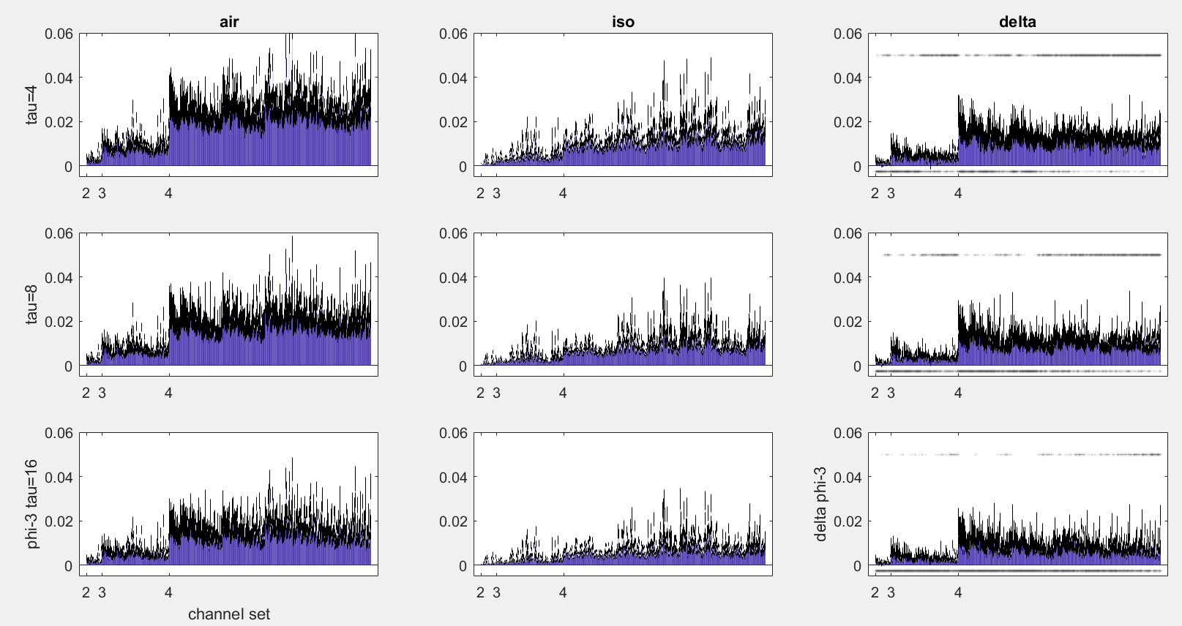

FIGURE: averaged phis for all channel sets: two columns for two taus (extremes: 4 and 16 ms), rows are air, iso, and delta; significance pattern must be visible (to convey possible point that more central combinations give a significant difference)

### Equal likelihood of feedback MIP cuts under isoflurane

As it is not immediately obvious as to whether a partitioning of three channels or more is feedback or not, we took only candidate networks consisting of 2 channels and compared the portion of feedback to feedforward cuts between conditions. This parallels the two-channel nature of GC analysis which was previously conduced on the data {Cohen, #2}. For comparability with the past finding of reduced feedback in the data under iso, the same periphery-centre channel pairings were selected.

FIGURE: boring bar plot – maybe conduct tests per channel set, like in other sections

### Phi-star is moderately correlated with phi-3

As with phi-3, an linear mixed effects model was used to assess the fixed effects of condition, lag, and channels used. Figure x shows the values at each channel combination (no t-tests survived correction for multiple comparisons at q=0.05; logged t-tests still give results). This was repeated for mutual information and entropy.

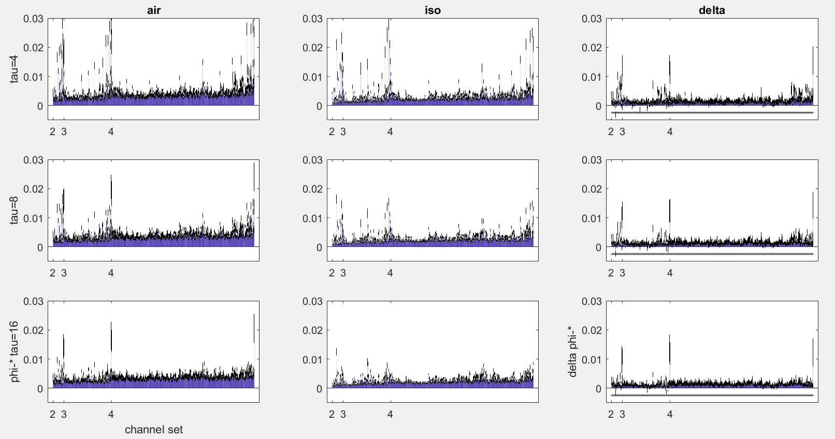

FIGURE: phistars at two taus, same as phi3 figure

Despite no difference between conditions at the individual network level, phi-star at individual networks was generally correlated with phi-3 (after correction). More correlations were significant in the air condition, and the proportion of significant correlations increased with tau lag. (Look into proportion of significance per nChannels). The average correlation (after Fisher z-r transformation and backtransform) was x.

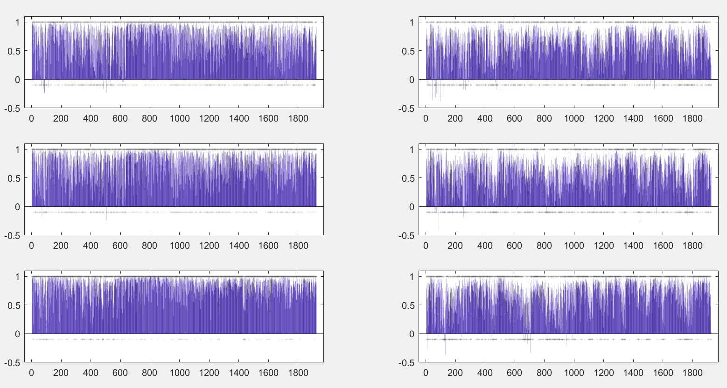

FIGURE: phi correlations at one tau, similar as phi3 figure

However, the likelihood of having matching MIPs was not significantly different from chance.

## CHAPTER 3: DISCUSSION AND CONCLUSION

Blah blah blah discuss discuss, etc. etc.

More blah blah blah stuff.

This stuff can be related to modelling the brain as a graph, possible future approach may be to calculate phi in the core vs in the periphery. The two approaches (IIT and core-periphery search) may go together as IIT calculates phi over a set of nodes. Furthermore the search for phi may help identify the core (or at least the conscious core), which may be dynamic, especially in line with the ideas of segregation and integration.

A major direction is in the algorithmic/mathematical derivation of phi. A key limiting factor to computing phi is the search for the MIP, which requires searching over all possible partitions of a system. Reduction of this problem to decrease compute time is already underway, but given the mathematical nature of the theory proofs are required equating approximations of the MIP to the actual MIP.

Though the search for the MIP hinders the practicality of computing phi, significant progress is being made to overcome this limitation. Already in IIT 3.0, the minimum information bipartition is used (as if any part of the system is independent, then it will be picked up by some bipartition). Another approach to this problem is to approximate the MIP through clustering algorithms {Toker, 2017 #62}.

## CHAPTER 4: REFERENCES