**ENSF 408**

**Lab 4**

**Shamin Rahman (30037908) and Avneet Gill (30037556)**

**18 oct 2019**

**B01**

**EX A:**

**EX B:**

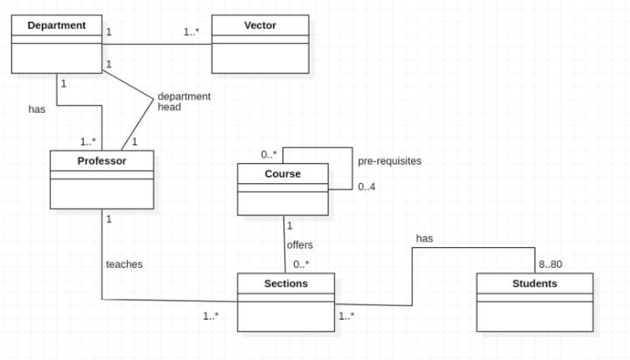

**EX C:**

Car.h:

#include “Vehicle.h”

class Car: public Vehicle{

    private:

        int seats;

    public:

        Car(int seats);

        void turn();

}

Moveable.h:

class Moveable{

    public:

        virtual void forward() = 0;

        virtual void backward() = 0;

};

Resizable.h:

class Resizable{

    public:

        virtual void enlarge(int n) = 0;

        virtual void shrink (int n) = 0;

};

Vehicle.h:

#include <string>

#include "Moveable.h"

class Vehicle : public Resizable, public Moveable{

    protected:

        std::string name;

    public:

        Vehicle(std::string name);

        void move();

};

**EX D:**

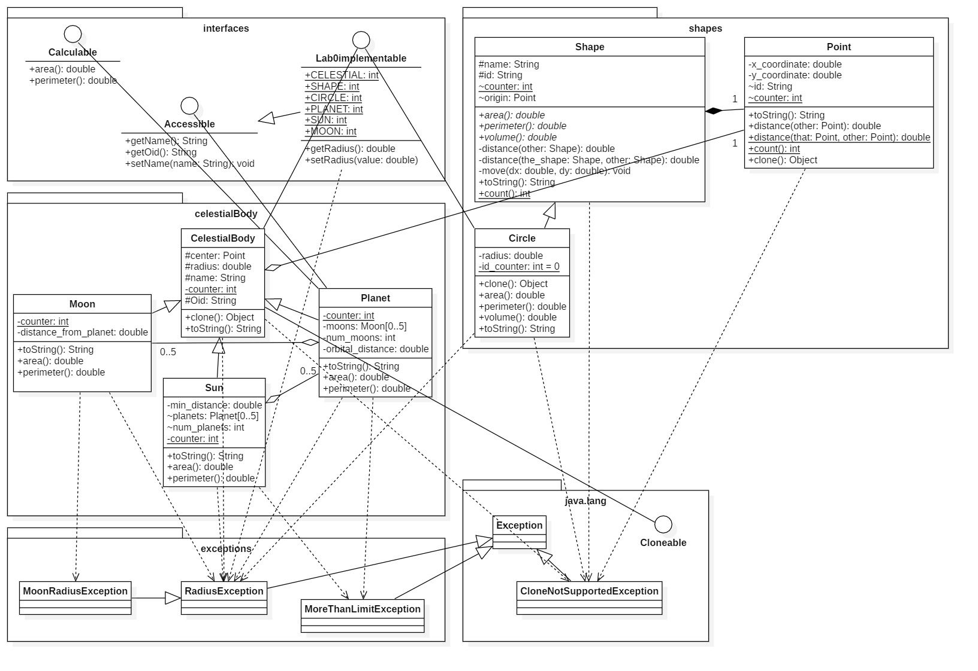

**EX E: (GLOBAL FUNCTIONS AND CONSTANTS ARE NOT SHOWN IN DIAGRAM)**

