


数据库系统原理
课程设计报告

 | 题 目: | 《三进两联一交友管理系统》
 | 姓 名: | 张津豪
 | 学 院: | 计算机与信息工程学院
 | 专 业: | 计算机科学与技术
 | 班 级: | 计科182
 | 学 号: | 220184681
 | 指导教师: | 蔡朝朝

1.系统概述
三进两联一交友管理系统是针对新疆特色“进教室”“进宿舍”“进食堂”“联系学生”“联系家长”“老师与学生交朋友”的“三进两联一交友”活动设计的基于SQLite数据库与Python后端控制台程序，其中包含基本信息：学生基本信息、教师基本信息、三二一师生关系基本信息、活动次数统计基本信息，实现了登录系统、增删改查、退出系统的功能。

2.系统设计

2.1 需求分析
新疆高校高度重视新疆特色“进教室”“进宿舍”“进食堂”“联系学生”“联系家长”“老师与学生交朋友”的“三进两联一交友”工作，并积极设计与开展。面对新疆高校学生数量多，与教师干部相比，人数相差巨大、根据教师、学校干部一人联系多个学生这样的一对多的关系，设立此三进两联一交友管理系统，实现对三进两联关系信息的统计与操作，减少人力物力财力资本，易于看清理清关系，具有重要的意义。

2.2 开发技术和数据库
SQLite数据库与Python后端控制台程序

2.3 系统功能结构设计
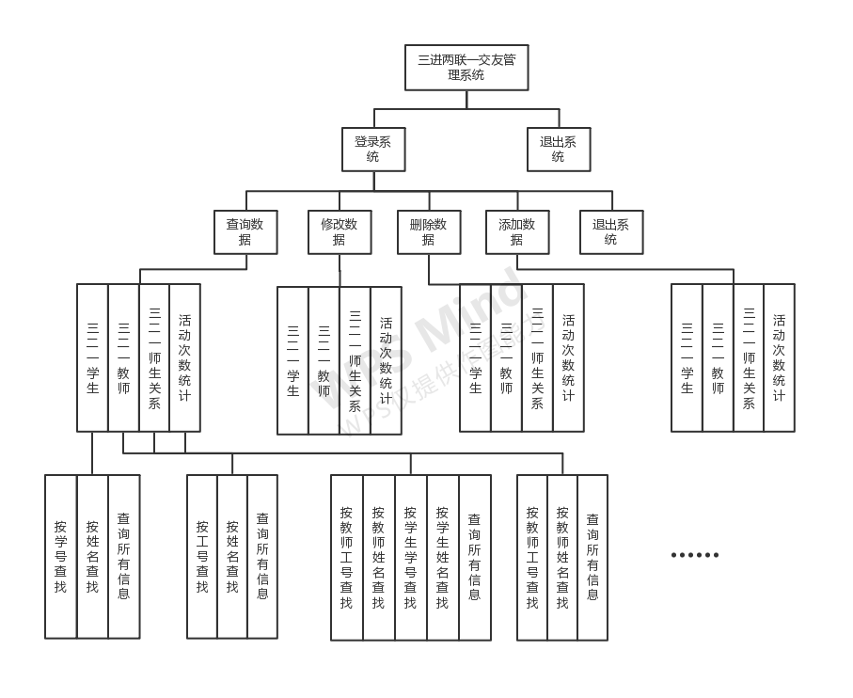

3.数据库设计

3.1 概念结构设计
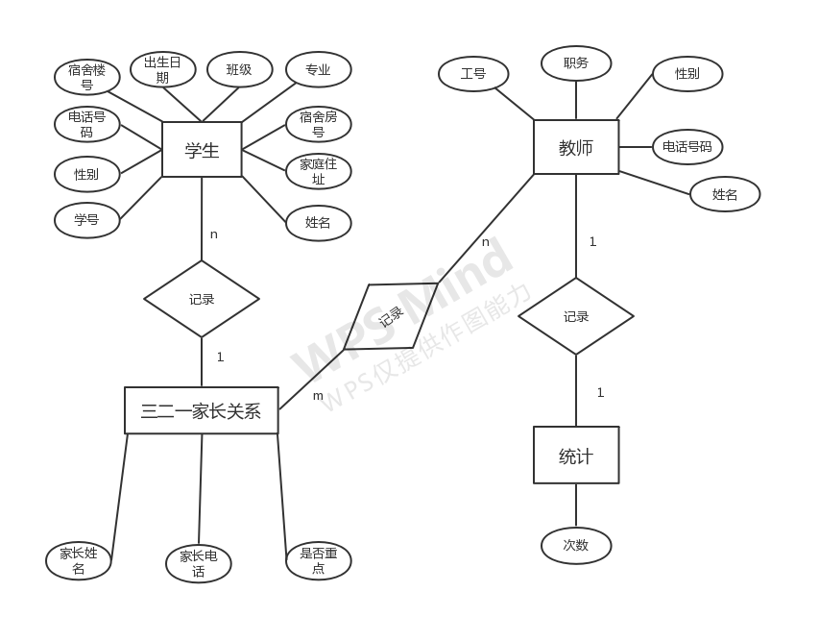

3.2 逻辑结构设计
学生（学生学号，学生姓名，专业，班级，性别，出生日期，电话号码，宿舍楼，宿舍号，家庭住址）
教师（教师工号，教师姓名，性别，电话号码，职务）
三二一家长关系（学生家长姓名，学生家长电话，是否为重点关注对象，教师姓名，教师电话，学生姓名，学生电话，教师工号，学生学号）
活动统计（与学生三二一活动次数，教师姓名，教师工号）

3.3 数据库详细设计

学生表
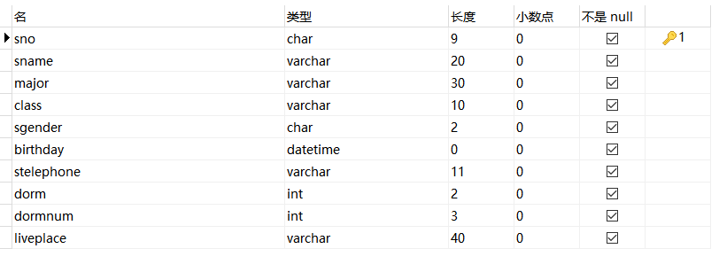

教师表
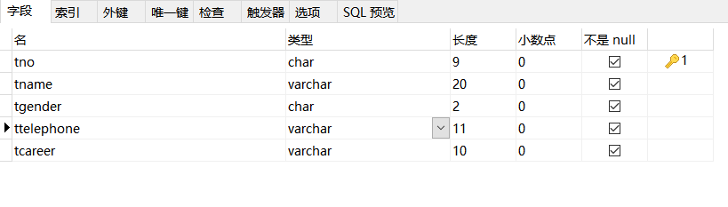

三二一师生关系表
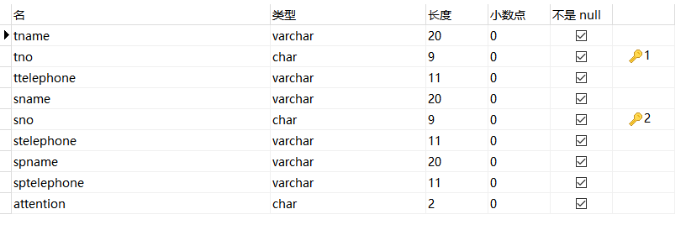

活动次数统计表
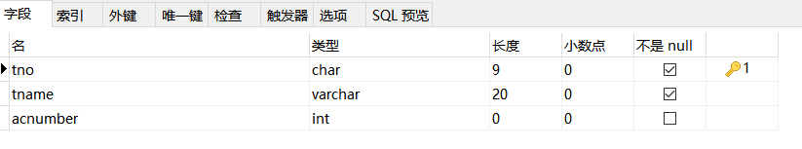

4.系统程序设计与实现

4.1 创建表、创建触发器、初始化数据、返回信息是否存在功能模块的设计与实现
4.1.1 导入SQLite、创建数据库
import sqlite3
import sys
# 创建一个数据库
conn = sqlite3.connect('zjh.db')
# 创建一个游标
cursor = conn.cursor()
print('数据库连接成功')
cursor.close()
conn.commit()
conn.close()

4.1.2 创建表
# 创建学生表：学号 姓名 专业 班级 性别 出生日期 电话号码 宿舍楼 宿舍号 家庭住址
sql = "create table student(" \
"sno char(9) not null primary key," \
"sname varchar(20) not null," \
"major varchar(30) not null," \
"class varchar(10) not null," \
"sgender char(2) not null," \
"birthday varchar(10) not null," \
"stelephone varchar(11) not null," \
"dorm char(2) not null," \
"dormnum char(3) not null," \
"liveplace varchar(40) not null)"
# cursor.execute(sql)
# 创建教师表：工号 姓名 性别 电话号码 职务
sql1 = "create table teacher(" \
"tno char(9) not null primary key," \
"tname varchar(20) not null," \
"tgender char(2) not null," \
"ttelephone varchar(11) not null," \
"tcareer varchar(10) not null) "
# cursor.execute(sql1)
# 创建三二一师生关系表 老师姓名 工号 老师电话 学生姓名 学号 学生电话 学生家长姓名 学生家长电话 是否为重点关注对象
sql2 = "create table relative(" \
"tname varchar(20) not null," \
"tno char(9) not null," \
"ttelephone varchar(11) not null," \
"sname varchar(20) not null," \
"sno char(9) not null," \
"stelephone varchar(11) not null," \
"spname varchar(20) not null," \
"sptelephone varchar(11) not null," \
"attention char(2) not null," \
"primary key(tno,sno)," \
"foreign key(tname) references teacher(tname)," \
"foreign key(tno) references teacher(tno)," \
"foreign key(ttelephone) references teacher(ttelephone)," \
"foreign key(sname) references student(sname)," \
"foreign key(sno) references student(sno)," \
"foreign key(stelephone) references student(stelephone))"
# cursor.execute(sql2)
# 创建三二一活动记录表 老师工号 姓名 与学生三二一活动次数
sql3 = "create table calculate(" \
"tno char(9) not null primary key," \
"tname varchar(20) not null," \
"acnumber char(3)," \
"foreign key(tno) references teacher(tno)," \
"foreign key(tname) references teacher(tname))"
# cursor.execute(sql3)

4.1.3 创建触发器
# 创建触发器：一旦删除三二一师生关系的学生信息，学生表也会删除学生信息
sql4 = "create trigger tr after delete on relative for each row begin delete from student where sno = old.sno; end;"
# cursor.execute(sql4)
# 创建触发器：一旦删除三二一师生关系的学生信息，学生表也会删除学生信息
sql5 = "create trigger tr1 after delete on relative for each row begin delete from student where sname = old.sname; end;"
# cursor.execute(sql5)
# 创建触发器：一旦修改学生表信息-电话号码，三二一师生表也会修改学生信息
sql6 = "create trigger tr2 after update on student for each row begin update relative set stelephone = new.stelephone where stelephone = old.stelephone;end;"
# cursor.execute(sql6)
# 创建触发器：一旦修改教师表信息-电话号码，三二一师生表也会修改教师信息
sql7 = "create trigger tr3 after update on teacher for each row begin update relative set ttelephone = new.ttelephone where ttelephone = old.ttelephone;end;"
# cursor.execute(sql7)

4.1.4 初始化数据
# 初始化数据-插入数据
def insert_data1():
sql1 = "insert into student values('220163321','那孜衣拉·赛力克','信息管理与信息系统','信管161','女','1998-1-1','16699218020',3,432,'新疆乌鲁木齐市头屯河区万泰阳光城二期62号楼')"
sql2 = "insert into student values('220163331','祖丽皮亚木·阿不都瓦力','信息管理与信息系统','信管162','女','1998-1-28','17881123965',3,432,'新疆呼图壁县芳草湖镇团结北路232号')"
sql3 = "insert into student values('220163332','古力米拉·如孜','信息管理与信息系统','信管171','女','1999-2-12','18199461551',12,423,'新疆霍城县清水河镇开封路南2巷11号')"
sql4 = "insert into student values('220163334','阿吉古力·米吉提','信息管理与信息系统','信管172','女','1999-2-21','15899465955',3,425,'新疆特克斯县乔拉克铁热克镇乌尊布拉克路八巷22号')"
sql5 = "insert into student values('220163335','古丽巴哈尔·库尔班','信息管理与信息系统','信管181','女','2000-3-14','15292532758',12,427,'新疆省乌苏市皇宫镇西海子村250号')"
sql6 = "insert into student values('220163349','阿热孜古力·巴拉提','计算机科学与技术','计科171','女','1999-8-11','13279720779',12,423,'新疆奎屯市柳沟125团兴隆里1栋161号')"
sql7 = "insert into student values('220163350','吾尔尼沙·吐逊','计算机科学与技术','计科172','女','1999-8-24','18599013480',3,426,'新疆乌鲁木齐市天山区1195号')"
sql8 = "insert into student values('220163352','阿曼尼沙·托合提','计算机科学与技术','计科174','女','1999-9-18','13809949757',12,427,'甘肃省永登县中堡镇清水河村三社')"
sql9 = "insert into student values('220163353','帕沙姑丽·阿布力米提','计算机科学与技术','计科175','女','1999-9-19','13579878402',3,425,'新疆昭苏县阔克吐拜镇77团丁香路1号楼4单元402室')"
sql10 = "insert into student values('220163356','吐尔逊姑丽·艾木都拉','计算机科学与技术','计科171','女','1999-5-23','17881121322',12,429,'新疆阿勒泰市富蕴县吐尔洪乡阔仔肯村52号')"
sql11 = "insert into student values('220190408','姜雨航','物联网工程','物联192','男','2001-8-8','15696744086',6,202,'重庆市垫江县五洞镇文龙村5组')"
sql12 = "insert into student values('220190409','刘丹','物联网工程','物联161','女','1998-12-31','13320363122',12,334,'重庆市垫江县杠家镇双溪2组二十号')"
sql13 = "insert into student values('220190410','谭治强','物联网工程','物联162','男','1998-12-31','13272722840',6,203,'重庆市开州区岳溪镇石坪村9组77号')"
sql14 = "insert into student values('220190412','翁建明','物联网工程','物联171','男','1999-1-2','15608021662',6,332,'四川省安岳县千佛乡桥亭村')"
sql15 = "insert into student values('220190413','张海洋','物联网工程','物联172','男','1999-1-17','15099585532',6,334,'四川省梓潼县文昌镇五丁路北段233号')"
sql16 = "insert into student values('220190416','吕朋辉','电子信息科学与技术','电科161','男','1998-9-15','17808243601',6,204,'四川省大英县蓬莱镇碑垭村10社23号')"
sql17 = "insert into student values('220190418','鞠直成','电子信息科学与技术','电科162','男','1998-9-23','17628330168',6,336,'四川省乐山市沐川县永福镇永兴村3组10号')"
sql18 = "insert into student values('220190419','雷鑫','电子信息科学与技术','电科171','男','1999-10-17','18582813701',6,336,'四川渠县李馥乡真武村三组1号')"
sql19 = "insert into student values('220190420','李奇峰','电子信息科学与技术','电科172','男','1999-10-18','18382713299',6,205,'将军大道24号南林山庄2幢3单元201室')"
sql20 = "insert into student values('220190421','苟玉鲜','电子信息科学与技术','电科181','男','2000-6-19','15082714268',6,205,'四川省巴中市平昌县灵山乡民意村11社')"
sql21 = "insert into student values('220163341','努尔比耶姆·图尔荪','信息管理与信息系统','信管162','女','1998-5-21','15160896514',3,425,'新疆温宿县依希来木其乡团结村2组253号')"
sql22 = "insert into student values('220163359','美合日·托合提麦麦提','计算机科学与技术','计科191','女','2001-12-22','17881127509',12,423,'新疆新源县阿勒玛勒乡铁勒喀拉村巴彦德路十二巷6号')"
sql23 = "insert into student values('220163358','麦热耶·拜克尔','计算机科学与技术','计科181','女','2000-4-21','15276833340',3,429,'新疆喀什地区喀什市英吾斯坦乡')"
sql24 = "insert into student values('220190431','付柳婷','电子信息科学与技术','电科191','女','2001-11-21','18009933660',12,335,'新疆石河子市21小区8栋122')"
sql25 = "insert into student values('220190429','李傲','电子信息科学与技术','电科191','男','2001-7-19','13079972246',6,204,'河南省平舆县射桥古城后柴楼村')"
sql26 = "insert into student values('220190415','张濒方','物联网工程','物联192','男','2001-9-5','18508390091',6,334,'四川省广元市苍溪县石马镇千佛村三组32号')"
# cursor.execute(sql1)
# cursor.execute(sql2)
# cursor.execute(sql3)
# cursor.execute(sql4)
# cursor.execute(sql5)
# cursor.execute(sql6)
# cursor.execute(sql7)
# cursor.execute(sql8)
# cursor.execute(sql9)
# cursor.execute(sql10)
# cursor.execute(sql11)
# cursor.execute(sql12)
# cursor.execute(sql13)
# cursor.execute(sql14)
# cursor.execute(sql15)
# cursor.execute(sql16)
# cursor.execute(sql17)
# cursor.execute(sql18)
# cursor.execute(sql19)
# cursor.execute(sql20)
# cursor.execute(sql21)
# cursor.execute(sql22)
# cursor.execute(sql23)
# cursor.execute(sql24)
# cursor.execute(sql25)
# cursor.execute(sql26)
#
def insert_data2():
sql1 = "insert into teacher values('120010043','蔡朝朝','女','15352517720','干部教师')"
sql2 = "insert into teacher values('120010041','李湘','女','13999917205','干部教师')"
sql3 = "insert into teacher values('120190008','王晓东','男','15276710090','团委书记')"
sql4 = "insert into teacher values('120020025','杨抒','男','13999913640','副院长')"
sql5 = "insert into teacher values('119850032','金晓龙','男','18690190015','党委书记')"
sql6 = "insert into teacher values('120160018','阿迪力','男','13999187347','辅导员')"
sql7 = "insert into teacher values('119970034','冯向萍','女','13579200192','副院长')"
sql8 = "insert into teacher values('119900028','张太红','男','13325538255','院长')"
# cursor.execute(sql1)
# cursor.execute(sql2)
# cursor.execute(sql3)
# cursor.execute(sql4)
# cursor.execute(sql5)
# cursor.execute(sql6)
# cursor.execute(sql7)
# cursor.execute(sql8)
def insert_data3():
sql1 = "insert into relative values('蔡朝朝','120010043','15352517720','那孜衣拉·赛力克','220163321','16699218020','赛力克·木哈提','15999255384','是')"
sql2 = "insert into relative values('蔡朝朝','120010043','15352517720','祖丽皮亚木·阿不都瓦力','220163331' ,'17881123965','阿不都瓦力·阿不拉','13239978179','是')"
sql3 = "insert into relative values('蔡朝朝','120010043','15352517720','古力米拉·如孜','220163332','18199461551','如孜·阿不拉','18196376818','是')"
sql4 = "insert into relative values('李湘','120010041','13999917205','阿吉古力·米吉提','220163334','15899465955','米吉提·日西提','13139868821','是')"
sql5 = "insert into relative values('李湘','120010041','13999917205','阿热孜古力·巴拉提','220163349','13279720779','巴拉提·艾买提','17799544076','是')"
sql6 = "insert into relative values('李湘','120010041','13999917205','吾尔尼沙·吐逊','220163350','18599013480','古力那尔·巴拉提','15599849866','是')"
sql7 = "insert into relative values('李湘','120010041','13999917205','阿曼尼沙·托合提','220163352','13809949757','托合提·买合苏提','15739964926','是')"
sql8 = "insert into relative values('王晓东','120190008','15276710090','帕沙姑丽·阿布力米提','220163353','13579878402','阿布力米提·苏来曼','13779725409','是')"
sql9 = "insert into relative values('王晓东','120190008','15276710090','吐尔逊姑丽·艾木都拉','220163356','17881121322','艾木都拉·阿布拉','19999282868','是')"
sql10 = "insert into relative values('杨抒','120020025','13999913640','姜雨航','220190408','15696744086','吴小琼','13108661836','否')"
sql11 = "insert into relative values('杨抒','120020025','13999913640','刘丹','220190409','13320363122','刘士汉','15059837630','否')"
sql12 = "insert into relative values('杨抒','120020025','13999913640','谭治强','220190410','13272722840','谭世明','13650373478','否')"
sql13 = "insert into relative values('杨抒','120020025','13999913640','张海洋','220190413','15099585532','张冬梅','15882856368','否')"
sql14 = "insert into relative values('杨抒','120020025','13999913640','翁建明','220190412','15608021662','翁绍武','13458666358','否')"
sql15 = "insert into relative values('金晓龙','119850032','18690190015','吕朋辉','220190416','17808243601','吕维兵','19961085714','否')"
sql16 = "insert into relative values('金晓龙','119850032','18690190015','鞠直成','220190418','17628330168','鞠远伦','13990630721','否')"
sql17 = "insert into relative values('金晓龙','119850032','18690190015','雷鑫','220190419','18582813701','江文惠','18228675792','否')"
sql18 = "insert into relative values('阿迪力','120160018','13999187347','李奇峰','220190420','18382713299','宋国英','18382796710','否')"
sql19 = "insert into relative values('阿迪力','120160018','13999187347','苟玉鲜','220190421','15082714268','吴蓉珍','18728747056','否')"
sql20 = "insert into relative values('阿迪力','120160018','13999187347','美合日·托合提麦麦提','220163359','17881127509','托合提麦麦提·佧马力','15214924947','是')"
sql21 = "insert into relative values('阿迪力','120160018','13999187347','麦热耶·拜克尔','220163358','15276833340','拜克尔·托合图木尔','15276000464','是')"
sql22 = "insert into relative values('冯向萍','119970034','13579200192','付柳婷','220190431','18009933660','付国华','18009936665','否')"
sql23 = "insert into relative values('冯向萍','119970034','13579200192','李傲','220190429','13079972246','李国宾','13629901239','否')"
sql24 = "insert into relative values('冯向萍','119970034','13579200192','张濒方','220190415','18508390091','张毅','13780130570','否')"
# cursor.execute(sql1)
# cursor.execute(sql2)
# cursor.execute(sql3)
# cursor.execute(sql4)
# cursor.execute(sql5)
# cursor.execute(sql6)
# cursor.execute(sql7)
# cursor.execute(sql8)
# cursor.execute(sql9)
# cursor.execute(sql10)
# cursor.execute(sql11)
# cursor.execute(sql12)
# cursor.execute(sql10)
# cursor.execute(sql11)
# cursor.execute(sql12)
# cursor.execute(sql13)
# cursor.execute(sql14)
# cursor.execute(sql15)
# cursor.execute(sql16)
# cursor.execute(sql17)
# cursor.execute(sql18)
# cursor.execute(sql19)
# cursor.execute(sql20)
# cursor.execute(sql21)
# cursor.execute(sql22)
# cursor.execute(sql23)
# cursor.execute(sql24)
def insert_data4():
sql1 = "insert into calculate values('120010043','蔡朝朝',10)"
sql2 = "insert into calculate values('120010041','李湘',7)"
sql3 = "insert into calculate values('120190008','王晓东',5)"
sql4 = "insert into calculate values('120020025','杨抒',4)"
sql5 = "insert into calculate values('119850032','金晓龙',14)"
sql6 = "insert into calculate values('120160018','阿迪力',9)"
sql7 = "insert into calculate values('119970034','冯向萍',1)"
# cursor.execute(sql1)
# cursor.execute(sql2)
# cursor.execute(sql3)
# cursor.execute(sql4)
# cursor.execute(sql5)
# cursor.execute(sql6)
# cursor.execute(sql7)

4.1.4 返回信息是否存在
# 查询学生函数
def select_student():
conn = sqlite3.connect('zjh.db')
cursor = conn.cursor()
cursor.execute('select * from student')
res = cursor.fetchall()
cursor.close()
conn.close()
return res
# 查询老师函数
def select_teacher():
conn = sqlite3.connect('zjh.db')
cursor = conn.cursor()
cursor.execute('select * from teacher')
res = cursor.fetchall()
cursor.close()
conn.close()
return res
# 查询三二一师生关系函数
def select_relative():
conn = sqlite3.connect('zjh.db')
cursor = conn.cursor()
cursor.execute('select * from relative')
res = cursor.fetchall()
cursor.close()
conn.close()
return res
# 查询三二一活动记录函数
def select_calculate():
conn = sqlite3.connect('zjh.db')
cursor = conn.cursor()
cursor.execute('select * from calculate')
res = cursor.fetchall()
cursor.close()
conn.close()
return res
# 查询某个学生的学号
def select_sno(number):
for i in range(len(select_student())):
if (select_student()[i][0] == number) == True:
return 1
# 查询某个老师的工号
def select_tno(number):
for i in range(len(select_teacher())):
if (select_teacher()[i][0] == number) == True:
return 1
# 查询某个学生的名字
def select_sname(name):
for i in range(len(select_student())):
if (select_student()[i][1] == name) == True:
return 1
# 查询某个老师的名字
def select_tname(name):
for i in range(len(select_teacher())):
if (select_teacher()[i][1] == name) == True:
return 1
# 从关系表中查询某个学生学号
def select_relative_sno(sno):
for i in range(len(select_relative())):
if(select_relative()[i][4] == sno) == True:
return 1
# 从关系表中查询某个学生姓名
def select_relative_sname(sname):
for i in range(len(select_relative())):
if(select_relative()[i][3] == sname) == True:
return 1
# 从关系表中查询某个老师姓名
def select_relative_tname(tname):
for i in range(len(select_relative())):
if(select_relative()[i][0] == tname) == True:
return 1
# 从关系表中查询某个老师工号
def select_relative_tno(tno):
for i in range(len(select_relative())):
if(select_relative()[i][1] == tno) == True:
return 1
# 从统计表中查询某个老师工号
def select_calculate_tno(tno):
for i in range(len(select_calculate())):
if(select_calculate()[i][0] == tno) == True:
return 1
# 从统计表中查询某个老师姓名
def select_calculate_tname(tname):
for i in range(len(select_calculate())):
if(select_calculate()[i][1] == tname) == True:
return 1

4.2 界面类与主函数模块的设计与实现
4.2.1 界面类功能的实现
# 主界面类
class Desktop(object):
def in_table(self):
print( "※※※※※※※※※※※※※※※※※※※※※※※※※※※ \n")
print( "※ ※ \n")
print( "※ 三进两联一交友管理系统 ※ \n")
print( "※ ※ \n")
print( "※※※※※※※※※※※※※※※※※※※※※※※※※※※ \n")
print( "※ ※ \n")
print( "※ 1、登录系统 2、退出系统 ※ \n")
print( "※ ※ \n")
print( "※※※※※※※※※※※※※※※※※※※※※※※※※※※ \n")
def main_table(self):
print( "※※※※※※※※※※※※※※※※※※※※※※※※※※※ \n")
print( "※ ※ \n")
print( "※ 三进两联一交友管理系统 ※ \n")
print( "※ ※ \n")
print( "※※※※※※※※※※※※※※※※※※※※※※※※※※※ \n")
print( "※ ※ \n")
print( "※ 1、查询信息 2、修改信息 ※ \n")
print( "※ ※ \n")
print( "※ 3、删除信息 4、添加信息 ※ \n")
print( "※ 0、退出系统 ※ \n")
print( "※※※※※※※※※※※※※※※※※※※※※※※※※※※ \n")
def exit_table(self):
print( "※※※※※※※※※※※※※※※※※※※※※※※※※※※ \n")
print( "※ ※ \n")
print( "※ 感谢您使用三进两联一交友管理系统! ※ \n")
print( "※ ※ \n")
print( "※※※※※※※※※※※※※※※※※※※※※※※※※※※ \n")

4.2.1 主函数功能的实现
def recircle():
demo.main_table()
choice = int(input("请输入操作项："))
if choice == 0:
demo.exit_table()
sys.exit(0)
elif choice == 1:
get_data()
elif choice == 2:
alter_data()
elif choice == 3:
del_data()
elif choice == 4:
add_data()
def mainfunction():
number = 3
demo.in_table()
pas = int(input("请输入操作项："))
if pas == 2:
demo.exit_table()
sys.exit(0)
elif pas == 1:
while number > 0:
pam = input("请输入密码：")
if pam == "123456":
print('密码输入正确!')
break
else:
number = number-1
print('密码输入有误，一共3次机会!')
if number == 0:
print('密码输误次数过多，自动退出系统')
sys.exit(0)
else:
while(True):
recircle()
# 定义对象
demo = Desktop()
# 主函数
mainfunction()
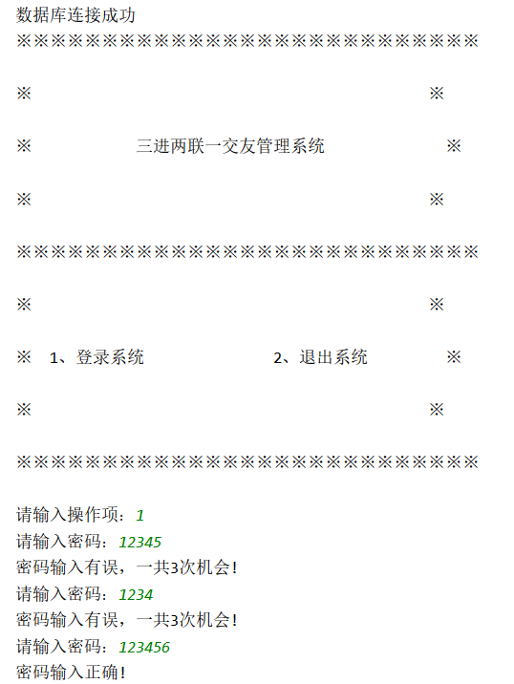
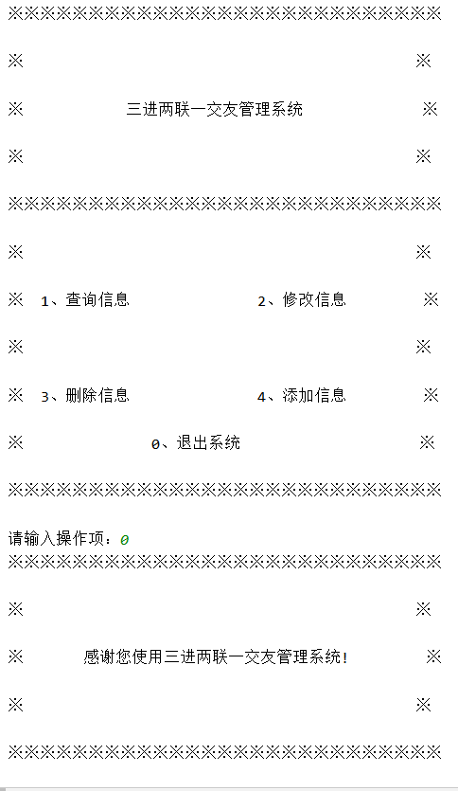

4.3 四张表增删改查功能模块的设计与实现
4.3.1 添加功能的实现
# 添加信息
def add_data():
conn = sqlite3.connect('zjh.db')
cursor = conn.cursor()
content = input("请输入添加的数据：三二一学生/三二一老师/三二一师生关系/老师三二一活动次数统计\n")
if content == '三二一学生':
sname = input("学生姓名：")
sno = input("学生学号：")
major = input("专业：")
cls = input("班级：")
sgender = input("性别：")
birthday = input("出生日期：")
stelephone = input("电话号码：")
dorm = input("宿舍楼号：")
dormnum = input("宿舍号：")
liveplace = input("家庭住址：")
for row in select_student():
if sno == row[0]:
print("此学生已在，无需添加！")
else:
cursor.execute(
"insert into student(sno,sname,major,class,sgender,birthday,stelephone,dorm,dormnum,liveplace) values ('%s','%s','%s','%s','%s','%s','%s','%s','%s','%s')" % (
sno, sname, major, cls, sgender, birthday, stelephone, dorm, dormnum, liveplace))
conn.commit()
print('\n学生信息添加完成\n')
if content == '三二一老师':
tno = input("教师工号：")
tname = input("教师姓名：")
tgender = input("性别：")
ttelephone = input("电话号码：")
tcareer = input("教师职务：")
for low in select_teacher():
if tno == low[0]:
print("此教师已在，无需添加！")
else:
cursor.execute(
"insert into teacher(tno,tname,tgender,ttelephone,tcareer) values ('%s','%s','%s','%s','%s')" % (
tno, tname, tgender, ttelephone, tcareer))
conn.commit()
print('\n教师信息添加完成\n')
if content == '三二一师生关系':
tname2 = input("教师姓名：")
tno2 = input("教师工号：")
ttelephone2 = input("教师电话号码：")
sname2 = input("学生姓名：")
sno2 = input("学生学号：")
stelephone2 = input("学生电话号码：")
spname = input("学生家长姓名：")
sptelephone = input("学生家长电话号码：")
attention = input("是否为重点关注对象：是/否")
for how in select_relative():
if sno2 == how[4]:
print("此学生已在，无需添加！")
else:
cursor.execute(
"insert into relative(tname,tno,ttelephone,sname,sno,stelephone,spname,sptelephone,attention) values ('%s','%s','%s','%s','%s','%s','%s','%s','%s')" % (
tname2, tno2, ttelephone2, sname2, sno2, stelephone2, spname, sptelephone, attention))
conn.commit()
print('\n师生关系信息添加完成\n')
if content == '老师三二一活动次数统计':
tno3 = input("教师工号：")
tname3 = input("教师姓名：")
acnumber = input("与学生三二一活动次数：")
for tow in select_calculate():
if tno3 == tow[0]:
print("此教师已在，无需添加！")
else:
cursor.execute("insert into calculate(tno,tname,acnumber) values ('%s','%s','%s')" % (
tno3, tname3, acnumber))
conn.commit()
print('\n老师三二一活动次数统计信息添加完成\n')
cursor.close()
conn.close()
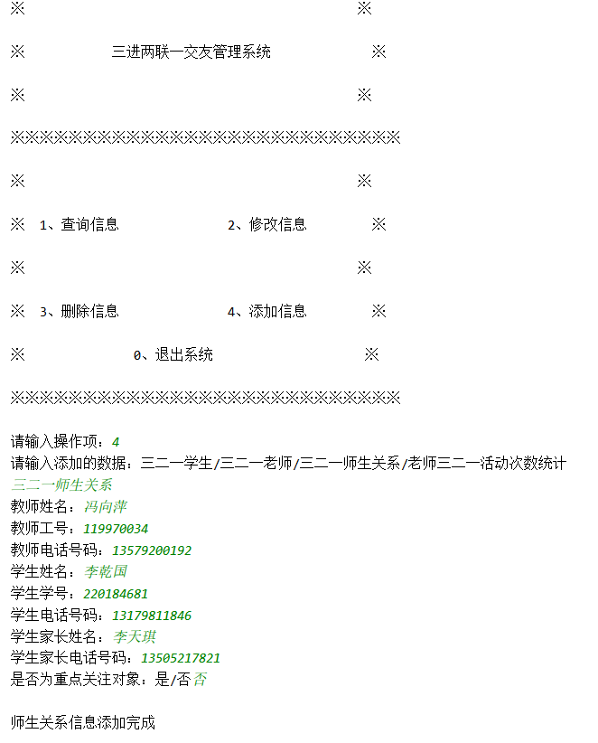
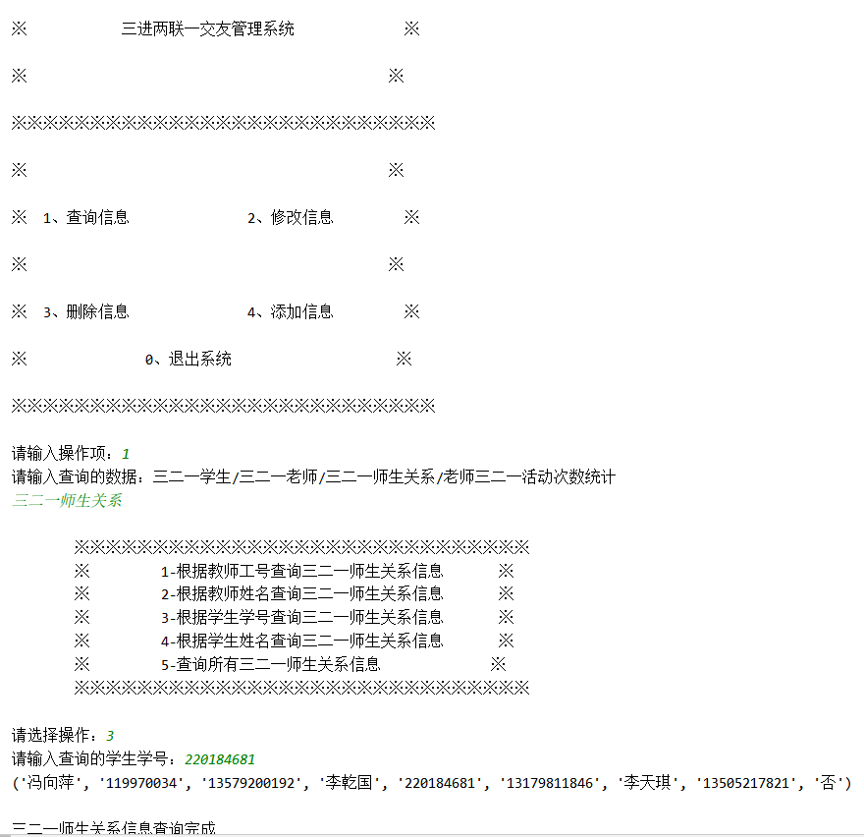

4.3.2 修改功能的实现
def alter_data():
conn = sqlite3.connect('zjh.db')
cursor = conn.cursor()
content = input("请输入修改的数据：三二一学生/三二一老师/三二一师生关系/老师三二一活动次数统计\n")
if content == "三二一学生":
print('''
※※※※※※※※※※※※※※※※※※※
※ 1-根据学号修改学生信息 ※
※ 2-根据姓名修改学生信息 ※
※※※※※※※※※※※※※※※※※※※
''')
number = int(input("请选择操作："))
while number < 1 or number > 2:
number = int(input('请重新选择操作：'))
if number == 1:
while True:
num = input('请输入修改的学生学号：')
if select_sno(num) != 1:
print("此学生不在其中，请重新输入！")
else:
break
print('''
※※※※※※※※※※※※※※※※
※ 1-修改学生电话号码 ※
※ 2-修改学生宿舍楼号 ※
※ 3-修改学生宿舍房号 ※
※※※※※※※※※※※※※※※※
''')
choice = int(input('请选择操作：'))
if choice == 1:
newtelephone = input('请输入新的电话号码：')
cursor.execute("update student set stelephone = '%s' where sno = '%s'"
%(newtelephone,num))
conn.commit()
print('\n数据修改成功\n')
elif choice == 2:
newdorm = input('请输入新的宿舍楼号：')
cursor.execute("update student set dorm = '%s' where sno = '%s'"
%(newdorm,num))
conn.commit()
print('\n数据修改成功\n')
elif choice == 3:
newdormnum = input('请输入新的宿舍房号：')
cursor.execute("update student set dormnum = '%s' where sno = '%s'"
%(newdormnum,num))
conn.commit()
print('\n数据修改成功\n')
elif number == 2:
while True:
name = input('请输入修改的学生姓名：')
if select_sname(name) != 1:
print("此学生不在其中，请重新输入！")
else:
break
print('''
※※※※※※※※※※※※※※※※※
※ 1-修改学生电话号码 ※
※ 2-修改学生宿舍楼号 ※
※ 3-修改学生宿舍房号 ※
※※※※※※※※※※※※※※※※※
''')
choice1 = int(input('请选择操作：'))
if choice1 == 1:
newtelephone1 = input('请输入新的电话号码：')
cursor.execute("update student set stelephone = '%s' where sname = '%s'"
%(newtelephone1,name))
conn.commit()
print('\n数据修改成功\n')
elif choice1 == 2:
newdorm1 = input('请输入新的宿舍楼号：')
cursor.execute("update student set dorm = '%s' where sname = '%s'"
%(newdorm1,name))
conn.commit()
print('\n数据修改成功\n')
elif choice1 == 3:
newdormnum1 = input('请输入新的宿舍房号：')
cursor.execute("update student set dormnum = '%s' where sname = '%s'"
%(newdormnum1,name))
conn.commit()
print('\n数据修改成功\n')
elif content == "三二一老师":
print('''
※※※※※※※※※※※※※※※※※
※ 1-根据工号修改教师信息 ※
※ 2-根据姓名修改教师信息 ※
※※※※※※※※※※※※※※※※※
''')
number2 = int(input("请选择操作："))
while number2 < 1 or number2 > 2:
number2 = int(input('请重新选择操作：'))
if number2 == 1:
while True:
num2 = input('请输入修改的教师工号：')
if select_tno(num2) != 1:
print("此教师不在其中，请重新输入！")
else:
break
print('''
※※※※※※※※※※※※※※※
※ 1-修改教师电话号码 ※
※ 2-修改教师职务 ※
※※※※※※※※※※※※※※※
''')
choice2 = int(input('请选择操作：'))
if choice2 == 1:
newtelephone2 = input('请输入新的电话号码：')
cursor.execute("update teacher set ttelephone = '%s' where tno = '%s'"
%(newtelephone2,num2))
conn.commit()
print('\n数据修改成功\n')
elif choice2 == 2:
newtcareer = input('请输入新的职务：')
cursor.execute("update teacher set tcareer = '%s' where tno = '%s'"
%(newtcareer,num2))
conn.commit()
print('\n数据修改成功\n')
elif number2 == 2:
while True:
name2 = input('请输入修改的教师姓名：')
if select_tname(name2) != 1:
print("此教师不在其中，请重新输入！")
else:
break
print('''
※※※※※※※※※※※※※※※※※※※
※ 1-修改教师电话号码 ※
※ 2-修改教师职务 ※
※ ※ ※※※※※※※※※※※※※※※※
''')
choice3 = int(input('请选择操作：'))
if choice3 == 1:
newtelephone3 = input('请输入新的电话号码：')
cursor.execute("update teacher set ttelephone = '%s' where tname = '%s'"
%(newtelephone3,name2))
conn.commit()
print('\n数据修改成功\n')
elif choice3 == 2:
newtcareer3 = input('请输入新的职务：')
cursor.execute("update teacher set tcareer = '%s' where tname = '%s'"
%(newtcareer3,name2))
conn.commit()
print('\n数据修改成功\n')
elif content == "老师三二一活动次数统计":
print('''
※※※※※※※※※※※※※※※※※※※※※※※※※※※※※
※ 1-根据教师工号修改老师三二一活动次数统计信息 ※
※ 2-根据教师姓名修改老师三二一活动次数统计信息 ※
※※※※※※※※※※※※※※※※※※※※※※※※※※※※※
''')
number3 = int(input("请选择操作："))
while number3 < 1 or number3 > 2:
number3 = int(input('请重新选择操作：'))
if number3 == 1:
while True:
num3 = input('请输入修改的教师工号：')
if select_tno(num3) != 1:
print("此教师不在其中，请重新输入！")
else:
break
newacnumber = input('请输入新的活动次数：')
cursor.execute("update calculate set acnumber = '%s' where tno = '%s'"
%(newacnumber,num3))
conn.commit()
print('\n数据修改成功\n')
elif number3 == 2:
while True:
name3 = input('请输入修改的教师姓名：')
if select_tno(name3) != 1:
print("此教师不在其中，请重新输入！")
else:
break
newacnumber2 = input('请输入新的活动次数：')
cursor.execute("update calculate set acnumber = '%s' where tname = '%s'"
%(newacnumber2,name3))
conn.commit()
print('\n数据修改成功\n')
elif content == "三二一师生关系":
print('''
※※※※※※※※※※※※※※※※※※※※※※※※※※※
※ 1-根据学生学号修改三二一师生关系信息 ※
※ 2-根据学生姓名修改三二一师生关系信息 ※
※※※※※※※※※※※※※※※※※※※※※※※※※※※
''')
number4 = int(input("请选择操作："))
while number4 < 1 or number4 > 2:
number4 = int(input('请重新选择操作：'))
if number4 == 1:
while True:
num5 = input('请输入修改三二一师生关系的学生学号：')
if select_relative_sno(num5) != 1:
print("此学生不在其中，请重新输入！")
else:
break
print('''
※※※※※※※※※※※※※※※※※※※
※ 1-修改学生家长电话号码 ※
※※※※※※※※※※※※※※※※※※※
''')
newnumber = int(input('请选择操作：'))
if newnumber == 1:
newsptelephone = input("请输入新的家长电话号码：")
cursor.execute("update relative set sptelephone = '%s' where sno = '%s'"
%(newsptelephone,num5))
conn.commit()
print('\n数据修改成功\n')
elif number4 == 2:
while True:
name4 = input('请输入修改三二一师生关系的学生姓名：')
if select_relative_sname(name4) != 1:
print("此学生不在其中，请重新输入！")
else:
break
print('''
※※※※※※※※※※※※※※※※※※※
※ 1-修改学生家长电话号码 ※
※※※※※※※※※※※※※※※※※※※
''')
newnumber2 = int(input('请选择操作：'))
if newnumber2 == 1:
newsptelephone2 = input("请输入新的家长电话号码：")
cursor.execute("update relative set sptelephone = '%s' where sname = '%s'"
% (newsptelephone2, name4))
conn.commit()
print('\n数据修改成功\n')
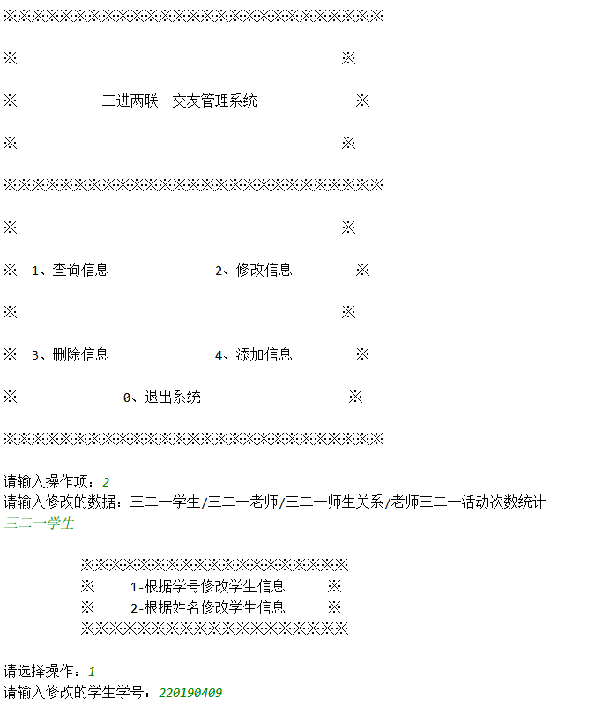
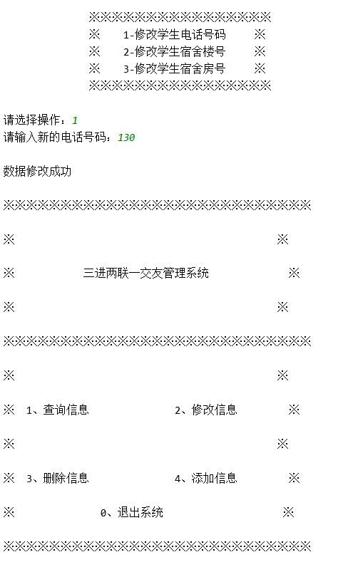
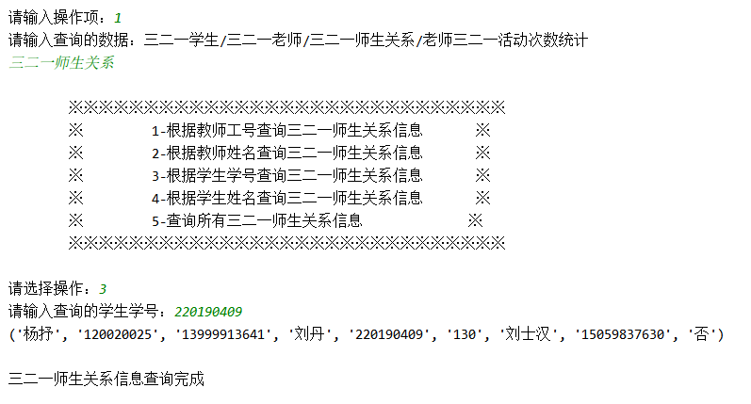

4.3.3 删除功能的实现
def del_data():
conn = sqlite3.connect('zjh.db')
cursor = conn.cursor()
content2 = input("请输入删除的数据：三二一学生/三二一老师/三二一师生关系/老师三二一活动次数统计\n")
if content2 == "三二一学生":
print('''
※※※※※※※※※※※※※※※※※
※ 1-根据学号删除学生信息 ※
※ 2-根据姓名删除学生信息 ※
※ 3-根据班级删除学生信息 ※
※※※※※※※※※※※※※※※※※
''')
number = int(input("请选择操作："))
while number < 1 or number > 4:
number = int(input('请重新选择操作：'))
if number == 1:
while True:
num = input('请输入删除的学生学号：')
if select_sno(num) != 1:
print("此学生不在其中，请重新输入！")
else:
break
cursor.execute("delete from student where sno = %s" % num)
conn.commit()
print('\n数据删除成功\n')
elif number == 2:
while True:
name = input('请输入删除的学生姓名：')
if select_sname(name) != 1:
print("此学生不在其中，请重新输入！")
else:
break
cursor.execute("delete from student where sname = '%s' " % name)
conn.commit()
print('\n数据删除成功\n')
elif number == 3:
cla = input("请输入你想删除学生的班级：信息管理与信息系统/计算机科学与技术/电子信息科学与技术/物联网工程\n")
if cla == "信息管理与信息系统":
cursor.execute("delete from student where class = %s" % cla)
conn.commit()
print('\n数据删除成功\n')
elif cla == "计算机科学与技术":
cursor.execute("delete from student where class = %s" % cla)
conn.commit()
print('\n数据删除成功\n')
elif cla == "电子信息科学与技术":
cursor.execute("delete from student where class = %s" % cla)
conn.commit()
print('\n数据删除成功\n')
elif cla == "物联网工程":
cursor.execute("delete from student where class = %s" % cla)
conn.commit()
print('\n数据删除成功\n')
elif content2 == "三二一老师":
print('''
※※※※※※※※※※※※※※※※※※※※※
※ 1-根据工号删除教师信息 ※
※ 2-根据姓名删除教师信息 ※
※※※※※※※※※※※※※※※※※※※※※
''')
number2 = int(input("请选择操作："))
while number2 < 1 or number2 > 2:
number2 = int(input('请重新选择操作：'))
if number2 == 1:
while True:
num2 = input('请输入删除的教师工号：')
if select_tno(num2) != 1:
print("此教师不在其中，请重新输入！")
else:
break
cursor.execute("delete from teacher where tno = %s" % num2)
conn.commit()
print('\n数据删除成功\n')
elif number2 == 2:
while True:
name2 = input('请输入删除的教师姓名：')
if select_tname(name2) != 1:
print("此教师不在其中，请重新输入！")
else:
break
cursor.execute("delete from teacher where tname = '%s' " % name2)
conn.commit()
print('\n数据删除成功\n')
elif content2 == "三二一师生关系":
print('''
※※※※※※※※※※※※※※※※※※※※※※※※※※※※※※※※※※※※※
※ 1-根据学生学号删除三二一师生关系(删除学生表的学生信息) ※
※ 2-根据学生姓名删除三二一师生关系(删除学生表的学生信息) ※
※※※※※※※※※※※※※※※※※※※※※※※※※※※※※※※※※※※※※
''')
number3 = int(input("请选择操作："))
while number3 < 1 or number3 > 3:
number3 = int(input('请重新选择操作：'))
if number3 == 1:
while True:
num3 = input('请输入删除三二一师生关系的学生学号：')
if select_relative_sno(num3) != 1:
print("此学生不在其中，请重新输入！")
else:
break
# cursor.execute("create trigger tr after delete on relative for each row begin delete from student where sno = old.sno; end;")
cursor.execute("delete from relative where sno = '%s' " % num3)
conn.commit()
print('\n数据删除成功\n')
elif number3 == 2:
while True:
name3 = input('请输入删除三二一师生关系的学生姓名：')
if select_relative_sname(name3) != 1:
print("此学生不在其中，请重新输入！")
else:
break
cursor.execute("delete from relative where sname = '%s' " % name3)
conn.commit()
print('\n数据删除成功\n')
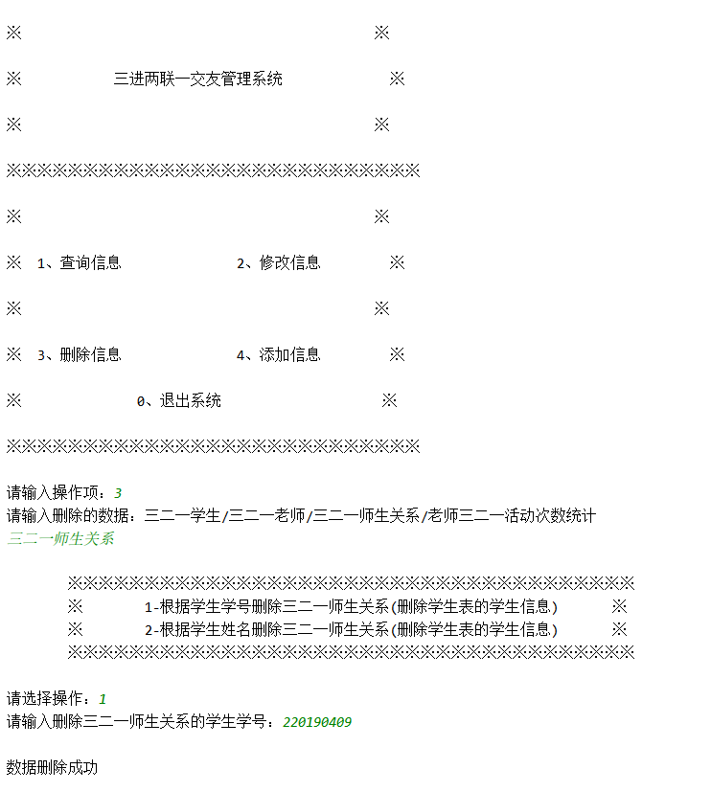
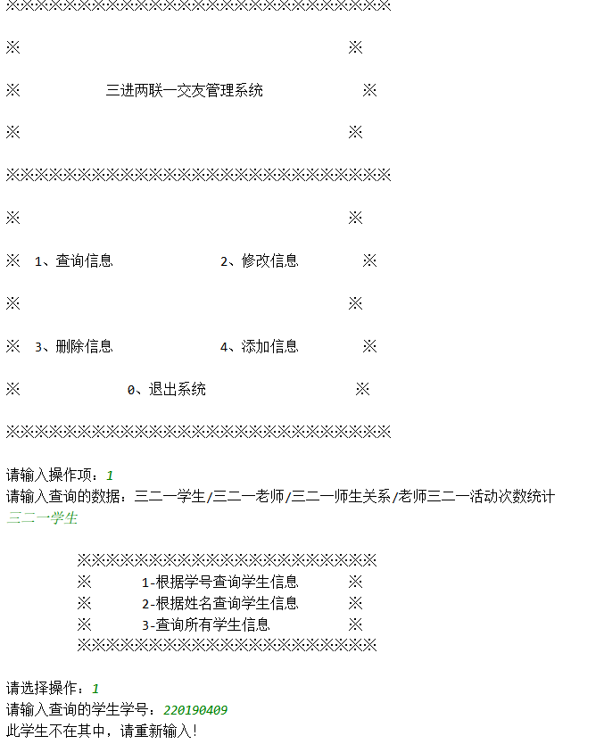

4.3.4 查询功能的实现
def get_data():
conn = sqlite3.connect('zjh.db')
cursor = conn.cursor()
content = input("请输入查询的数据：三二一学生/三二一老师/三二一师生关系/老师三二一活动次数统计\n")
if content == "三二一学生":
print('''
※※※※※※※※※※※※※※※※※※※※※
※ 1-根据学号查询学生信息 ※
※ 2-根据姓名查询学生信息 ※
※ 3-查询所有学生信息 ※
※※※※※※※※※※※※※※※※※※※※※
''')
number = int(input("请选择操作："))
while number < 1 or number > 3:
number = int(input('请重新选择操作：'))
if number == 1:
while True:
num = input('请输入查询的学生学号：')
if select_sno(num) != 1:
print("此学生不在其中，请重新输入！")
else:
break
cursor.execute("select * from student where sno = '%s'" % num)
res = cursor.fetchall()
for line in res:
print(line)
print('\n学生信息查询完成\n')
cursor.close()
conn.close()
elif number == 2:
while True:
name = input('请输入查询的学生姓名：')
if select_sname(name) != 1:
print("此学生不在其中，请重新输入！")
else:
break
cursor.execute("select * from student where sname = '%s'" % name)
res1 = cursor.fetchall()
for line1 in res1:
print(line1)
print('\n学生信息查询完成\n')
cursor.close()
conn.close()
elif number == 3:
cursor.execute("select * from student ")
res0 = cursor.fetchall()
for line0 in res0:
print(line0)
print('\n学生信息查询完成\n')
cursor.close()
conn.close()
elif content == "三二一老师":
print('''
※※※※※※※※※※※※※※※※※※※※
※ 1-根据工号查询教师信息 ※
※ 2-根据姓名查询教师信息 ※
※ 3-查询所有教师信息 ※
※※※※※※※※※※※※※※※※※※※※
''')
number2 = int(input("请选择操作："))
while number2 < 1 or number2 > 3:
number2 = int(input('请重新选择操作：'))
if number2 == 1:
while True:
num2 = input('请输入查询的教师工号：')
if select_tno(num2) != 1:
print("此教师不在其中，请重新输入！")
else:
break
cursor.execute("select * from teacher where tno = '%s'" % num2)
res2 = cursor.fetchall()
for line2 in res2:
print(line2)
print('\n教师信息查询完成\n')
cursor.close()
conn.close()
elif number2 == 2:
while True:
name2 = input('请输入查询的教师姓名：')
if select_tname(name2) != 1:
print("此教师不在其中，请重新输入！")
else:
break
cursor.execute("select * from teacher where tname = '%s'" % name2)
res3 = cursor.fetchall()
for line3 in res3:
print(line3)
print('\n教师信息查询完成\n')
cursor.close()
conn.close()
elif number2 == 3:
cursor.execute("select * from teacher ")
resz = cursor.fetchall()
for linez in resz:
print(linez)
print('\n教师信息查询完成\n')
cursor.close()
conn.close()
elif content == "三二一师生关系":
print('''
※※※※※※※※※※※※※※※※※※※※※※※※※※※※※
※ 1-根据教师工号查询三二一师生关系信息 ※
※ 2-根据教师姓名查询三二一师生关系信息 ※
※ 3-根据学生学号查询三二一师生关系信息 ※
※ 4-根据学生姓名查询三二一师生关系信息 ※
※ 5-查询所有三二一师生关系信息 ※
※※※※※※※※※※※※※※※※※※※※※※※※※※※※※
''')
number3 = int(input("请选择操作："))
while number3 < 1 or number3 > 5:
number3 = int(input('请重新选择操作：'))
if number3 == 1:
while True:
num3 = input('请输入查询的教师工号：')
if select_relative_tno(num3) != 1:
print("此教师不在其中，请重新输入！")
else:
break
cursor.execute("select * from relative where tno = '%s'" % num3)
res4 = cursor.fetchall()
for line4 in res4:
print(line4)
print('\n三二一师生关系信息查询完成\n')
cursor.close()
conn.close()
elif number3 == 2:
while True:
name3 = input('请输入查询的教师姓名：')
if select_relative_tname(name3) != 1:
print("此教师不在其中，请重新输入！")
else:
break
cursor.execute("select * from relative where tname = '%s'" % name3)
res5 = cursor.fetchall()
for line5 in res5:
print(line5)
print('\n三二一师生关系信息查询完成\n')
cursor.close()
conn.close()
elif number3 == 3:
while True:
num4 = input('请输入查询的学生学号：')
if select_relative_sno(num4) != 1:
print("此学生不在其中，请重新输入！")
else:
break
cursor.execute("select * from relative where sno = '%s'" % num4)
res6 = cursor.fetchall()
for line6 in res6:
print(line6)
print('\n三二一师生关系信息查询完成\n')
cursor.close()
conn.close()
elif number3 == 4:
while True:
name4 = input('请输入查询的学生姓名：')
if select_relative_sname(name4) != 1:
print("此学生不在其中，请重新输入！")
else:
break
cursor.execute("select * from relative where sname = '%s'" % name4)
res7 = cursor.fetchall()
for line7 in res7:
print(line7)
print('\n三二一师生关系信息查询完成\n')
cursor.close()
conn.close()
elif number3 == 5:
cursor.execute("select * from relative ")
res8 = cursor.fetchall()
for line8 in res8:
print(line8)
print('\n三二一师生关系信息查询完成\n')
cursor.close()
conn.close()
elif content == "老师三二一活动次数统计":
print('''
※※※※※※※※※※※※※※※※※※※※※※
※ 1-根据教师工号查询活动次数信息 ※
※ 2-根据教师姓名查询活动次数信息 ※
※ 3-查询所有教师三二一活动次数信息 ※
※※※※※※※※※※※※※※※※※※※※※※
''')
number4 = int(input("请选择操作："))
while number4 < 1 or number4 > 3:
number4 = int(input('请重新选择操作：'))
if number4 == 1:
while True:
num5 = input('请输入查询活动次数的教师工号：')
if select_calculate_tno(num5) != 1:
print("此教师不在其中，请重新输入！")
else:
break
cursor.execute("select * from calculate where tno = '%s'" % num5)
res8 = cursor.fetchall()
for line8 in res8:
print(line8)
print('\n教师信息查询完成\n')
cursor.close()
conn.close()
elif number4 == 2:
while True:
name5 = input('请输入查询活动次数的教师姓名：')
if select_calculate_tname(name5) != 1:
print("此教师不在其中，请重新输入！")
else:
break
cursor.execute("select * from calculate where tname = '%s'" % name5)
res9 = cursor.fetchall()
for line9 in res9:
print(line9)
print('\n教师信息查询完成\n')
cursor.close()
conn.close()
elif number4 == 3:
cursor.execute("select * from calculate")
res10 = cursor.fetchall()
for line10 in res10:
print(line10)
print('\n教师信息查询完成\n')
cursor.close()
conn.close()
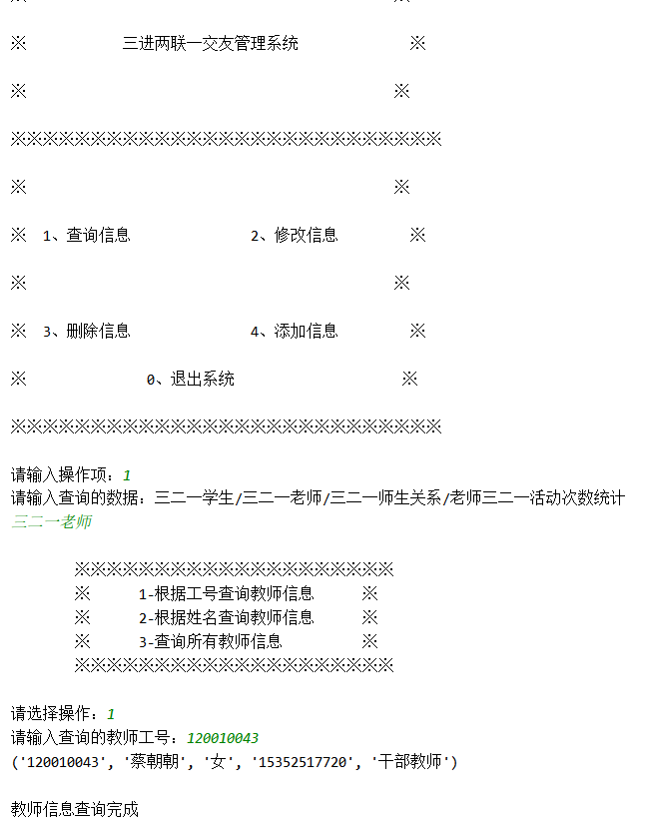
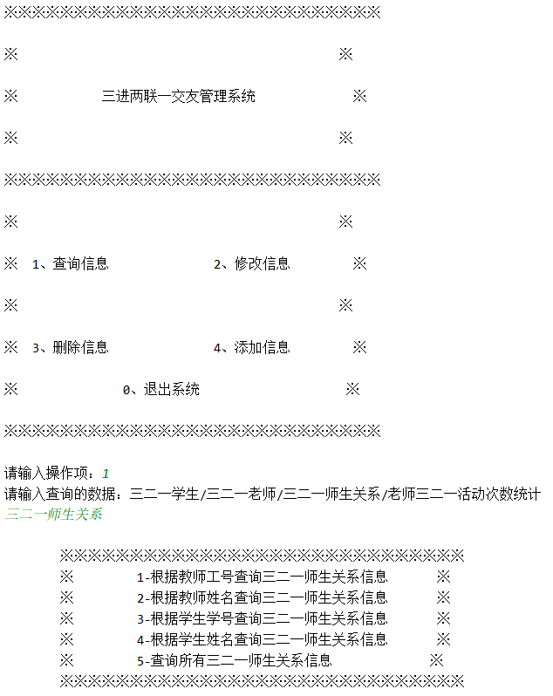
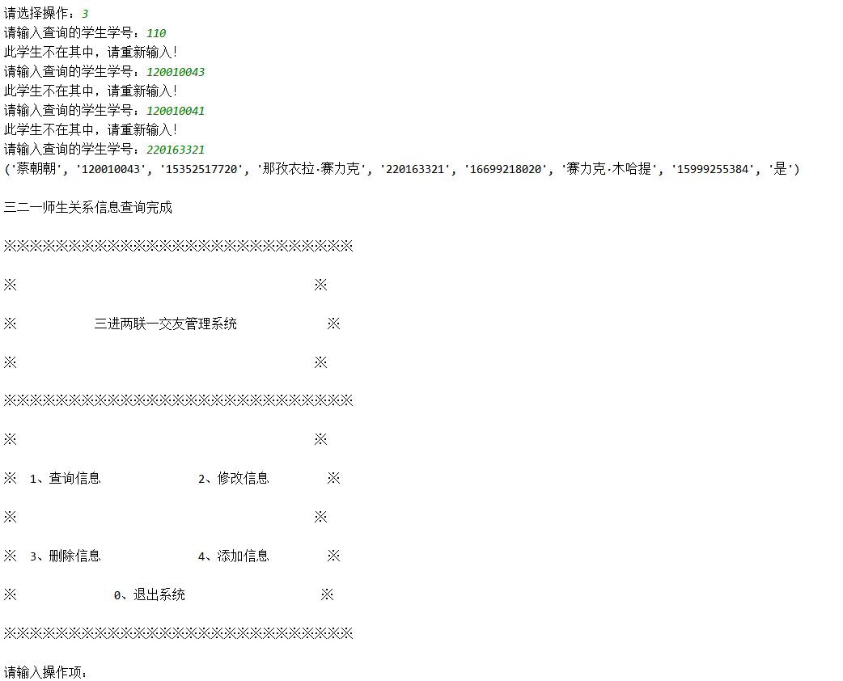

5 系统开发总结
本次课程设计我主要是将SQLite数据库导入Python，利用Python语句和SQL语句，向数据库增删改查信息。起初我是想将SQLite数据库导入VS，利用C语言控制台、Easy_x图形化界面包，弄成一个窗口化的三进两联一交友管理系统，因为之前做过推箱子、泡泡堂这样的窗口化小游戏，所以还是比较有把握去实现的，但是从网上查找配置环境方法鱼龙混杂，而且基本上都是导入MySQL与SQL Server，最终还是没有完成。因为Python内嵌了sqlite3，所以在使用它不需要安装其他东西，原本打算利用tkinter这个包实现图形化界面，可惜没有时间了，直接做一个控制台程序。
在整个过程其实还是蛮顺利的，对于在Python对sqlite3的使用，网上都有例子，其实在写数据库语句还是没有多大问题的。后来我想了一下，整个过程都是面向过程的，在创建主界面用到了类，对于学生表、教师表、师生关系表、活动次数表，其实可以均创建对象，其属性包含其学生学号、学生姓名、等变量和增删改查等函数方法，其实这样代码量是比面向过程的代码量多了很多的，所以就选择面向过程。
在每次进行查询、删除、添加、修改信息，都需要向数据库里去判断是否存在，利用Python语句cursor.fetchall()的返回一个二维元组，我导入第三方软件Navicat可以方便查看表与其中的内容，对二维元组索引便可判断该内容是否已经存在。在查看学生信息、老师信息等，我创建三个视图，选择其中的属性进行查询。同时，创建四个触发器，一旦删除与修改三二一师生关系的学生信息与教师信息，学生表也会删除与修改学生信息，教师表也会删除与修改教师信息，在创建表的语句下面创建触发器，在删除与修改函数的sql语句一旦触发，便会启动触发器，做到信息同步。这里的触发器语句和之前的增删改查语句是不一样的，在执行语句结尾要有;，在end后要添加;，这是与s增删改查sql在Python里不一样的，网上也并有找到这样的例子，也是摸索出来的。
本次课程设计从中收获颇多，对于不懂的方面需要动手去搜索摸索，对于本学期所学的SQL语句也更加熟练，也看到了不足之处，对于图形化界面、前端交互这方面其实还是欠缺的，和其他同学还是有差距的，还是应该提高学习之外的学习兴趣，不断地学习新的知识。

课程设计评分标准 | 项  目 | 评分标准 | 标准分 | 得分
课程设计评分标准 |  | 系统总体设计是否合理，需求分析是否正确。 | 10
课程设计评分标准 |  | 系统功能模块设计是否合理，内容是否全面。 | 10
课程设计评分标准 |  | 表的分析是否正确，创建是否正确。 | 10
课程设计评分标准 |  | 是否有数据库其他对象的创建，功能是否合理。 | 10
课程设计评分标准 |  | 功能实现是否全面，应用程序开发是否完整，是否存在bug，界面是否美观等。 | 20
课程设计评分标准 |  | 对系统描述是否完整正确，思路是否清晰，对知识点掌握是否全面，设计难度情况，是否具有分析问题能力，工作量如何，设计质量及是否具备一定的科研能力和水平。 | 20
课程设计评分标准 | 课  程  报  告 | 课程报告内容是否完整全面。 | 6
课程设计评分标准 | 课  程  报  告 | 课程报告内容是否正确，分析是否透彻。 | 8
课程设计评分标准 | 课  程  报  告 | 课程报告纸质版文档格式是否规范。 | 3
课程设计评分标准 | 课  程  报  告 | 课程报告文档是否按时提交。 | 3
总分 |  |  | 100

指导教师签字：
年 月 日

