|  |  |
| --- | --- |
|  |  |
|  | DUNGEOON OF DOOOM  REPORT V01 |

|  |
| --- |
| [TEAM MEMBERS]  MATTSI JANSKY  ARYA ramdev  SELIN KUTLAMIS  TASOS GEMTOS  QIAN ZHOU  XIAOXIAO FAN |

PROJECT OVERVIEW

The **problem is creating multi-player online game with agile development practices. The goal is complete the game until 16 December 2016 with a 3-tier architecture and TDD analysis while working in pairs. Team is working together in requirements analysis. For coding, operation team is divided into three. Experienced programmers Mattsi and Tasos lead the team in technical issues. They work in both front and back end side. Selin and Arya work on front-end side. Qian and Xiaoxiao had an experience on graphical design they are responsible for the map creation. After sprint 5 pair groups are assigned by one experienced programmer and one unexperienced programmer. By doing this experience programmer can share his/her experience with other team member and unexperienced programmer can check the code if there is any mistake. Sprint and customer meetings are weekly happened.**

READER’S GUIDE

1. Customer Requirements

This document contains the first version requirements for Dungeon of Dooom. These requirements have been derived from Moodle.

1.1 Types of Reader

Our readers are Senior Lecturer Julian Padget and Charlie Ann Page.

1.2 Technical Background Required

To understand code’s structure and development phases, readers should have knowledge on computer science.

1.3 Scope of the Project

To analyse, specify, design and implement a multi-player on-line game.

2. Requirement Analysis

To determine requirements, a team was gathered. Scrum meetings are done for weekly. For agile development phases, Trello is installed in every team member’s computer. Github accounts are created for each team member.

3. Meeting Notes with Customer

3.1 Target and Budget of the Project

According to customer meeting notes; target is everyone. It is an online game and it is not requiring any technical background, training or education. There is no specific budget according to customer meetings.

3.2 General Constraints

Customer didn’t specify any specific languages. So in the sprint, team decided to use Java. For tile creation and parsing JSON is decided to use. For interface applications html and JavaScript are chosen. IntelliJ platform is installed.

3.3 Assumptions and Dependencies

Finished product can be delivered over the internet. No need for specific skills to play the game. Project should be finished until 16 December 2016.

Initial Process Of The Project Development

For the sprint 0, project team started to produce project diaries. A project diary template is prepared. Project meeting minutes were added. For the sprint 1 based on these functional specifications initial uses cases were created. Each team member should create use case. In addition to these, product timescale document is written. Participants whose experiences vary decide to how much time is needed for completing tasks.

Producing Project Timescale

Project timescale is created by Windows Excel.

**Graphic 1. Product Timescale**

|  |  |  |  |  |  |  |  |  |
| --- | --- | --- | --- | --- | --- | --- | --- | --- |
| Sprint | Effort points | Sprint 0 | Sprint 1 | Sprint 2 | Sprint 3 | Sprint 4 | Sprint 5 | Sprint 6 |
| Date | **1 = 0.5 day** | **31/10/16** | **7/11/16** | **14/11/16** | **21/11/16** | **28/11/16** | **5/12/16** | **12/12/16** |
| Milestones |  | **Start** |  |  | **Start Coding** | **Basic Functionality** | |  |
| Login Function. | **3** |  |  |  |  | **X** |  |  |
| Regist. Function. | **3** |  |  |  |  | **X** |  |  |
| Login/Registration Layout | **1** |  |  |  | **X** |  |  |  |
| Menu Design | **2** |  |  |  | **X** |  |  |  |
| Menu Tutorial | **2** |  |  |  | **X** |  |  | **X** |
| Score Layout | **2** |  |  |  | **X** |  |  |  |
| Leaving (exit by menu) | **4** |  |  |  |  |  |  | **X** |
| Timeout (exit by absence) | **2** |  |  |  |  |  |  | **X** |
| Design map JSON | **4** |  |  |  | **X** |  |  |  |
| Parse map JSON | **4** |  |  |  |  | **X** |  |  |
| Model map in code | **2** |  |  |  |  | **X** |  |  |
| Render the map in client | **3** |  |  |  |  | **X** |  |  |
| Create player model in server | **2** |  |  |  |  | **X** |  |  |
| Comm. Between ser/cli | **4** |  |  |  |  |  | **X** |  |
| Visibility- server | **4** |  |  |  |  |  | **X** |  |
| Visibility- client | **4** |  |  |  |  |  |  | **X** |
| Move.- update playrPos | **2** |  |  |  |  |  | **X** |  |
| Score- model | **4** |  |  |  |  |  | **X** |  |
| Score- calculate | **1** |  |  |  |  |  | **X** |  |
| Score- add coin | **2** |  |  |  |  |  |  | **X** |
| Setup database | **2** |  |  |  | **X** |  |  |  |
| Add winning condi. | **4** |  |  |  |  |  |  | **X** |
| Sprint effort | **61** |  |  |  | **12** | **16** | **16** | **17** |

**Table 1. Effort Table**

Functional Requirements

1. The user must log in to play the game.
   1. If the player is not registered to the game, he can register by giving a username, a password.
2. The user chooses options from a menu (single, multiplayer, score or tutorial)
   1. If player selects single player game, he enters the level selection screen.
   2. If player selects multiplayer game, he enters the level selection screen.
   3. If player selects score, he sees the scoreboards.
   4. If player selects tutorial, the player sees the instructions of the game.
   5. If player can select exit or closes the tab.
3. The world is loaded on the server’s memory.
4. The player can see a part of the dungeon (explored tiles), other players (human or bots), gold coins, passages and exit.
   1. A dungeon is a collection of rooms that are connected with passages. A room may have gold coins.
   2. A dungeon can be arbitrary size.
   3. Dungeon must contain the minimum gold coins so the player can win.
5. Player interacts with the dungeon:
   1. Indicating which way to move (UP, DOWN, LEFT, RIGHT)
   2. Picking up gold.
   3. Player can move around to reveal the room.
   4. Leaving the game.
6. Winning Condition:
   1. If the player collects all the gold coins, needed to win, and find the exit, player wins.
   2. Else if another player wins first or the player gives up, the player loses.
7. After winning condition, the player goes to result screen.

Use Cases and User Stories Creation

Use Case 1 – Log in

As a player, I want to login for seeing main menu

* User can view the login page.
* User can enter a username and password for login to the game.
* User can view fail screen if error is happened.

|  |
| --- |
| Actor Actions |
| 1. Open the game page. |
| 1. Input the username and password. |
| 1. Press “OK” button. |

Table 2. Actor Actions in Login

|  |
| --- |
| System Actions |
| 1. System displays the login page |
| 1. System displays the error message if there is an error. |

Table 3. System Actions in Login

Use Case 2 – Registration

As a player, I want to register for returning login page.

* User can view the register page.
* User can enter username, password1 and password2 for playing the game.
* User can view warning messages if s(he) enters wrong information.

|  |
| --- |
| Actor Actions |
| 1. Open the registration page. |
| 1. Input the username, password1 and password2. |
| 1. Press “OK” button. |

**Table 4. Actor Actions in Registration**

|  |
| --- |
| System Actions |
| 1. System displays the registration page. |
| 1. System displays the username and both passwords. |
| 1. System displays the warning messages if there is a wrong information. |

**Table 5. System Actions in Registration**

Use Case 3 – Main Menu

As a player, I want to see the main menu to choose player type.

* User can enter the main menu.
* User can select between two options single and multiplayer for playing the game.
* User can view level section for match.
* User can view dungeon after selection of level.
* User can play the game after seeing map.
* User can select score table for seeing the score.
* User can select tutorial to learn how to play.
* User can exit or log out from the system for returning login page.

|  |
| --- |
| Actor Actions |
| 1. Begins when player click single player of multiplayer button |
| 1. The user selects a match to play in. |

**Table 6. Actor Actions in Main Menu**

|  |
| --- |
| System Actions |
| 1. System displays the main menu. |
| 1. System displays the types of the players. |
| 1. System displays the level selection. |
| 1. System displays the score table,tutorial and exit options. |

**Table 7. System Actions in Main Menu**

Use Case 4 – World Creation

As a player, I want to see the world which consists of rooms, passages and golds.

* User can view the dungeon which consists of rooms for playing.
* User can view the rooms, passages which connect rooms.
* User can view the golds in the rooms for earning points.
* User can view the arbitrary size of rooms based on his/her level.
* User can see the minimum numbers of gold coins for winning the game.

|  |
| --- |
| Actor Actions |
| 1. Begins when player selects a match. |

**Table 8. Actor Actions in the World**

|  |
| --- |
| System Actions |
| 1. System displays the dungeon. |
| 1. System displays the rooms, passages and coins. |
| 1. System displays minumum number of gold coins for winning the game. |

**Table 9. System Actions in Dungeon**

Use Case 5 – Movement

As a player, I want to move in the dungeon for entering rooms and collect coins.

* User can move in the dungeon and go to rooms with passages.
* User can view the walls which block the direction.

|  |  |  |
| --- | --- | --- |
| |  | | --- | | Actor Actions | | 1. Begins when player presses movement key | |

**Table 10. Actor Actions in Movement**

|  |  |  |
| --- | --- | --- |
| |  | | --- | | System Actions | | 1. System displays the movement of the player in the dungeon. | |

**Table 11. System Actions in Movement**

Use Case 6 – Coins

As a player, I want to picking up gold coins for winning the game.

* User can move to a tile and collects the coins in the room for scoring.

|  |
| --- |
| Actor Actions |
| 1. Player begins to move to a gold coin. |

**Table 12. Actor Actions in Coins**

|  |
| --- |
| System Actions |
| 1. System displays the coins in the rooms. |

**Table 13. System Actions in Coins**

Use Case 7 – Map visibility

As a player, I want to see the map.

* User can view the map while moves around the dungeon.
* User can go from one tile to another for discover map layout.

|  |
| --- |
| System Actions |
| 1. System displays map and tiles. |

**Table 14. System Actions in Map**

Use Case 8 – Exit

As a player, I want to leave the game for stopping.

* User can view the exit option in the game.
* User can return to the main menu by using exit option.

|  |
| --- |
| Actor Actions |
| 1. The player presses the exit button. |

**Table 15. Actor Actions in Exit**

|  |
| --- |
| System Actions |
| 1. System displays the exit option. |

**Table 16. System Actions in Exit**

Use Case 9 – Winning Condition

As a player, I want to win by getting all coins.

* User can view the winning status.
* User can return Main map to select different level.
* User can win the game by passing through exit.
* User can view the scoreboard; unlock the new level in the result screen with details which include time, coins or other entities player collected.
* User can view “You lose” message and return to result screen if another user exits first.

|  |
| --- |
| Actor Actions |
| 1. The player won the game. |

**Table 17. Actor Actions in Winning Condition**

|  |
| --- |
| System Actions |
| 1. System displays the status of the game. |
| 2. System displays the Main map with levels. |
| 3. System displays the scoreboard with details. |
| 4. System displays the “You lose” message if another user exists first. |

**Table 18. System Actions in Winning Condition**

Process of the Use Case Creation

* User stories are great for understanding of what actually clients want. Development teams can ask who, what and why questions to the clients to understand their requirements. It should be written in non-technical format. By creating user stories, target goals can be reached more efficiently (Writing effective use case, 2016). According to Cockburn in the use cases; actors have goals under the declared system responsibilities. And scenarios have a particular result with the respect to the goal.
* For Dungeon of Dooom game, user stories are discussed in the brain-storming sessions in the sprint meetings.
* Cases are written on the blackboard.
* As a result of the first discussion, in an online game, player should see firstly login and registration. For making process simpler, in the login page, only username and password should be entered. If player is not registered, then player should be linked to register page. Team decided asking only username and two passwords from user.
* Scenarios are created according to what if user wants to exit in the main page. Then exit in the main login is decided, which is connected to login page.
* In one of the user scenario, new users won’t know how to play the game. Based on this, creating tutorial decision is made.
* Movement scenario includes which characters in the keyboard will be used and movements are made until players encounter with the wall.
* Game should be over when all specified gold coins are collected and exit door is reached by the player. Coin use case is created as a result of this.
* Team decided to add three levels to the game. Unlocking other levels are counted as additional features and not implemented yet.
* Ending of the game is discussed then exit use case is created.
* All of the team members contributed the use cases and came up with the different ideas. And tell their ideas in front of the blackboard.

REPORT V.02

CRC Cards

|  |  |
| --- | --- |
| **Responsibilities** | **Collaboration** |
| **Class: Player** | |
| Username  Password  Level  Type | Character  Score |
| **Class: Score Table** | |
| Score  Calculate  Max  ID (time-stamp) | Player |
| **Class: Level** | |
| Load from file | Dungeon  Match  Coins |
| **Dungeon** | |
| Size  Name  Number of coins | Character  File  Level |
| **Character** | |
| Position  Gold coins collected  Movement  Track collected coins | Player  Score |
| **Tile** | |
| Type  Visibility | Dungeon |
| **Match** | |
| Check  Victory  Condition | Score |

Process of Creating CRC Cards

* CRC cards useful in OO paradigm. Cards represent class of objects, its behavior and its relationships. There is no universal syntax for CRC cards *(*Introduction to CRC cards, no date). According Alshehri and Benedicenti from University of Regina creating CRC cards are the way of measuring the quality of the your product and ensuring about design simplicity. (Prioritizing CRC cards as a simple design tool in extreme programming,2016)
* After development of the use cases, in the sprint 1 meeting, investigation of CRC cards is done by team. Participants have read and familiarized themselves the documentations. For the next meeting, each team member came up with a CRC card case based on their use case. Each CRC card is converted from the use cases. Domain experts are leading to team to make correct assumptions.
* In the brain storming session team decided, each player should have four different responsibilities: Username, password, level and type (single or multiplayer). Each player should have a relationship with character and the score.
* After score relationship is added for the player, CRC card of score table is created. It has an id and for each player and a max score should be calculated and should be shown in ascending order in the score table. Basically responsibilities are decided based on which class will affect the system more? Score table will be affected from the player.
* Level CRC card should have collaboration with match, dungeon and coins. Classes are created with the idea of "what happens when...” like “What is going to be happen when all the coins are collected? Should new level will unlock?”
* Dungeon CRC card should have size, name and number of coins.
* For the character CRC Card “How position will change based on movement?” Tile type is defined like wall, passage and extra items. Tile should have a relationship and collaboration with the dungeon.
* For the last CRC card new ideas (“What is going to happen to the match after win condition?” and “How lose conditions are specified?”) are decided. Every match should have a relationship with score.
* At the end we had a live prototyping, identified the holes in the requirements and now we can continue with the other uses cases by using these CRC cards.

Uses Cases with Server and Client Relations

Use Case 1 – Login with System and Client Relationship

UC1-1: Use Case: Log In

UC1-2: Author: QZ, XF

UC1-3: Date: Sprint 3

UC1-4: Purpose: Log in to the play the game

UC1-5: Overview: System requests username and password for login. System validates username and password (if the username and password already exists in the player database) then player enters the Main Menu Screen.

|  |  |  |
| --- | --- | --- |
| **Actor Actions** | **Client System Actions** | **Server System Actions** |
| 1. **Open the game page.** |  |  |
| 1. **Input the username and password.** |  |  |
| 1. **Press “OK” button.** |  |  |
|  | 1. Sends the username and password to server. |  |
|  |  | 1. Check if the username already exists in the membership database and validates the password. |
|  |  | 1. Sends response. |
|  | 1. Receives and parses the response. |  |
|  | 1. Jump to the main menu interface. |  |

UC1-10: Alternative flow of events:

Step 5: Username and password is not in the player database. Display an error message, and ask player to reenter their credentials.

UC1-11: Exceptional flow of events:

Steps 4, 6, 7: If the connection with the server is not established return an error message.

Use Case 2 – Registration with Server and Client Relationship

UC2-1: Registration

UC2-2: Author: AG

UC2-3: Date: Sprint 3

UC2-4: Purpose: Player registers to the game

UC2-5: Overview: The user fills a form with his desired username and desired password. If the username and password does not exist on the system’s database, then the system saves these details and returns to log in screen.

**Alternative 1:** if username and password exists in database, then an appropriate message is returned to the user and the user must pick a different username or password.

**Alternative 2:** if the email does not contain “@” and “.” characters the client must give an appropriate message.

UC2-6: Cross Reference: Functional Requirements R1.1, R1

UC2-7: Actors: Player

UC2-8: Pre-Conditions:

UC2-Pre-1: The registration web page must be loaded.

UC2-Pre-2: The player must not have an account.

UC2-9: Post-Conditions:

UC2-Post-1: The player returns to log in screen.

UC2-Post-2: The player’s information is stored into the server’s database.

|  |  |  |
| --- | --- | --- |
| **Actor Actions** | **Client System Actions** | **Server System Actions** |
| 1. **Open the registration page.** |  |  |
| 1. **Input the username, the email and the password.** |  |  |
| 1. **Press “OK” button.** |  |  |
|  | 1. Sends the username, and password to server. |  |
|  |  | 1. Stores the username and the password to system’s database. |
|  |  | 1. Sends response. |
|  | 1. Receives and parses the response. |  |
|  | 1. Jump to the log in page. |  |

UC2-9: Alternative flow of events:

Step 5: Username or password already exists on the system’s database. Appropriate message is returned to the player so the player can pick different username or password.

UC2-9: Exceptional flow of events:

Step 4, 6, and 7: If the connection with the server is not established return an error message.

Use Case 3 – Main Menu with Server and Client Relationship

UC3-1 Use Case: Player Choose Menu

UC3-2 Author: XF, QZ

UC3-3: Date: Sprint 3

UC3-4: Purpose: The user chooses options from the main menu.

UC3-5: Overview: The player must select a match level he wants to play in, the client sends a request to server and the server sends dungeon data to the client. The user is prompted into the dungeon map and starts playing the game.

**Alternative 1**: if the player selects score, the game client sends a request to the server to retrieve the score table from the database. The server sends the data back to client.

**Alternative 2**: if the player selects the exit button, the player logs out of the system and returns to log in screen.

UC3-6: Cross References: Functional Requirements R2, R2.1, R2.2, R2.3, R2.4, R2.5

UC3-7: Actors: Player

UC3-8: Pre-Condition:

UC3-Pre-1: The player must be in menu (i.e. not the dungeon).

UC3-Pre-2: The player must already be logged in.

UC3-9: Post Condition:

UC3-Post-1: The player is sent to appropriate web page based on his/her action.

Single/Multiplayer

|  |  |  |
| --- | --- | --- |
| Actor Actions | Client System Actions | Server System Actions |
| 1. Begins when player click single player of multiplayer button |  |  |
|  | 1. Sends button request to the server |  |
|  |  | 1. The server initiates the player’s session. |
|  | 1. Jumps to level selection web page. |  |
| 1. The user selects a match to play in. |  |  |
|  | 1. The client sends a request to the server |  |
|  |  | 1. The server responds with dungeon data. |
|  | 1. Client receives the response and creates a graphical representation of the data. |  |

Score

|  |  |  |
| --- | --- | --- |
| Actor Actions | Client System Actions | Server System Actions |
| 1. Begins when player click score button |  |  |
|  | 1. Sends button request to server |  |
|  |  | 1. Retrieve the scoreboard from database. |
|  | 1. The user is prompted to score table web page and shows the data. | 1. Send response |

Tutorial

|  |  |  |
| --- | --- | --- |
| Actor Actions | Client System Actions | Server System Actions |
| 1. Begins when player click Tutorial button |  |  |
|  | 1. The user is prompted to tutorial page. |  |

UC3-9: Alternative flow of events:

UC3-10: Exception flow of events:

In steps where the client sends a request or the server sends a response, if the client does not receive any response in time, appropriate message should be displayed.

Use Case 4 – World Creation with Server and Client Relationship

UC4-1 Use Case: World Creation

UC4-2 Author: SK

UC4-3: Date: Sprint 3

UC4-4: Purpose: To create map, dungeon, coins, passages

UC4-5: Overview: The client sends a request to server to retrieve graphical representation of the dungeon.

UC4-6: Cross Reference: Functional Requirements R3, R4, R4.1, R4.2, R4.3

UC4-7: Actors: Player

UC4-8: Pre-Condition:

UC4-Pre-1: The player must select a match.

UC4-Pre-2: The player must already log on.

UC4-9: Post Condition:

UC4-Post-1: Player enters the game map and sees a graphical representation of the dungeon.

|  |  |  |
| --- | --- | --- |
| Actor Actions | Client System Actions | Server System Actions |
| 1. Begins when player selects a match. |  |  |
|  | 1. Sends button request to server |  |
|  |  | 1. Dungeon is created with rooms, passages and coins. Server saves this information on its memory. |
|  |  | 1. Sends response with visible area by the player |
|  | 1. Receives and parses response |  |
|  | 1. The client draws the graphical representation of the dungeon. |  |

Use Case 5 – Movement with Server and Client Relationship

UC5-1 Use Case: Player Moves Character

UC5-2 Author: AG, MJ

UC5-3: Sprint3

UC5-4: Purpose: Move the player in one of the four directions

UC5-5: Overview: The player character’s location is a particular point on the map. The Player presses one of the keys W, A, S or D and arrow keys. These keys map to up, left, down, right respectively. The game client sends a request to the server with the details on the action. The server validates this input and decides whether or not the player character can move in that direction. If the character can be moved the server updates the character’s position in-memory. The server responds with the current location of the character. The client updates the dungeon graphical representation.

**Alternative 1:** A wall is blocking the direction that the player wishes to move their character in. The server does not update the player’s position and responds with the current player location the same as it was.

UC5-6: Cross References: Functional Requirements R5, R5.1

UC5-7: Actors: Player

UC5-8: Pre-Condition:

UC5-Pre-1: The player must be in a dungeon (i.e. not the menu).

UC5-Pre-2: The map has been loaded.

UC5-9: Post Condition:

UC5-Post-1: The player’s position is the player’s previous position moved one unit in the chosen direction.

UC5-Post-2: The client’s graphical representation has updated.

|  |  |  |
| --- | --- | --- |
| Actor Actions | Client System Actions | Server System Actions |
| 1. Begins when player presses movement key |  |  |
|  | 1. Sends movement request to server |  |
|  |  | 1. Checks whether or not the player can move in that direction. |
|  |  | 1. Sends response |
|  | 1. Receives and parses response |  |
|  | 1. Updates dungeon graphical representation |  |

UC5-10: Alternative flow of events:

Step 3: The movement is illegal. Server doesn’t update player location, responds with player in the same location.

UC5-11: Exception flow of events:

Steps 2, 4, 5: The request or response network packets are dropped or corrupted. Sender sends a request for the current state of the system. If that request fails, the client displays an appropriate message regarding network connectivity problems to the player.

Use Case 6 – Coins with System and Client Relationship

UC6-1: Use Case: Picking up Gold coins

UC6-2: Authors: AG, MJ

UC6-3: Date: Sprint 3

UC6-4: Purpose: Moves to gold coin to collect it.

UC6-5: Overview: The player moves to a tile with a gold coin on it. The server responds that the gold coin in no longer in its previous position, it increments player’s gold coin collection and moves the player to the location of the coin. The client updates the dungeon graphical representation.

UC6-6: Cross References: Functional Requirements R5, R5.2

UC6-7: Actors: Player

UC6-8: Pre-condition:

UC-6-Pre-1: The player must be in a dungeon (i.e. not in the menu)

UC-6-Pre-2: The player should be one unit away from the gold coin.

UC6-9: Post-condition:

UC-6-Post-1: The player’s gold coin collection is incremented.

UC-6-Post-2: The player moves to the updated location.

UC-6-Post-3: The client updates the dungeon graphical representation.

|  |  |  |
| --- | --- | --- |
| Actor Actions | Client System Actions | Server System Actions |
| 1. Player begins to move to a gold coin. |  |  |
|  | 1. The client sends a request to the server. |  |
|  |  | 1. The server receives the request. |
|  |  | 1. The server validates the action. |
|  |  | 1. The server increments player’s gold coin collection. 2. The server updates gold coin location. 3. Sends response |
|  | 1. Receives and parses the response 2. Updates the graphical representation. |  |
|  |  |  |

Use Case 7 – Map visibility with System and Client Relationship

UC7-1 Use Case: Player movement reveals the map

UC7-2 Author: AG, MJ

UC7-3: Date: Sprint 3

UC7-4: Purpose: To discover the layout the dungeon

UC7-5: Overview: The player character is moving from one tile to another. The server decides which tiles are visible to the player character. The server response includes the current state of the tiles now visible to the player character. The client adds these tile states to its memory. The client remains aware of previously discovered tiles but may not be aware of their current state, i.e. whether another player has moved their character to that location. The client updates the graphical representation including the newly visible tiles.

UC7-6: Cross References: Functional Requirements R5, R5.3

UC7-7: Actors: Player

UC7-8: Pre-Condition:

UC7-Pre-1: The player must be in a dungeon (i.e. not the menu)

UC7-Pre-2: The player is in a state of moving from one tile to the next

UC7-9: Post Condition:

UC7-Post-1: The client updates its memory with new tile states.

UC7-Post-2: The client now displays additional tiles that may not have been previously visible.

|  |  |  |
| --- | --- | --- |
| Actor Actions | Client System Actions | Server System Actions |
|  |  | 1. Begins when the server interprets a move command |
|  |  | 1. Decides which tiles are visible to the character |
|  |  | 1. Responds to move request, including the current state of tiles now visible to the player character |
|  | 1. Receives and parses the response |  |
|  | 1. Adds the updated and/or new tiles to its memory |  |
|  | 1. Updates the graphical representation |  |

Use Case 8 – Exit with System and Client Relationship

UC8-1: Use Case: Leaving the Game

UC8-2: Authors: AG, MJ

UC8-3: Date: Sprint 3

UC8-4: Purpose: To exit the game.

UC8-5: Overview: The player presses a button to return to the main menu. The client sends a request to server to terminate the session. The server removes the player’s character.

UC8-6: Cross References: Functional Requirements R5, R5.4

UC8-7: Actors: Player

UC8-8: Pre-condition:

UC-8-Pre-1: The player must be in a dungeon (i.e. not in the menu)

UC-8-Pre-2: The player presses the leave button

UC8-9: Post-condition:

UC-8-Post-1: The player returns to main menu

UC-8-Post-2: The server removes the player from the game.

|  |  |  |
| --- | --- | --- |
| Actor Actions | Client System Actions | Server System Actions |
| 1. The player presses the leave button. |  |  |
|  | 1. Sends request to the server. |  |
|  |  | 1. Receives the request. |
|  |  | 1. Removes the player’s character. |
|  | 1. Returns to main menu. |  |

UC8-11: Exception flow of events:

Step1: The player closes the browser to exit the game. The server notices that the client has not sent any request within a time limit and removes the player’s character.

Use Case 9 – Winning Condition with System and Client Relationship

UC9-1: Use Case: Winning condition

UC9-2: Authors: AN

UC9-3: Date: Sprint3

UC9-4: Purpose: To show the winning status and Main map with levels.

UC9-5: Overview: The player won the game by passing through exit. The client sends the request to update the score. Server starts processing request. Server updates the results in scoreboard, and sends a response back to client to show the result screen with details which include time, coins or other entities player collected. Client displays the main map to player, which shows the levels with an option to return to main menu.

UC9-6: Cross References: Functional Requirements R6, R6.1, R6.2, R7

UC9-7: Actors: Player

|  |  |  |  |  |
| --- | --- | --- | --- | --- |
| Actor Actions | | Client System Actions | Server System Actions | |
| 1. The player won the game. | |  |  | |
|  | 1. Sends the updated result to the server. |  | |
|  |  | 1. Receives the request. | |
|  |  | 1. Update the scoreboard. 2. Sends the result screen. | |
|  | 1. Shows the result screen 2. Shows the main map with levels 3. Returns to main menu. |  | |

UC9-11: Exception flow of events:

Step1: If player loses the connection to the network after winning the game, client waits for a specified amount of time. If player comes back, client sends request to server and steps 2-8 will carry on. If the server hasn’t got any request within the time limit, then server will remove the player’s character.

UML Diagrams

UML diagrams are created with Creatly Online Diagram Software Tool. According to use cases definition there should be two sides in the system: server and client side. Client side is separated with model, controller. Model has main attributes of the uses cases. View side is the screen and results that are shown to the actors in the game. For the server side, controllers are used for keep tracking of movement, state, position and the services of match. In addition to these database should keep the records of the game.

//can be more

4.1 Client Side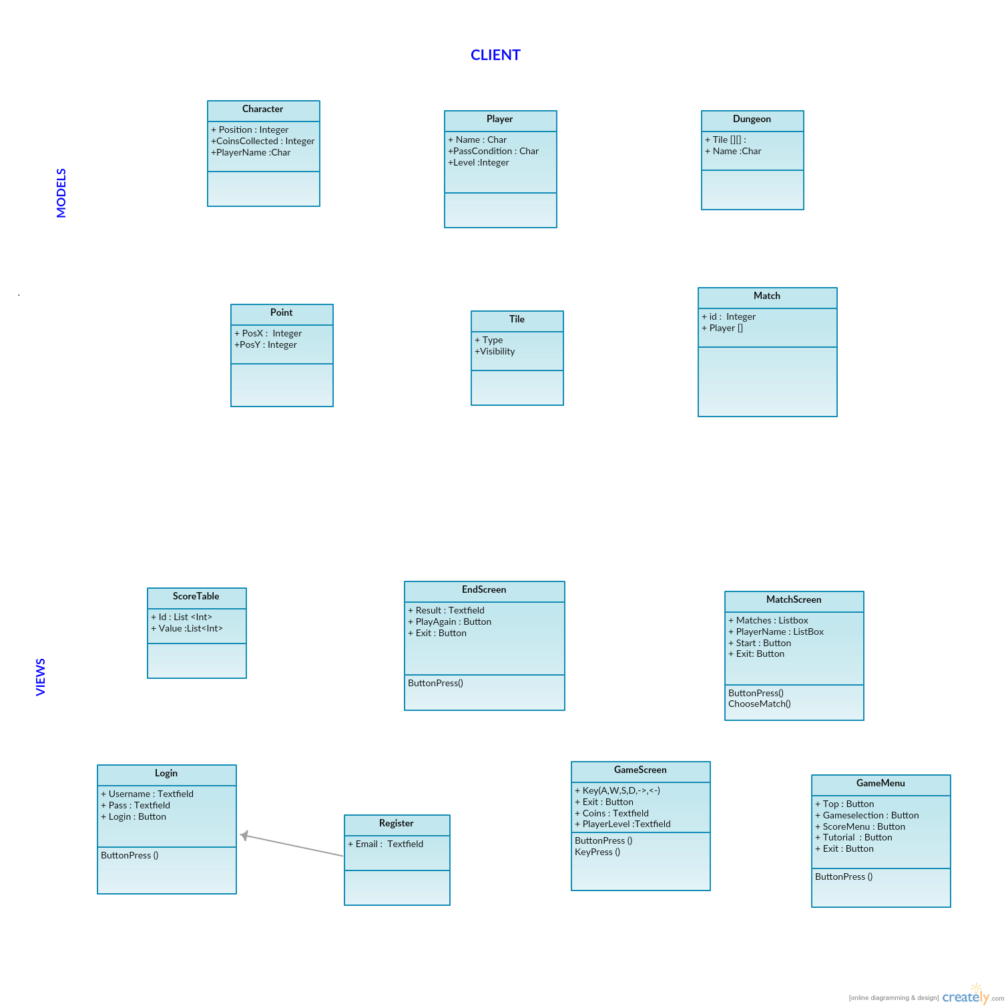

4.2 Server-side Controllers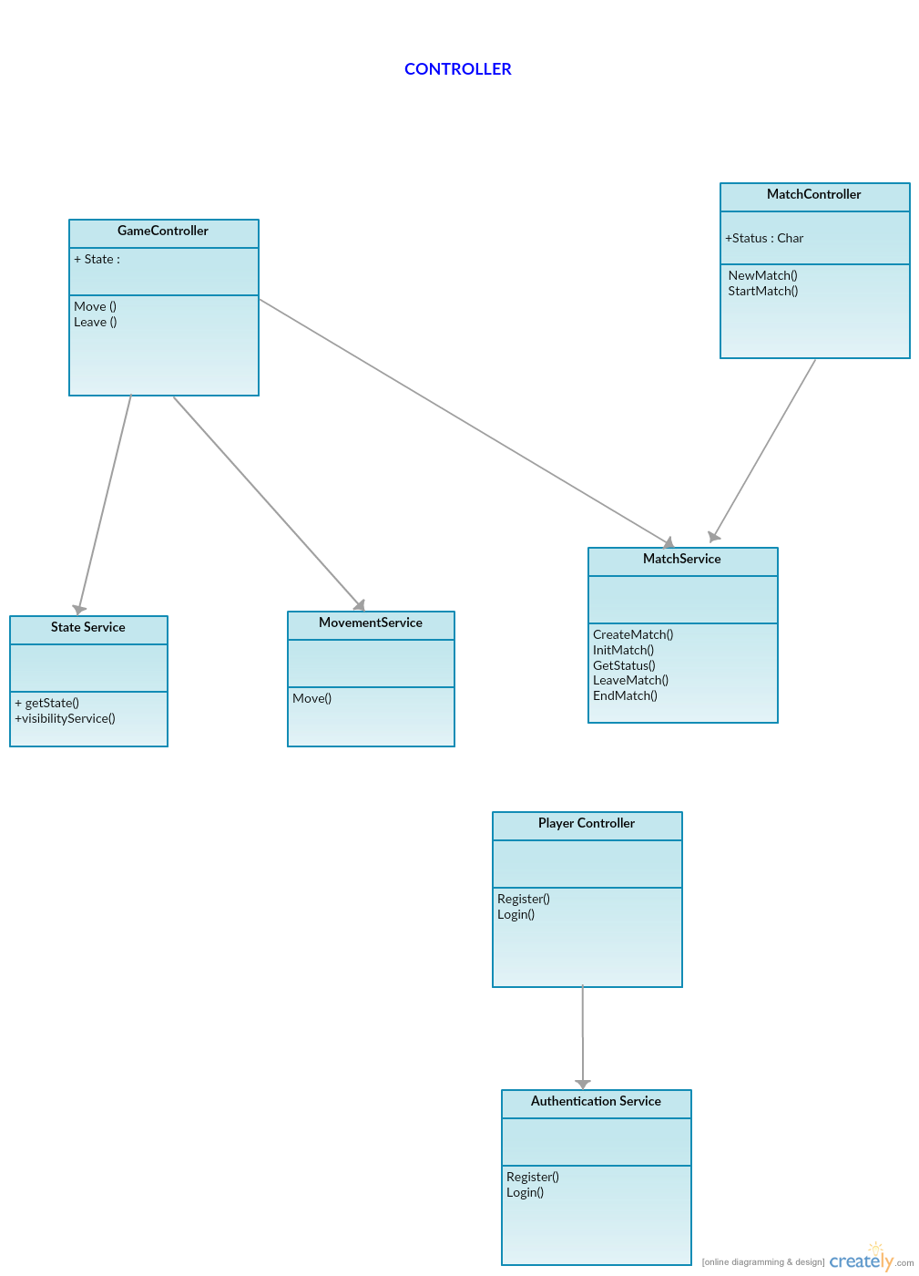

4.3 Server-Side Models & Database

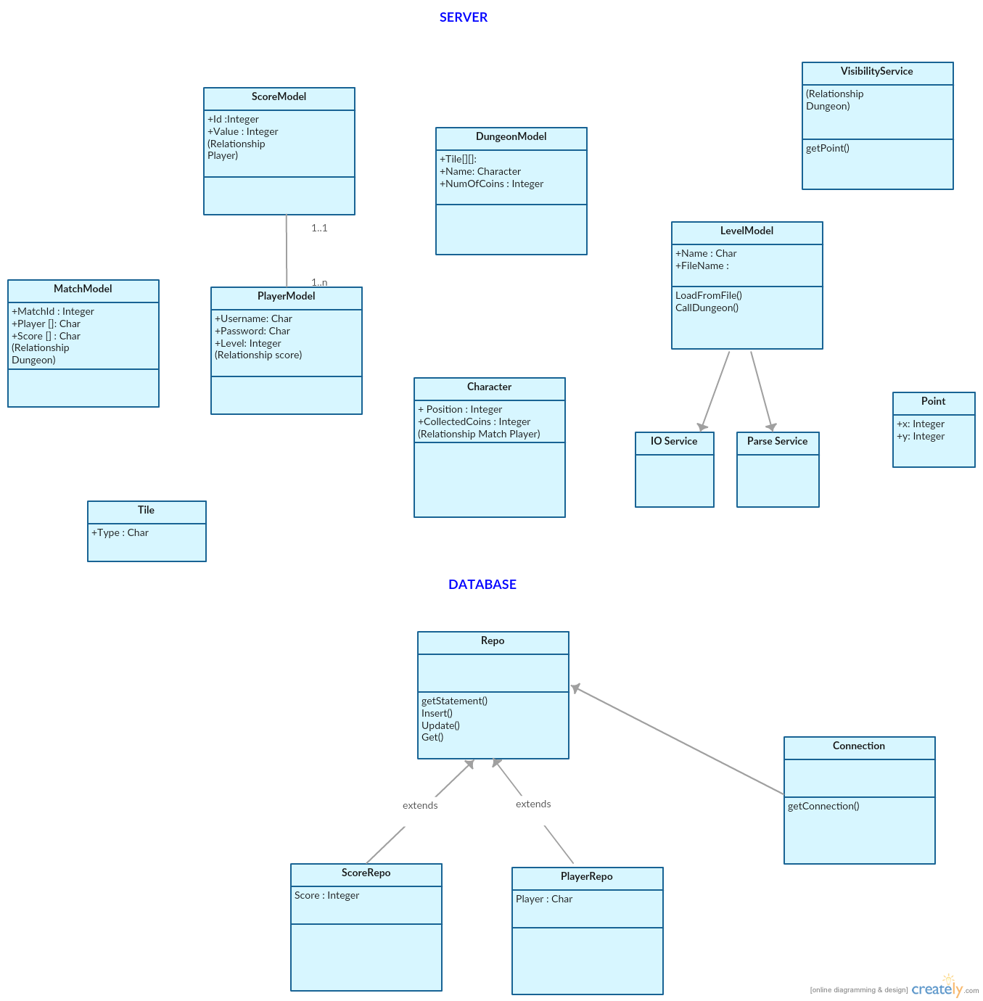

After the development of UML diagrams, system is ready for development. Now proper system components should be selected based on nonfunctional requirements. In third sprint,

Team discussed about what languages, components should be used for both front-end and back-end. How should MVC be implemented? Which database is more suitable for java connection? How design layouts should be implemented?

Defining Non-Functional Requirements

System consists of 3 components: Presentation layer, Business Logic Layer and Database Layer

4.1 Database Layer has a MySQL database that contains information about players and score table (server side).

4.2 Business Logic Layer contains Web services and Models of game’s components. These components will be written in Java (server side).

4.3 Presentation Layer contains GUI (view) for the user and controllers that interact with the server via Web services. These components will be written in HTML5 & CSS3 and JavaScript (client side).

Layouts of Design

1. Mock up Design

In the 4.sprint meeting, design alternatives are discussed. Firstly simple drafts of design are drawn to the paper. Then drafts are converted into simple figures.

Login/Registration Form Score Layout

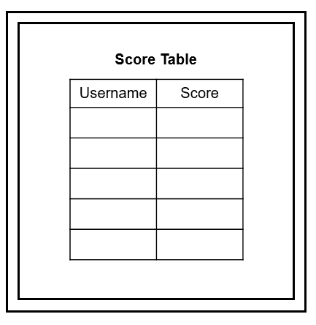 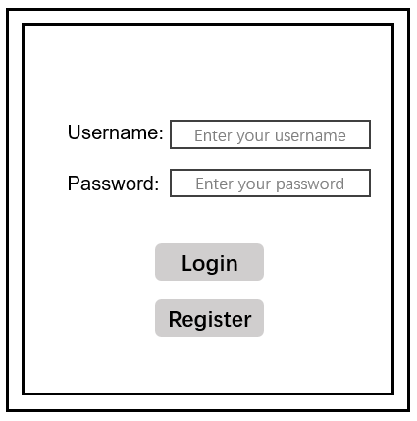

Figure 1. Login and Registration Layout Figure 2. Score Table Layout

The layouts of the dungeon are shown in the figure below. There are three levels in the dungeon in our game. Each dungeon consists of four rooms; each room includes walls, paths. The number of coins in the map is defined in the beginning and coins are placed in the path randomly. The amount of coins required to win will be shown to players.

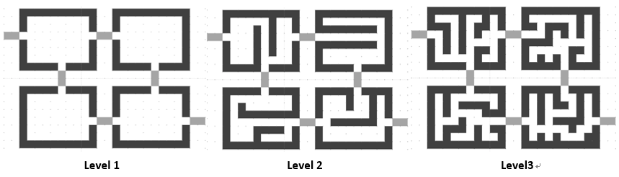

Figure 3.Levels of the Game

2. Implementation of Design and Interface

In the process of designing the user interface, we designed our game pages through following aspects for making a good user interface:

* Unity: all the pages in our game have a united background.
* Simplicity: we minimize the number of button which make it easier to operate and reduce the redundancy of functions. The rooms in the map are arranged orderly and the paths in the dungeon are straight. which will make it easier for users to enter another room and find the exit.
* Intuitive: In the game map, we use different colours to represent different type of tiles which users can distinguish them better. There are some text and word areas to show the game state for users including the number of coins they have collected and the amount of coins required to win.
* User-friendly: While playing the game, the character of user always stands at the centre of the screen, the different areas of the map will be shown in the screen according to the movement of users.

By considering all the possibilities which may lead errors and designing corresponding countermeasures including return error messages and reload the map, the user interface can be more robust.

System Architecture

1. Three-Tier Architecture

The online multiplayer will be implementing by three-tier client–server architecture model. Three-tier architecture allows any one of the three tiers to be upgraded or replaced independently. The user interface is implemented on a desktop PC, which is client side of multiplayer game and uses a standard graphical user interface with different modules running on the application server. The relational database management system on the database server contains the computer data storage logic, which is implemented using json and mysql.

The three tiers in three-tier architecture are:

**Presentation Tier**: It includes the top level and presents the information related to services available on client side. This tier sends data to other tiers to communicate. For ex: sending result of game to database. All communication with the Presentation layer is done through Web Services.

**Application Tier**: Also called the logic tier or business logic, this tier is responsible for controlling application functionality by performing detailed processing.

**Data Tier**: Houses database servers where information is stored and retrieved. The Data Layer provides persistence for the system and all communication is done through SQL queries and views. Data in this tier is kept independent of application servers or business logic. For ex: storing score, storing records of players

2. Design Pattern

The design pattern associate with our multiplayer game is MVC (Model View Controller) design pattern. The MVC design pattern clearly separated the web application’s behavior, presentation and control. The modularity of this design pattern allows for easier code reuse, more centralized control, bugs easier to track down and code easier to modify. The client will be running on presentation layer. The presentation, or view, of the multiplayer game will be implemented in HTML, CSS and Javascript. The database layer includes json files and mysql.

The business tier includes the model classes of multiplayer game.

Apart from that, the system needs to satisfy any functional, non-functional or aesthetic needs in a software system. The Dungeon of Doom follows the three-tier architectural style, which includes presentation tier, business tier, and data tier. The following is a simple description of what will be included in each of the tiers:

Presentation Tier

Business Tier

Data Tier

**Figure 4. Three Tier Architecture**

**Presentation Tier:** used to present the information to the player.

**Business Tier:** used to implement the logic of the system

**Data Tier:** To storing the data and other external services that the system may use.

User Guide

//will be written

Project Diaries

References

1. ISTQB Exam Certification. (n.d.). What is Component testing? Retrieved 11 26, 2016, from ISTQB Exam Certification: http://istqbexamcertification.com/what-is-component-testing/
2. Kaner, C. (2006, Novemer 17). Exploratory Testing from Florida Institute of Technology, Quality Assurance Institute Worldwide Annual Software Testing Conference, Orlando, FL. Retrieved from Kaner.com: http://www.kaner.com/pdfs/ETatQAI.pdf
3. Writing effective use case (2016) Available at: https://www.visual-paradigm.com/tutorials/writingeffectiveusecase.jsp (Accessed: 10 December 2016).
4. Introduction to CRC cards (no date) Available at: http://www.openloop.com/education/classes/umn_98/umn_cpp/crc.htm (Accessed: 10 December 2016).
5. Cockburn, A. (no date) *Humans and Technology*. Available at: https://www.infor.uva.es/~mlaguna/is1/materiales/BookDraft1.pdf (Accessed: 11 December 2016).
6. Prioritizing CRC cards as a simple design tool in extreme programming - IEEE Xplore document (2016) Available at: http://ieeexplore.ieee.org/stamp/stamp.jsp?arnumber=6567820 (Accessed: 11 December 2016).

Appendix:

Individual Diaries:

Mattis:

|  |  |  |  |  |  |  |  |
| --- | --- | --- | --- | --- | --- | --- | --- |
| **Date** | **Monday** | **Tuesday** | **Wednesday** | **Thursday** | **Friday** | **Saturday** | **Sunday** |
| **31s Oct** | Attended first group meeting |  | Attended second group meeting |  |  | Reviewed lecture slides/notes and spec in prep for Monday meet | Reviewed lecture slides/notes and spec in prep for Monday meet |
| **7th Nov** | Attended group meeting  Gave presentation on findings  Worked with group on requirements analysis Introduced team to Trello & setup backlog/sprint boards  Kept meeting notes  Proposed choosing leader | Worked with Tassos to produce several usecases | Attended group meeting  Worked with group on CRC cards  Added some tasks to Trello |  |  |  |  |
| **14th Nov** | Attended group meeting  Worked with group on CRCs and task estimations | Produced timescale document, to be discussed with team Weds. | Attended team meeting  Introduced team to timescale document, made final changes to it. |  | Worked with Tassos on database creation, basic project layout and interfacing with database. |  |  |
| **21st Nov** | Attended team meeting  Worked on UML |  | Attended team meeting |  |  | Worked on Test Plan and researched Java API frameworks | Worked on Test Plan and researched Java API frameworks |
| **28th Nov** | Attended team meeting  Arranged next Sprint Created all remaining Trello cards and filled in various technical details of cards  Had meeting with Julian  Tested Java API framework | Setup Jersey API framework  Refactored project structure  Worked with Tassos to setup skeleton of project ie blank endpoints, services and tests | Worked with Qian to: implement IOservice, add JSON framework to project, start JSON service (implement tests) |  | Worked with Qian to implement JSON service |  |  |
| **5th Dec** | Worked with Selin and Arya to review their work on the login/registration card  Picked up the login/registration card and started work on it  Set up Sprint 5 in Trello  Attended team meeting  Attended team meeting with customer | Implemented AuthorisationService  Fixed web service setup issues  Implemented PlayerController  Added validation to web service  Started client-server interaction | Continued client-server interaction, implemented login/registration from client side  Attended team meeting  Implemented state memory architecture (MatchList)  Began implementing MatchService/ MatchController | Continued implementing MatchService/ MatchController  Improved state memory architecture  Implemented JSON support in service  Implemented JSON support in Java test client to test endpoints (and later for bot?) | Finished implementing MatchService / MatchController  Implemented StateService (except for visibility)  Implemented “Game/Status” endpoint  Implemented basic client lobbying | Implemented match details, joining a match, starting a new match in client  Implemented starting a match in client  Implemented basic rendering in client based on Tassos’ render code, added players to display | Implemented game loop & communication  Implemented automatic refresh for lobby list & match status  Improved graphics  Added functionality to leave a game, in server and client  Added StateService use of VisibilityService  Implemented basic use of visible tiles in client  Began to implement bot project Began to merge client design with prototype |
| **12th Dec** | Finished merging functional prototype with client design  Improved the client and fixed bugs  Added ability to load different levels  Fixed a lot of bugs  Added endgame state  Implemented graphical visibility in the client  Implemented scoreboard controller/action in server  Implemented scoreboard in client | Fixed a lot of bugs  Implemented simultaneous start between players |  |  |  |  |  |

Tasos:

|  |  |  |  |  |  |  |  |
| --- | --- | --- | --- | --- | --- | --- | --- |
| **Date** | **Monday** | **Tuesday** | **Wednesday** | **Thursday** | **Friday** | **Saturday** | **Sunday** |
| **31s Oct** | Team Meeting  (sprint 0) |  | Team Meeting |  |  |  |  |
| **7th Nov** | Team Meeting (sprint 1) | I worked on use cases with Mattsi about player actions in the dungeon. | Team Meeting (use cases, CRC) |  |  |  |  |
| **14th Nov** | Team Meeting (CRC, Task estimation)  (sprint 2) |  | Team Meeting  (Created UML classes and discussed about system architecture) |  | Worked with Mattsi on setting up the database. We implemented some functionality based on models from UML classes |  |  |
| **21st Nov** | Team Meeting  (Completed the UML classes both in client and server)  (sprint 3) |  | Team Meeting  (Reviewed all the documentation so far) |  |  |  | Updated the requirement analysis and the use cases on our documents. |
| **28th Nov** | Team Meeting  (worked on a document about document style and code style conventions, created draft overview of our work so far, meeting with customer)  (sprint 4) | Worked with Mattsi on the skeleton of web server’s framework. | Team Meeting  (Worked with Xiao on database) | Completed the database functionality. | Worked on rendering the dungeon’s map on web browser. | Completed the rendering of dungeon’s map on web browser. |  |
| **5th Dec** | Team Meeting  (Meeting with Julian to discuss our progress)  (sprint 5) | Worked on Character model. | Worked with Qian on Visibility on the server-side. | Completed the Visibility service to meet unit tests requirements. |  |  | Worked with Arya on Movement service. |
| **12th Dec** | Added coin collection functionality on movement service. Worked on movement on client side. Updated documentation. Team Meeting (with Julian to show him our playable demo).  (sprint 6) |  |  |  |  |  |  |

Selin:

|  |  |  |  |  |  |  |  |
| --- | --- | --- | --- | --- | --- | --- | --- |
| **Date** | **Monday** | **Tuesday** | **Wednesday** | **Thursday** | **Friday** | **Saturday** | **Sunday** |
| **31s Oct** | First group meeting, understand the document of project |  | Second group meeting,  Understand the document of project |  |  |  | Prep for Monday meet |
| **7th Nov** | Team meeting  Worked with group on requirements analysis Meet Trello  Brainstorming, Discussion  Add meeting notes  Choose leader |  | Attended group meeting  Worked with group on use cases |  |  |  |  |
| **14th Nov** | Group meeting  Worked with group on CRCs and task estimations |  | Write timescales Pair Groups are defined |  |  | Preparation for Uml diagrams | Investigate layout design |
| **21st Nov** | Uml diagrams creation |  | Menu/Login/Score Layout  Worked with Pair Programmer Arya | Customer Requirements /Reader’s Guide documentation | Customer Requirements /Reader’s Guide documentation | Creation of mock up | Creation of uml diagrams and continued to document checking. |
| **28th Nov** | Weekly meeting and discussion |  | Sprint meeting |  | Investigation on login and registration with MVC  Work with pair programmer Arya | Investigation on login and registration restful api | Investigation on login and registration restful api |
| **5th Dec** | Working with pair programmers Mattsi,Arya on login and registration  Meeting with customer |  | Sprint meeting discussion  Produce documentation layout |  | Work on documentation | Work on documentation | Work on documentation  Score Interaction investigation |
| **12th Dec** | Team meeting  Writing Document 1 and document2  Meeting with customer | Worked with the Pair Programmer Tasos on score/timer interaction | Team Meeting  Writing Document 1 and document2 |  |  |  |  |

Qian:

|  |  |  |  |  |  |  |  |
| --- | --- | --- | --- | --- | --- | --- | --- |
| **Date** | **Mondy** | **Tuesday** | **Wednesday** | **Thursday** | **Friday** | **Saturday** | **Sunday** |
| **31s Oct** | Team Meeting |  | Team Meeting |  |  |  |  |
| **7th Nov** | Team Meeting (sprint0) – worked with group on the requirements analysis. | Worked with Xiao on the use cases about the user interaction before playing the game. | Team Meeting – worked with group on the use cases and CRC cards. |  |  |  |  |
| **14th Nov** | Team Meeting – worked with group on the CRC cards and task estimations. |  | Team Meeting - worked with group on the UML classes and system architecture. Discuss about the timescale and divided the tasks for pair programming. |  | Worked on the design of the map interface. | Worked on the design of the map interface. |  |
| **21st Nov** | Team Meeting - worked with group on the UML classes both in client and server. |  | Team Meeting – Worked on the documentation. |  | Create the Json files for different levels of the dungeon. | Create the Json files for the maps. Write the documentation about the Json files. |  |
| **28th Nov** | Team Meeting - separate the tasks in next sprint, had a meeting with Julian.  Worked with Xiao on determining the final design of our maps and finished the Json file. | Create and add two classes - Map and Tile to the project. | Worked with Mattis to implement the IOservice, add Json Framework to project, start Json service (including tests). |  | Worked with Mattis to implement Json service (parse map Json, Model map in code). |  |  |
| **5th Dec** | Team Meeting – separate the tasks in Sprint 5. |  | Worked with Tasos on the visibility in server. |  |  |  |  |
| **12th Dec** | Team Meeting – list the unfinished work both for codes and documentation, and arrange the tasks in the final week. | Worked on the interface part of the documentation. | Worked on the documentation. |  |  |  |  |

Xiao:

|  |  |  |  |  |  |  |  |
| --- | --- | --- | --- | --- | --- | --- | --- |
| **Date** | **Monday** | **Tuesday** | **Wednesday** | **Thursday** | **Friday** | **Saturday** | **Sunday** |
| **31s Oct** | Team Meeting |  | Team Meeting |  |  |  |  |
| **7th Nov** | Team Meeting (sprint 1) | I worked on a use case with Qian about log in and menu design in the dungeon. | Team Meeting (use cases, CRC)  (I took the Meeting Minutes) |  |  |  |  |
| **14th Nov** | Team Meeting (the rest of CRC)  (sprint 2) |  | Team Meeting (Task estimation) |  |  |  |  |
| **21st Nov** | Team Meeting (UML, Diagram)  (sprint 3) |  | Team Meeting (Client UML, Diagram, documentation tasks distribution) |  |  | Learn JSON | Dungeon interface |
| **28th Nov** | Team Meeting  Create JSON file about the interface of Dungeon(Qian)  (sprint 4) |  | Creating database  Build play model,  Connect SQL with JAVA(Tasos), Building web service framework |  |  |  |  |
| **5th Dec** | Researching web game named Forestry maze |  |  |  |  |  |  |
| **12th Dec** | Team meeting (found the unfinished work and divided to every team member, have discuss with Julian) | Finding the reference about UML Diagram, Writing documentation about UML Diagram | Writing documentation about UML Diagram |  |  |  |  |