JSON MAP:

**1 Design of the map**

The dungeon is consisted of five rooms, each room has a map with walls and coins. The basic design of the room is shown in Figure 1. The grey tile is wall and the gold tile is coin. The path and the number of coins in map are defined. There is a required number of coins need to collect if user want to exit the room.

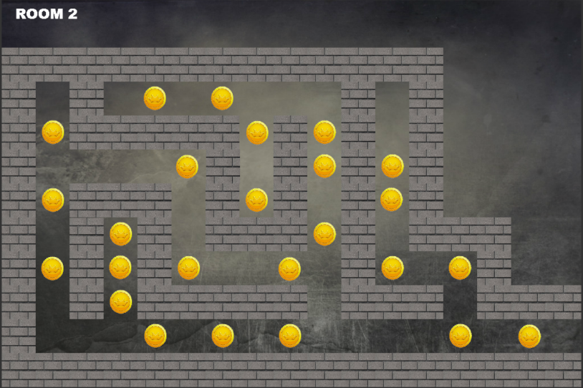

**Figure 1 Design of the room**

**2 JSON file to implement the design**

JSON (JavaScript Object Notation) is an open-standard format that uses human-readable text to transmit data objects consisting of attribute-value pairs.

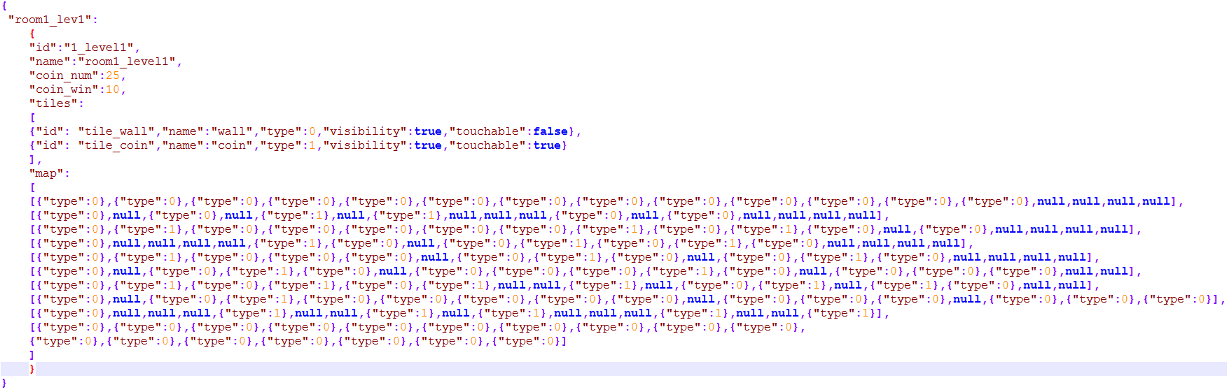In our project, JSON files are used to design the layout of map (including different rooms for different level). Figure 2 shows an example which define all the features in a room. With the array of map, the layout of the map can be drawn.

**Figure 2 An example of JSON file**

Like the example above, each JSON file has defined the meta-info of the map.

A JSON file in our project consist of following features:

* Name of map: “name”
* Number of coins total in map: “coin_num”
* Number of coins required to win: “coin_win”
* Tiles in map: “tiles” (an array – contain different types of tiles with their own properties.)
  + Name of tiles: “name”
  + Type of tiles: “types”
  + If the tile can be visible: “visibility”
  + If the tile can be touched: “touchable”
* Map layout (separate the map into several rows and define the layout of map row-by-row): In the format of map, each array under “map” defines a row of tiles. For example:
  + The entry 0 in the first array ({“type”:0}): the tile at position (0,0) is wall.
  + The entry 4 in the second array ({“type”:1}): the tile at position (1,4) is coin.
  + The entry 1 in the fourth array (null): there is no tile at position (3,1).