mCriminal Identification System

By

Ehsanul Karim
Roll: 1907039
&
Ankon Chowdhury
Roll: 1907048



Supervisor:
Dr. Sk. Md. Masudul Ahsan
Professor
Dept. of Computer Science and Engineering Signature
Khulna University of Engineering & Technology

Department of Computer Science and Engineering
Khulna University of Engineering & Technology
Khulna 9203, Bangladesh
30th November 2023

Acknowledgement

We extend our heartfelt gratitude to Allah, the Most Merciful and Powerful, for granting us the talents and capabilities to successfully complete the Criminal Identification System project. We are thankful for the invaluable guidance and supervision provided by Dr. Sk. Md. Masudul Ahsan, supervisor of this project. His expertise and knowledge in the field of computer science were very useful in the successful completion of the project. His constructive criticism, insightful suggestions, and constant encouragement helped us to overcome the challenges that we faced during the development of the system.
We would also like to thank our seniors, who inspired us to implement different ideas and suggestions throughout this project. We would also like to thank our friends for their association and cooperation with our project. Last but not least, our deepest gratitude is expressed to our parents, whose moral support and encouragement gave us the strength to complete this project.

Ehsanul Karim and Ankon Chowdhury

Abstract

The police force serves as a crucial public servant, and in their pursuit of criminals, they often employ various methods, including the utilization of sketch artists who create facial depictions based on victims’ descriptions. Subsequently, these sketches are compared with a criminal database to identify potential matches. Regrettably, these procedures are time consuming, and in the realm of law enforcement, time is of paramount importance. Again, the current online law enforcement website doesn’t extend to all criminal activities. Thus, to address these issues, the proposed system seeks to enhance efficiency by incorporating deep-learning models to capture facial features with a moderate degree of precision. The resulting data is then stored in a local database, facilitating expedited searches for potential matches, improving both time efficiency and accuracy. The web application has also been designed to handle a wide variety of criminal activities and provide better navigation of the system. The proposed models use a technique called Convolutional Neural Network (CNN) and have an accuracy of close to 88%. Mainly because the data set images consisted of good lightning conditions and a white background. A total of nearly 17,000 images were used to train the models, with each model having about 50 million trainable parameters. Facial features are extracted through various models but the base pre-trained model that was used for this system was Resnet50. The web application was also built with Django as the backend technology, as it provided lots of built in features, and incorporating the models was smoother due to the similar language environments.

Contents

 |  | Page
Acknowledgement |  | ii
Abstract |  | iii
Contents |  | iv
List of Tables |  | vi
List of Figures |  | vii

1 | Introduction | 1
 | 1.1 Background | 1
 | 1.2 Objectives | 1
 | 1.3 Scopes | 2
 | 1.4 Unfamiliarity of the problem | 2
 | 1.5 Project planning | 2
2 | Related Work | 4
 | 2.1 Existing solutions | 4
 | 2.2 Limitation in existing solutions | 4
3 | System Design | 4
 | 3.1 Analysis of the system  3.1.1 Data Flow Diagram  3.1.2 Use case Diagram | 4  4  5
 | 3.2 System architecture  3.2.1 Class Diagram  3.2.2 ER Diagram | 7  7  7
 | 3.3 Tools used | 7
 | 3.3.1 Django | 7
 | 3.3.2 Jupyter Notebook  3.3.3 VS Code  3.3.4 SQLite | 7  7  10
4 | Project Implementation | 10
 | 4.1 System implementation  4.1.1 Web Implementation  4.1.2 Model Implementation  4.1.3 Model Architecture  4.1.4 Dataset | 10  10  16  16  18
 | 4.2 Morality or Ethical issues | 19
 | 4.3 Socio-economic impact and sustainability | 20
 | 4.4 Financial analyses and budget | 20
5 | Conclusions | 21
 | 5.1 Conclusion and challenges faced | 21
 | 5.2 Future work | 22
 | References | 22

List of Tables

Table No. | Description | Page
4.1 | Statistics of individual model | 17
4.2 | Financial analysis and budget of the project | 20

List of Figures

Figure No. | Description | Page
1.1 | Gantt Chart of the project | 3
3.1  3.2  3.3  3.4  4.1  4.2  4.3  4.4  4.5  4.6  4.7  4.8  4.9 | DFD diagram of the project  Use case diagram of the project  Class diagram of the project  ER diagram of the project  Welcome page of the web app  Sign-up page of the web app  Sign-in page of the web app  User dashboard and advanced search page of the web app  Case description of the charge sheet form  Admin dashboard and criminal record insertion page of  Super-admin dashboard page of the web app  Architecture of Resnet50 model  A snapshot of the dataset | 5  6  8  9  11  11  12  13  14  15  16  18  19

- Introduction

  - Background

In today's competitive job market, companies receive a massive influx of resumes for every job posting, making it increasingly difficult to manually screen candidates efficiently. Traditional recruitment processes are time-consuming, inconsistent, and often biased. On the other hand, job seekers struggle with optimizing resumes, preparing for interviews, and receiving actionable feedback during their job hunt.
To address these challenges, our proposed system introduces a comprehensive AI-powered job portal developed using the MERN stack. This platform automates and enhances various aspects of the recruitment process through the integration of advanced technologies. The system includes intelligent resume parsing and summarization using Natural Language Processing (NLP) and machine learning, a user-friendly resume builder, an AI chatbot for career guidance, an interactive quiz generator for skill evaluation, a mock interview system with real-time feedback, and a voice assistant built using Python and Google AI for seamless user interaction.
This system provides an all-in-one solution for both recruiters and job seekers — simplifying resume screening, improving applicant matching, and delivering personalized support to candidates through AI-driven tools.

  - Objectives

The main goals of the project are to streamline the recruitment process, improve candidate preparation, and enhance resume screening using AI. The specific objectives are:
- To implement an intelligent resume parser and summarizer that extracts relevant candidate information and condenses it for recruiter review.
- To develop a customizable resume builder to help candidates create professional, AI-optimized resumes.
- To integrate a voice assistant powered by Python and Google AI for enhanced platform navigation and accessibility.
- To build an AI chatbot for answering user queries regarding job applications, interview tips, and resume feedback.
- To design an AI-based quiz generator for testing candidate skills and knowledge in specific domains.
- To offer an AI mock interview module that simulates real interview environments and provides constructive feedback.
- To bridge the gap between recruiters and candidates by automating repetitive tasks and improving the quality of hiring decisions.

  - Scope

The scope of the system focuses on improving the hiring and job preparation process using artificial intelligence and modern web technologies. While the platform supports features like resume parsing, summarization, voice interactions, and AI-based assistance, it does not extend to legal or contractual hiring procedures beyond resume screening and candidate engagement.
Limitations include:
- The system's accuracy in parsing resumes depends on resume formatting and content quality.
- The voice assistant requires a stable internet connection and clear speech input for optimal performance.
- The AI feedback during mock interviews is based on trained models and may not cover all behavioral nuances of human interviews.
Despite these constraints, the system provides a robust and intelligent framework that significantly enhances both the recruiter and applicant experience in a scalable and user-friendly manner.

  - Unfamiliarity of the problem

The development of an AI-powered resume screening system presented multiple layers of unfamiliar challenges. Integrating Natural Language Processing (NLP) techniques such as resume parsing and summarization was a novel experience, as these advanced concepts were not part of our academic curriculum. Implementing OpenAI’s language models for building features like chatbot, quiz generator, and mock interview assistant required understanding of prompt engineering and fine-tuning behaviors, which was initially quite challenging.
Furthermore, developing a voice assistant using Python and Google AI introduced speech recognition and synthesis aspects, which were new and complex. Although the MERN (MongoDB, Express.js, React, Node.js) stack was familiar in parts, orchestrating full-stack development alongside AI integrations tested our system design, API management, and deployment skills.

  - Project planning

The planning phase for the system project involved detailed steps: requirement analysis, understanding AI/NLP models, exploring integration possibilities with the MERN stack, designing an intuitive UI/UX, and finally implementing all the components together into a seamless platform.
The major modules—resume parser, summarizer, resume builder, chatbot, AI quiz generator, AI mock interview system, and voice assistant—were planned in parallel sprints to manage dependencies and allow iterative testing. API development, model integration, and UI construction were handled in phased timelines.
The project timeline was visualized through a Gantt chart (Figure 1.1) that maps each phase with its respective duration. This helped ensure smooth coordination between backend development, AI integration, and frontend presentation—leading to efficient completion of the system.

Figure 1.1: Gantt Chart of the project.

- Related Works

There are several existing job portals and online recruitment platforms such as bdjobs.com and LinkedIn. These platforms primarily focus on listing job openings and enabling users to apply by submitting resumes. However, most of these platforms lack the integration of intelligent tools that can streamline and personalize the recruitment process. While some systems offer keyword-based filtering of resumes, they do not incorporate AI for summarizing candidate profiles or conducting interactive mock interviews. This limits both job seekers and employers from fully benefiting from the power of automation and machine learning.
  - Gap in Existing Solutions
- Current job portal solutions provide only basic functionalities, such as browsing job categories and uploading resumes. They do not support advanced features like automatic resume screening using Natural Language Processing (NLP) or generating interview questions based on job descriptions and resume content. Additionally, there is no feature that offers real-time evaluation of interview answers or suggests improvements based on AI feedback. Most importantly, these platforms lack an interactive interface that can help users prepare for interviews through personalized quizzes, voice-based questioning, or performance analytics. This leaves a significant gap in usability and efficiency for both job seekers and recruiters.
- System Design
The system is built with modern web architecture to ensure scalability, security, and flexibility. Using the MERN stack, it supports modular components like resume parsing, AI question generation, mock interviews, and admin control. Python-powered AI models handle NLP tasks on the backend. The user-friendly UI/UX emphasizes accessibility and ease of navigation. Key features include profile management, job listings, resume analysis, interview simulation, and automated feedback, creating a comprehensive job application and evaluation platform.

  - Analysis of the system

The system is analyzed using visual diagrams to clearly represent the processes and interactions among its components. This section includes a Data Flow Diagram (DFD) and a Use Case diagram, which illustrate the sequence of operations and data movement within the system.

    - Data Flow Diagram

The system’s operation procedure consists of multiple steps. Working with large amounts of data or sensitive information, requires an efficient understanding of the flow of the system. As such the movement of data is shown in the Data Flow Diagram (DFD), Figure 3.1.

Citizen
Super-admin
Request for emergency
Complain
of incident

Add new crime type

Add information
Add Police-Officer to a dedicated Thana
Police Officer
Add Criminal Records
Update Case Records
Process criminal Image
Show user some criminal images

.

Figure 3.1: DFD diagram of the project.

    - Use Case Diagram

The system involves multiple user roles, each interacting with different functionalities. To provide a comprehensive overview of these interactions, a high-level Use Case diagram is presented in Figure 3.2. This diagram illustrates the key actors and their respective interactions with the system’s main features.

Add Complain Report
Search uploaded complain, use advance search
Update complain status
Apply CIS to extract facial features from criminal image
View Complain within his area
Add criminal record
See location of emergency
Police
Registration/Login with email authentication
Emergency help request
Get Notification
View status of uploaded complain
User
Login with auth given by developer
Create police officer for each thana. Provide 1 time pass
Delete any kinds of records
Add FAQ, notices, crime types
Login
Advance search in criminal database

SuperAdmin

Figure 3.2: Use case diagram of the project.
  - System architecture

    - Understanding the project’s architecture is crucial for its successful implementation. The overall structure is demonstrated through a class diagram, highlighting encapsulation and relationships among key classes. Additionally, the database design and its entities with their relationships are depicted using an Entity-Relationship (ER) diagram.

    - Class Diagram

Figure 3.3 illustrates the class diagram, showcasing the encapsulation of data and the associations between core components of the system.

    - ER Diagram

The ER diagram in Figure 3.4 presents the main entities, their attributes, and the relationships connecting them within the database.

  - Tools used

A wide variety of tools were used to complete the system. Each tool played a significant role in the completion of the project.
4.3.1 MERN Stack
The MERN stack (MongoDB, Express.js, React.js, and Node.js) was used for full-stack web development, providing a powerful and flexible JavaScript-based environment. MongoDB offers a NoSQL database solution, Express and Node.js manage the backend APIs, and React.js handles the dynamic and responsive frontend interface.
4.3.2 Kaggle
Kaggle served as the platform for data exploration, preprocessing, and model training. Its robust environment supports Python-based machine learning workflows and enabled efficient experimentation with NLP models for resume parsing and summarization.
4.3.3 Visual Studio Code
Visual Studio Code was the primary code editor, providing a customizable and lightweight development environment. Its rich ecosystem of extensions facilitated smooth coding for both backend and frontend development, along with Python for AI model integration.

User
_id: ObjectId
fullname: String
email: String
password: String
phoneNumber: String
role: String (student / recruiter)
profilePhoto: String
profile: Object (bio, skills, resume, resumeOriginalName)
createdAt: Date
updatedAt: Date

register()
login()
logout()
updateProfile()

Company
_id: ObjectId
name: String
userId: ObjectId (recruiter User)
description:String(optional)
website: String (optional)
logo: String (optional)
createdAt: Date
updatedAt: Date

registerCompany()

updateCompany()

getCompany()

getCompanyById()

Job
_id: ObjectId
title: String
description: String
requirements:Array<String>
salary: Number
location: String
jobType: String
experienceLevel: Number
position: Number
company: ObjectId (Company)
created_by: ObjectId (recruiter User)
applications: Array<ObjectId>
createdAt: Date
updatedAt: Date

postJob()
getAllJobs()
getJobById()
getAdminJobs()

Application
_id: ObjectId
job: ObjectId (Job)
applicant: ObjectId (User - student)
status: String (pending, accepted, rejected)
createdAt: Date
updatedAt: Date

applyJob()
updateStatus()
getAppliedJobs()
getApplicants()

Figure 3.3: Class diagram of the project.
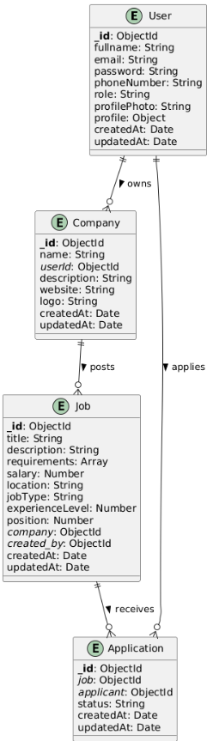
Figure 3.4: ER diagram of the project

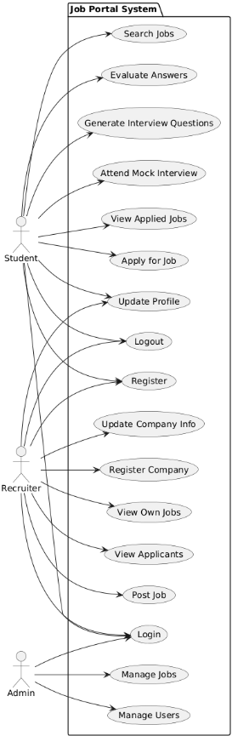
Figure 3.2: Use case diagram of the project
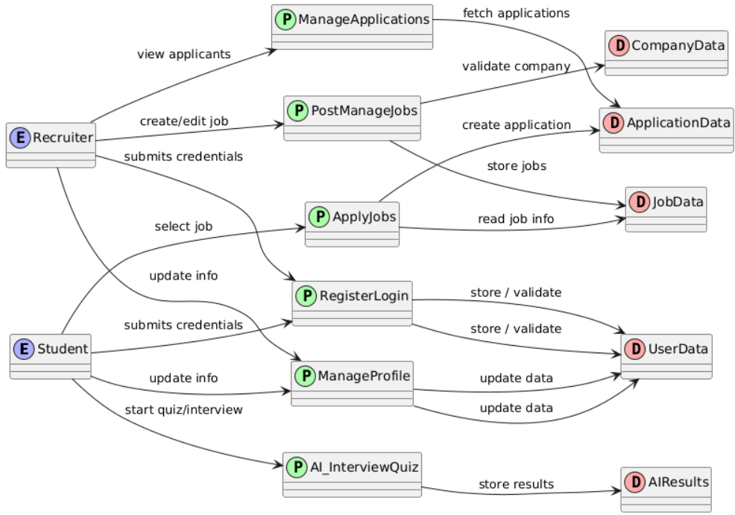
Figure 3.1: DFD diagram of the project.

1
M
1
1
1
M
1
M
1

1
1
1
1

1
1
1
1

1

1
1
1

Figure 3.4: ER diagram of the project.
4.3.4 MongoDB:

MongoDB, a flexible NoSQL document-oriented database, was chosen for efficient and scalable storage of the system’s data. Its schema-less design allows easy handling of diverse data types, making it well-suited for managing user profiles, resumes, and AI-generated data within the project.

- Project Implementation

This chapter will describe the steps and individual procedures that was taken to complete the system project. The system consists of collaborative and systemic process which is described in the following.
  - System implementation

The system being a web application, a website was designed using Django as the backend and basic HTML, CSS, JS as the frontend. The CNN technique was used for the model training, and a pre-trained model was collected for the task. The dataset for the task was also acquired through the web. The details of these procedures are as following.

    - Web Implementation

The welcome page serves as the initial gateway for users visiting the platform. It offers straightforward options to either register a new account or log in for returning users. Upon successful authentication, users are directed to their respective dashboards tailored to their roles—student or recruiter.

Student Dashboard:
After logging in as a student, the dashboard presents an overview of available job listings posted by recruiters. Each job listing includes a summarized version of the job description, allowing students to quickly assess the opportunity before applying. The application process is streamlined, enabling students to apply directly through the platform. The dashboard also provides access to a profile section where students can use a built-in resume-builder tool to create, edit, and download professional resumes customized for different job applications.
    - Additionally, the learning section enriches the student experience by integrating AI-powered features such as:
- AI Chatbot: Assists with queries related to job searching, resume building, and interview preparation.
- Voice AI Assistant: Facilitates hands-free interaction, enabling users to navigate the platform or receive guidance via voice commands.
- AI Quiz Generator: Allows students to take topic-specific quizzes and receive instant answers and detailed results to track their learning progress.
    - Interview Module:
Accessible through the navigation bar, the interview section requires users to authenticate via Google Sign-In. Once logged in, students can participate in AI-driven mock interviews tailored to job roles, receiving immediate, personalized feedback on their answers. The system securely stores previous interview sessions, allowing users to review and reflect on their performance over time. Upon signing out, users are redirected back to the homepage.
    - Recruiter Dashboard:
Recruiters have a dedicated dashboard designed to manage job postings and applicants efficiently. They can create and publish new job offers, view applications, and sort candidates based on various criteria. A notable feature is the integrated resume parsing tool, which processes uploaded resumes to generate concise summaries. This allows recruiters to quickly evaluate applicants’ qualifications without manually reading through lengthy documents.
    - Overall, the system supports seamless navigation between different user roles and functionalities, ensuring a smooth experience for all participants. The responsive navigation bar provides quick access to key features such as Home, Browse Jobs, Interview, and Profile, adapting dynamically based on user login status and role.
    - This comprehensive platform combines robust backend AI capabilities with an intuitive frontend interface built on the MERN stack, delivering a full-fledged ecosystem for job seekers and recruiters alike, from resume building and job searching to interview practice and candidate screening.

Figure 4.1: Welcome page of the web application.

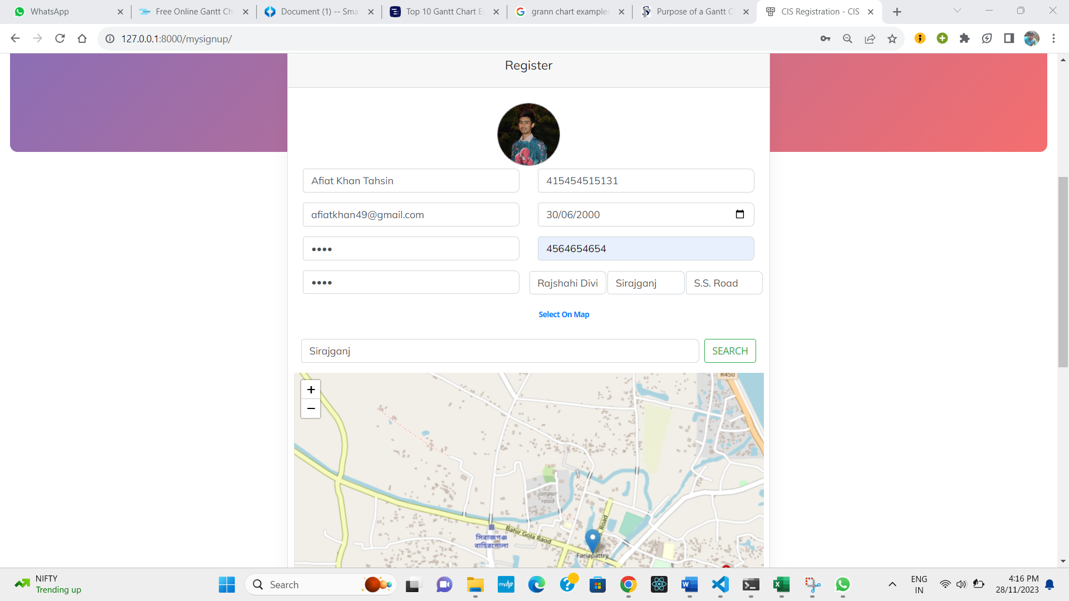
Figure 4.2: Sign-up page of the web application.
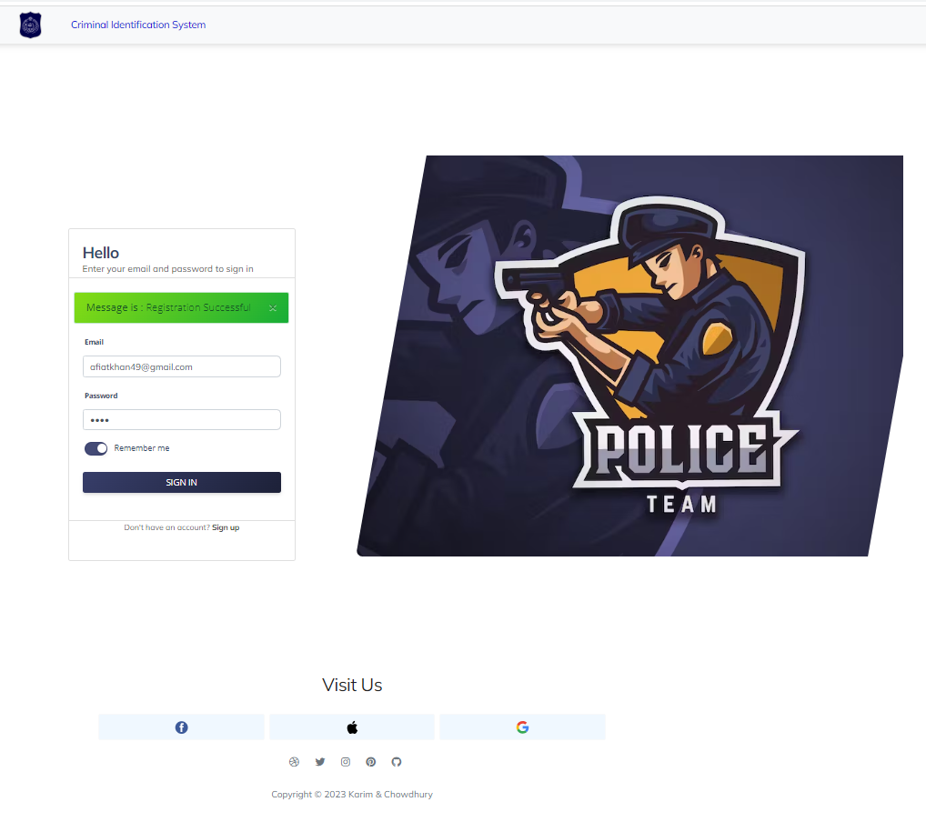

Figure 4.3: Sign-in page of the web application.

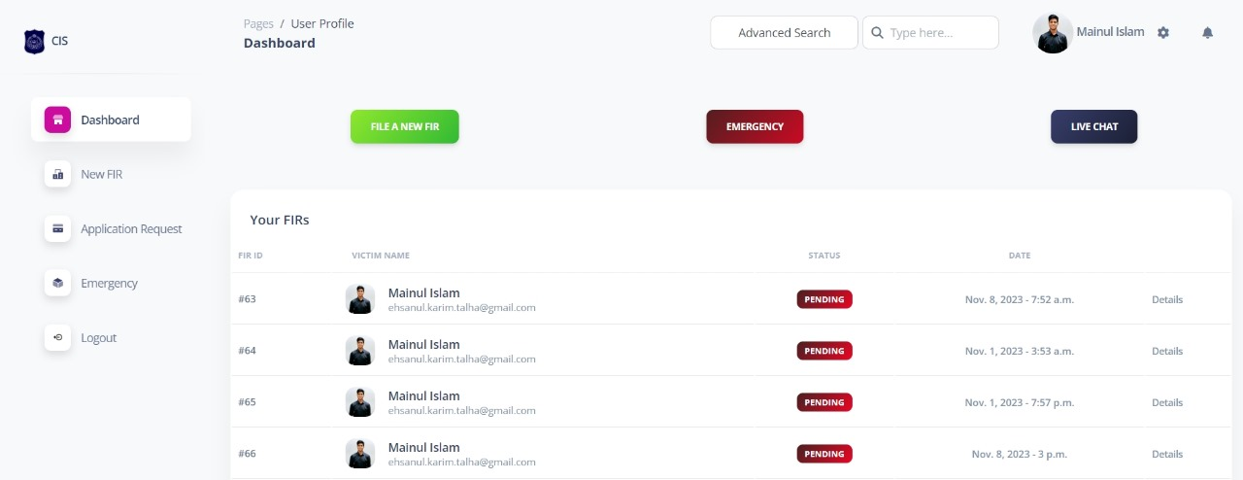

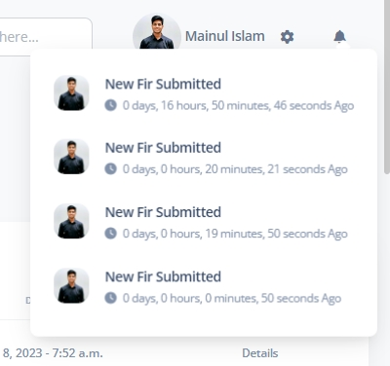

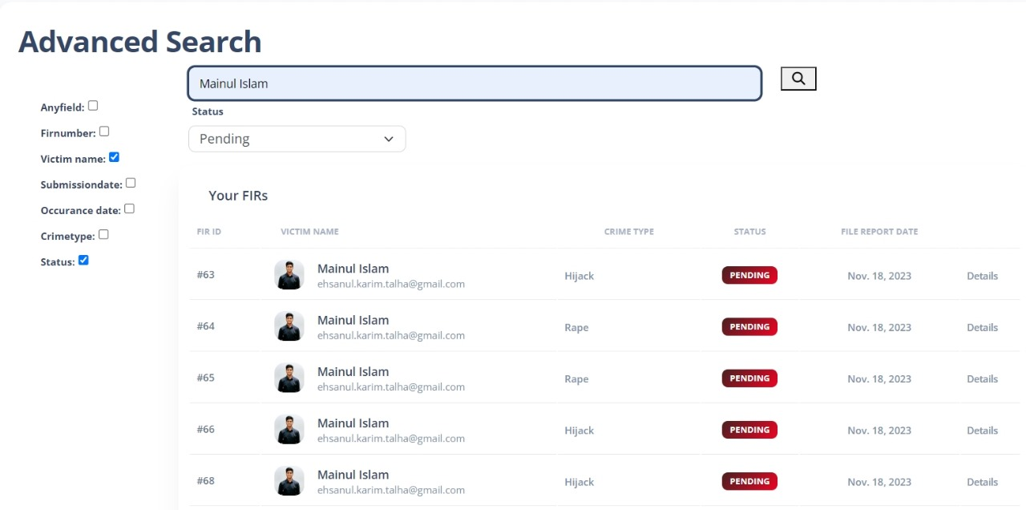

Figure 4.4: User dashboard and advanced search page of the web application.
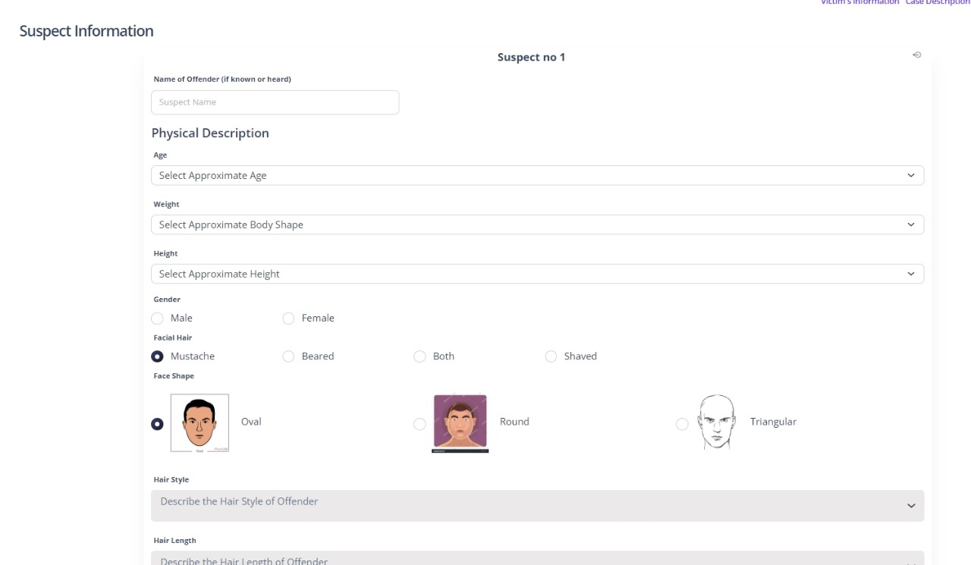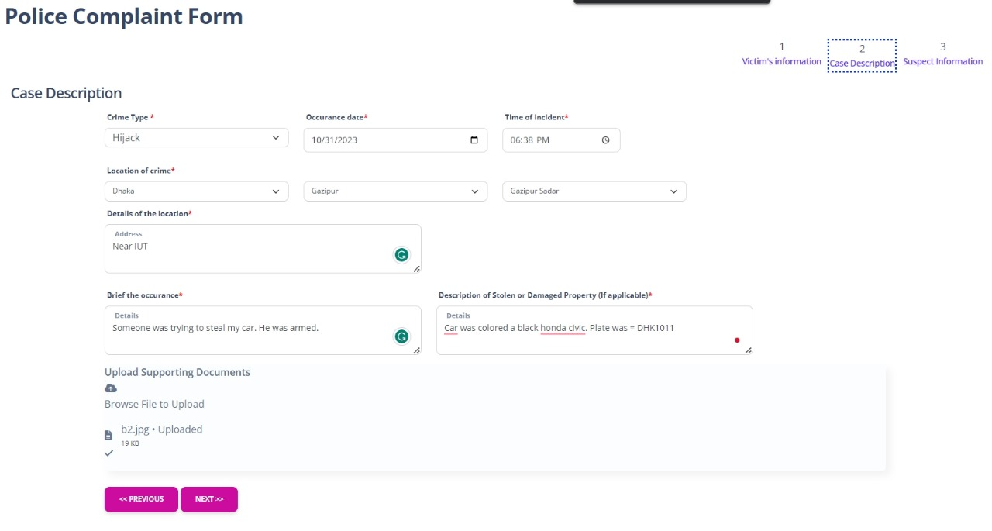

Figure 4.5: Case description of the charge sheet form.

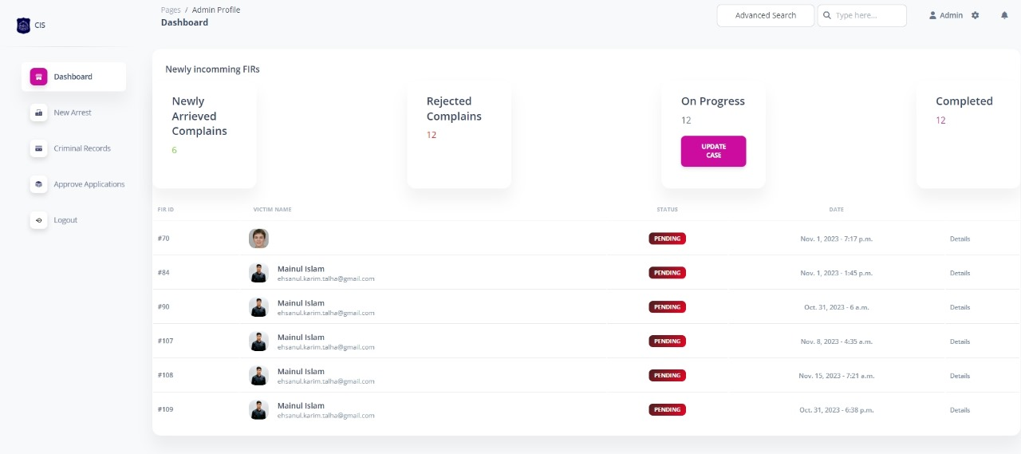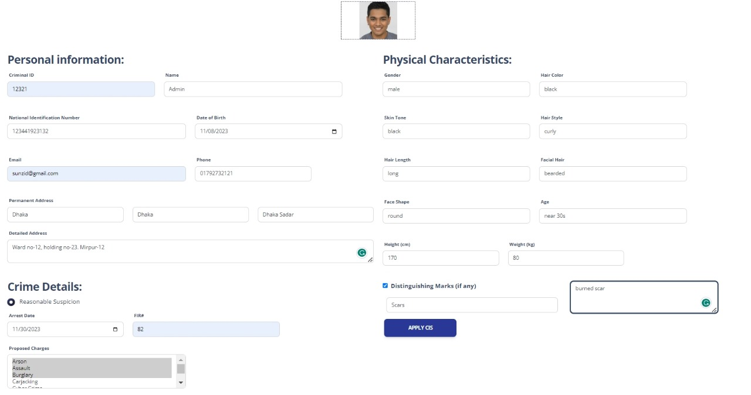

Figure 4.6: Admin dashboard and criminal record insertion page of the web app.

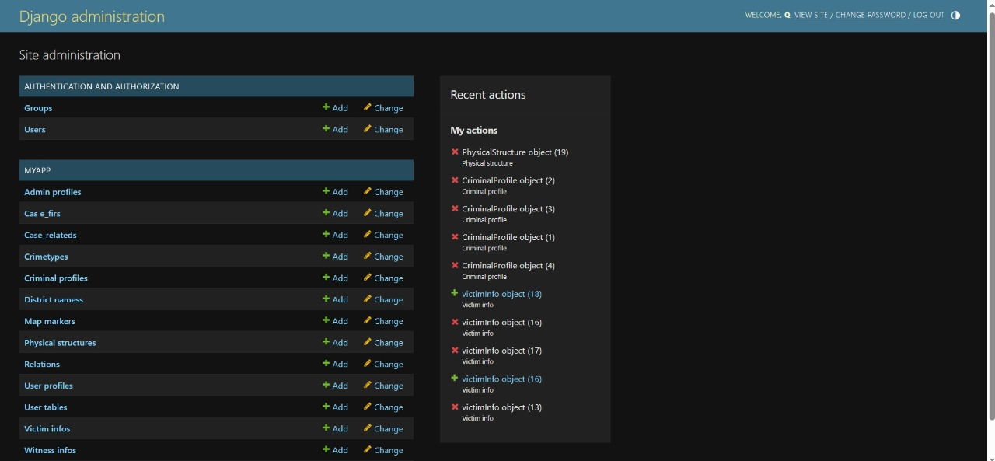

Figure 4.7: Super-admin dashboard page of the web app.

    - Model Implementation

    - Resume Categorization Model:
The system classifies resumes into job categories using NLP and machine learning. It converts raw resume text into numerical vectors with TF-IDF and applies classifiers like Random Forest or SVM to predict categories. Preprocessing includes tokenization, stopword removal, and normalization for clean input.
    - 2. Resume Parsing Architecture:
Raw text is extracted from PDFs using pdfminer.six. Then, regex and NLP techniques extract key details like contact info, skills, education, and names. Regex handles structured data, while NLP tools like spaCy identify names and complex patterns.
    - 3. Summarization Model:
The summarizer is built on the T5 transformer model, fine-tuned for text summarization. It uses the Hugging Face library and T5-Small variant for efficient training and inference.

    - Model Architecture

    - 1. Summarization Model Architecture:
The summarization model is based on T5-Small, a compact Transformer with about 60 million parameters. It uses an encoder-decoder structure where the encoder converts input text into latent representations, and the decoder generates summaries token-by-token. The model employs multi-head attention, feed-forward networks, and layer normalization, with a SentencePiece tokenizer to handle rare or unknown words.
    - 2. Resume Categorization & Parsing Implementation:
The system modularizes resume parsing into separate functions for extracting contact info, skills, education, and names from raw text. This modular design improves accuracy and maintainability. It combines text extraction libraries, regex pattern matching, and lightweight NLP tools to convert unstructured resumes into structured data for downstream categorization or database storage.
    - 3. System Integration & Deployment:
The architecture is integrated into a MERN stack where React frontend lets users upload resumes, and a Node.js/Express backend handles parsing and communicates with the Python ML model via API. The model, trained with scikit-learn in Jupyter, performs TF-IDF vectorization and classification. MongoDB stores user info and metadata, enabling scalable, real-time resume categorization and additional features like summary generation.

Table 4.1 : Resume Parsing Model Statistics
Model Component | Number of Parameters | Accuracy | Number of Classes | Description / Details
Text Extraction | N/A (Library-based) | N/A | N/A | Uses pdfminer.six for extracting raw text from PDF resumes.
Information Extraction | N/A (Regex + NLP) | N/A | Multiple | Uses regex and NLP (spaCy) to extract contact info, skills, education, and names.
Resume Categorization Model | ~1,000,000 (Random Forest) | Accuracy depends on training | Multiple (job categories) | TF-IDF vectorization + Random Forest classifier for categorizing resumes into job categories.

Table 4.1: Statistics of individual model

    - Dataset

    - A well-curated dataset is essential for effectively training both the summarization and resume parsing models. For the Samsum summarization model, a total of over 16,000 dialogue-summary pairs were collected from publicly available conversation datasets. These dialogues vary in length and context, providing diverse examples to fine-tune the T5-Small model for concise and accurate summarization.
    - For the Resume Categorization and Extraction system, a dataset of approximately 10,000 resumes was compiled from multiple sources, covering various industries and job roles. The resumes are available in multiple formats such as PDF and Word documents, with text content extracted and normalized for uniform processing. The dataset includes resumes with clear and structured information, such as contact details, skills, education, and work experience, essential for robust feature extraction and classification.

    - Text data preprocessing involved cleaning, tokenization, and normalization to ensure consistency across samples. The resumes and dialogues were transformed into numerical representations using TF-IDF vectorization for categorization and tokenization compatible with the T5 model for summarization. Overall, the datasets are of high quality, featuring well-formatted documents and dialogue texts that contribute to the models’ effective learning and generalization.
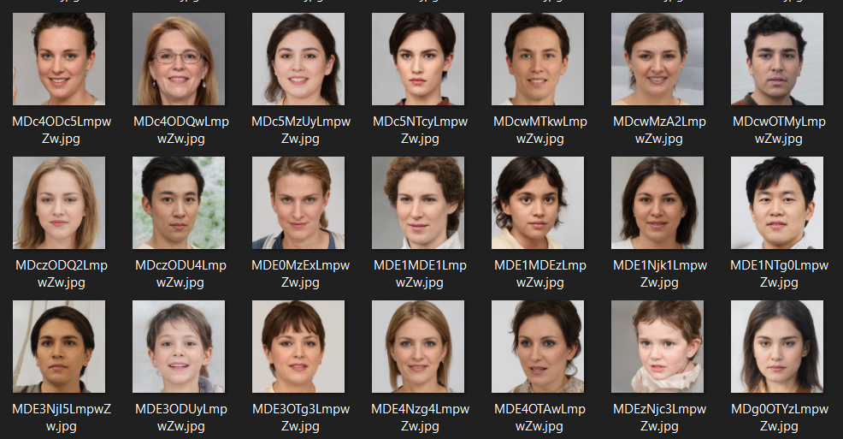

Figure 4.9: A snapshot of the dataset.

  - Morality or ethical issues

  - The resume parsing and summarization project leveraged publicly available datasets of resumes and dialogue transcripts to ensure ethical sourcing of data. Pre-trained models such as T5-Small were utilized from trusted libraries like Hugging Face Transformers, following official documentation and best practices. The techniques implemented were inspired by recent research papers and reputable resources in Natural Language Processing and Machine Learning. The system processes sensitive personal information, including contact details and educational background, but strict measures are in place to ensure data privacy and confidentiality. All extracted data is securely stored and access is restricted to authorized personnel only. No personal information is shared with third parties, and the system complies with relevant data protection regulations. Ethical standards are rigorously maintained to protect users’ privacy and build trust in the system’s use.

  - Socio-economic impact and sustainability

The resume parsing and summarization system positively impacts job seekers and recruiters by streamlining the recruitment process, reducing manual effort, and accelerating candidate screening. It enhances accessibility by enabling organizations to process large volumes of resumes efficiently, helping candidates receive timely feedback. This automation supports socio-economic development by improving employment opportunities and reducing hiring biases. The system’s modular architecture ensures adaptability to emerging technologies and evolving recruitment needs, promoting long-term sustainability and scalability. While increased use might lead to higher computational resource consumption, the system is optimized for efficiency and designed to integrate with cloud infrastructure to mitigate environmental impact. Overall, this solution contributes to a fairer, faster, and more inclusive job market.

  - Financial analysis and budget

Financial analysis and budget for this project involves the cost of development, equipment, implementation, maintenance and other relevant expenses. A general measurement of the budget has been estimated in following Table 4.2.
Table 4.2: Financial analysis and budget of the project
Types of cost | Budget(tk)
Personnel Salaries | 1,00,000 – 1,50,000
Hardware | 50,000 – 80,000
Software | 10,000 – 40,000
Data collection and processing | 10,000 – 30,000
Development tools | 10,000 – 15,000
Admin training | 10,000 – 20,000
Types of cost | Budget(tk)
Project management tools | 5,000 – 12,000
Miscellaneous | 5,000 – 8,000
Total: | 2,00,000 – 3,50,000

The overall budget is characterized by minimal external expenditures, with majority of costs being self-funded and utilization of available software and technologies.

- Conclusion

  - The development of the resume parsing and summarization system marks a significant advancement in automating and streamlining the recruitment process through the application of Natural Language Processing and machine learning techniques.

  - Conclusion and challenges faced

  - The system offers users an efficient and accessible platform to extract structured information from unstructured resumes and generate concise summaries, thereby simplifying candidate evaluation for recruiters. By combining text extraction, feature parsing, and classification models, it enhances the accuracy and speed of resume screening. Despite its successful implementation, the project encountered several challenges. One major difficulty was handling the variability and formatting inconsistencies across different resume types and file formats, which impacted text extraction quality. Training robust models required curated datasets that are representative of diverse resume styles, which was time-consuming to compile. Integrating the Python-based machine learning components with the web-based MERN stack also presented challenges related to performance optimization and API communication. Nonetheless, these challenges were addressed effectively, ensuring a functional and scalable system.

  - Future Study

There are multiple avenues for future improvement and expansion. The dataset can be enlarged and diversified to enhance model generalizability across industries and resume formats. Incorporating more advanced NLP techniques, such as transformer-based models fine-tuned specifically for resume data, could improve extraction and summarization quality. Future development could also focus on integrating more features like keyword highlighting, personalized resume feedback, and multi-language support. Optimization of the system architecture to enable real-time processing and smoother frontend-backend integration will further enhance user experience. Ultimately, the system aims to become a comprehensive, intelligent recruitment assistant adaptable to evolving hiring needs..

References

[1] Jain, A., & Singh, A. (2020). Resume Parsing using Natural Language Processing Techniques. International Journal of Computer Applications, 175(40), 1–7. https://doi.org/10.5120/ijca2020920145
[2] Kaur, J., & Singh, G. (2019). Automated Resume Screening System using Machine Learning. Procedia Computer Science, 152, 124–131. https://doi.org/10.1016/j.procs.2019.05.018
[3] Vaswani, A., Shazeer, N., Parmar, N., Uszkoreit, J., Jones, L., Gomez, A. N., … Polosukhin, I. (2017). Attention is All You Need. Advances in Neural Information Processing Systems (NeurIPS), 30, 5998–6008. https://arxiv.org/abs/1706.03762
[4] Raffel, C., Shazeer, N., Roberts, A., Lee, K., Narang, S., Matena, M., … Liu, P. J. (2020). Exploring the Limits of Transfer Learning with a Unified Text-to-Text Transformer. Journal of Machine Learning Research, 21(140), 1–67. https://arxiv.org/abs/1910.10683
[5] Pedregosa, F., Varoquaux, G., Gramfort, A., Michel, V., Thirion, B., Grisel, O., … Duchesnay, É. (2011). Scikit-learn: Machine Learning in Python. Journal of Machine Learning Research, 12, 2825–2830. http://jmlr.org/papers/v12/pedregosa11a.html
[6] Honnibal, M., & Montani, I. (2017). spaCy 2: Natural language understanding with Bloom embeddings, convolutional neural networks and incremental parsing. To appear. https://spacy.io
[7] Wolf, T., Debut, L., Sanh, V., Chaumond, J., Delangue, C., Moi, A., … Rush, A. M. (2020). HuggingFace’s Transformers: State-of-the-art Natural Language Processing. Proceedings of the 2020 Conference on Empirical Methods in Natural Language Processing: System Demonstrations, 38–45. https://doi.org/10.18653/v1/2020.emnlp-demos.6
[8] Chollet, F. (2018). Deep Learning with Python. Manning Publications.
[9] Russell, S., & Norvig, P. (2020). Artificial Intelligence: A Modern Approach (4th ed.). Pearson.

