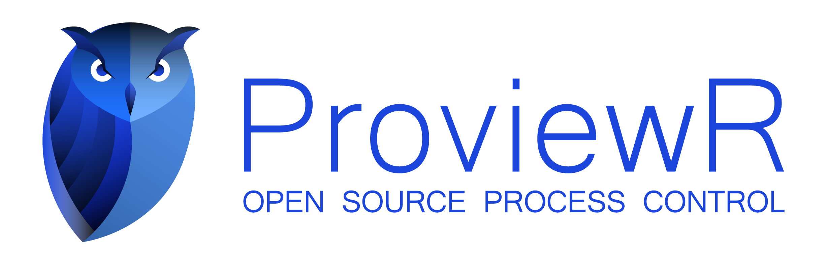

Release Notes V7.0

2026 04 01

Copyright © 2005-2026 SSAB EMEA AB

Permission is granted to copy, distribute and/or modify this document
under the terms of the GNU Free Documentation License, Version 1.2
or any later version published by the Free Software Foundation;
with no Invariant Sections, no Front-Cover Texts, and no Back-Cover Texts.

Table of Contents
Upgrading to ProviewR V7.0 4
Updates 4
List of all changes 4
Added 4
Fixed 5
Changed 6
Deprecated 7
Removed 7
Notable Changes 7
Semantic Versioning 7
PROFINET (SSAB Only) 8
PROFINET Runtime 8
RestartLimit 0 in RemNode objects 8
Notable Additions 8
Datatype BitField added 8
New Profinet viewer 9
Accessibility Support 13
PMTU Discovery for UDP 13
New upgrade tool 13
Wireshark plugin for qcom in lua 13
RFC5424 Logging 14
Notable Removals 14
Lucida Sans font removed 14
Upgrade procedure 14
The new tool 14
1. Making a copy of the project 18
2. Dump the databases 19
3. Changing the base version 19
4. Do the actual upgrading 20

Upgrading to ProviewR V7.0
This document describes new functions in ProviewR V7.0, and how to upgrade a project from V6.1.3 to V7.0.

Updates
For a complete list of changes see the CHANGELOG.md in the source root of the project. This changelog is new for this release and will be the place where all changes are being tracked. In the future we will try to link each issue aswell. But as our repo live on-prem at SSAB links will not work for external users.

List of all changes

Added
- Added triage bot to the project
- Added issue templates
- Added some ABB classes to the workbench palette for quick access
- Added the cJSON library to the project
- Added this changelog
- Prettier npm package and configuration for source code formatting.
- Add an error section to the bottom of the help window that displays up to 20 error messages.
  - Improve contextual feedback in the help window (e.g., via XTT, WTT) with clearer, more actionable error messages.
  - Include detailed error information, such as the filename and line number where each issue occurs.
- Added BitField8/16/32/64 data representation. These represent bitfields that are not byte-swapped, in accordance with their definition.
- New pin for DSup, ActiveNotAcked for when the DSup is active but has not yet been ackknowledged.
- A new Profinet Viewer has been added with more functionality and a topology view.
- CoLogger has been added (co_logger.h) that can be used in applications for easy logging in RFC5424 format.
- bcomp: Added MinOut to compposit
- PROFIBUS: Added support for jokerblocks introduced in GSD revision 4/5
- Accessibility support (ATK interface implementations) for widgets created by GE editor. Enabling external onscreen touch keyboards to popup when focusing input fields, if installed and activated.
- RemnodeUDP: Added PMTU discovery setting (Do/Don't Fragment, DF bit).
- A new pwr_upgrade tool has been added that unifies what reload.sh and upgrade.sh did. It should simplify the upgrade procedure for both users and devs.
  - reload.sh and upgrade.sh will be kept until the next version
- Added packet-qcom.lua plugin for Wireshark. This can be copied to the Wireshark lua plugin folder which one can find in the wireshark menu Help->About Wireshark->Folders (tab).
  - Start Wireshark from a terminal with PWR_BUS_ID set and it will find and dissect qcom messages with the filter "qcom".
- Support for treating char arrays as strings in ge using format '%s' on a datatype like ##Char#16.
- PROFINET: IM0 tab in object graph for class PnDevice.
- PROFINET: Added a configurable Startup Mode choice under Device Properties in the configurator, with guidance for when Legacy may be preferable if Advanced startup causes issues with large fragmented startup traffic.
- PROFINET: Added configurable watchdog factor for devices. New option is found in Timing Properties in the DAP for the Device.

Fixed
- Deb archive installation script would cause the script to fail since the service file had been renewed.
- Templates for objects inheriting PnDevice are now fixed.
- Animation bug in javascript ge graphs caused execution to stop in the browser.
- Fix build scripts where some directories where not created as they should when using parallel build.
- rt_plc_process: Fixed PlcThreadObjects remaining-slot clearing loop that used > instead of <, causing an out-of-bounds write past the 20-element array.
- bcomp/simul: Fixed off-by-one in CompIMC_Fo delay reset loops (i <= MAXCELLS → i < MAXCELLS) that wrote one element past the 100-element D[] array, causing undefined behavior.
- The "Alarm and event analyzer" would not start due to missing environmental variables.
- Fix a bug that caused the operator graph to crash when an input lost focus.
- Some aggregates for ABB and Eurotherm did not have their dynamic graphs generated correctly. They do now.
- Fix some renamed/misspelled images for the documentation.
- Fix the SsEnd/SsBegin objects for grafcet. They could not be used with boolean inputs and if connected prior to an upgrade they generated errorenous code.
- QCom had a high chance of deadlocking the entire QCom library on a node due to incorrect signal handling, causing communication outage.
  - Signal handling is removed in QCom leaving it up to the user to handle application specifics in regards to signals, as it should be.
  - Signal handling was added to the most common utilities used such as rt_xtt and rt_rtt where signals will be handled in an application specific manner and exit accordingly without deadlocks.
- Fix error handling for help-related issues, ensuring that "file not found" and "topic not found" errors are properly managed.
- DsFastCurve could crash because of an uninitialized variable used for the TriggIndex. It is now fixed.
- The Event Log would not convert Event Name to the correct coding resulting in garbled text in the Event Name and no results in the search.
- PROFINET: The configurator was unprepared for unpopulated slot 0. It is now well prepared for this.
- PROFINET: The configurator could show some inconsistencies in slots when changing DAP when the starting index of the physical slots did not start at 0.
- PROFINET: The configurator will now truncate strings to 79 characters before writing attributes using cdh-functions that doesn't add null termination.
- PROFIBUS: The configurator has more known keywords, reducing amount of console ouptut.
- PROFIBUS: The configurator supports multilines where windows style CRLF where used reducing weird console output that could occur.
- PID + CompPID: Fixed incorrect function when PidAlg was set to only I. It will now integrate correct with respect to Inverse flag.
- Traces for ConstAv and ConstIv are now working as they should. And can be used as one would expect.
- Fixed a display regression bug from color theme implementation in the workbench for various types across the workbench for void and status types. Code for DataArithms for instance, would show up in the DataIn1/2/3/4 attributes. And also, in objects where statuses are used, the value of the Status attribute would show up as the attribute value from the attribute above.
- Fixed a display bug in ge tables where buffers had no room for a null termination and thus data from the next cell was shown in the cell before.
  - Also added support for 64-bit integers and float, both size wise and with regards to formatting flags.
- Fixed rabbitmq + mqtt message size calculations
- UDP IO: Implemented stall action
- Various dereferenced null pointers in the workbench that caused the workbench to crash
- Message handler application requests no longer block for up to one hour waiting for a qcom_Request() reply. They now use the normal MH send/receive timeout and preserve MH__TMO on timeout.
- Distribution is now SSH-only. RemoteAccessType only offers SSH, and the old upgrade path rewrites older distribution settings to the SSH defaults.
- Package distribution now writes a per-target SSH log file and reports that path on failure.
- Closing a subwindow without adding anything to it or building it will no longer end up in an inconsistent state when trying to open that subwindow again.
- Fixed random flickering of Flags and icons when displaying a ChanCo class item in the device listing in rt_xtt.
- Double signal connections are now caught by syntaxcheck.
- GE/rt_xtt: Fixed RefUpdate for objid-based subgraph references by tracking referenced values with the actual subscription size instead of treating them as AttrRef. This makes nullified objid links trigger a reconnect/reset without reopening the graph.
  - Updated the GE Designers Guide with the RefUpdate dynamic.
- Fixed typos, bugs and missing features in the Web interface.

Changed
- The rs_export_rtdb executable now uses the common library for cJSON.
- Simplify the dir_symbols.mk file.
- $pwrp_doc is now created on rt systems and ready for distribution of documentation.
- pwr_stop.sh has been updated to remove the POSIX log message queue.
- profibus: The PROFINET configurator was not prepared for multiple fixed Virtual Submodule Items, it is now.
- profibus: PROFINET startup sequence now waits StartupTime seconds before checking IOCS status from devices
- Updated the documentation for the PID controller.
- PROFINET: The configurator will now rename modules and change the description if you change them. For instance, when changing DAP.
- PROFINET: The configurator will now do a sanity check on the modules configured for the DAP and remove submodules not in the submodules list for the DAP
  - This could happen during an upgrade when inconsistency in the GSDML files used as source would imply that a submodule should exists. This is due to the way things were implemented in the old configurator using simple indexes to map DAPs.
- Threads checking in on CycleSup objects will now tell you which CycleSup object triggered the EmergencyBreak.
- UDP (rs_remote_udpip) have had its buffer increased to 65507 bytes. But do try to keep UDP packets small.
- rt_errh/rt_errl has been changed to log in rfc5424 format.
- Xtt console log has been updated to read both old and new format of the proviewr log file (pwr_{hostname}.log).
- Xtt console log has had its filters and search improved and controls moved to the toolbar instead of a separate window.
- PROFINET: Softing headers have moved outside the codebase.
- Update Classes will now be more thorough and check sizes of class definitions compared to database and update accordingly. (#189 (closed))
- Various exit/return paths changed in some wb tooling used in reload/upgrade process. Some errors have been downgraded to warnings which is more in line with how one would expect things to be.
- A RestartLimit of 0 in a Remnode object will now be restarted by the rs_remotehandler forever but with increased backoff like 1s, 2s, 4s and so on until it reaches 30s backoff. If backend service hasn't restarted for 5s this is reset back to shorter backoff.

Deprecated
- Nodave for communcating with legacy S7 300/400 will be removed next release.
- MQ (dmq) which is a 32-bit message queue will be removed next release.

Removed
- Java support, only the websocket server will remain java for now. This was however removed several versions back. It's here to make it official.
- Lucida Sans font due to it being licensed. All uses of this font will be replaced with Helvetica.
- The old Profinet Viewer has been removed and replaced with the new and improved one.
- Removed rt_version.dat. The runtime version is now compiled in from pwr_version.h instead of read from a file that was only created during packaging. This also fixes the empty Version field in the runtime status monitor on non-packaged (dev) builds.
- Removed all remnants of the Motif framework that was still present.
- Removed URL search param from index.html in the Web interface due to file encoding error.

Notable Changes

Semantic Versioning
ProviewR changed versioning to now adhere to semantic versioning (https://semver.org/). Our hope is that this will provide more meaningful version numbers.

PROFINET (SSAB Only)
The PROFINET stack was upgraded to support IO-Link profiles.

PROFINET Runtime
The runtime part of the PROFINET implementation has been updated. Apart from many fixes we automatically read IM0 for each connected Profinet device.

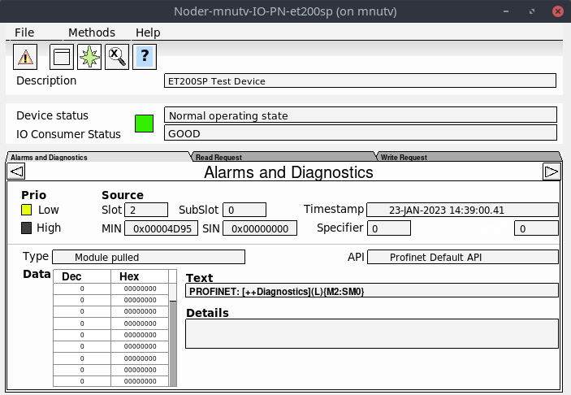
RestartLimit 0 in RemNode objects
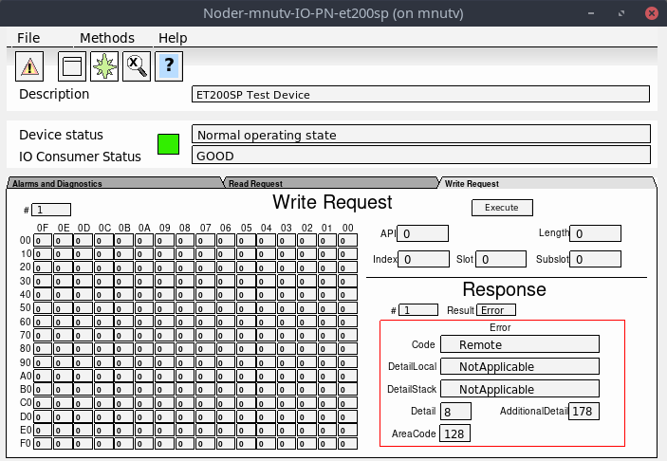Figure 1: PnDevice Write Request after an erroneous write request
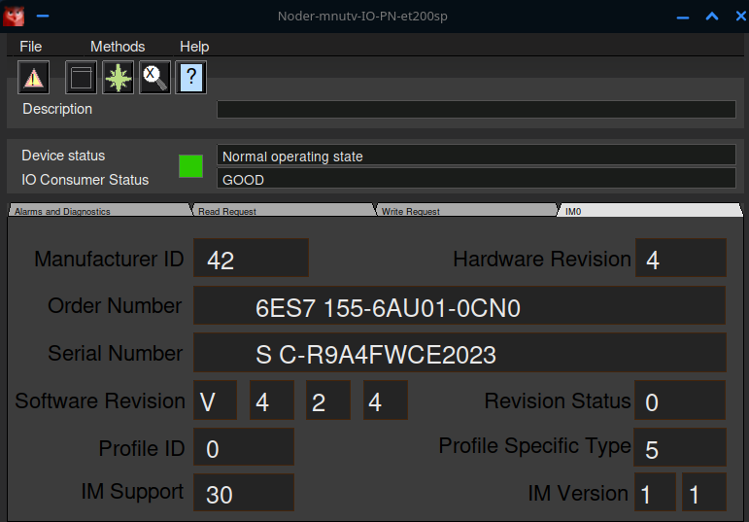Figure 1: PnDevice showing IM0 tab for an ET200SP
A RestartLimit of 0 in RemNode objects will now tell rs_remotehandler to restart the remnode handler process at all times but with an increasing backoff if it does not stay alive for a set amount of time.

Notable Additions

Datatype BitField added
A new datatype BitField8/16/32/64 has been added that isn’t byte swapped by the IO framework.

New Profinet viewer
A new Profinet Viewer has been added and the old one removed.
You can right click on a device for a context menu where you can copy information about the device to ease provisioning in ProviewR. Here you also find the “configure…” menu which you can also go to by double clicking a device.
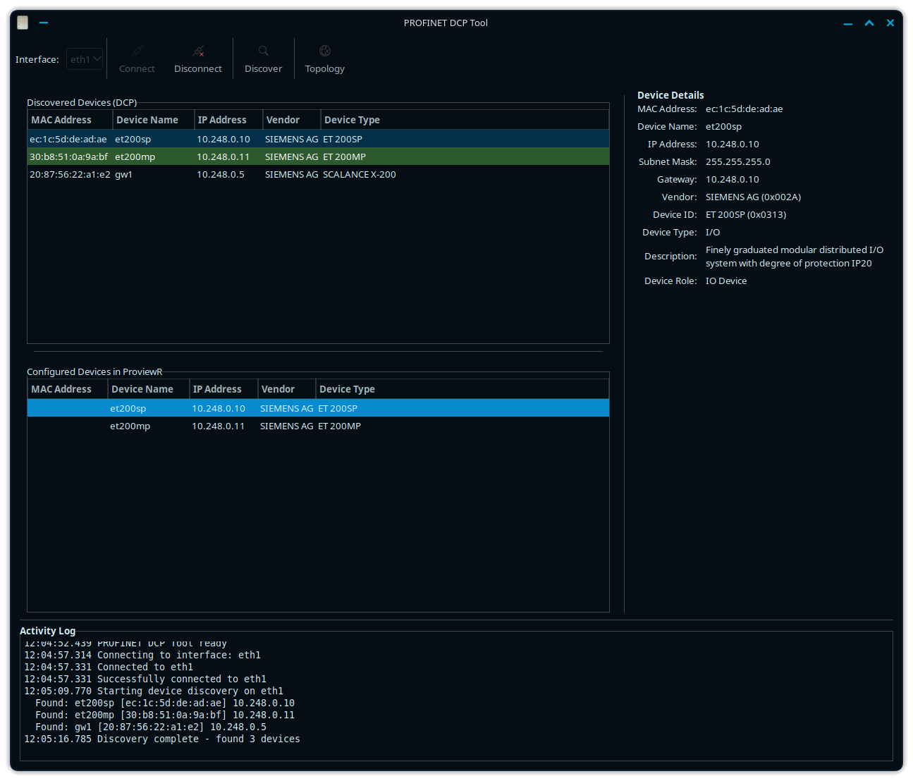Figure 2: Profinet Viewer showing information about a selected et200sp
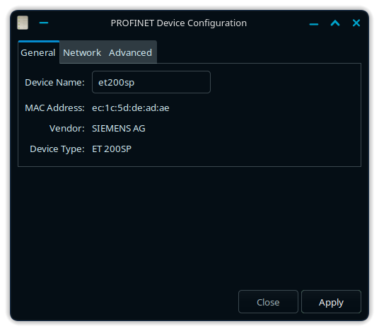
Set the device name in the General tab.
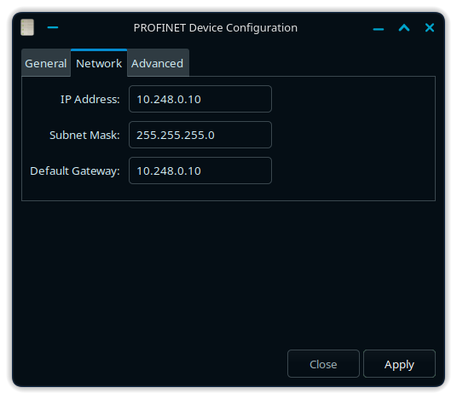
IP addressing under Network tab.
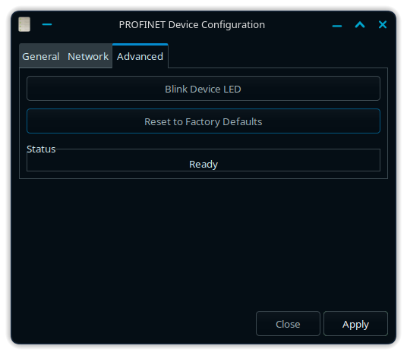
Under the Advanced tab you can issue a command to blink the leds on a device to find it during commisioning and also reset the device to various different states.
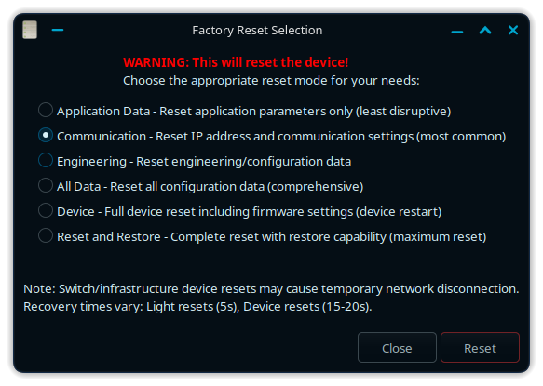

Accessibility Support
The input fields in our GE graphs now have basic support for the ATK interface enabling various other tools like on-screen keyboards to work if the need arises. The events on focus and such are now fired and should be picked up by these tools.

PMTU Discovery for UDP
A new flag for setting the “Don’t Fragment” bit when using UDP has been added.

New upgrade tool
In an effort to try to make upgrading easier in the future we have moved to one tool named pwr_upgrade which combines the functionality of the upgrade.sh and reload.sh tools. The old tools are kept one version for overlapping reasons.

Wireshark plugin for qcom in lua
The wireshark plugin is now shipped as a lua file in addition to the old delivery where Wireshark had to be rebuilt. It is placed in /usr/lib/x86_64-linux-gnu/wireshark/plugins on a standard install on Debian, keep in mind that depending on distro/arch the path may be different. The name of the lua file is packet-qcom.lua.

RFC5424 Logging
ProviewR will now log in RFC5424 format to make it easier for log pipelines to process logs from all process systems. The log viewer “System Messages” in rt_xtt still display log messages as one expects with the difference being that the filtering has been moved from menus to a toolbar.

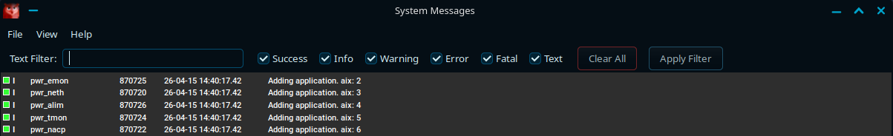
And the search is improved aswell.

Notable Removals

Lucida Sans font removed
The Lucida Sans font was removed due to licensing. The upgrade procedure will replace this font with Helvetica which is of the same type but a neo-grotesque sans-serif instead of the humanist sans-serif Lucida Sans was.

Upgrade procedure
The upgrading has to be done from any V6.1.X. If the project has a lower version, the upgrade has to be performed stepwise following the schema
V2.1 -> V2.7b -> V3.3 -> V3.4b -> V4.0.0 -> V4.1.3 →V4.2.0→V4.5.0→V4.6.0→V4.7.0→V4.8.6→(V5.0.0)→V5.1.0→V5.2.0→V5.3→V5.4→V5.5→V5.6→V5.7→V5.8→V5.9→V6.0→V6.1.X
From this point on the upgrade procedure will always be the same with the exception being the reload part since the new pwr_upgrade.sh does not exist in the old version we are upgrading. The point of this is to make it easier to learn by heart every action needed to upgrade.
The upgrade procedure is split into two phases. One phase in the old “base”, that is before we switch base to the newer one. And a second phase in which we have changed base to the new version and will reload the database from the dump and apply version specific procedures.

The new tool
If you’re not interested in details just skip to the Upgrade Procedure section. The new pwr_upgrade.sh tool is the new go to place for upgrading projects. It’s based on Python and comes with a new structure to make it easier for us developers to create different types of required upgrade steps, whatever they might be for each version.

The argument --help will give you a summary of the arguments and the standard steps that will always be run:
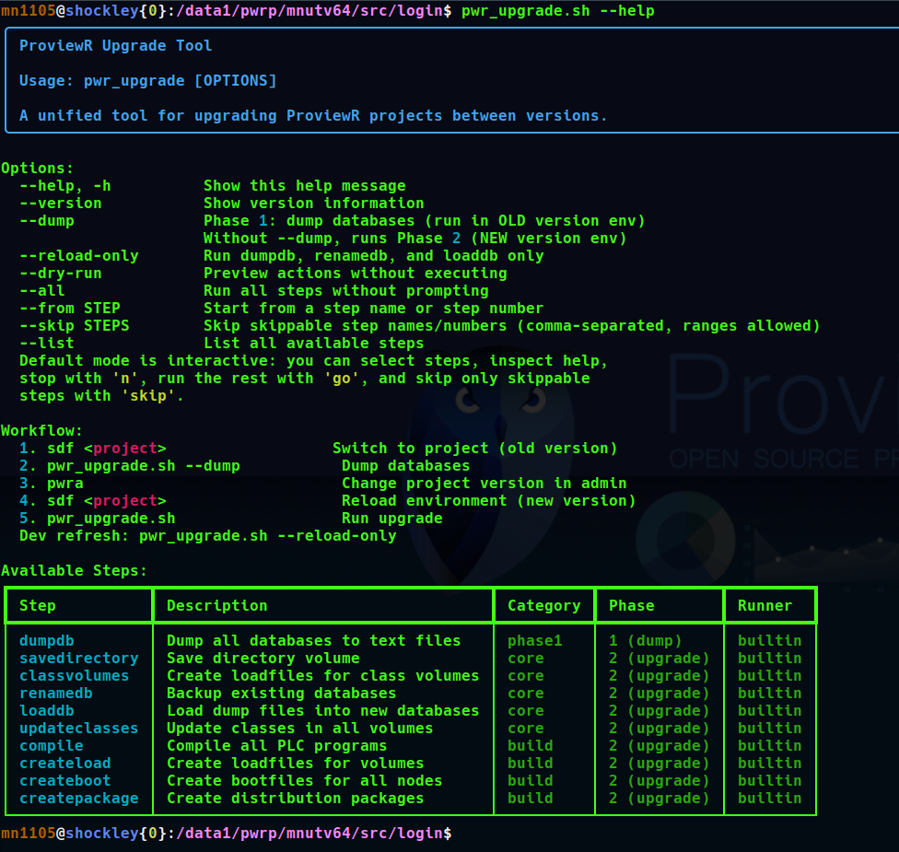
It will also give you a workflow hint.
The new tool will also log the upgrade procedure to $pwrp_log for your convenience.
If in the future you come from a V7.0 system the procedure is to run phase 1, which is the dump right now, in the old project instead of reload.sh.

The new tool will check locks on the database before proceeding with the upgrade:
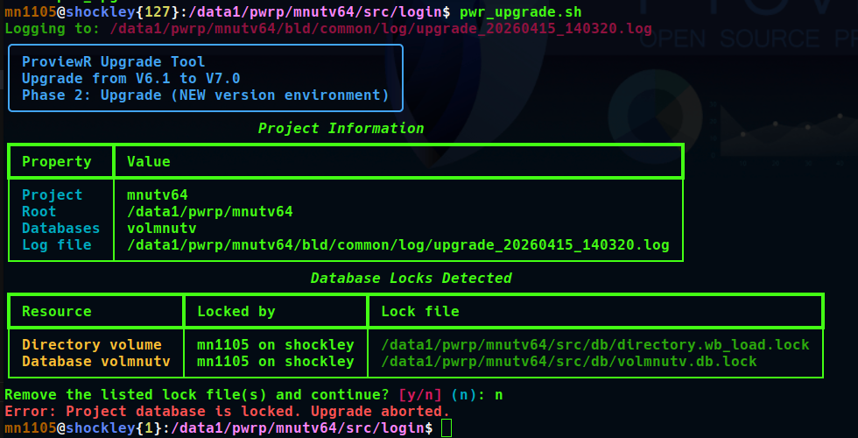Figure 3: Database is locked
Should you choose to remove the locks or if there are no locks you are presented with the upgrade path for the current version you are on:
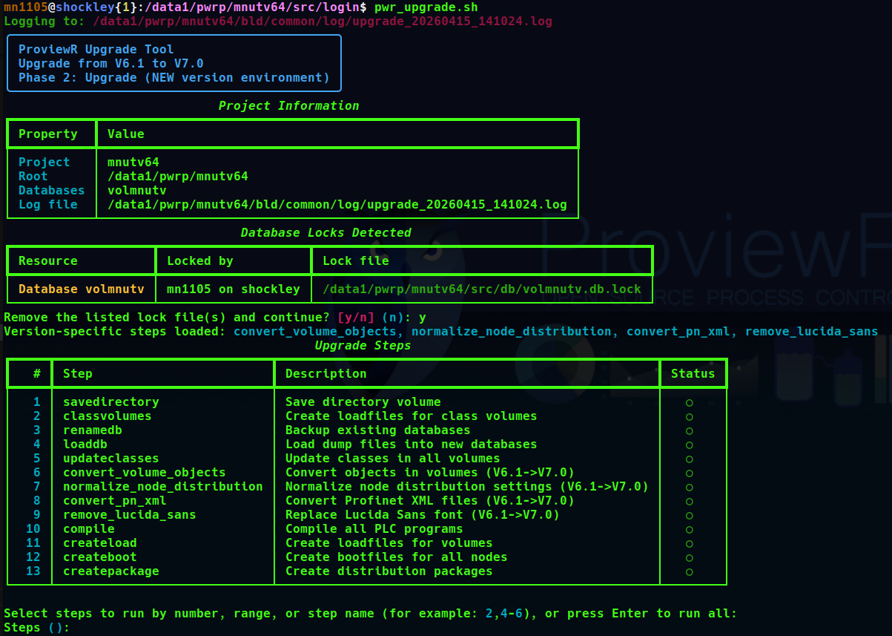
The advanced user can choose what steps to do. But hitting enter will go through all required steps. But as you might see the steps done after the version specific steps like compile PLCs and create loadfiles and such can be skipped if you prefer to do this manually later.
The upgrade tool will try to check the outcome of each step and stop if any fail, asking the user what to do.
When starting the steps you have the option to say “go” to just quickly execute them all. Otherwise you get to say y/n on each step. A new option “help” is also available that will tell you what the step does.

1. Making a copy of the project
This is optional but always recommended, as with everything we do, a backup is never a bad idea.
Do sdf to the project and start the administrator:

sdf project_name
pwra

- With the Project List opened, login as administrator if you lack access.
- Enter edit mode and find the current project, right click it, and select Copy Project from the context menu of the ProjectReg object.
- Open the newly copied object and assign a suitable project name and path.
- Save and close

2. Dump the databases
Do sdf to the project if you haven’t.

sdf project_name

Now execute the reload.sh script

reload.sh

It will say:

Enter start pass [dumpdb] >

Hit enter to execute the default starting step “dumpdb”. It will ask if you want to continue:

Do you want to continue ? [y/n/go]
Say “y” here and press enter.

The script will now dump the databases in the volume. If by chance you get the error that the database is locked, you need to redo this step after making sure the database isn’t locked by someone.
The script then stops at the next step asking you if you want to continue. Choose n, as we don’t want to continue.
After that the script ends and we have our dump files.

3. Changing the base version
Enter the administrator again, and locate your project in the Project List. Change the version of the project to V7.0. Note that since we have moved to semantic versioning we now only have the major and minor parts.
Save and close the administrator.
With the base changed for the project we can now issue sdf to the project once again to set everything up for the new version.

sdf project_name

4. Do the actual upgrading
If you want some information about the new tool check the section “The new tool”.
Once you have changed base to the new version and have done sdf to it execute pwr_upgrade.sh.

pwr_upgrade.sh

This will bring up the upgrade program. Without the --dump argument the pwr_upgrade.sh tool starts in phase 2:
Hit enter to execute all the steps. It will stop on each step asking you y/n, unless you say “go” and it will do them all without asking.

