

Release Notes V5.4

2016 03 16

Copyright © 2005-2016 SSAB EMEA AB

Permission is granted to copy, distribute and/or modify this document
under the terms of the GNU Free Documentation License, Version 1.2
or any later version published by the Free Software Foundation;
with no Invariant Sections, no Front-Cover Texts, and no Back-Cover Texts.

Table of Contents
Upgrading to Proview V5.4.0 6
New functions 6
Ge Custom color palette 6
Object graphs updated 7
Color themes 8
Using color theme in projects graphs 11
Description of color theme colors 12
Ge dynamics ColorThemeLightness 13
Ge dynamics DigBackgroundColor 13
Ge dynamics DigSwap 14
Store and recall object properties 14
New properties in Ge objects 15
Rectangle properties 15
Background color 15
fill_eq_background 15
bgcolor_gradient 15
Arc properties 15
Background color 15
fill_eq_background 15
Polyline properties 15
Background color 15
fill_eq_background 16
fill_eq_bglight 16
fill_eq_bgshadow 16
Subgraph and Group properties 16
Background color 16
Ge object name 16
Ge search object 16
New Subgraphs 17
New Ge commands 17
customcolor write 17
customcolor read 17
customcolor print 17
customcolor set 17
New Ge script functions 17
GetFirstObject() 17
GetNextObject() 17
GetObjectAttribute() 17
GetObjectBorder() 17
GetObjectBorderColor() 17
GetObjectClass() 18
GetObjectDynType() 18
GetObjectFill() 18
GetObjectFillColor() 18
GetObjectGradient() 18
GetObjectName() 18
GetObjectShadow() 18
GetObjectText() 18
GetObjectTextColor() 18
GetObjectType() 18
GetRgbColor() 18
GroupGetFirstObject() 18
GroupGetNextObject() 18
Reload() 19
SetObjectAttribute() 19
SetObjectBackgroundColor() 19
SetObjectFill() 19
SetObjectShadow() 19
SetObjectTextColor() 19
SetRgbColor() 19
New Xtt script functions 19
GetUser() 19
GetPrivileges() 19
Web configuration 19
Android app configuration 20
PID and CompPID modification for long integration times 20
TimeMean, cumulative mean value 20
QCom monitor update 20
Export buffer limit 20
Acknowledge delay 20
Segment size 20
Min and max resend time 20
rt_rtt show qnode picture updated 21
Event handler alarm status message 22
Application index 22
Interface to video management system Aimetis 22
Position in Trace and Plc editor navigator window 22
Remote transactions with QCom 23
Address calculation for PSS9000 cards 23
New Classes 23
OpPlaceWeb 23
OpPlaceApp 23
TimeMean 23
VideoMgmServer 23
XttVideoMgm 23
RemnodeQCom 23
Modified Classes 24
WebHandler 24
OpPlace 24
PID and CompPID 24
NodeConfig and SevNodeConfig 24
FriendNodeConfig 24
$Node 24
Ssab_BaseACard, Ssab_BaseDiCard, Ssab_BaseDoCards, Ssab_CO4uP 24
V5.4.1 Additions 24
Virtual keyboard 24
Ge dynamics DigScript 25
New property DecimalsAttr for Ge dynamics Value 26
Internal model controller IMC 26
Simulate objects 27
Sim_SigGen 27
Sim_Integrator 27
Sim_LeadLagFilter 27
Sim_LagFilter 28
Sim_Delay 28
Sim_SouFilter 28
Sim_SouTOoFilter 28
Sim_SlwRateLimiter 28
Upgrade procedure 29
Make a copy of the project 29
Linux release upgrade 29
Change version 29
upgrade.sh 29
savedirectory 29
classvolumes 29
updateclasses 29
cnvobjects 30
compile 30
createload 30
buildnodes 30
createpackage 30
List example 30

Upgrading to Proview V5.4.0
This document describes new functions i Proview V5.4.0, and how to upgrade a project from V5.3.0 to V5.4.0.

New functions

Ge Custom color palette
The new custom color palette is positioned below the ordinary color palette. It contains 90 colors that can be defined by the user. By double clicking on a color, the color selector is opened where the color is specified. The colors in the custom color palette can be used as fill color, border color, text color and in color dynamics as any other color. If a custom color is modified, all objects drawn with this color is updated with the new color.
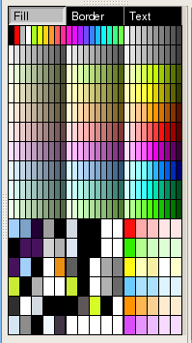
Fig Custom color palette
it is possible to save the colors in custom color palette to file and load them into other graphs. This is done by activating File/CustomColors/Save and File/CustomColors/Load in the menu. The colors are stored in pwrc-files on $pwrp_exe.
It's also possible to use a common color file for several graphs in a project. If a color-file is specified in ColorTheme in Graph attributes, this file will be loaded automatically when the graph is opened. When a color is adjusted and stored, it will affect all object drawn with this color in all graphs with this color-file. In this way the colors in the graphs can easily be adjusted.

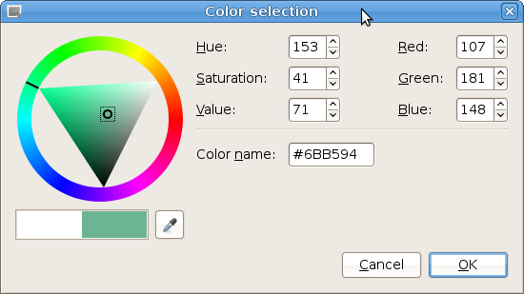
Fig Color selector

Object graphs updated
All object graphs are redrawn and updated. The graphs are drawn with color themes and follow the currently selected theme.
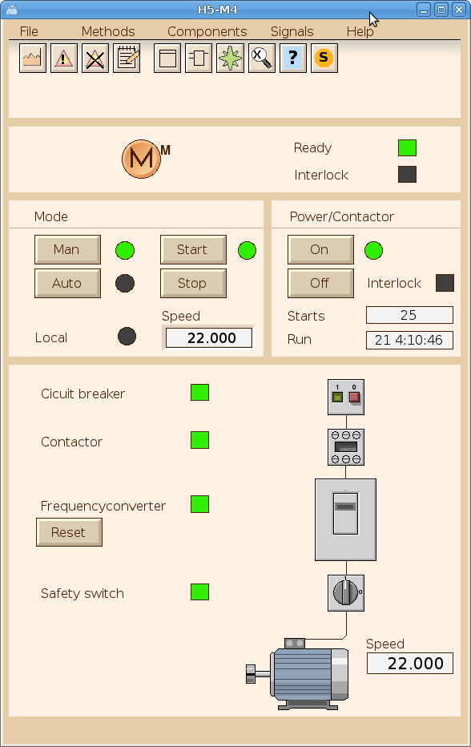
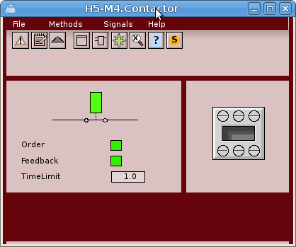
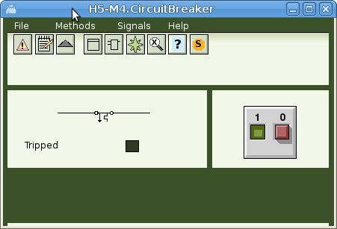

Color themes
The color theme is selected by the operator from Functions/View/Color Theme in the operator window menu.
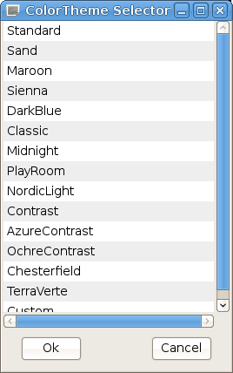
The color theme will specify the colors for the operator window, object graphs, and possibly also project graphs if these are drawn with a colortheme table. Here are some examples of color themes.

Fig Operator window with Sand color theme

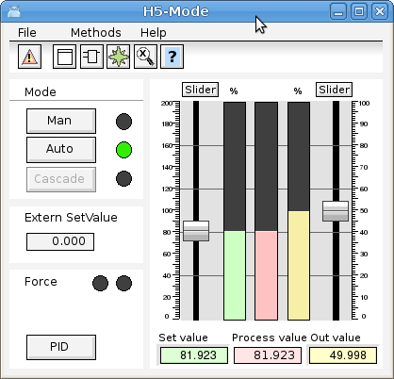
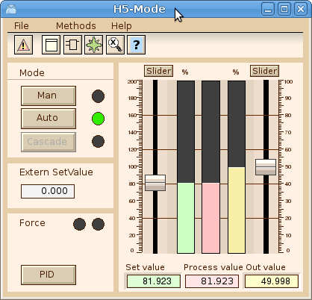
Standard and Sand
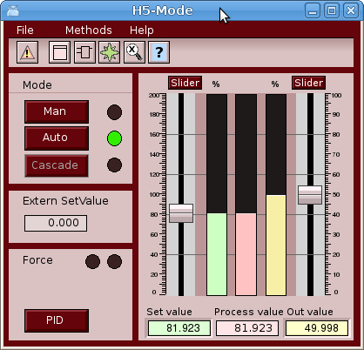
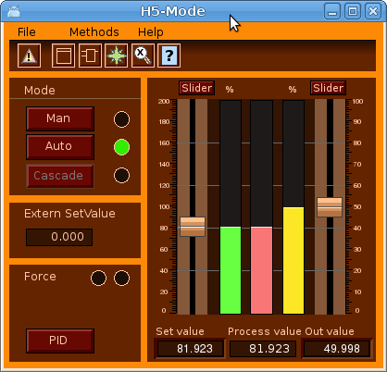
Marron and Sienna
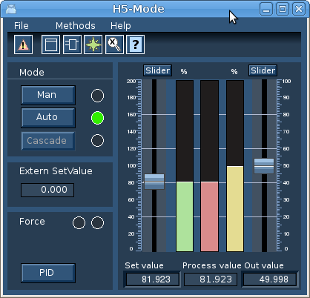
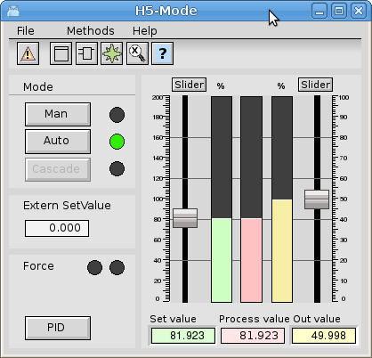
DarkBlue and Classic
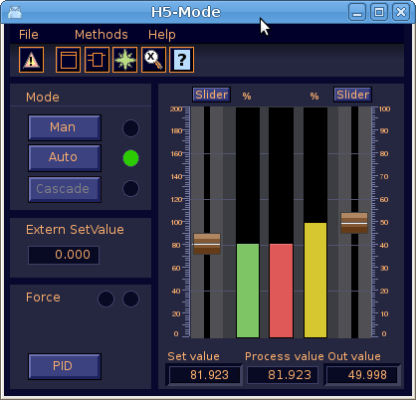
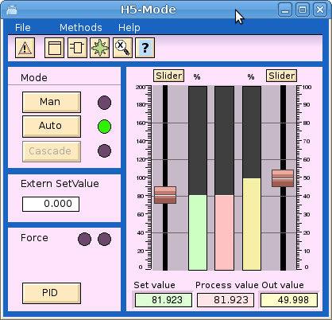
Midnight and Playroom
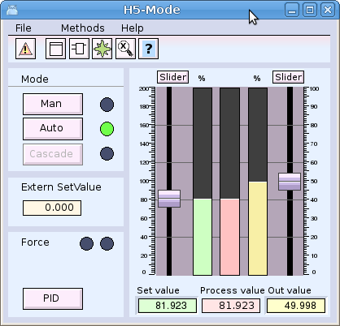
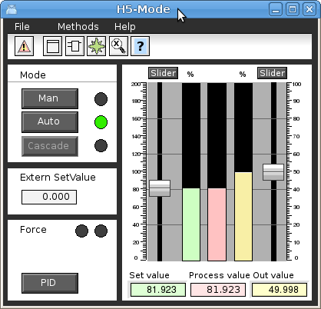
NordicLight and Contrast
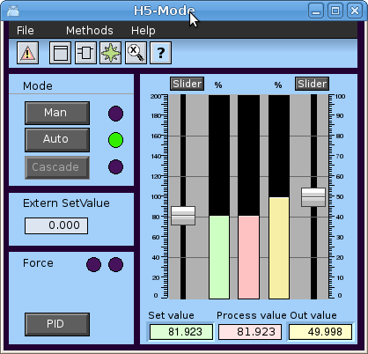
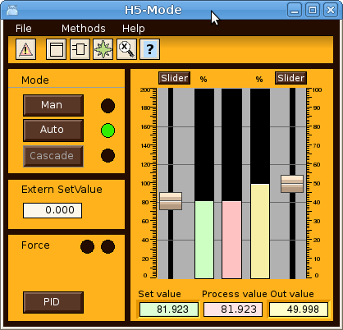
AzurContrast and OchreContrast
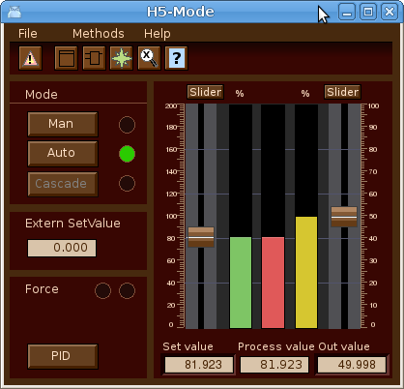
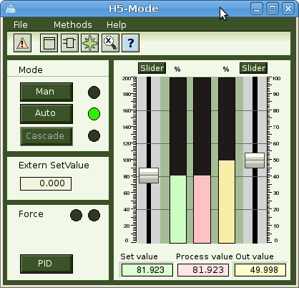
Chesterfield and TerraVerte
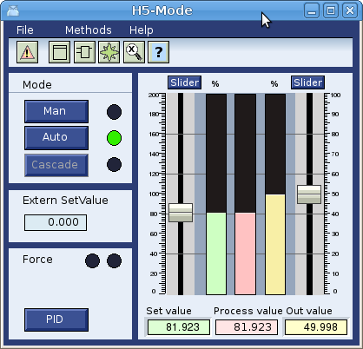
Polar
Graphs drawn with color theme uses color tables for custom colors where

Using color theme in projects graphs
The color themes can also be used when drawing graphs in a project. These graphs will follow the appearance of the color theme selected by the operator, but it requires that specific colors in in the custom color palette is used when drawing different objects.
A color theme is loaded from File/ColorTheme/Select in the Ge menu. The colors for the theme is then loaded into the custom colors palette. Every color in the custom color palette is adjusted for a specific purpose. The first color for example is the background color for the graph, and the fifth color should be set on texts on the background. By placing the cursor on a color in the palette, the purpose of this color will be written in a field below the palette.
The color theme has support for specific elements in a graph. In the example below the background color is lightgreen. The dark green lines are called delimiter areas. In this case it is rectangles the divides the graph into different sections. It's also possible to use if for larger areas with text and indicators. At the top there is a menu bar with pulldown menues, and below this a gradient to make a shadow below the menu. Object graphs should contain a method toolbar positions below the menu. Other elements are bars, axises, buttons, indicators, texts on the background, and texts on a delimiter area, sliders, value fields and input fields, tables, diagrams etc.
For more complex elements that are are not suited for a change of fill color, as the gray actuator and valve below, the dynamic ColorThemeLightness can be used to adapt the lightness of these elements to the lightness of the theme.
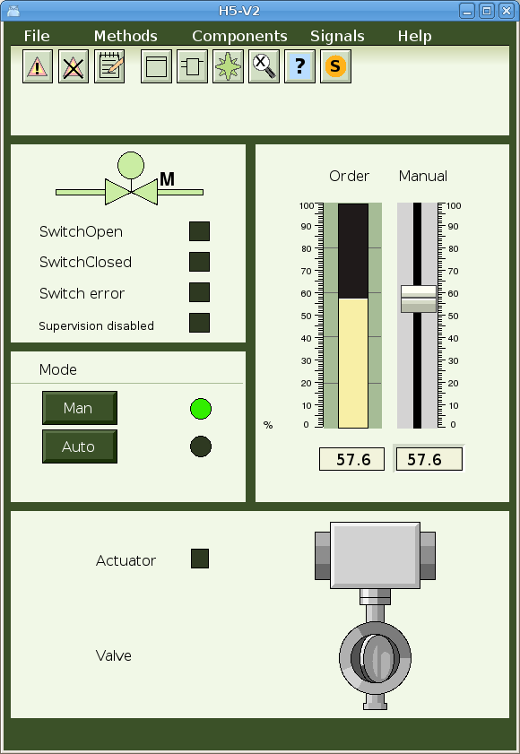

Description of color theme colors

Num | Name | Description
1 | Background | Should be set as background color for the graph. Light green in the example above.
2 | Background gradient | Can be used for gradients to the background color, eg the gradient under the menu above.
3 | Delimiter area | Color of delimiter areas. The dark green areas.
4 | Delimiter lines | Color of lines that divides the background, eg the line under Mode above.
5 | Text/Lines on background | Color of texts and lines on the background.
6 | Input field fill color | Fill color for ValueInput objects.
7 | Input field border color | Border color for ValueInput objects.
8 | Input field text color | Text color for ValueInput objects.

16 | Indicator border color | Should be set as border color on indicators.
17 | Indicator low color | Low color for indicator
18 | Indicator on delimiter low color | Low color for an indicator on a delimiter area.
19 | Slider color | Color for sliders.
20 | Slider background color | Color for slider background.
21 | Value field fill color | Fill color for Value objects.
22 | Value field border color | Border color for Value objects.
23 | Value field text color | Text color for Value objects.

31 | Limit switch high color | Color for limit switch when it's high.
32 | Limit switch low color | Color for limit switch when it's low.
33 | Limit switch border color | Color for limit switch border.
34 | Text/Lines on delimiter | Color for text or lines on a delimiter area.
35 | Button active color | Color to indicate that a button is active.
36 | Button fill color | Fill color for buttons.
37 | Button border color | Border color for buttons
38 | Button text color | Text color for buttons
39 | Button insensitive text color | Text color set when button is set insensitive by Invisible dynamics.
40 | Button insensitive border color | Border color when button is set insensitive by Invisible dynamics.

46 | Symbol fill color | Color that can be used component symbols.
47 | Symbol border color | Color for symbol border.
48 | Symbol low color | Color when symbols is low.
49 | Symbol empty color | Color that can be used to indicate that a valve in closed or empty.
50 | -
51 | Bar bar color | Color for the value part of a bar object.
52 | Bar background color | Color for background part of a bar object.
53 | Bar bar limit color | Color for edge of bar.
54 | Bar background area | Color used for surrounding area for bar objects. Dark green in the example above.
55 | Bar background lines | Color for lines on the surrounding area for bar objects.

61 | Menu fill color | Fill color for menu bars and menus.
62 | Menu text color | Color for menu texts.
63 | Toolbar fill color | Color for method toolbar in object graphs
64 | Toolbar border color | Border color for method toolbar.
65 | Toolbar text color | Text color for method toolbar.
66 | Diagram fill color | Fill color for diagrams.
67 | Diagram border color | Border color for diagrams.
68 | Diagram curve color | Default curve color for diagram.
69 | Axis border color | Color for axis objects.

Ge dynamics ColorThemeLightness
A color theme has a lightness property that is negative for dark themes and positive for light themes. The theme Midnight has for example lightness -5 while NordicLight has 1. Adding dynamic ColorThemeLightness to an object will increase or decrease the lightness of the object dependent on the colortheme lightness value. The ColorThemeLightness dynamic has no properties.

Ge dynamics DigBackgroundColor
The DigBackgroundColor dynamics makes it possible to set dynamics on the new background color. DigBackgroundColor works analogous with DigColor, but will changes the background color instead of the fill color. The DigBackgroundColor has several instances and thus can be connected to several digital signals, and change between several colors.
DigBackground color makes it possible to modify the color of two parts of a subgraph or group independently of each other. In the example below, the gray rectangle is drawn with fixed gray color, the left circle has the fill color, and the right background color. Drawing a circle with background color is achieved by setting the fill_eq_background property of the circle.
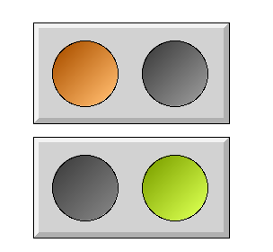
When setting dynamic DigColor and DigBackgroundColor to the group, the DigColor dynamic will affect the left circle drawn with fill color, and the DigBackgroundColor dynamics will affect the right circle drawn with background color.
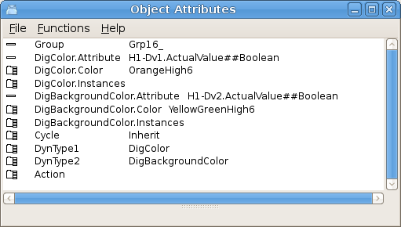

Ge dynamics DigSwap
DigSwap will disconnect all subscriptions in the graph and reconnect them again. This is useful when subscriptions by reference is used with the &() syntax, eg &(H1-Plate.Ref).Length##Float32. In this example H1-Plate.Ref is an attribute reference that points to an object containing the Length attribute. If the reference in H1-Plate.Ref is changed, the subscriptions has to be reconnected to the new reference, and this is done by DigSwap. DigSwap is connected to a digital signal that will activate the swap.

Store and recall object properties
A new function in the Ge editor to store the properties for the currently selected object, and later recall these properties to another object, is added. The function is activate from 'Edit/Objects Attributes Store (Shift+Control A)' and 'Edit/Object Attributes Recall (Shift+Control D)' in the menu. The function is the same as Store and Recall in the object editor. The advantage is that the object editor doesn't have to be opened. Properties and dynamics can be copied by first selecting the source object and pressing Shift+Control A, and then selecting the target object and pressing Shift+Control D.

New properties in Ge objects

Rectangle properties
Rectangle has the new properties background color, fill_eq_background and bgcolor_gradient.

Background color
The background color can be set to a rectangle in the Ge editor by selecting the rectangle and clicking with Shift/Ctrl on a color in the palette.

fill_eq_background
When fill_eq_background is set, the rectangle will be filled with the background color instead of the fill color. If the rectangle belongs to a subgraph or group, it will be filled with the background color for the sugraph or group.

bgcolor_gradient
When bg_color_gradient is set, any gradient will drawn between the background color and the fill color. In the left example below the background color for the rectangle is yellowgreen and the fill color is orange. In the right example background color is black, and fill color orange.



Arc properties

Background color
The background color can be set to an ac in the Ge editor by selecting the rectangle and clicking with Shift/Ctrl on a color in the palette.

fill_eq_background
When fill_eq_background is set, the arc will be filled with the background color instead of the fill color. If the arc belongs to a subgraph or group, it will be filled with the background color for the sugraph or group.

Polyline properties

Background color
The background color can be set to a polyline in the Ge editor by selecting the polyline and clicking with Shift/Ctrl on a color in the palette.

fill_eq_background
When fill_eq_background is set, the polyline will be filled with the background color instead of the fill color. If the polyline belongs to a subgraph or group, it will be filled with the background color for the sugraph or group.

fill_eq_bglight
When fill_eq_bglight is set, the polyline will be filled with a lighter tone of the background color.

fill_eq_bgshadow
When fill_eq_bglight is set, the polyline will be filled with a darker tone of the background color.

Subgraph and Group properties

Background color
All rectangles, arcs and polyline that is part of a subgraphs or group, that has the properties fill_eq_background, fill_eq_bglight or fill_eq_bgshadow set, will be drawn with the background color for the subgraph or group.
The background color for a subgraph or group is set by selecting the subgraph or group, and clicking with Shift/Ctrl on a color in the color palette.
In the left example below, the green round indicator has a surrounding yellow arc with fill_eq_background set and with diagonal gradient. The square indicator has two yellow poly lines around it, one with fill_eq_bgshadow, and one with fill_eq_bglight set. By setting the background color of the indicators, the background components can be adapted to the current background of the graph.
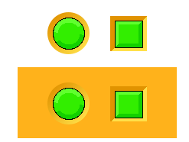

Ge object name
The name of a Ge object is displayed in the object editor. It can also be changed there. The possibility to change an object name from the menu 'Edit/Change name' is removed.

Ge search object
The menu entry 'Edit/Search object' in the Ge editor, makes it possible to search an object by name. As some error messages contains the name, the search function makes it easier to locate the error.

New Subgraphs
A number of new subgraph with colors adapted to the color theme palette is added. They can be found under the ColorTheme map.

New Ge commands

customcolor write
Write custom colors to file.
> customcolor write /file=

customcolor read
Read custom colors from file.
> customcolor read /file=

customcolor print
Print rgb-values for custom colors.
> customcolor print

customcolor set
Set properties lightness and isdefault to current color theme.
> customcolor set /lightness= /isdefault

New Ge script functions

GetFirstObject()
Get the first object in a graph.

GetNextObject()
Get the next object in a graph.

GetObjectAttribute()
Get an attribute value of an object.

GetObjectBorder()
Get object border property.

GetObjectBorderColor()
Get the border color of an object.

GetObjectClass()
Get the subgraph of an object.

GetObjectDynType()
Get dynamic and action type of an object.

GetObjectFill()
Get object fill property.

GetObjectFillColor()
Get the fill color of on object.

GetObjectGradient()
Get the gradient type of an object.

GetObjectName()
Get the name of an object.

GetObjectShadow()
Get the shadow property of an object.

GetObjectText()
Get the text of a text object.

GetObjectTextColor()
Get the text color of an object.

GetObjectType()
Get the object type.

GetRgbColor()
Get rgb values for a color.

GroupGetFirstObject()
Get first object in a group.

GroupGetNextObject()
Get next object in a group.

Reload()
Read the current graph from file.

SetObjectAttribute()
Set an attribute value of an object.

SetObjectBackgroundColor()
Set the background color of an object.

SetObjectFill()
Set the fill property of an object.

SetObjectShadow()
Set the shadow property of an object.

SetObjectTextColor()
Set the text color of an object.

SetRgbColor()
Set rgb values for a color.

New Xtt script functions

GetUser()
GetUser() returns a string with the current Proview user.

GetPrivileges()
GetPrivileges() returns the privilege mask for the current user.

Web configuration
The new class OpPlaceWeb is used to configure web pages. Attributes to configure the buttons for language, login, alarm and event list, event log, runtime navigator, project and Proview help is moved from the EventHandler object to the OpPlaceWeb object. Several web pages with different menues can be configured by creating several OpPlaceWeb objects with different filenames.
Buttons for Ge graphs and links are as before configured with WebGraph and WebLink objects, but they should now be positioned under the OpPlaceWeb object.
The WebHandler object is still used to configure the web server processes, rt_webmon, rt_webmonmh and rt_webmonelog.

Android app configuration
The OpPlaceApp object configures the android app. AppGraph and AppLink objects, previously configured under the WebHandler object, should now be configured under the OpPlaceApp object.

PID and CompPID modification for long integration times
The PID and ComPID objects are modified to avoid problems with remaining error when long integration times are used together with short scan times. The OpWindup and AbsOut attributes are changed from Float32 to Float64.

TimeMean, cumulative mean value
TimeMean is a plc function object that calculates the cumulative mean value over time.

QCom monitor update
The QCom monitor that handles all communication between nodes has been updated and adapted to higher network speeds.

Export buffer limit
During times of heavy load or bad network when outgoing messages can't be emitted in the pace they are entering the qcom monitor, they are buffered in an export queue. Previously there was no limit on this queue which could cause the network to go down on all links. Now this queue is limited and the queue will be purged when the limit is reached. The limit is configurable and can be set in NodeConfig.AComExportBufQuota. The limit, current usage and number of executed purges can be seen in the qcom node picture in rt_rtt.

Acknowledge delay
All QCom messages are sent with acknowledge to verify that the message has reached the target. If no ack is received within a certain time, the message is resent. Previously there was a delay of 1 tick (10 ms) before the ack was sent. This delay time is now configurable in NodeConfig.QComAckDelay.

Segment size
Large QCom messages are divided into segments. Previously the segment size was hard coded to 8192 bytes. It can now be configured in NodeConfig.QComSegmentSize. Note that all communicating nodes must have the same segment size.

Min and max resend time
When a messages is sent and no ack is received within the min resend time, the message will be resent. This time the timeout time is doubled, and if still no ack is received, the timeout time is doubled again. This continues until the timeout time reaches the max resend time, where the link is taken down. The min and max resend time previously had default values of 0.5 and 10 s which could be increased with configuring attributes in the NodeConfig object. Now they can also be decreased. The default value for min resend time is changed to 0.05 s.

rt_rtt show qnode picture updated
The rt_rtt qnode picture, opened from System/Communication/QCom/QCom Nodes, is updated and now displays the Round trip time in seconds. The segment size, acknowledge delay and export buffer quota and usages are also displayed. An error counter for segment sequence errors is also added.
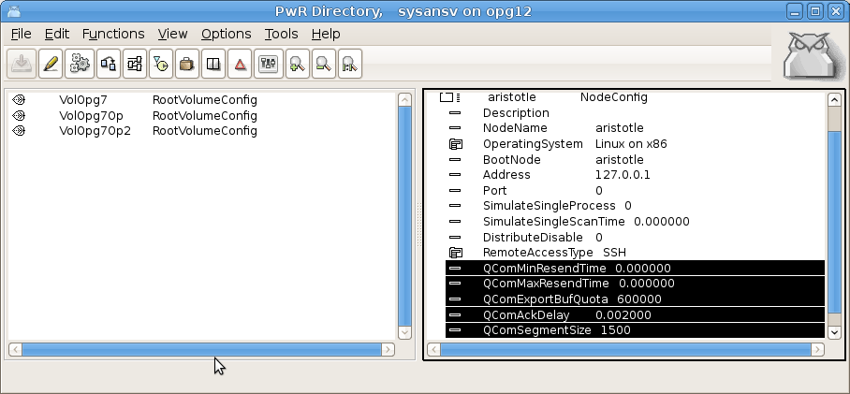
Fig QCom settings in the NodeConfig object

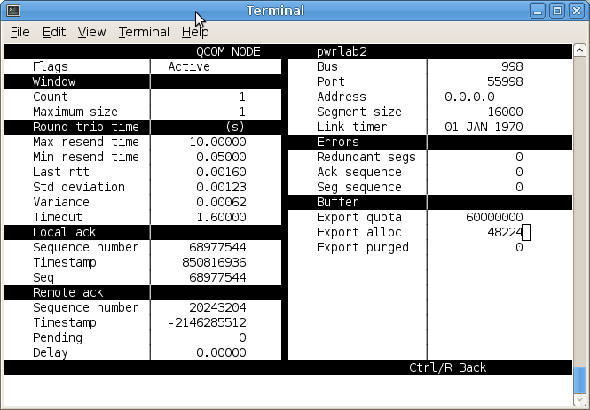
Fig The QCom node picture in rt_rtt

Event handler alarm status message
A new cyclic message is introduced in the communication between the event monitor and outunits. The Alarm status message contains a list of all not acknowledged or active alarms. This will ensure that the alarm list always is up to date even at times with bad network when event messages are lost.

Application index
The number of applications that can be supervised is increased from 20 to 50.

Interface to video management system Aimetis
Aimetis Thin Client is a video management system that can display video camera streams, either as panels, ie combinations of different cameras on one screen, or as one cameras full screen. The selection of panels and cameras can be made from Proview with the XttVideoMgm object. Panels or cameras is viewed by selecting a panel or camera in the lists to the left. Panels can also be modified by selecting camera in the in the screen layout to the right. It's also possible to create new panels from the Add/Remove button.
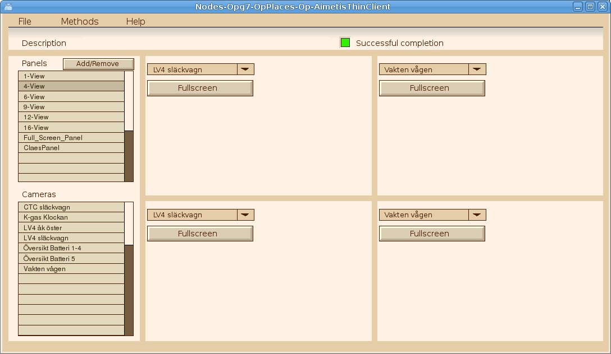
A new server process handles the video communication and this has to be configured with a VideoMgmServer object in the node hierarchy.

Position in Trace and Plc editor navigator window
Sometimes it can be hard to find the rectangle for the currently viewed area in the navigator window in Trace or Plc editor. It's now possible to position the rectangle to the current cursor position with Shift/Click MB1.
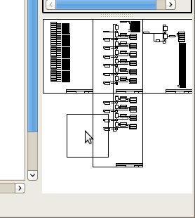
Fig Position the rectangle with Shift/Click MB1

Remote transactions with QCom
It's now possible to send remote transactions on Qcom with the new RemnodeQCom object.

Address calculation for PSS9000 cards
A calculation of the address for PSS9000 card is added. The calculation is made when a card object is created, and is made from the current position in the rack. If the position is changed, and new calculation can be made from the SetAddress method in the popup menu. Also the address switch settings is calculated and displayed in the SwitchSettings attribute.

New Classes

OpPlaceWeb
Configures a web page.

OpPlaceApp
Configures an Android app.

TimeMean
Plc object to calculate a cumulative mean value.

VideoMgmServer
Configuration of the video management server. The video management server handles communication with video management system.

XttVideoMgm
Configuration of the control of a video management system. So far control of Aimetis Thin Client is implemented.

RemnodeQCom
Configuration of remote transactions on QCom.

Modified Classes

WebHandler
Several attributes moved to OpPlaceWeb and OpPlaceApp.

OpPlace
Attribute ColorTheme added to select default color theme.

PID and CompPID
Modification for better handling of long integration times together with short scan times.

NodeConfig and SevNodeConfig
Added attributes for QCom configuration, QComExportBufQuota, QComAckDelay and QComSegmentSize.

FriendNodeConfig
Added attributes for QCom configuration, QComExportBufQuota, QcomAckDelay.

$Node
Arrays for ProcessStatus etc are increased to be able to handle the increased number of application processes.

Ssab_BaseACard, Ssab_BaseDiCard, Ssab_BaseDoCards, Ssab_CO4uP
The attribute SwitchSettings is added to show the desired setting of the address switch on the boards. The attribute VectAddress is removed.

V5.4.1 Additions

Virtual keyboard
The virtual keyboard is used for touch screens and configured in the OpPlace object by settting VirtualKeyboard in options. The virtual keyboard is enabled on input fields in Ge graphs, and for each input field the type of keyboard can be specified in the ValueInput property KeyboardType. The keyboard types are 'standard', 'alphabetic' and 'numeric' displayed in the figures below.

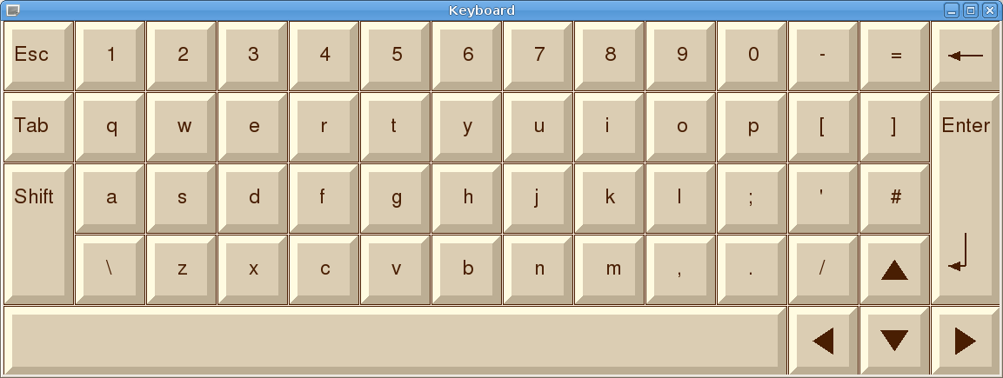
Fig Virtual keyboard of type standard
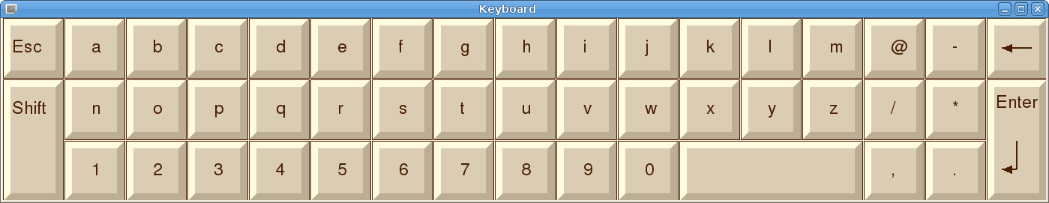
Fig Keyboard of type alphabetic
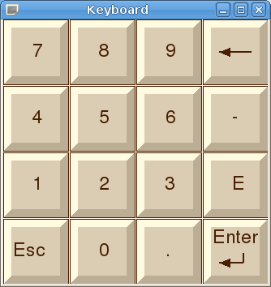
Fig Keyboard of type numeric

Ge dynamics DigScript
Dig script is connect to a digital signal, and executes a script. Dependent on the DigScript.Level property, the script is executed when the signal is high or when the signal goes from low to high.
The script is edited in DigScript.Script.
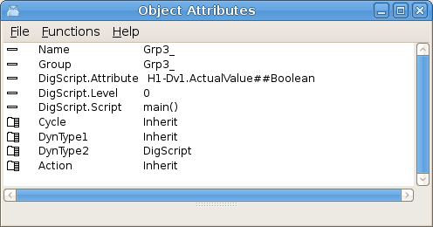
Fig DigScript properties

New property DecimalsAttr for Ge dynamics Value
Ge dynamic Value has new property DecimalsAttr. It is used to state the number of decimals in a float, ie the number of characters after the point. DecimalsAttr should be connected to a signal of type integer or enum that states the number of decimals. A special enum type is created for this, FloatPrecisionEnum that can have the value 0 – 5.

Internal model controller IMC
An internal model controller is implemented in Proview by Bruno PERMANNE, with the objects CompModeIMC and CompIMC. See http://www.proview.se/misc/en_us/CompIMC_doc.pdf for more information.
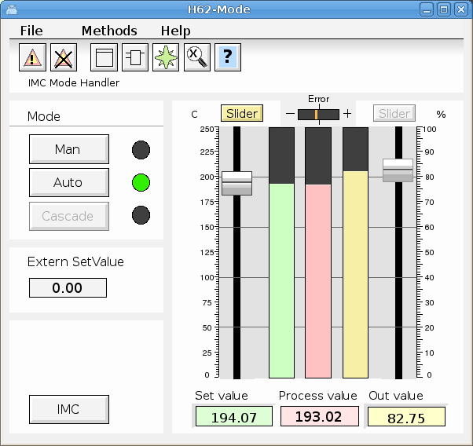
Fig Object graph for mode object CompModeIMC

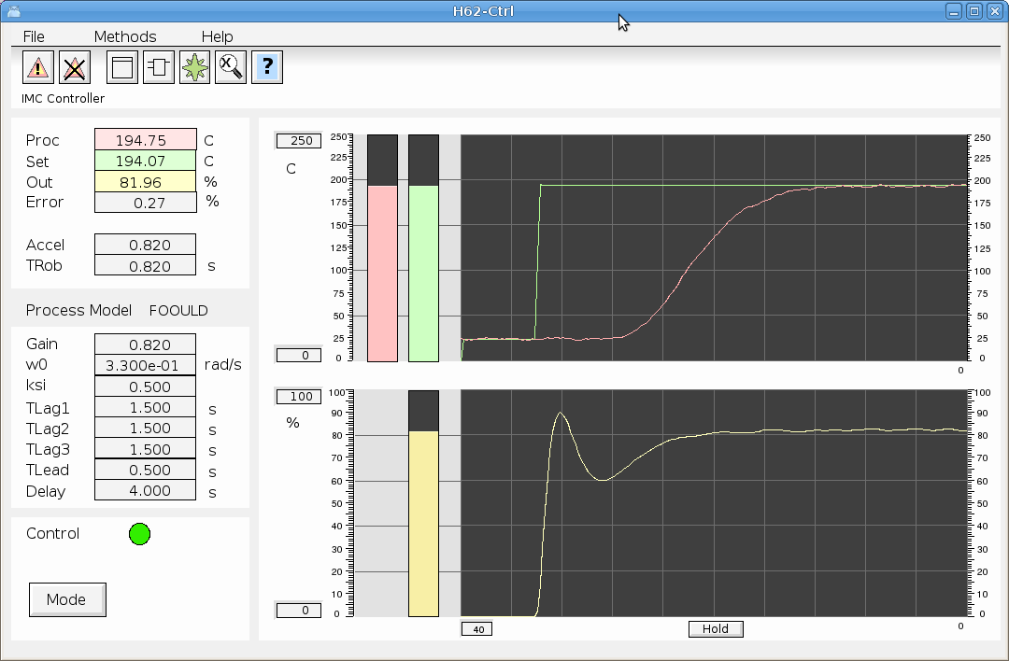
Fig Object graph for controller object CompIMC

Simulate objects
Also some simulate objects are added by Bruno.

Sim_SigGen
This is a signal generator (sine, triangle, rectangle). Noise and offset can be added to simulate real world behavior.

Sim_Integrator
Integrator.
Performs a discrete time integration with dynamic gain.
In Laplace transform:
K
F(s) = -------
s

Sim_LeadLagFilter
Lead / lag filter.
Performs a discrete time lead / lag filtering.
In Laplace transform:

1 + Tlead.s
F(s) = ----------------
1 + Tlag.s

Sim_LagFilter
Lag filter.
Performs a discrete time lag filtering.
In Laplace transform:
1
F(s) = --------------
1 + Tlag.s

Sim_Delay
Analog 100 cells delay plc function.
Performs a discrete time delay on a 100 float numbers cells shift register.
In Laplace transform:

F(s) = exp(-T.s)

Sim_SouFilter
Second order underdamped filter.

Performs a discrete time second order underdamped filtering.
In Laplace transform:

1
F(s) = ---------------------------------
1/(w0^2).s^2 + 2.ksi/w0.s + 1

Sim_SouTOoFilter
Second order underdamped/overdamped filter.
Performs a discrete time second order uderdamped to overdamped filtering.
In Laplace transform:

1/(w0^2).s^2 + 2.ksi/w0.s + 1
F(s) = -----------------------------------
(1 + Tlag1.s) . (1 + Tlag2.s)

Sim_SlwRateLimiter
Slew rate limiter.
Performs a slew rate limitation.

Upgrade procedure
The upgrading has to be done from any V5.2. If the project has a lower version, the upgrade has to be performed stepwise following the schema
V2.1 -> V2.7b -> V3.3 -> V3.4b -> V4.0.0 -> V4.1.3 ->V4.2.0->V4.5.0->V4.6.0->V4.7.0->V4.8.6->(V5.0.0)->V5.1.0->V5.2.0->V5.3->V5.4
The upgrade procedure is to execute the script upgrade.sh.
If the previous version should be kept, first make a copy of the project.

Make a copy of the project
Do sdf to the project and start the administrator
> pwra
Now the Projectlist is opened. Enter edit mode, login as administrator if you lack access. Find the current project and select Copy Project from the popup menu of the ProjectReg object. Open the copy and assign a suitable project name and path. Save and close the administrator.

Linux release upgrade
If you are using an older Ubuntu version to upgrade the linux release and install the pwr54 package.

Change version
Enter the administrator and change the version of the project to V5.4.0. Save and close the administrator.

upgrade.sh
Do sdf to the project.
upgrade.sh is a script that is divided into a number of passes. After each pass you you have to answere whether to continue with the next pass or not.
Start the script with

> upgrade.sh

Start from the savedirectory pass.

Enter start pass [savedirectory] >

savedirectory
Save the directory volume.

classvolumes
Create loadfiles and structfiles for the class volumes.

updateclasses
Updates classes and objects to new version.

cnvobjects
Converts or updates specific object.

compile
Compile all the plc programs.

createload
Create loadfiles for the root volumes.

buildnodes
Builds the nodes in the project.

createpackage
Creates distribution packages for the nodes.

List example
>
> sdf opg14
Setting base /data0/x5-4-0/rls
>
> upgrade.sh

upgrade.sh Upgrade from V5.3.1 to V5.4.0

Pass

savedirectory Save directory volume.
classvolumes Create loadfiles for classvolumes.
updateclasses Update classes.
cnvobjects Create OpPlaceWeb objects.
compile Compile all plcprograms in the database
createload Create new loadfiles.
buildnodes Build all nodes in the project.
createpackage Create distribution packages for all nodes in the project.

-- Upgrade opg14

Enter start pass [savedirectory] >

----------------------------------------------------------------------------
Pass save directory volume
----------------------------------------------------------------------------
Do you want to continue ? [y/n/go] y
-- Processing line: 51
-- Building volume directory
I Volume directory loaded
I Database opened /data0/pwrp/opg14/src/db/directory.wb_load
-- Saving file /data0/pwrp/opg14/src/db/directory.wb_load -> /data0/pwrp/opg14/src/db/directory.wb_load.1
%WNAV-E-MSG, Session saved

Found classvolumes:

----------------------------------------------------------------------------
Pass create structfiles and loadfiles for classvolumes
----------------------------------------------------------------------------
Do you want to continue ? [y/n/go] y

----------------------------------------------------------------------------
Pass update classes
----------------------------------------------------------------------------
Do you want to continue ? [y/n/go] y
-- Update classes in volume volopg7
Berkeley DB 4.8.30: (April 9, 2010)
info get: 0
W Local class volume "pwrs" [2016-03-09 12:00:00.00] (/data0/pwrp/opg14/src/db/volopg7.db/pwrs.dbs), in data base "VolOpg7", can be updated [2016-03-14 11:37:25.53]
W Local class volume "pwrb" [2016-03-09 12:00:00.00] (/data0/pwrp/opg14/src/db/volopg7.db/pwrb.dbs), in data base "VolOpg7", can be updated [2016-03-14 11:37:29.63]
...
I A total of 39 objects of 23 classes, and 0 attribute references, were updated
%WNAV-I-MSG, Classvolumes updated

----------------------------------------------------------------------------
Pass convert objects in loaded database
----------------------------------------------------------------------------
Do you want to continue ? [y/n/go] y
-- Convert volume volopg7
Berkeley DB 4.8.30: (April 9, 2010)
info get: 0
I Database opened /data0/pwrp/opg14/src/db/volopg7.db
--
-- Creating OpPlaceWeb object Noder-opg7-OpWeb
--
%WNAV-E-MSG, Session saved

----------------------------------------------------------------------------
Pass compile plcprograms
----------------------------------------------------------------------------
Do you want to continue ? [y/n/go] y
Berkeley DB 4.8.30: (April 9, 2010)
info get: 0
I Database opened /data0/pwrp/opg14/src/db/volopg7.db
-- Plc window generated H1-Plc-W
-- Plc window compiled for x86_linux optimized -O3 H1-Plc-W
%GSX-I-CCSUCC, Window compiled H1-Plc-W
I %GSX-I-CCSUCC, Window compiled H1-Plc-W
-- Plc plcpgm compiled for x86_linux optimized -O3 H1-Plc

----------------------------------------------------------------------------
Pass create loadfiles
----------------------------------------------------------------------------
Do you want to continue ? [y/n/go] y
Berkeley DB 4.8.30: (April 9, 2010)
info get: 0
I Database opened /data0/pwrp/opg14/src/db/volopg7.db
-- Building archive for volume: 000_001_001_024
-- Archive built for volume: 000_001_001_024
-- Working with load file volume 'VolOpg7'...
-- Open file...
-- Successfully created load file for volume 'VolOpg7'
-- 40 objects with a total body size of 57256 bytes were written to new file.

----------------------------------------------------------------------------
Pass build nodes
----------------------------------------------------------------------------
Do you want to continue ? [y/n/go] y
-- Build all nodes
-- Building node aristotle
Berkeley DB 4.8.30: (April 9, 2010)
info get: 0
I Database opened /data0/pwrp/opg14/src/db/volopg7.db
-- Build node aristotle
-- Web startpage generated $pwrp_web/index.html
I Build: OpPlaceWeb Webpage generated /data0/pwrp/opg14/bld/common/web/index_opwin_menu.html
I Build: OpPlaceWeb xtt_help.dat converted to html
I Build: OpPlaceWeb plc xtthelp-file for volume VolOpg7 converted to html
%WNAV-I-MSG, History html file generated, $pwrp_web/wb_history.html
-- Creating bootfile for node aristotle
-- Plc thread generated priority 22, scantime 0.10000 s, 1 plcpgm's
-- Plc process compiled for x86_linux optimized -O3 Dummy
-- Plc program linked for x86_linux plc_aristotle_0999_plc
I Build: Node aristotle
%LFU-S-SUCCESS, successful completion

----------------------------------------------------------------------------
Pass create packages
----------------------------------------------------------------------------
Do you want to continue ? [y/n/go] y
-- Creating distribution packages for all nodes
W No file found: $pwrp_load/rtt_crr_000_001_001_024.dat
W No file found: $pwrp_load/rtt_crro_000_001_001_024.dat
W No file found: $pwrp_load/rtt_crrc_000_001_001_024.dat
W No file found: $pwrp_load/rtt_crrs_000_001_001_024.dat
W No file found: $pwrp_load/pwrp_alias.dat
W No file found: $pwrp_exe/*.pwg
W No file found: $pwrp_load/aristotle/b55/Rt_xtt:$pwrp_load/aristotle/Rt_xtt:$pwrp_load/Rt_xtt
W No file found: $pwrp_load/aristotle/b55/xtt_setup.rtt_com:$pwrp_load/aristotle/xtt_setup.rtt_c
W Distribute warnings node aristotle: 8 warnings
I Distribute package for node aristotle

-- The upgrade procedure is now accomplished.

