

Release Notes V5.9

2021 10 22

Copyright © 2005-2021 SSAB EMEA AB

Permission is granted to copy, distribute and/or modify this document
under the terms of the GNU Free Documentation License, Version 1.2
or any later version published by the Free Software Foundation;
with no Invariant Sections, no Front-Cover Texts, and no Back-Cover Texts.

Table of Contents
Upgrading to ProviewR V5.9.0 4
New functions 4
Ge dynamic script arguments 4
Ge graph opening and closing scripts 4
Xtt command ‘set subevents’ 4
Xtt command ‘open file’ 4
Window icons color changed to orange 4
Guide to Storage Enviroment 4
Status monitor, Xtt and Runtime monitor started with ssh 4
Remote transactions with MQTT 5
MQTT IO 6
Home automation with zigbee2mqtt 8
ProviewR Mqtt server 9
Get 9
Set 9
Subscribe 10
Closesub 10
Sublist 11
Closesub 11
History 12
Eventhist 12
Python example 1 14
Python example 2 14
Python example 3 17
Upgrade procedure 18

Upgrading to ProviewR V5.9.0
This document describes new functions i ProviewR V5.8.0, and how to upgrade a project from V5.7.0 to V5.8.0.

New functions

Ge dynamic script arguments
Dynamics for executing scripts in Ge, DigScript and Script, can now handle script arguments.
The arguments are set in the ‘Argument’ property and is used as p1, p2 etc in the script. This can be used for example to transmit the current instance object for an object graph to the script.

Ge graph opening and closing scripts
Script can be executed when a Ge graph is opened and when it’s closed. This is done with the Script action that has the new property TriggerEvent, that can be set to Open or Close. Open will execute the script when the graph is opened, and Close when the graph is closed. The default ClickMB1 will execute the script when MB1 is clicked on the object.

Xtt command ‘set subevents’
The command disables events in a Ge window or table object.
Window and table objects grab all events inside their area, and click sensitive objects can’t be placed on top of them. If they temporarily should be covered by a sensitive object though, the eventhandling can be turned off for window and table objects in the graph.
xtt> set subevents ‘graphname’ [/on] [/off]

Xtt command ‘open file’
Opens a file or URL in the user’s preferred application.
xtt> open file ‘filename’

Window icons color changed to orange
To easier separate runtime and development windows, the runtime icons are now orange and the development icons blue.

Guide to Storage Enviroment
New documentation for the storage server.

Status monitor, Xtt and Runtime monitor started with ssh
Xtt and Runtime monitor was previously started via gsoap and required remote access the X server. For security reasons ssh is used instead.

Remote transactions with MQTT
Remote transactions can now be sent and received via MQTT with the RemnodeMQTT object.
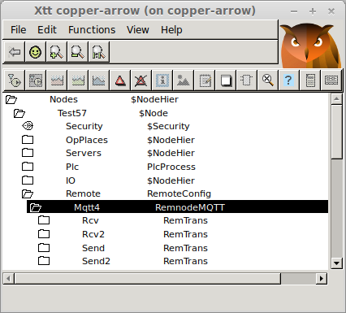
Fig Remote configuration with MQTT
The communication is configured with a RemnodeMQTT object. The MQTT server, topics for publishing and subscribing are specified here.
The specification of topics differs if the remote header is disabled or not.
If the header is present
- Sending: publishing is made with the topic in PubishTopic in the RemnodeMQTT. Address[0] and Address[1] in the RemTrans object is used to match RemTrans objects.
- Receiving: Subscriptions are med with the topic in SubscribeTopic in the RemnodeMQTT object. The message is directed to the RemTrans with matching Address[0] and Address[1].
If header is disabled
- Sending: publishing is made with the topic in RemTrans.TransName
- Receiving: A generic topic is set in SubscribeTopic in the RemnodeMQTT object, eg 'lab57/rcv/#'. A more narrow topic is set in RemTrans.TransName, eg 'lab57/rcv/msg1'.

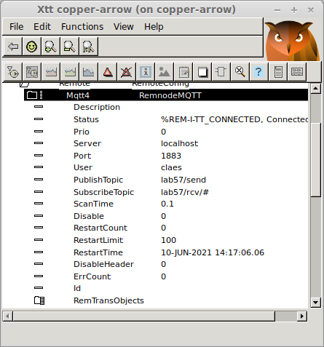
Fig RemnodeMQTT object

MQTT IO
The MQTT IO can read values published on an MQTT server into insignals and publish values of outsignals to an MQTT server.
The configuration is done with a MQTT_Client object and MQTT_Device objects.
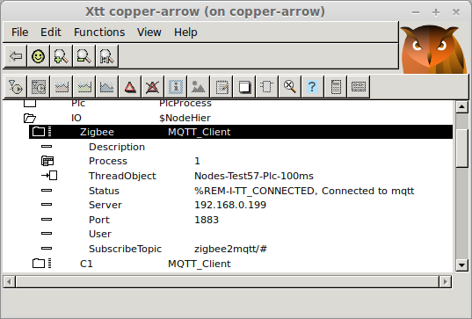
Fig MQTT_Client
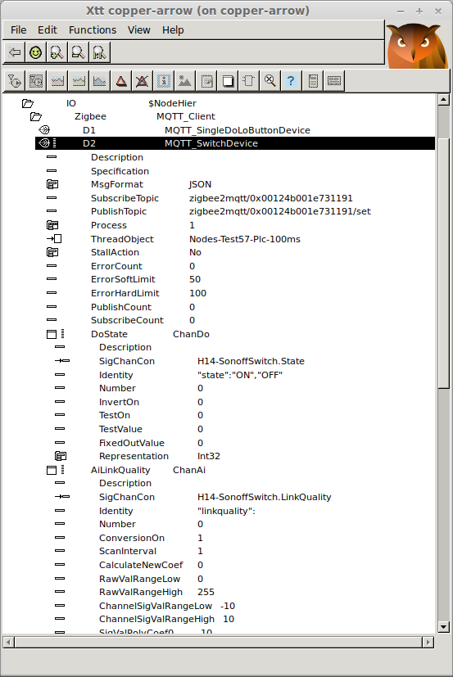
Fig Switch object based on MQTT_Device with a Do and an Ai channel

Home automation with zigbee2mqtt
For those interested in home automation I just want to mention zigbee2mqtt that makes it possible to access a large range of zigbee devices. Zigbee2mqtt is flashed to a usbstick that acts a zigbee coordinator. A server program is run on RasberryPi that presents the zigbee communication on an MQTT server in json format. This can then be accessed by the ProviewR MQTT IO.

ProviewR Mqtt server
The ProviewR Mqtt server is a program that can answer request via MQTT about attribute values and history data. It is also possible to setup subscriptions and set values.
The server is configured with a MqttServer object in the node hierarchy. When this object is created the server program rt_mqtt_server will start.
Requests can be put to a specific topic on an MQTT broker. The topic is configured in the MqttServer object and is 'proviewr/server' by default. The request should be on json format and contain “action” that specifies the type of request. The action can be get, set, subscribe, closesub, sublist, closesublist or history.

Get
Get the value of an attribute.
Request
action | Should be “get”.
attribute | Full name of the attribute.
reply | MQTT topic where the reply should be published.

Reply
status | Return status.
value | Attribute value.

Example
Request
{"action":"get","attribute":"H16-Av1.ActualValue","reply":"repl/get"}
Reply
{“status”:141459465,"value":45.9577}

Set
Set the value of an attribute.
Request
action | Should be “set”.
attribute | Full name of the attribute.
reply | MQTT topic where the reply should be published.

Reply
status | Return status.

Example
Request
{"action":"set","attribute":"H16-Av1.ActualValue","reply":"repl/get"}
Reply
{“status”:141459465}

Subscribe
Set up a subscription of an attribute. The value of the attribute should cyclically be sent to the reply topic until the duration time has elapsed, or the subscription is closed with a closesub message.
Request
action | Should be “subscribe”.
attribute | Full name of the attribute.
cycle | Cycle time in seconds.
duration | Max duration of the subscription.
reply | MQTT topic where the reply should be published.

Reply
subref | Subscription reference.
status | Not yet implemented.
value | Attribute value.

Example
Request
{"action":"subscribe","attribute":"H16-Av1.ActualValue","cycle":"1.0","duration":"300.0","reply":"repl/subscribe"}
Reply
{'subref': 1, 'status': 0, 'value': -14.98953}

Closesub
Close a subscription started with the subscribe action.
Request
action | Should be “closesub”.
subref | Subscription reference.

No reply is sent.

Example
Request
{"action":"closesub","subref”:5}

Sublist
Set up a subscription of a number of attributes. The values of the attributes should cyclically be sent to the reply topic until the duration time has elapsed, or the subscription is closed with a closesublist message.
Request
action | Should be “sublist”.
attribute | Array of index and full name of the attribute.
cycle | Cycle time in seconds.
duration | Max duration of the subscription.
reply | MQTT topic where the reply should be published.

Reply
subref | Subscription reference.
a | Array of index and attribute value.

Example
Request
{"action":"sublist","cycle":"1.0","duration":"15.0","reply":"repl/sublist","attribute":[{1,"H16-Av1.ActualValue"},{2,"H16-Av2.ActualValue"},{3,"H16-Av4.ActualValue"}]}
Reply
{"subref":2,"a":[{"idx":1,"value":39.3397},{"idx":2,"value":39.3397},{"idx":3,"value":42.1814}]}

Closesub
Close a subscription started with the subscribe action.
Request
action | Should be “closesublist”.
subref | Subscription reference.

No reply is sent.

Example
Request
{"action":"closesublist","subref”:2}

History
Get process history for an attribute.
Returns process history from a sev database.
Request
action | Should be “history”.
server | Server from which the history should be fetched.
object | Full object name.
attribute | Attribute name.
from | Start time for history data, eg '20-JUN-2021 12:00:00'.
to | End time for history data, eg '21-JUN-2021 12:00:00'.  To get the most recent data 'now' can be used for the current time, and a delta time can be given in 'from', eg 'to':'now' and 'from':'1 00:00:00'.
maxpoints | Max number of points that should be returned.
reply | MQTT topic where the reply should be published.

Reply
status | Status of the action.
values | Array of attribute values.
time | Array of time for the values.

Example
Request
{"action":"history","server":"localhost","object":"H1-Av1",”attribute”:”ActualValue”"reply":"repl/history","from":”0:15:0”, “to”:”now”,”maxrows”:6}
Reply
{“status":1315888905,"values":[-96.1745, -34.2858, 82.5293, 99.5304, 96.0948, 56.3516],”time”:["14-JUN-2021 15:08:48.00","14-JUN-2021 15:09:09.00","14-JUN-2021 15:09:17.00","14-JUN-2021 15:09:23.00","14-JUN-2021 15:09:38.00","14-JUN-2021 15:09:59.00"]}

Eventhist
Get alarm and event history for a table defined by a SevHistEvent object.
Returns event history from a sev database.
Request
action | Should be “eventhist”.
server | Server from which the history should be fetched.
object | Name or identity of SevHistEvent object.
eventtype | Mask for event types that should be searched for. Optional.  1: Ack,  2: Block  4: Cancel  8: CancelBlock  16: Missing  32: Reblock  64: Return  128: Unblock  256: InfoSuccess  512: Alarm  1024: MaintenanceAlarm  2048: SystemAlarm  4096: UserAlarm1  8192: UserAlarm2  16384: UserAlarm3  32768: UserAlarm4  65536: Info
eventprio | Mask for event priorities that should be searched for. Optional.  1: Prio A  2: Prio B  4: Prio C  8: Prio D
text | Event text with wild card that should be search for. Optional.
name | Event name with wild card that should be searched for. Optional.
from | Start time for history data, eg '20-JUN-2021 12:00:00'.
to | End time for history data, eg '21-JUN-2021 12:00:00'.  To get the most recent data 'now' can be used for the current time, and a delta time can be given in 'from', eg 'to':'now' and 'from':'1 00:00:00'.
options | Mask that states which values should be returned. Optional.  1: Time  2: Event type  4: Event priority  8: Event text  16: Event name  32: Event identity
maxpoints | Max number of points that should be returned.
reply | MQTT topic where the reply should be published.

Reply
status | Status of the action.
time | Array of event time.
type | Array of event type.
prio | Array of event priority.
text | Array of event text.
name | Array of event name.
id_nix | Array of event identity, nix.
id_idx | Array of event identity, idx.

Example
Request
{"action":"eventhist","server":"localhost","object":"H1-SevHistEvents","reply":"repl/eventhist","from":”7 0:0:0”, “to”:”now”,”maxrows”:10}
Reply
{"status":135888905,"time":["07-JUN-2021 15:06:21.00","07-JUN-2021 15:06:55.00","07-JUN-2021 15:11:56.00","07-JUN-2021 15:11:56.00","07-JUN-2021 15:11:56.00","07-JUN-2021 15:11:56.00","07-JUN-2021 15:11:58.00","07-JUN-2021 15:11:58.00","07-JUN-2021 15:12:02.00","07-JUN-2021 15:12:02.00"],"type":[256,7,64,64,64,64,64,64,7,7],"text":["System status error, node copper-arrow","","Dv 8 alarm","Dv 7 alarm","Dv 2 alarm","Dv 1 alarm","Dv 10 alarm","Dv 9 alarm","Dv 10 return","Dv 9 return"]}

Python example 1
This example fetches the value for an attribute with the 'get' action.
#!/usr/bin/python3
#
import paho.mqtt.client as mqtt
import sys
import time
from datetime import datetime
import json

# Print reply
def on_message(client, userdata, message):
reply = json.loads(str(message.payload.decode("utf-8")))
value = reply['value']
print("Reply:", reply)
print("Value:", value)

# Connect to MQTT on localhost
client = mqtt.Client('MyClient')
client.username_pw_set('pwrp','pwrp')
client.on_message = on_message
client.connect('localhost')

# Send request and subscribe on reply
client.subscribe("repl/get", 1);
client.publish('proviewr/server', '{"action":"get","attribute":"H16-Av1.ActualValue","reply":"repl/get"}')

# Wait for reply
for i in range (0, 3):
client.loop_start()
time.sleep(1)
client.loop_stop()

Python example 2
Simple graph with a pushbutton, an indicator and a value field.
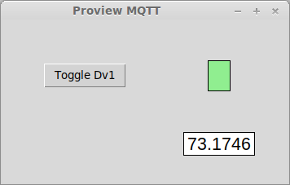

#!/usr/bin/python3
#
from tkinter import *
import paho.mqtt.client as mqtt
import sys
import time
from datetime import datetime
import json
import random

def on_closing():
global subref

# Close subsciptions
if subref != 0:
client.publish('proviewr/server', '{"action":"closesublist","subref":' + str(subref) + '}')

window.destroy()

def on_message(client, userdata, message):
global val1
global val2
global subref
global set_reply
global sublist_reply

if message.topic == sublist_reply:
data = json.loads(str(message.payload.decode("utf-8")))
subref = data['subref']
val1 = data['a'][0]['value']
val2 = data['a'][1]['value']

if message.topic == set_reply:
pass

# Button click callback
def button_click_cb():
global set_reply

client.subscribe(set_reply, 1);
if val2 == 0:
client.publish('proviewr/server', '{"action":"set","attribute":"H17-Dv1.ActualValue","value":"1","reply":"' + set_reply + '"}')
else:
client.publish('proviewr/server', '{"action":"set","attribute":"H17-Dv1.ActualValue","value":"0","reply":"' + set_reply + '"}')

# Cyclic scan function
def scan():
global sub1_old
global sub2_old
global val1
global val2

if val2 != sub2_old:
if val2 == 1:
dv1_label["bg"] = "lightgreen"
else:
dv1_label["bg"] = "black"
sub2_old = val2

if val1 != sub1_old:
av1_label["text"] = val1
sub1_old = val1

window.after(500, scan)

# Create window
window = Tk()
window.title("Proview MQTT")
window.geometry('350x200')

# Create unique name and topics to be able to run serveral instances
rand = str(random.randint(1,999999))
name = 'MqttTest' + rand
sublist_reply = 'repl/' + rand + '/sublist'
set_reply = 'repl/' + rand + '/set'

# Create button
button = Button(window, text="Toggle Dv1", command=button_click_cb,
bg="lightgray")
button.grid(column=0, row=0, padx=50, pady=50)

# Create indicator label
dv1_label = Label(window, width=3, height=2, bg="black", borderwidth=1,
relief="solid")
dv1_label.grid(column=1, row=0, padx=50, pady=50)

# Create value label
av1_label = Label(window, width=7, bg="white", borderwidth=1, relief="solid",
font=("Helvetica",16))
av1_label.grid(column=1, row=2, padx=20, pady=0)

# Attach MQTT
client = mqtt.Client(name)
client.username_pw_set('pwrp','pwrp')
client.on_message = on_message
client.connect('localhost')

# Set up subscriptions
client.subscribe(sublist_reply, 1);
client.publish('proviewr/server', '{"action":"sublist","cycle":"1.0","duration":"150.0","reply":"' + sublist_reply + '","attribute":[{1,"H17-Av1.ActualValue"},{2,"H17-Dv1.ActualValue"}]}')

subref = 0
sub1_old = -1
sub2_old = -1
val1 = 0
val2 = 0

window.protocol("WM_DELETE_WINDOW", on_closing);

client.loop_start()
scan()
window.mainloop()

Python example 3
Drawing a history curve with matplotlib

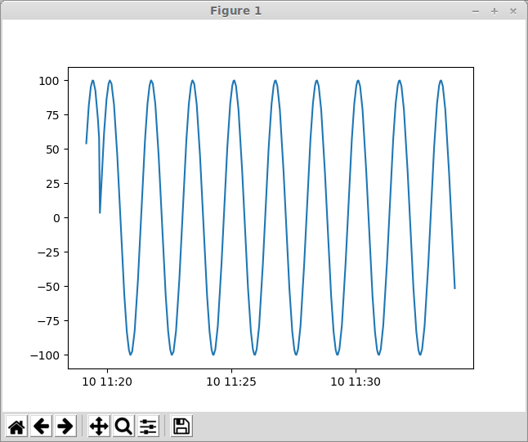
#!/usr/bin/python3
#
import paho.mqtt.client as mqtt
import sys
import time
from datetime import datetime
import json
import matplotlib.pyplot as plt
from datetime import datetime

def on_log(client, userdata, level, buf):
print("log: ",buf)

def on_message(client, userdata, message):
print("message received ", datetime.now(), str(message.payload.decode("utf-8")), flush=True)
data = json.loads(str(message.payload.decode("utf-8")))

# Convert time strings to datetime objects
t = []
for dt in data['time']:
t.append(datetime.strptime(dt+'0000', '%d-%b-%Y %H:%M:%S.%f'))

# Plot the curve, use drawstyle='steps-pre' for digital signals
plt.plot(t, data['values'], label='Diff')
plt.show()

# Connect to MQTT server
client = mqtt.Client('Claes')
client.username_pw_set('pwrp','pwrp')
client.on_message = on_message
client.connect('localhost')

# Subscribe to reply
client.subscribe("repl/history", 1)

# Send history request
client.publish('proviewr/server', '{"action":"history","reply":"repl/history","server":"localhost","object":"H1-Av1","attribute":"ActualValue","from":"0:15:0","to":"now","maxrows":2000}')

for i in range (0, 3):
print("Loop");
client.loop_start()
time.sleep(1)
client.loop_stop()

Upgrade procedure
The upgrading has to be done from any V5.8. If the project has a lower version, the upgrade has to be performed stepwise following the schema
V2.1 -> V2.7b -> V3.3 -> V3.4b -> V4.0.0 -> V4.1.3 ->V4.2.0->V4.5.0->V4.6.0->V4.7.0->V4.8.6->(V5.0.0)->V5.1.0->V5.2.0->V5.3->V5.4->V5.5->V5.6->V5.7->V5.8->V5.9

Enter the administrator and change the version of the project to V5.9.0. Save and close the administrator.

Enter the directory volume and save.
I you have any class volumes, enter the class editor and build the volume.
Enter the configurator for each root volume and activate 'Function/Update Classes' and build.

