

Home automation with Zigbee

Getting Started Guide

Beta version

2025-02-05

Copyright © 2005-2025 SSAB EMEA AB

Permission is granted to copy, distribute and/or modify this document
under the terms of the GNU Free Documentation License, Version 1.2
or any later version published by the Free Software Foundation;
with no Invariant Sections, no Front-Cover Texts, and no Back-Cover Texts.

Table of Contents
About this guide 4
Introduction 5
Installation 7
Devices 8
Pairing 8
ProveiwR configuration 9
Create a project 9
Configure the MQTT client 9
Device configuration 9
Plc programming 13
Enable Zigbee2mqtt 16
Runtime 18

About this guide
This guide will take you through the steps of configuring and running a small ProviewR project with zigbee home automation devices. It’s an extension of to the Getting started guide and sections described in the Getting started guide is not repeated here. The guide does not intend to be comprehensive. For detailed documentation, please consult the Designer's Guide or the Ge (graphical editor) Manual. These documents are available at the ProviewR [http://www.proview.se] site.

Introduction
In this guide we will use four Zigbee devices from IKEA, a Zigbee USB dongle (Sonoff Zigbee 3.0 USB Dongle Plus), a Raspberry Pi, the software zigbee2mqtt and a MQTT server to create a minimal home automation system.
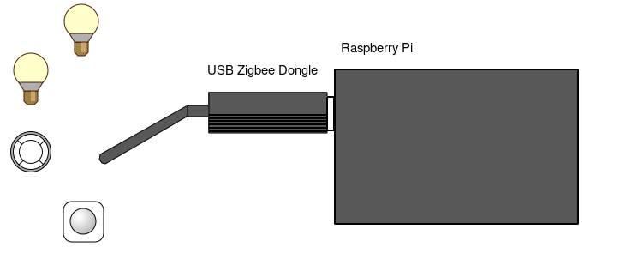
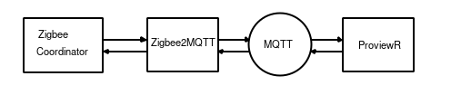

Zigbee2MQTT is an open source software that makes it possible to read and write data from an to the devices via a MQTT broker. Zigbee2MQTT supports over 3000 devices from 400 vendors. Before you order any devices make sure they are supported by Zigbee2MQTT.
As MQTT broker we will use Mosquitto. The broker is accessible over the network and ProviewR can handle multiple brokers which makes a variety of different configurations possible. In the figure below two Raspberry Pi are handled by ProviewR running in a PC. We will though create a minimal configuration and pack all into our Raspberry Pi.
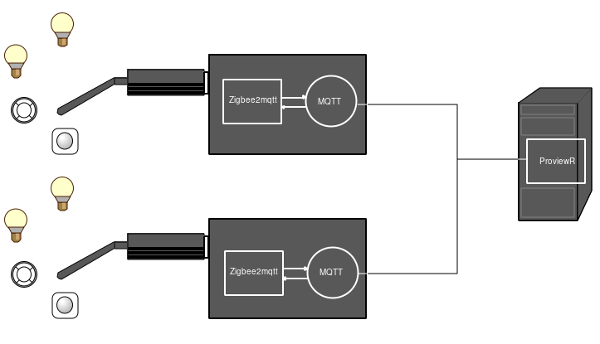

Installation
Install the MQTT broker. In this guide the mosquitto server is used
sudo apt install -y mosquitto-server

It’s also convenient to install the mosquitto client for test and trouble shooting
sudo apt install -y mosquitto-clients

We will also need the mosquitto development archive to build our project in ProviewR
sudo apt install -y mosquitto-dev

I you want authentication to the mosquitto server, this is required for remote access, you create a password file on /etc/mosquitto and add this file in /etc/mosquitto/mosqitto.conf
sudo su
cd /etc/mosquitto
mosquitto_passwd -c mqtt_passwd.txt pwrp
Password:****

Edit mosqitto.conf and add the line
password_file /etc/mosquitto/mqtt_passwd.txt

Install zigbee2mqtt. Follow the instructions in https://www.zigbee2mqtt.io, Getting started / Installation / Linux. There are also instructions on how to download the Zigbee software to the USB dongle. For some dongles (as the Sonoff Zigbee 3.0 USB Dongle Plus the we are using) the software is preloaded.

Install ProviewR development package, pwr61 V6.1.4 or later. Download the package from sourceforge and install with dpkg.
sudo apt-get install -y libgtk-3-0 libasound2 libdb5.3 libdb5.3++ \
libsqlite3-0 librsvg2-2 g++ xterm libmariadb3 librabbitmq4 \
libusb-1.0-0 libhdf5-openmpi-103 librabbitmq4 libmosquitto1 \
libgstreamer1.0-0 libgstreamer-plugins-base1.0-0 openjdk-17-jdk \
xterm xfonts-100dpi sudo procps libpython3-dev python3

dpkg -i pwr61_6.1.4-i_arm64.deb

Devices
We will configure four devices
- An IKEA color bulb, LED2109G6, named ‘Bulb1’
- An IKEA bulb, LED1836G9, named ‘Bulb2’.
- An IKEA remote control, E1810, named ‘RemoteControl’.
- An IKEA motion sensor, E2134 (vallhorn), named ‘MotionSensor’.
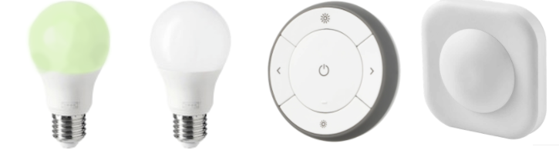
Fig Devices

Pairing
The devices should be paired with the Zigbee coordinator. Make sure that zigbee2mqtt is set in paring mode before you start the pairing.
The pairing mechanism differs between devices. The bulb for example should be turn on and off a number of times, while the remote control and the motion sensor has a pair button that should be pressed four times. See the documentation of each device for more info.
Check in the zigbee2mqtt log that the pairing is successful and note the device identity. Below is the log for the color bulb that has the identity '0x8c65a3fffe992a36'. We will need this later when we configure the device in ProviewR.
[2024-11-01 10:48:29] info: zh:controller: Successfully interviewed '0x8c65a3fffe992a36'
[2024-11-01 10:48:29] info: z2m: Successfully interviewed '0x8c65a3fffe992a36', device has successfully been paired
[2024-11-01 10:48:29] info: z2m: Device '0x8c65a3fffe992a36' is supported, identified as: IKEA TRADFRI bulb E26/E27, color/white spectrum, globe, opal, 806 lm (LED2109G6)

ProveiwR configuration

Create a project
Follow the instruction in Getting started guide to create a project.

Configure the MQTT client
The connection to the MQTT server is done with a Zigbee2MQTT_Client object. The object is found under Node/IO/Zigbee2mqtt in the palette. Positioned the object under the IO object in the Node hierarchy. If the server is running in a remote node, the host name or IP address should be inserted in the Server attribute. We will use a local server and use the default value ‘localhost’. If the server requires user name and password this should also be inserted.
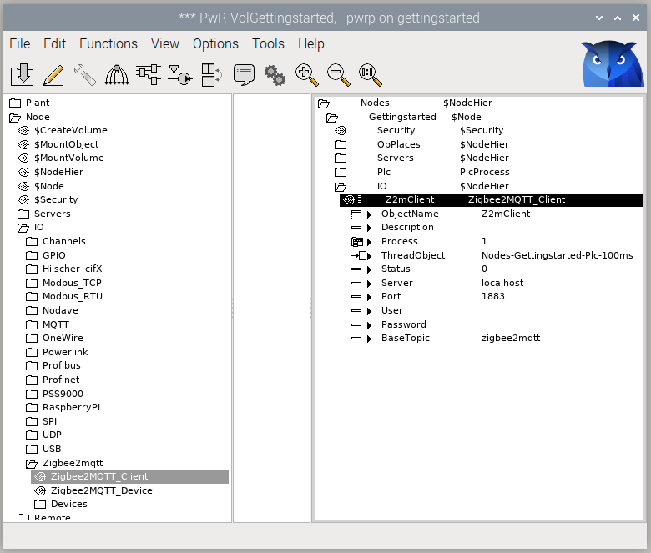
Fig MQTT client configuration

Device configuration
Devices are separated in two objects, a main object that is positioned in the Plant hierarchy, and an IO object that is positioned in the Node hierarchy under the Zigbee2MQTT_Client object. For most devices there is also a function object that is used in the plc code.
We open the configurator for the root volume VolGettingStarted and create some hierarchies in the Plant hierarchy to describe our home installation. We also create a PlcPgm object that will be used later for the plc programming.
The main object for our color bulb, IKEA_LED2109G6, is found under Plant/Components/Zigbee2mqtt/IKEA in the palette. We create the object in the ‘Livingroom’ map and name it ‘Bulb1’.
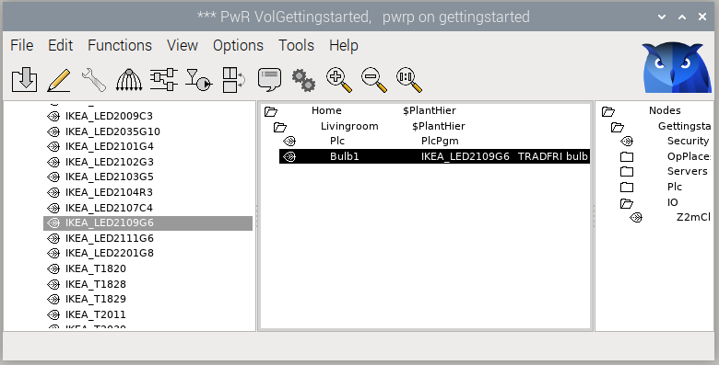
Fig Bulb main object configuration

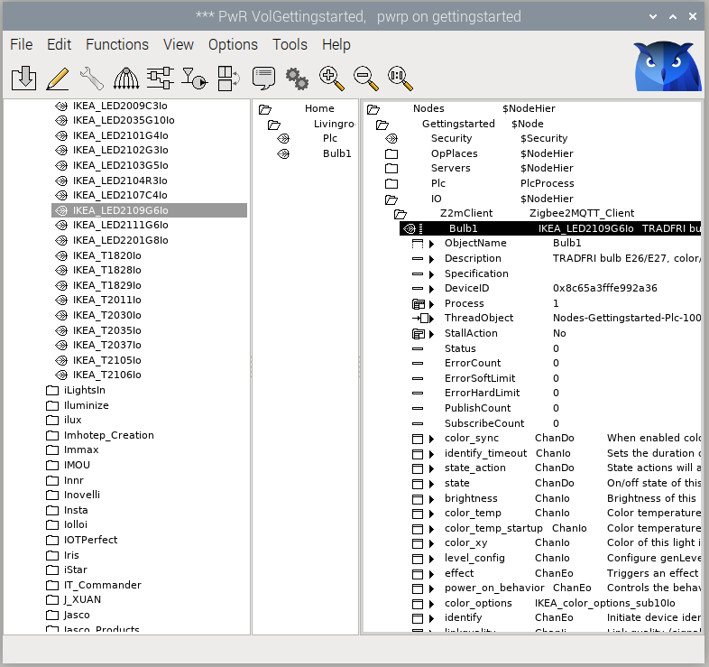
The IO object is found under Node/IO/Zigbee2mqtt/Devices/IKEA in the palette, and is created below the Zigbee2MQTT_Client object. The device identity, that we fetched from the zigbee2mqtt log, is inserted into the DeviceID attribute.
Fig Bulb IO object
The next step is to connect the IO object with the main object. Select the IO object, right click on the main object, and activate ‘Connect IO’ in the popup menu.
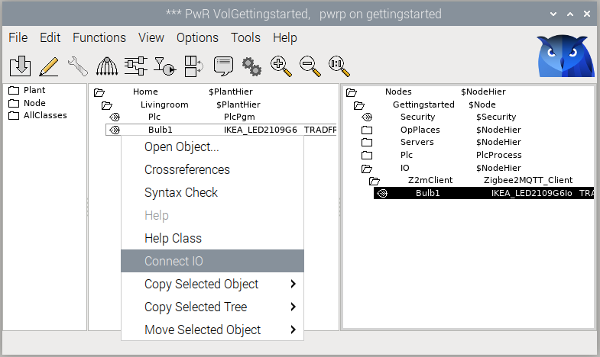
Fig Connect IO object and main object
Now we create main object, IO object, insert device identity and activate Conntect IO for the other three devices.
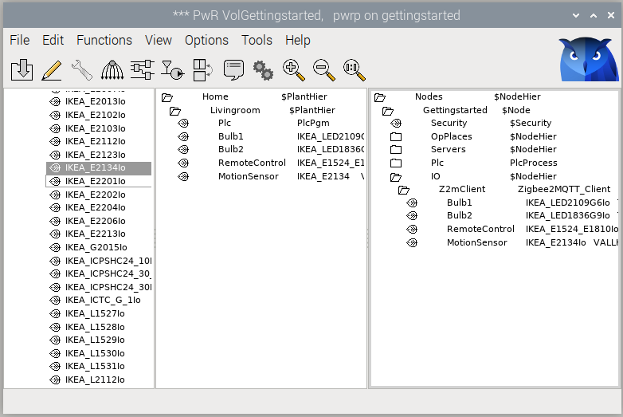
Fig All main and IO objects configured

Plc programming
In the plc we will program the interaction between the devices. First we will connect the remote control with the color bulb, and make it possible to switch the bulb on and off from the remote, and also to change the brightness of the bulb.
Leave edit mode in the configurator and open the PlcPgm. The function object for Bulb1, IKEA_LED2109G6Fo, is found under Components/Zigbee2mqtt/IKEA in the palette.

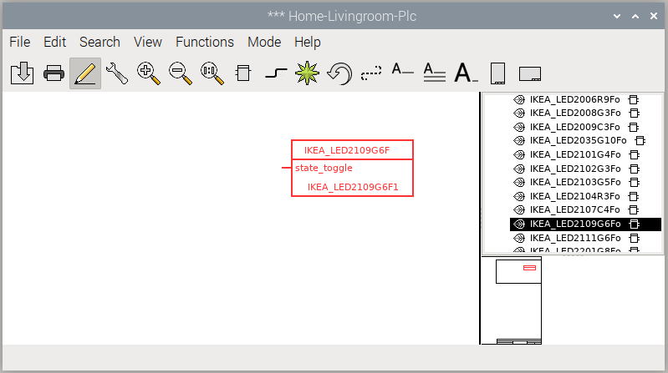
Fig Bulb Plc function object
Create the function object and open the Object Editor. Turning the bulb on or off is controlled by the State attribute, and by setting this to true or false, the bulb is turned on or off. By default the state_toggle input is visible, but we also want to control the brightness from the remote control. We check the Used boxes for brightness_moveup, brightness_movedown and brightness_movestop.
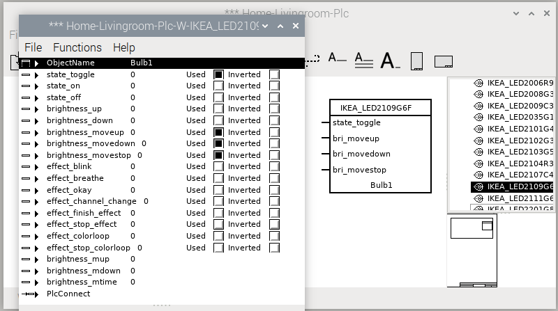
Fig Attribute editor for function object
We also create the function object for the remote control, IKEA_E1524_E1819Fo, and enable the output pins action_brightness_up_hold, action_brightness_up_release, action_brightness_down_hold and and action_brightness_down_release. The figure below shows how to connect the function objects.
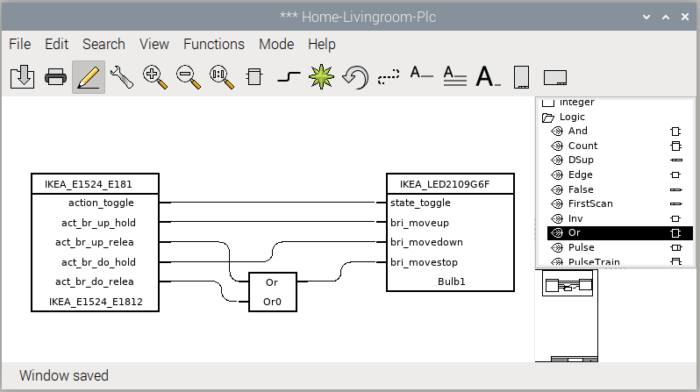
Fig Remote control function object added
The function object for a device has to be connected to the main object, and this is done by selecting the main object in the configurator, right clicking on the function object and activating Connect in the popup menu. This is done for both the bulb and the remote control.

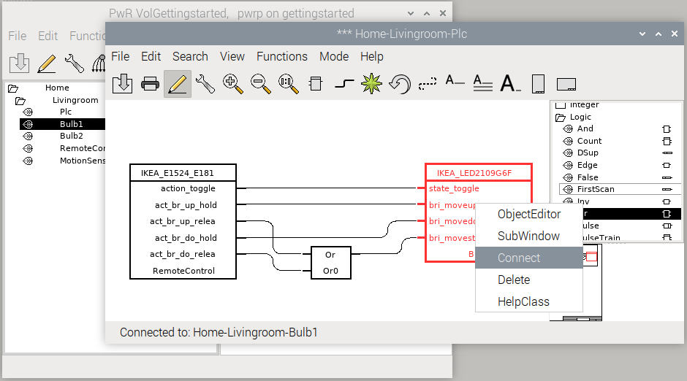
Fig Bulb function object and main object connected

We also write the code for the second bulb that will be controlled by the motion sensor. The function object for the bulb, IKEA_LED1836G9Fo, is created. It’s more convenient to use the inputs state_on / state_off instead of state_toggle, thus state_on and state_off is checked in the Object editor, and the check for state_toggle is removed.
The motion sensor, IKEA_E2134, doesn’t have a function object, and we have to fetch the value of the occupancy Di signal with a GetDi instead. Create a GetDi from Signals/Digital/GetDi in the palette. Connect the occupancy Di by opening the main object for the motion sensor in the configurator and selecting the occupancy Di. Then right click on the GetDi and activate Connect in the popup menu. The occupancy is connected to the bulb as in the figure below, where the bulb is turned on at positive edge of occupancy, while the turn off is delayed 30 seconds after negative edge of occupancy.
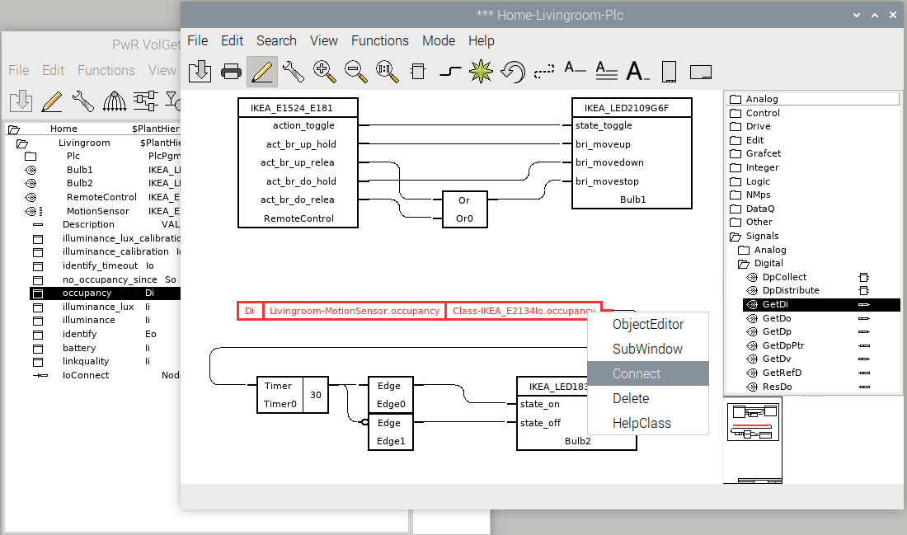
Fig Connect motion sensor occupancy signal

Enable Zigbee2mqtt
I you haven’t built the GettingStarted project before you have to build the node (see Getting started guide) with lots of error messages before you can enable the zigbee2mqtt module in the project. After the build, edit $pwrp_inc/ra_plc_user.h and insert the lines
#include "pwr_zigbee2mqttclasses.h"
#include "z2m_plc_zigbee2mqtt.h"

Note! In V6.1.4-1 instead insert
#include "pwr_zigbee2mqtt1classes.h"
#include "pwr_zigbee2mqtt2classes.h"
#include "pwr_zigbee2mqtt3classes.h"
#include "pwr_zigbee2mqtt4classes.h"
#include "pwr_zigbee2mqtt5classes.h"
#include "pwr_zigbee2mqtt6classes.h"
#include "pwr_zigbee2mqtt7classes.h"
#include "pwr_zigbee2mqtt8classes.h"
#include "pwr_zigbee2mqtt9classes.h"
#include "z2m_plc_zigbee2mqtt.h"

Open the directory volume and create a BuildOptions object under the NodeConfig object. Set PlcProcess to ‘plc’ and set Zigbee2mqtt in SystemModules.
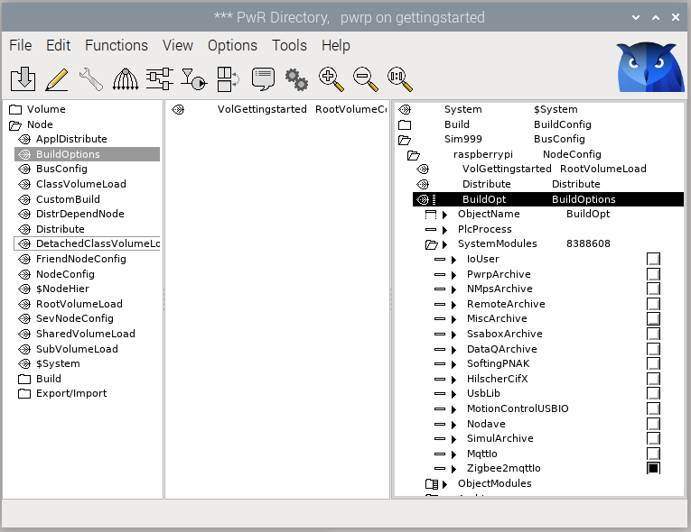
Fig Configuring build options
Now you should be able to build the node without error messages.

Runtime
Follow the Getting started guide to start ProviewR runtime and xtt. Make sure zigbee2mqtt is started also.
Open Nodes/Gettingstarted/IO/Z2mClient and check that the connection to the MQTT server is ok. It should be %REM-I-TT_CONNECTED, Connected to mqtt.
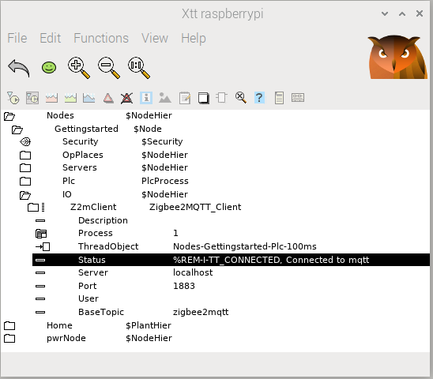
Fig Status of MQTT connection
Now we can open the object graph for the color bulb, by selecting the main object and activate Object graph in the popup menu. The bulb can be switched on and of the the On/Off buttons, the color can be changed with the color slider, and the brightness with the brightness slider. You can also apply different effect from the Effect menu.
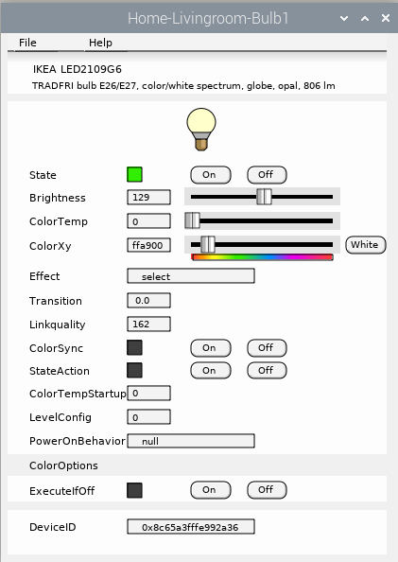
Fig Bulb1 object graph

