

Release Notes V6.0

2022 11 15

Copyright © 2005-2022 SSAB EMEA AB

Permission is granted to copy, distribute and/or modify this document
under the terms of the GNU Free Documentation License, Version 1.2
or any later version published by the Free Software Foundation;
with no Invariant Sections, no Front-Cover Texts, and no Back-Cover Texts.

Table of Contents
Upgrading to ProviewR V6.0.0 4
New functions 4
Ge transparency 4
Ge dynamic DigTransparency 4
Ge dynamic AnalogTransparency 4
Ge antialiasing 5
Ge editor tool button to view object tree 5
Ge scripts in web interface 5
Ge script functions 5
Export Ge graph as script 5
Ge unit conversion 5
Dark and light color theme 6
Plc include files 8
Background image in Ge graph 9
Text size in operator environment 9
Additions in V6.0.1 9
Status server communication changed to TCP 9
Class list initialization optimized 9
Class flags Plc and Obsolete added 9
Remote RabbitMQ option to queue messages when occupied 9
Hierarchy in class volume 10
Upgrade procedure 10

Upgrading to ProviewR V6.0.0
This document describes new functions i ProviewR V6.0.0, and how to upgrade a project from V5.9.0 to V6.0.0.

New functions

Ge transparency
Objects in Ge can be drawn transparent.
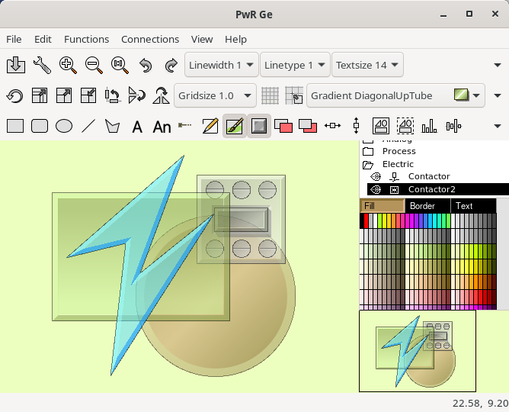

Ge dynamic DigTransparency
An object will shift between two transparency levels dependent on a digital signal.

Ge dynamic AnalogTransparency
An object will gradually change transparency dependent on the value of an analog signal.

Ge antialiasing
Antialiasing is added to ge graphs. Antialiasing is selected in GraphAttributes.

Ge editor tool button to view object tree
A new tool button is added to the tool bar in the Ge editor to view or hide the object tree.

Ge scripts in web interface
Graphs written in ge script can be displayed in the web interface.

Ge script functions
New Ge script functions
GetWindowSize(), GetUI_Env(), GetGraphConfig, SetDefaultFill(), SetDefaultBorder(), SetDefaultShadow(), SetDefaultFillColor(), SetDefaultBorderColor(), SetDefaultTextColor()

Export Ge graph as script
The Ge editor contains a new function to export a graph as a script. The function is activate from File/Export/Script in the menu. Some less common objects as BarChart, Pie etc are not yet implemented and will not be exported.

Ge unit conversion
A new dynamic, UnitConvert, can be added to value and value input fields and makes it possible to display a value in another unit than the database unit. The database value will be converted before displayed on the screen, and input values will be converted before they are stored in the database. Conversions are implemented for the following entities and units.
Acceleration | m/s², ft/s², in/s²
Angle | Rad, degree, min, mrad, percent, sec
Area | m², a, ac, cm², ha, km², mm², sq in, sq mi, sq ft, sq yd
Energy | J, cal, kJ
Force | N, kN, kp, MN, p
Frequency | Hz, kHz, MHz, rad/min, rad/s, RPM
General | 1:1, Tera, Giga, Mega, Kilo, Hecto, Deca, Deci, Centi, Milli, Micro, Nano, Pico
Length | m, cm, dm, ft, in, km, mi, mm, nm, NM, μm, yd
Mass | kg, g, hg, kt, lb, mg, oz, st, t, μg
MassFlow | kg/s, g/min, g/s, kg/min, lb/min, lb/s, mg/min, oz/min, oz/s
Power | W, hp, GW, kW, mW, MW, TW, μW
Pressure | Pa, atm, b, kPa, lb/ft², lb/in², mb, mPa, mmHg, Mpa
Speed | m/s, ft/min, ft/s, in/min, in/s, km/h, kn, m/min, mm/s, mi/h, yd/min, yd/s
Temperature | K, C, F, R
Time | s, d, h, min, ms, ns, μs, wk, y
Volume | m³, cm³, dm³, ft³, in³, mm³
VolumeFlow | m³/s, cl/s, in³/min, in³/s, ft³/min, ft³/s, l/s, m³/min, mm³/s, yd³/min, yd³/s
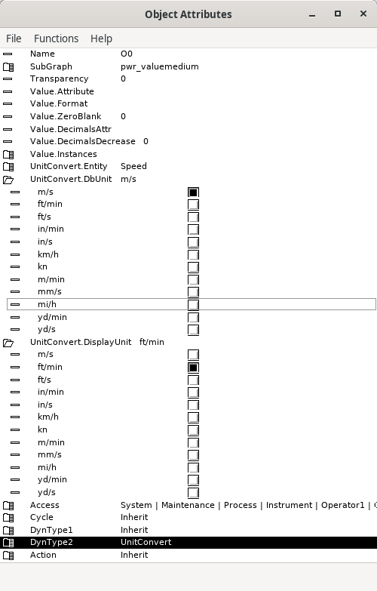
Fig Properties for dynamic UnitConvert

Dark and light color theme
The ProviewR color theme will adapt to the darkness of the currently selected theme. A dark colortheme now affects all windows.
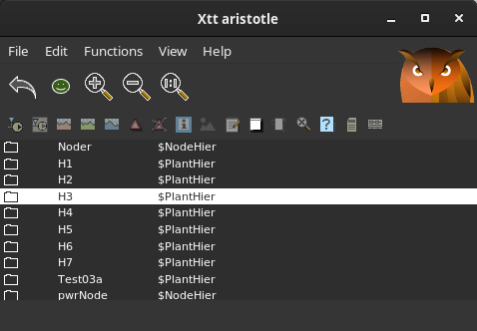
Fig Dark color theme
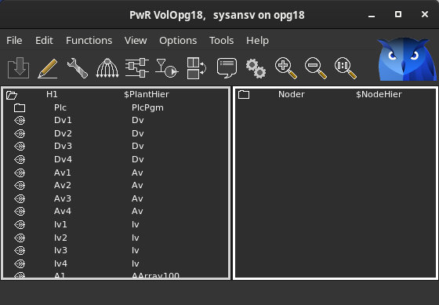
Also the development environment is available in dark theme. Dark or light theme is selected in Settings.
Fig Configurator with dark color theme

Plc include files
All plc header files are included by default in newly created projects, and doesn’t need to be included in ra_plc_user.h.

Background image in Ge graph
Previously the background image could be stated in Graph Attributes. Now it has to be set in the css-file for the operator environment $pwrp_load/rt_xtt.css. For the graph ‘overview’ the syntax is

#overview {
background-image: url("/pwrp/exe/overview_background.png");
}

Text size in operator environment
Text size of alarm texts, menus and buttons in the css-file for the operator environment, $pwrp_load/rt_xtt.css. For the syntax see the documentation for gtk3. An example of increasing the size is

button,label {
font-size: 20px;
}

window box label {
font-size: 20px;
}

Additions in V6.0.1

Status server communication changed to TCP
Previously the status server communication was made with gsoap. It is now changed to TCP, and not backward compatible with previous versions. An old version with the name rt_statussrv59 is included and makes it possible to communicate with older versions of the Supervision Center.

Class list initialization optimized
For classes containing long arrays of subclasses, the initialization of the class list at startup could delay the startup with a couple of minutes. This is now fixed.

Class flags Plc and Obsolete added
Plc and Obsolete are added in the Flag word of the $ClassDef object. The plc bit indicates that the object is a plc function object, and the Obsolete bit that the class is obsolete and will be removed in a later version.

Remote RabbitMQ option to queue messages when occupied
The default behavior for remote RabbitMQ is to discard messages that arrives when DataValid is set. It is now possible to requeue the message.

Hierarchy in class volume
It is now possible to create one extra level of $ClassHier objects under the Class hierarchy in a class volume. Previously a $ClassDef object had to be positioned directly under Class object. Now it’s allowed to place one $ClassHier between the Class object and the $ClassDef.
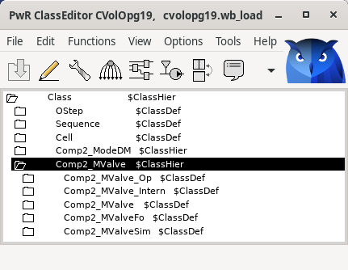

Upgrade procedure
The upgrading has to be done from any V5.9. If the project has a lower version, the upgrade has to be performed stepwise following the schema
V2.1 -> V2.7b -> V3.3 -> V3.4b -> V4.0.0 -> V4.1.3 ->V4.2.0->V4.5.0->V4.6.0->V4.7.0->V4.8.6->(V5.0.0)->V5.1.0->V5.2.0->V5.3->V5.4->V5.5->V5.6->V5.7->V5.8->V5.9->V6.0

Enter the administrator and change the version of the project to V6.0.1. Save and close the administrator.

Enter the directory volume and save.
I you have any class volumes, enter the class editor and build the volume.
Enter the configurator for each root volume and activate 'Function/Update Classes' and build.

