- Keep the ‘Mobile’ & ‘Landline No.’ fields as text field, not numeric.

- See the image below
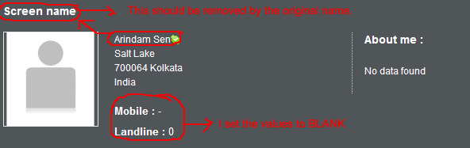

- See the image
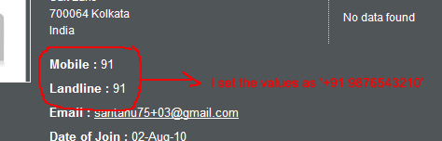

- Back Office >> Edit author – does not match with the front end.
  - ‘Nickname’ field is not required now
  - ‘About me’ has not been incorporated
  - ‘Mobile’ & ‘Landline’ numbers must be text fields
Please check the section with the front end. These two must be similar with each other.

- Please also check the above issues for the Producers section too. They exist for the producers too.

- See the image below, this is from the producer section
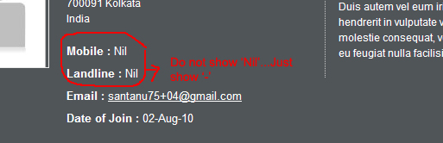
- Back Office >> My Scenarios >> Awaiting validation page – remove the hyperlink from the scenario title as there does not exist any page for displaying the scenarios online now.

- Back Office >> Edit Pilote Photo >> While adding photos, each time it goes to the listing page. This should not be like that. I guess this problem did not exist before.

