- Dashboard: “My Account Of Admin Panel”, make “O” to “o”.
- Menu:
  - Email → “Newsletter Subscription” to change to “Newsletter Subscriber”. Make this change to else where if you find.

- Newsletter Subscriber List:
  - Can we show the type of user, such as General, Buyer, Tradesman?
  - Same in the Details of Subscriber also.
  - Question: There is an Insert Record option for Newsletter Subsciber. Which type of user shall be added here? If only General User, then please make a note in the Insert Screen, provided this is not an Edit interface.
  - Newsletter Add screen: labels are breaking into second line. Please make it correct.

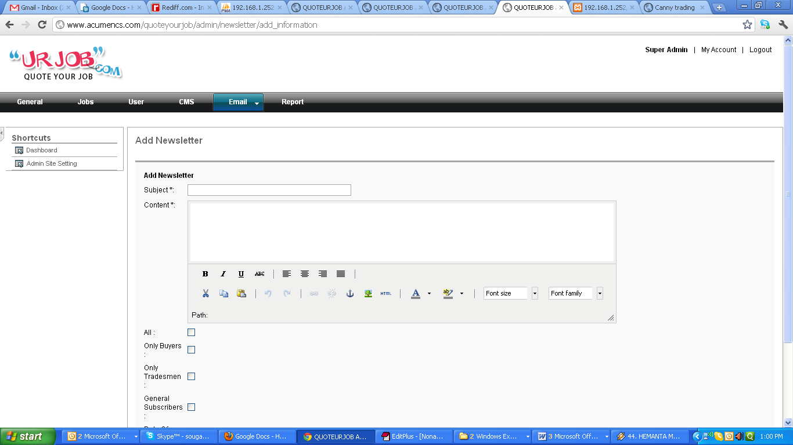

  - Newsletter List: Make the content properly, decrease the width, such that Created on Date should come in one line. Secondly, important, if the newsletter is in html format, how the data will be shown here.. will html tags be also shown here? If you find issue, then I suggest either remove content from here and details, or handle this case.

  - Insert/Edit Record Screen: “Date Of Sending”, “Of” can you make it “o”?

  - Test the Newsletter with a Valid HTML Content and setup the Cron, so that it can be finished once for all

- CMS Tab:
  - Static Pages: There are few other Static Pages, such as Mission Visions, Privacy Policy, Terms & Conditions, etc. create content for them also. Just Dummy Content would work. Do not just copy from other site.
  - Are the Categories for FAQ, Help dynamic?
  - Page Title and Meta Tags, create all the pages as mentioned in the specification. Also create one Default one. Here Language should be “en” default. We may hide this field. Google Site Verification is a text field, not an Editor. It would be nice if Description field is Text Area, instead of an Editor. Because these are only values, will not be shown in the HTML.

- User: In this site, Zipcode shall be replaced by Postal Code. So, please search through out the site and replace this. Already it has been implemented in the HTML files. I have found this in the Buyer Edit section.

- Manage Jobs:

  - Edit Jobs: Labels are wrapping in next line. Quoting Period (days)
  - Edit Feedback: Feedback can be Positive or Negative. Make one field for this also in the interface.

