Quote Your Job

System Overview:

This site is a market place website, where one types of users shall submit their requirement and other type of users will bid against those requirements. Some one of the second type will be awarded the job and complete the job. They will get payment and the job will be closed.

Functional Overview:

There shall be three types of users of the site, viz., Admin, Tradesman and Buyer.

Tradesman and Buyer will be front end type users and Admin user will have access to the Admin part of the Site. The registration process of the site is FREE. That is Buyers or Tradesman can register without paying to the Admin.

Role of different User Types:

Buyer: These users will post their requirement as Job or Work and they will select one Tradesman and assign the job. He can post different jobs and will rate the Tradesman once the job gets completed.

Tradesman: These users will place bids against the Jobs posted by the Buyers. Once selected by the Buyers, Tradesman will pay commission amount to the site owner and then will be able to start the work. Once the commission amount is paid he will be able to see the contact details of the buyer.

Admin: Admin users will have access to the admin panel, where they can monitor the site functionalities of the site. They will be able to view the different reports and will be able to delete, suspend, reactive a user based on the polices of the site

The buyer can directly click on post a job to fill up the form and if the buyer is not registered in the system, then after filling up the post job form buyer will be redirected to registration section, once he registers then only the job will get posted in the system. Also if the Buyer signs up directly then once he log in to his section he will get the link “post a job” from where he can post the job.

Tradesman/service providers can place quote on posted jobs, manage account, update job status and post feedback on the job posters/buyers. The tradesman will be charged after securing a job in the site.

The web development section would involve development of a robust admin management system which will enable the Site Admin to manage the website from the back end without any technical expertise.

Site Revenue Model:

Site Admin will charge commission from the Tradesman, when he/she accepts the Job. This amount will be the main revenue of the site.

The commission pattern will be as follows:
There shall be two commission slabs.

Slab 1: CAD(1-100) Commission 5%
Slab 2: CAD(>100) Commission 4%

If the Job bid amount is 90, then Tradesman needs to pay 5% of CAD 90 = CAD 4.5
Where as if the Job amount is CAD 190, then Tradesman will have to pay
5% of CAD100 + 4% of CAD 90 = CAD (5+4.5) = CAD 9.5.

Site Admin shall be able to change the % of commission through the Admin Panel. But he will not be able to add any more slabs or change the range of the slabs.

Waiver of Commission:

Tradesman can invite peoples. If invited peoples sign up to the site then tradesman can get some benefit to waive the commission they are going to pay to the commission against each job. Site admin will set a limit of invitation. Lets say that site admin has set that if 10 persons join by one tradesman, then the commission amount will not required to be paid by that tradesman. Site Admin can change this value from the admin section. So lets say that current value is 10. One tradesman has invited 100 people, and out of which 50 has signed up. Now the tradesman has won a job. So, when he accepts that job, he will not be required to pay commission to the Admin. So 40 more such credits remaining now. Now before he wins another job, site admin has changed the criteria to 25. So, for next job he will again get benefited and 15 more such credit will remain in his account and so on.

Technically system will check that while collecting the payment from the tradesman. When he will go for payment, system will redirect him to payment gateway, provided he does not have that much credit to exempt the commission.

Job Posting:

Once a Job is submitted, it will not be immediately shown in the Front End. Site Admin shall review all the new Jobs posted in the site. The jobs which are posted in the site will require admin approval. During Approval, Admin can modify the Jobs. But once Approved, Buyer will not be able to modify the jobs again. If a buyer wants to modify the jobs again after his job gets approved, then he needs to communicate with admin separately, which will be done out side the system. If Admin approves the job, then only it will show in the front end. A Buyer can post a job in 2 languages English and French. Whatever language he selects and uses will be shown. But if he is in French version and added the job description in English, system will not translate that to French. And there shall not be any option to check in which language the job has been posted. All jobs posted in the system will be shown.

In the Admin section also, there shall not be any multilingual option for the Jobs.

Section wise Information:

- General Section:
- Post a Job: Buyer needs to logged in to post a job or else while posting a Job, Buyer can signup to the site.
Following fields shall need to be provided against a Job.
  - *Trade (Category): Only one can be selected from the existing list.
  - *Title:
  - *Job Description:
  - *City: Free Text (The field city must be taken care of after checking the zip code database)
  - *State: Dropdown, list of all Canadian States
  - *Zipcode: Validated with Canadian Zipcode format. Additionally we can also validate the Zipcode with city.
  - *Should Tradesman Provide Material: Yes/No/Does Not Matter
  - *Keywords or Tags: Tags
  - *Quoting Period: Dropdown fixed value upto 60 days.
  - Budget if any: Text box (not mandatory field, its just an indicative budget that the Buyer prefers)
  - Attach Files: Maximum Five Files can be added, where file type can be either Image (jpg, or Document or PDF)

Following fields shall need to be provided for SignUp.
  - *Name: Only one can be selected from the existing list.
  - *Email: Unique throughout the site, which will check the Inactive or deleted users also.
  - *Phone Number:
  - *Public Username:
  - Skype IM: MSN IM YAHOO IM
  - *Contact Number:
  - Password:
  - Confirm Password:
  - Profile Photo: This is not mandatory.
  - I would like to receive Newsletter:
  - Accept Terms and Conditions

After Signup a mail will be sent to his email address for verification. If the Account is verified then only the Job will be shown in the Admin section for approval.

For existing Buyer can provide Login details to post a Job. Therefore, next step of Posting Job, there shall be two options, either Sign Up or Login to complete the submission.

- Find a Job & Job Details: This will be public section, so any one can find jobs. But if Tradesman wants to Bid on a Job, then he/she needs to login to the site and same tradesman cannot bid on the same job twice.
By default only Active Jobs will be shown, but viewer can search for Jobs in the site. The search fields should be as follows:
- Title: Likeness Search.
- Keywords: Likeness Search
- Zipcode:
- City:
- Radius: This will be a drop down. This will work together with the Zipcode Provided. If Zipcode field is blank then this will not work. The user must type in zip code or if he is logged in the zip code provided during registration will come here which he/she can edit if he is in a different address presently.
- Category: Dropdown, only one can be selected at a time.
- State: Open (i.e. Active), Assigned(frozen that is the tradesman is yet to accept the job) and Hired (In Progress)

Once the search is made, the search results page will show the following showing 10 jobs listed per page.
- Title:
- Location:
- Description: Upto 200 Characters. After that more will come
- Quote Price:
- Total Quotes:
- Job Post Date:
- Expiry Date / Days Remaining: This is for Open Job, for assigned or hired jobs, this column will be N/A
- View Details:
Title and View Details will open the Job Details. The page will be similar to this.
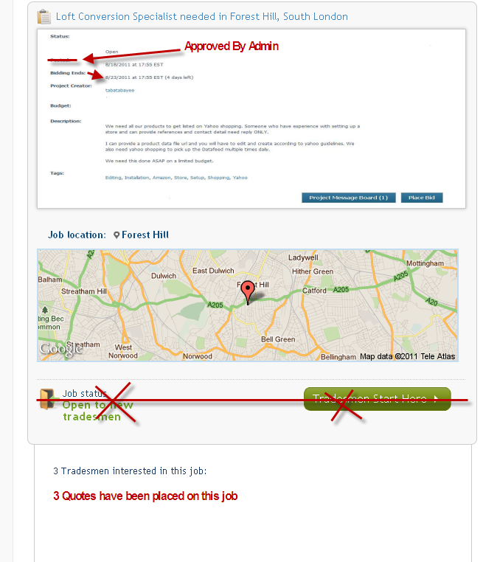

Title:
Status: Active/Assigned/Hired
Job Posted: Date
Job Expiry: Date
Job Creator: Buyer’s Username (not actual name)
Budget:
Job Description:
Total Quotes: Only the number. Tradesman cannot check the details of this, who has placed the bid and the bidding price.
Google Map: This is for showing the Job Location, provided buyer has given proper location.
Two Buttons: One is “Private Message Board” and “Place Bid”. If the Tradesman is not logged in then he/she will be asked to login to the site, once he/she logs in, the Message Posting Box will be open. Tradesman cannot see the message posted by other Tradesman on the same job to that buyer. But this screen will take him to his Member’s Areas Section. If he clicks into the “Place Bid” button, then another screen will open in light box, which will have two fields, one for “Bid Price” which is mandatory and the other will be “Comments”, which is not mandatory. Once this page is submitted, the bid will be posted in the site. A success message will be shown to the Tradesman.

- Tradesman Registration: The Tradesman Registration will have the following fields:
- *Name:
- *Email: Unique throughout the site, which will check the Inactive or deleted users also.
- *Password:
- *Title: This will represent the tradesman in short, max 200 characters.
- *Public Username:
- *Trade (Category):
- *Zipcode:
- Skype IM:
- *Contact Number:
- About Me:
- Profile Photo: This is not mandatory.
- Website:
- *Radius: Dropdown in miles.
- *Skills: Text Box, where Tradesman can provide skills in comma.
- *Qualification: Text Box, where Tradesman can provide skills in comma.
- *Upload Photo: Only single photo can be uploaded.
- I would like to receive Newsletter:
- Accept Terms and Conditions

After Sign up is done, admin shall get an email about this tradesman. Once Admin approves the account the Tradesman can login to the site and place bids. The sign up is free. Tradesman cannot change the Title after words, because here he can put his contact information. Every time Tradesman updates his/her skills and Qualification an email shall be sent to the Admin. Since here he/she can put contact information, which will be public. So, Admin can verify the site.

- Login: Both Buyer and Tradesman can login to the site using the login option. Once logged in they will be taken to their Dashboard.

- Buyer’s Details: Separately Buyer’s details will not be shown. Only in the Job details section, the location will be shown in the google map.

- Find Tradesman and Tradesman Details: Search for Tradesman will open a search screen. Following fields shall be there.
      - Skills: Text box Likeness Search
      - Trade (Category): Dropdown.
      - Zipcode:
      - City:
      - Radius: Dropdown.
      - Profile Name: Textbox, likeness search.
      - Sort By: Dropdown with values (Feedback Rating, Jobs won)

The Search listing would be similar to this following screen.
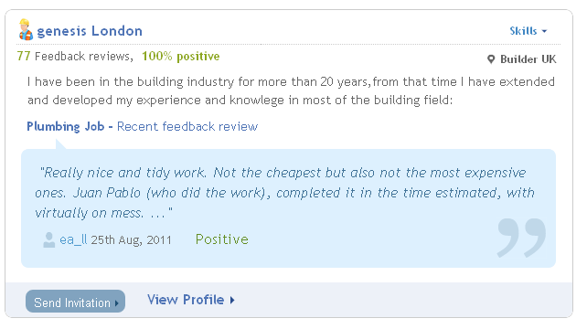

The content will have Thumb image of the Tradesman, title, total feedback, Positive Feedback, About the Tradesman, Trade, Recent Feeback, Send Invitaion, View Profile. View Profile will open the details profile of the Tradesman, which will look like this:

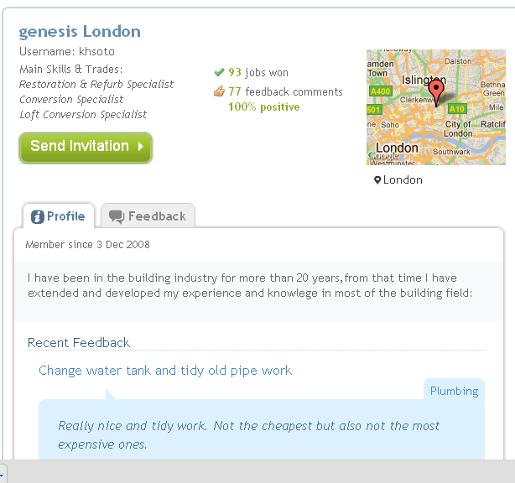

The First block will have contents, like Title, User name, Skills,
Trade, Member Since, Total Jobs won, Total Feedback, % positive, Location of Google Map, “Send Invitation” button. Below that section, there shall be two Tabs, one for Feedback and the second will be Photos. All Feedbacks will be shown with pagination option and Job Title will also be there, with link. Photos will show in block with option to slide show in Thickbox. “Send Invitaion” functionality will be same as in the Buyer’s My Account section.

- Buyer’s Area:
  - My Account:
    - Edit Profile: Profile information cab be updated from here.
    - Contact Details: Contact Details can be updated from here.
    - Change Password: Password can be changed from here.

  - Job’s I have Posted:
    - All Jobs (#): This section will list all the jobs buyer has posted. By default it will list all jobs in descending order of creation date. The fields shall be as follows:
- Title: Will be linked with Job Details, the link will open brief of the job in thickbox.
- Budget:
- Date of Expiry:
- Status: Status can be either Pending (not yet approved) or Active (Approved by Admin) or Rejected (Rejected by Admin) or Awarded / Assigned (Buyer has awarded the job and waiting for Tradesman Acceptance) or In Progress (Tradesman has accepted the Job and started working) or Feedback Asked (Tradesman has completed the job and asked for feedback. Until and unless Buyer gives the feedback, the Job will not be Completed), Completed ( After Buyer provides feedback, the status will be changed to Completed, here Buyer can reject the Feedback Request, in that case the status will again be changed to In Progress, but for that Buyer also need to put his comments) and ( if no one bids on the Job or Buyer has not chosen any one within the time he has set to finish the job, here system will automatically update the status to Expired.)
Rejected Job cannot be bring back to Pending State through the Admin section.
- Action: Action can be either Edit or Delete. This option will be conditional depending on the status of the Job. Till the Job is Assigned the Job can be Edited or Deleted.
Till the Job is approved by Admin, Buyer can Edit everything of the Job. After Admin has edited the job buyer can Edit the Keywords, Time and add Photos (provided he has not uploaded all photos)

- History: System will keep track of the history of the jobs. There shall be one icon for History, may be this can come under Action also. History will show the following information, when job has been posted by the user, when the job has been edited by the user, when admin approved the same job, when and who have placed bid, whom the buyer has awarded the job, if the winner rejects the job then when he rejected, if the tradesman accepted the job then when, when the feedback has been asked by the tradesman, when the buyer has given the feedback, or when the buyer denied to give feedback, when the job expired etc. That is the whole life cycle of the job. The messages will be prefixed. This history will open in new window. This section will be available through the buyer section and in the Admin section. But Tradesman cannot see this.

Job Details: This is not part of any Menu. This is private for Buyer, so this page shall have the left menu. In the right i.e., content section, will have the full job details. Following information shall be shown here.
- Title: Not linked.
- Post Date:
- Expiry Date:
- Description:
- Keywords:
- Files Provided by the Buyer: All are downloadable.
- Price:
- Number of Bids: Integer value but linked. Link will open the bids placed by different Tradesman below. All Bids details shall be shown. This is expandable and collapsible
- PMB:
- Post Similar Job: This will open the Post Job screen.

    - Active Jobs (#): All jobs, which are in the status of Active will be shown here.
      - Title: Will open the Job Details in the same window.
      - Quotes: Links will open the quotes Tradesman have placed.
      - Date of Expiry:
      - Action: Edit/Delete. If Buyer has deleted one Job, then the entire Tradesman who has placed bids on that job will get a mail.
      - History:
      - PMB Link: This will open the list of discussion has been done between the Buyer and the Tradesman on this particular Job.

    - Assigned Jobs (#):
      - Title: Will open the Job Details in the same window.
      - Contact Details of Tradesman:
      - Status: Status can be either Assigned or In Progress or Feedback Asked shown here. There shall be option for Accept/Deny feedback request. In any case a page shall open and with option to put comments.
      - History:
      - PMB Link: This will open the list of discussion has been done between the Buyer and the Tradesman on this particular Job.
      - Terminate the contract: The Buyer can terminate the assignment of this Job if he finds that the worker is not efficient enough to do the job. He will have the option to terminate the contract . May be he find some one else who can be more efficient. For this he needs to provide reasons of terminating the contract and must provide a negative feedback rating to the Tradesman involved. If this is done, then a mail will be sent to the Tradesman and admin that the buyer wants to terminate the contract of this job for the reason he provided. The job will be then terminated. The buyer can repost the job again to get the job done by filling up the details again via the post a job section. In the tradesman section however, under his completed jobs it will be shown as “Contract Terminated by Buyer” and the negative feedback and comments will be shown.

If the Tradesman fails to accept the Job within particular time (say 3 days, which will be managed by admin), then assignment will get deleted automatically and Job will be returned to Active Jobs. In this scenario, the Tradesman and the Buyer will get an email notification. If the again Buyer fails to assign some one and the expiry has reached, then the Job will be moved to the Expired Jobs state. The expired jobs in the system will be purged after 10 days. All data related to expired jobs will also be purged so as to keep the database free from garbage data.
    - Completed Jobs (#): Jobs which are in Completed Status, will be shown here.
      - Title: Will open the Job Details in the same window.
      - Tradesman: Linked to Details.
      - Completed Date:
      - History:
      - Feedback: It will show the feedback provided for that job by the buyer

    - Expired Jobs (#): All Jobs which are in Expired Status will be shown here.
      - Title: Will open the Job Details in the same window.
      - Budget: Linked to Details.
      - Expire Date:
      - History:
      - Action: Delete

All Expired Jobs will be removed from the system after 10 days of expiry. Simultaneously, all related data, such as bid history, PMB etc will also be removed from the system. But before that if Buyer wants to active the same job, then he can go to job details and click into the “Post similar Jobs”, which will take him to the Job creation page. After that, he can create a new job with the same details. If Buyer deletes the job or system removes the job, then neither buyer nor the bidders will get any alert or mail.
  - Search/ InviteTradesman: From this section, Buyer can invite a tradesman so that the better Tradesman or service providers with good qualification and ratings can place bid on his jobs posted.

    - Search for Tradesman: Search for Tradesman will open a search screen. Following fields shall be there.
      - Skills: Text box Likeness Search
      - Trade (Category): Dropdown.
      - Zipcode:
      - City:
      - Radius: Dropdown.
      - Profile Name: Textbox, likeness search.
      - Sort By: Dropdown with values (Feedback Rating, Total Jobs won)

The Search result will show the Thumb Photo, Name (will open View details), Skills, Rating, Trade, Feedback. There shall be checkboxes besides each row and the page shall have paginations. At the bottom of the page there shall be option for “Invite Tradesman”. If Buyer selects one or more checkboxes and press the “Invite Tradesman”, then Invitation shall be sent to the corresponding Tradesman. Tradesman will get an email alert that the buyer has invited him to place a bid on that particular job and also will be able to see the list of invitations from his dashboard once he logs in. Before sending the Invitation, an Intermediate Page shall open. This page will serve two purposes. This Intermediate Page shall show the Jobs against which the invitation is to be sent. If there is no active job for that Buyer, then an error message shall show that “Your Invitation cannot be sent, since you do not have any active Job”. If there are more than one Job then all jobs will be shown in a drop down and Buyer needs to select one Job. If there is only one active job, then buyer will be shown the job title.

Checking will be there whether a buyer has active jobs posted and whether the account sending the invitation is a Buyers account or not. The system will throw exception messages as appropriate after checking it.

  - Feedback:
- Work completion alert
When Tradesman completed the job and asked for work completion, the list will be shown here. If the buyer accepts work completion and click on yes then he will be forced to provide the feedback as a form will open for the feedback once he clicks on yes. Once he completes the process the job status will be declared as completed. It will go under completed jobs both for Buyers and Tradesman.

The Alert Body will be fixed and can be managed from the admin. Apart from the body provided by the Admin, Date and Time and Name of the person, along with Job Title. All new Alerts should be marked as new and once that is seen it will be marked as seen.

Feedback Provided: This section will list all the feedback Buyer has provided to the Tradesman for different Jobs.

  - My Email Alert Settings:
    - Price quote on your request
    - Service provider accepted job offer alert
    - Questions about your job
    - Job Completion by service provider email alert
    - Feedback alert
    - Send me Newsletter

Job alert from Tradesman (#): This section will show the alerts received come to the Buyer related to jobs. Alerts can be of the following types,
- When Tradesman Placed a Bid:
- When Tradesman Accepted the Job:
- When Admin Approved the Job:
- When Admin Rejected the Job:

  - General:
    - Recommend Us: This section will open a form where Buyer shall provide Name and Email Address. A mail will be sent to that person about the site with a link of the site. The body of this mail shall be managed through the Admin section. The buyer will receive no sort of extra privileges by referring anybody. He will just be able to see the persons whom he sent invitations and whether they have joined or not. This report will also be viewable for admin.

    - Your Testimonials: A Buyer can post multiple Testimonials. All testimonials shall require Admin approval. Also Admin can set some of the testimonials to be displayed in the Site.

    - Private Message Board (#):This section will show list of all messages. Tradesman can filter the messages by Date Range and Job. All message board messages will be scrutinized by admin before they get posted.

    - Dashboard: Dashboard will show a quick snapshot of his/her account. It will show the followings:
- Welcome <Buyer’s Name>
- How many New Messages he has in his account: This will be a number.
- Current Time of Server;
- My Open (Pending) Jobs: Five Jobs will be shown. If there are no open Jobs, then a message will be shown that there are not open jobs.
- My Pending Job completion alerts: This section will show the list of job completion alerts by the Tradesman. If there are such alerts, then maximum last five will be shown there.

Format will be similar to this
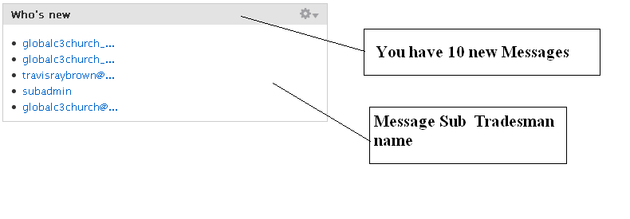
- Tradesman’s Area:
  - My Account:
    - Edit Email Id:
    - Change Password:
  - My Trade Profile
    - Edit My Trade Profile:
    - My Skills and Qualification:
    - Photo Gallery:
    - View My Trade Profile: (This will link to the public profile of the tradesman)
  - My Job Prospects:
    - All Prospects: By default list of all jobs posted in the site will be shown, but Tradesman can search/filter the Jobs so that according to his capabilities he can place his bid. The search fields should be as follows:
- Title: Likeness Search.
- Keywords: Likeness Search
- Zipcode: By default this will be Zipcode of the Tradesman.
- City:
- Radius: This will be a drop down, where Radius value will be pre-selected as he has set in his account. This will work together with the Zipcode Provided. If Zipcode field is blank then this will not work.
- Category: Dropdown, only one can be selected at a time.
- State: Open (i.e. Active), Assigned(frozen state, the tradesman has not yet accepted Buyers offer) and Hired (In Progress)
- Date Range (Job Posted): There shall be two Date Range field. System will search Jobs in between two dates (From Date – To Date) including both the dates. If only From Date is given, then system will show jobs which are posted after the same date. If To Date is only given then system will show list of all Jobs which are posted till that date.

The result shall have Job Title, Location, Starting Price, Job Expire, Number of Bids Placed (#). Tradesman can place a Bid through the Job Details.

    - Quotes: This list will show list of all Bids this Tradesman has placed on different Jobs. Following fields shall be shown here.
- Job Title:
- Job Location:
- Quote Price:
- Total No. of Quotes placed for that job:
- PMB Link: This will open the list of discussion has been done between the Buyer and the Tradesman on this particular Job.

    - Job Invitations (#): This section will show list of all invitations Tradesman has received from different buyers for different jobs. Job invitations are those invitations where a buyer manually searches and invites that particular tradesman to bid on his/her job. The tradesman may decide to bid on the project or not. It will be up to his own discretion.

    - Radar Jobs (#): This will again be one search option. The search criteria will be the Radius and Category (Trade) and Zipcode. When Tradesman will click into this link, the List shall show all the Jobs which are in Active State and matched with the above criteria which the Tradesman has already set from their radar search section. But Tradesman can change the zip code and the search radius.

Job Details: This is not part of any Menu. This is private for Tradesman, so this page shall have the left menu. In the right i.e., content section, will have the full job details. Following information shall be shown here.
- Title: Not linked.
- Post Date:
- Expiry Date:
- Description:
- Files Provided by the Buyer: All are downloadable.
- Price:
- Number of Bids: Integer
- PMB:
- Post Similar Job: This will open the Post Job screen.

  - Job Secured: This section will show the Jobs in which the Tradesman is dealing with.
    - Assigned Jobs: This section will list all the Jobs, Tradesman has been awarded or assigned. Here he will get option either to Accept or Reject. If he accepts the Job, then system will take him to the payment page. If he gets the opportunity of waive, then system will check automatically and will take him to the success page and inform him that, he gets benefit of this waive. Otherwise the Tradesman will be taken to Paypal Page for Payments. Once he makes the payment of the commission amount successfully the Success Page shall appear. The system will send 2 email alerts to the tradesman. 1. You have won the job with the buyer communication details. 2. The invoice of the commission payment will be mailed to him in PDF format. The buyer will also receive an alert that tradesman has won the job and the job is in progress. The Job Status will be changed to “In Progress” and the Job will be listed in the “In Progress” section.
If the Tradesman has rejected this, then the Job Status will again be changed to “Active”. Similarly, if he fails to pay the Job then the Job will remain in this state.
The lists shall have the following fields:

- Title: Link to Job Details.
- Location:
- Action: Accept/Reject

    - In Progress: All jobs which are accepted by this tradesman will be “In Progress” state after the successful payment procedure. This section shall have the following fields,
- Title:
- Location:
- Contact (details of Buyer):
- Action: Declare Job as Completed. This option will inform the Buyer that the Tradesman has completed the Job and has asked for Feedback.
- PMB: As discussed before.

    - Completed Jobs: All jobs which are completed will be shown here. That means jobs for which Buyer has confirmed that Jobs has been completed and given feedback.
Following fields shall be available here.
- Title:
- Location:
- Buyer Details:

    - Feedback Received: This section will show the list of feedbacks, Tradesman has received against different Jobs.

  - My Email Alert Setting: This section shall show the different email alerts of the Tradesman.
    - JOB Invitation:
    - Job Offer Accept:
    - Job Offer Won
    - New Job Offer
    - Client Cancelled Job Request
    - Answer to Your Questions: On any answer of a request, an alert will be generated.
    - Feedback Alert
    - Send Me Newsletter:

  - General:
    - Recommend Us: This section will open a form where tradesman shall provide Name and Email Address. A mail will be sent to that person about the site with a link of the site. The body of this mail shall be managed through the Admin section.

    - My Referrals: This section will show the list of referrals user has posted and the status. If some one has registered using the referral link as a Tradesman, then the status will be shown as Accepted. The Name of that person, Email Id and Status will be shown in the list. The referral section will also summarize and show whether the tradesman is yet to receive a commission waiver or has already received one. Based on the calculations it will show:
There are 3 more referrals joins left to receive a Commission waiver or you have already won a commission waiver and next commission waiver will be when you there will be 9 more referral joins and so on.

    - Your Testimonials: A Tradesman can post multiple Testimonials. All testimonials shall require Admin approval. Also Admin can set some of the testimonials to be displayed in the Site.

    - Private Message Board (#): This section will show list of all messages. Tradesman can filter the messages by Date Range and Job.

    - Dashboard: Dashboard will show a quick snapshot of his/her account. It will show the followings:
- Welcome <Tradesman Name>
- How many New Messages he has in his account.
- Current Time of Server;
- How many Referral benefit remaining which he/she can use.
- My Bids in a block.

Format will be similar to this.

