ISLAMICFASHION CLIENT FEEDBACK REPLY

1) Where would I be able to see the admin to confirm the customer list and updated sales? -Completed

Admin -> Sales -> Orders

2) I was reviewing the website and the product picture seems to be not the right size and looks weird. - Pending

3) The logo is very big and is very close to where it says account. – Completed

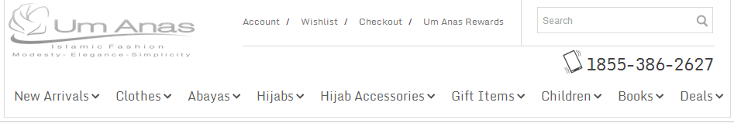

4) The background of the website shouldn't be simple but a nice crossed style. -Pending

5) Can you remove where it says: Cart and ENG on the top right corner and from where is says New Arrivals to Deals to be more opened spaced. - Completed

6) The Description of the product is a very small text and most of the items are not complete sentence. Can you make it bigger. The bottom Description is also small and needs bigger text. – Completed

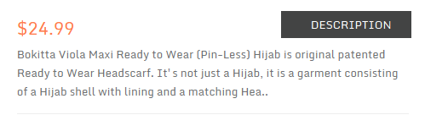

We restrict the characters for description placed on right corner for design consistent.Full content will display under description tab

7) Can you please add a Mastercard, Visa, American Express, Discover, and Paypal Icon on the bottom right corner of the website. - Completed

8) I do need a simplified check out process so everything in 1 page including their login and password information-Need Clarification

9) Any updates regarding Interac Debt. Moneris has been charging me $50 Dollars a month and I still don't have it install on the website. Need Clarification

10) I also need Live chat to be updated to the new windows box theme. Here is the codes: - completed.

This code needs to go in [https://my.livechatinc.com](https://my.livechatinc.com/) > Settings > Theme > Customize:

<http://pastebin.com/sEaBB6Yi>   
  
and this one needs to go into your website's CSS:   
<http://pastebin.com/M2W04fuZ>

Live Chat Login Info:

Username: [umanasislamicfashion@hotmail.com](mailto:umanasislamicfashion@hotmail.com)

Password: abc123