**Design issues:**

1. <http://www.acumencs.com/jobshoppa/buyer/dashboard>, <http://www.acumencs.com/jobshoppa/tradesman/dashboard>,

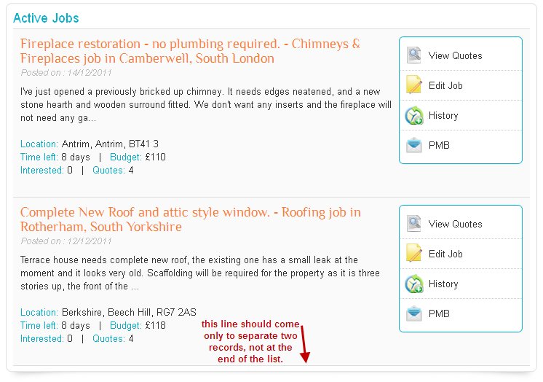

2. <http://www.acumencs.com/jobshoppa/user/subscription>

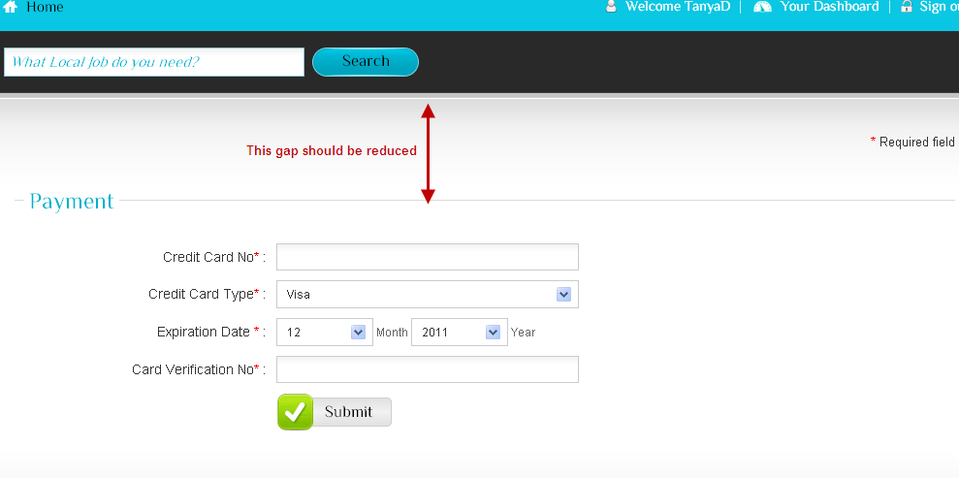

3. <http://www.acumencs.com/jobshoppa/tradesman/pay_job/TmpFallXTjE=>,

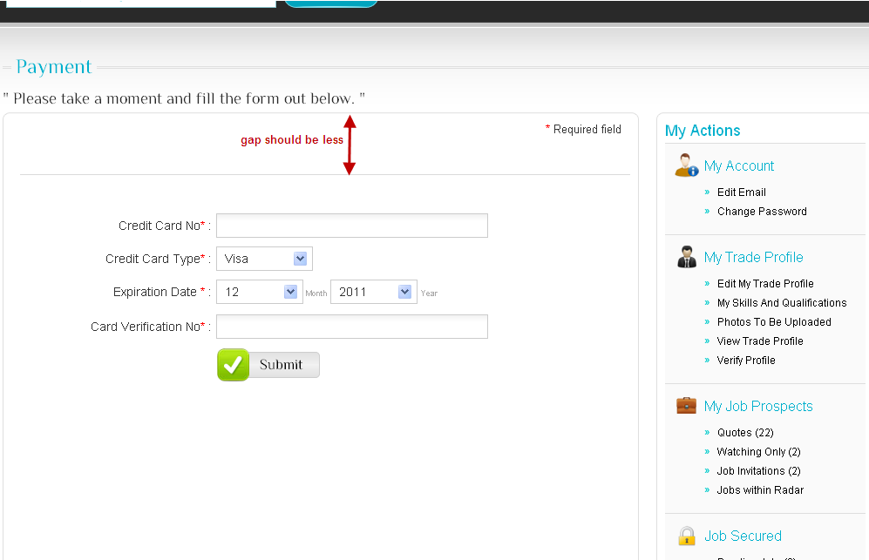

4. <http://www.acumencs.com/jobshoppa/tradesman_profile/TkRjallXTjE>=

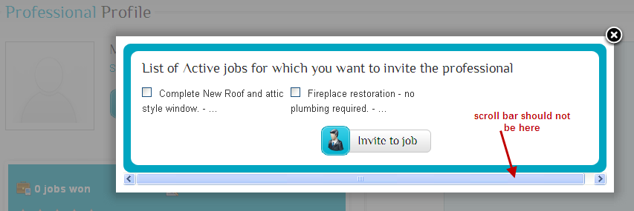

5. <http://www.acumencs.com/jobshoppa/tradesman/progress_jobs>,

