Elements

Project: Periodic Pickup

Game Design Document  
By: Jayvin Duong  
September 2013

Contents

Introduction 3

Game Design 4

Planet 5

Space 6

Gameplay 7

Planet 8

Space 9

Future Considerations 10

# Introduction

This section of the document will provide a brief summary about the game.

|  |  |
| --- | --- |
| **Genre** | Strategy adventure |
| **Game Engine** | Unity3D |
| **Modes** | Single-player |

Elements will be in a third person 3D perspective universe where it will be open world. The player will be able to explore the galaxy’s sector and search planets in the sector. While adventuring planets the player needs scavenge any elements to collect. When the player is travelling they have limited amount of time to explore (one week in game time) when they leave their home planet.

The elements that will be gathered will be based off the actual elements in the periodic table of elements.

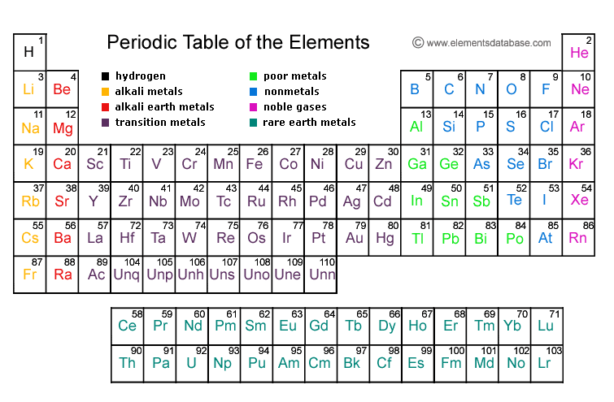

Elements in the Periodic Table

# Game Design

## Planet

Planet levels will be represented by using textured spheres. While being on a planet, the player will move around the sphere. The option to leave the planet to go continue their adventure is always available. Each planet will have each own unique properties such as:

* Name
* Element(s) available to collect
* Texture/material
* Size (radius)
* Background music

Out of all the planets there is a “home” planet is that players always teleport back here when time has expired. While being on this planet the timer will not count down and will only start when you leave to start exploring.

Since the goal of the game is to collect elements. Elements are shown by their short notation and appear as coloured cubes on planets. Depending on the type of element the colour will be different. In total there are **4 elements types**, energy sources (actinide elements), gases, metals and metalloids.

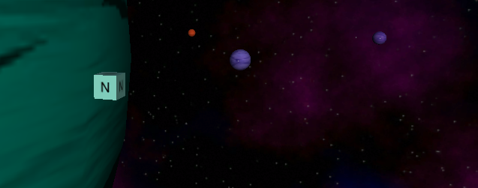

The cube with “*N*” represents the element Nitrogen as a Gas source.

Once the timer ends the game will **deduct elements** away from the player. For instance the game will take away 1 energy source element every week. If the player runs out of a particular element type, the game ends. To make things easy the player has some elements to begin with.

## Space

During the space portion of the game will be short. The player can only fly around the galaxy boundaries. Also the ship that the player will be controlling will not have any fighting capabilities. That means the ship will have to evade any obstacles that will harm the ship. Some of the obstacles in space that the player will have to dodge are:

* Asteroids
* Moons circling around the planet

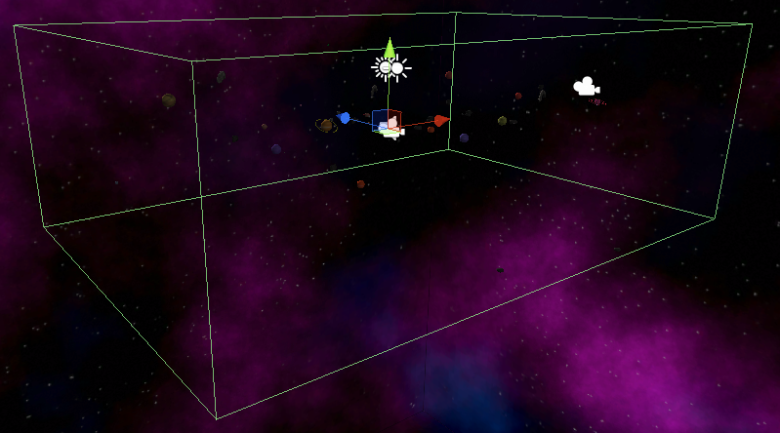  
The green wireframe represents the boundaries of the galaxy.

If the ship takes too much damage from colliding with objects the game will end. Likewise if the ship is outside of the galaxy’s boundaries for too long the game will end as well.

# Gameplay

## Planet

Gameplay on planets will be just focusing on gathering elements that exist. This is achieved by approaching elements and the game will pick up the element automatically.

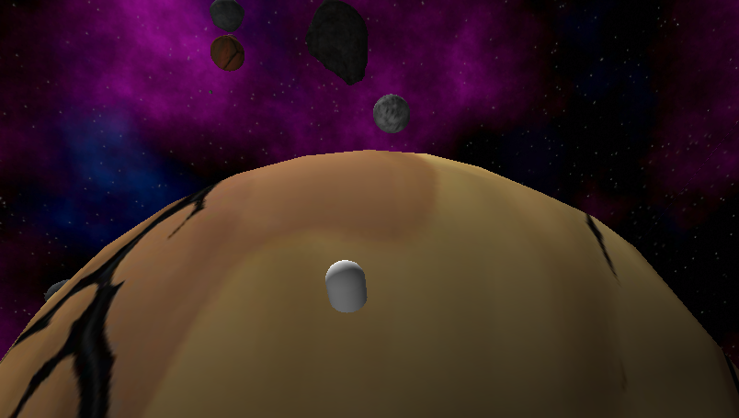

These screenshot shows the movement around the planet.

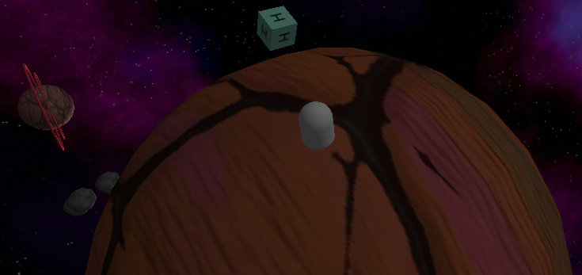

## Space

Space gameplay is rather easy. Since the game is focused on just traveling to planets and avoiding obstacles. Players can land on planets (except for the home planet) by simply flying straight into them.

Space obstacles will translate in a random direction throughout the game. They will have their own corresponding speeds, sizes, and damage.

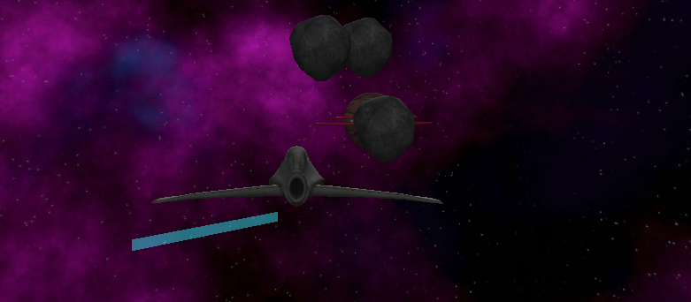  
This screenshot shows asteroids floating around in space.

# Future Considerations

The course of this game project was only one month. The gameplay is complete to what I design the game to be however there are more options to expand. Like the option to port the game to PCs. Improving mechanics by polishing more of the game. Finally, adding gameplay elements to continue teaching players more about science.

Exporting to web browsers was the easiest choice. As the designer I get to choose my own screen resolution and aspect ratios to work with. 16:10 and 1000 by 625 pixels was the aspect ratio and resolution respectively. Porting Elements to home consoles and PCs would have been different. The UI would appear off the screen, possibly stretched and would just look wrong. Research on dealing with different ratios and resolutions is a must. Currently Unity3D doesn’t have options work around the problem via the editor. Therefore UI elements would have to be positions through scripts.

Polishing games is the often upmost urgent phase of the game development. By taking a game that is complete (programming and design) wise and to make it look even better. Elements was polished to the extended where I was able to play the fine. However that would not be the case for other individuals. Some beta testing and some critical feedback would necessary to understand. I find no game can be completely polished and complete, but that doesn’t mean developers shouldn’t try.