Report
Of
Sales & Outreach Internship at Pawzz Foundation

Submitted
To

School of Computer Science and Engineering
IILM University, Greater Noida, U.P.

In partial fulfilment of the requirement of degree of
B.Tech CSE (AI & ML)


By

Roll Number of Student: 25SCS1003003788
Name of Student: NEHAL ALAM
Batch: 2025–2029

CANDIDATE'S DECLARATION
I, Nehal Alam, do hereby declare that this internship report titled “Sales & Outreach Internship at Pawzz Foundation” has been prepared by me to fulfil part of the requirement for the award of the degree of Bachelor of Technology in CSE (AI & ML). All references used have been duly acknowledged. I affirm that this report is my own work and has not been submitted to any other institute for any degree/diploma requirement, and I shall be solely responsible for any kind of copyright violation in this regard.
I further declare, in the interest of accuracy, that my engagement with Pawzz Foundation consisted of being selected for the Sales and Outreach internship through Internshala and exchanging outreach correspondence with the organization, as described in Section 4.5 of this report. This report presents that engagement honestly, alongside a description of the internship role and organization as publicly listed.

Signature
Student Name: Nehal Alam
Roll No.: 25SCS1003003788

ACKNOWLEDGEMENT
I am using this opportunity to express my gratitude to everyone who supported me during this internship engagement. I am thankful to Pawzz Foundation for the opportunity of selection and for their responses to my outreach communication.
I would also like to thank the faculty of the School of Computer Science and Engineering, IILM University, for their guidance regarding the internship and reporting process.
I express my gratitude to my parents for their support and encouragement.

Signature
Student Name: Nehal Alam
Roll No.: 25SCS1003003788

TABLE OF CONTENTS
Ch. No. | Chapter Name | Page Nos.
 | Cover Page | ---
1. | Candidate's Declaration | ii
2. | Acknowledgment | iii
4. | Project Description (incl. Certificate of Selection, Sec. 4.10) | 1
5. | Bibliography/References | 4

4. PROJECT DESCRIPTION
4.1 Introduction
This report documents my engagement with Pawzz Foundation under the Sales and Outreach (S&O) internship programme, for which I was selected through Internshala (Certificate of Selection dated October 9, 2025). The report describes the organization, the intended scope of the S&O role as advertised, and, separately and honestly, the actual extent of my personal engagement, which was limited to selection and outreach correspondence.
This approach is taken deliberately: rather than presenting fabricated tasks or results, this report distinguishes clearly between (a) the internship's intended scope as described by the organization, and (b) the work I personally carried out.
4.2 Organization Profile
Pawzz Foundation is an animal welfare organization based in Gurgaon, Haryana, India. It operates an online platform that connects animal lovers, pet parents, veterinary clinics, NGOs, and rescuers, enabling users to volunteer, adopt animals, fund campaigns, and share rescue stories. The organization's stated mission is to balance the human-animal ecosystem in India and reduce the stigma associated with animal welfare work. Pawzz offers a range of remote, outreach-driven internship roles, sourced primarily through the Internshala platform.
4.3 Problem Statement
Animal welfare organizations such as Pawzz depend on building and maintaining a wide network of partners — veterinary clinics, pet businesses, NGOs, and individual rescuers — while also engaging directly with pet parents and potential supporters. Manually identifying, contacting, and onboarding these stakeholders at scale is a significant operational challenge, which is why organizations like Pawzz rely on outreach-focused interns to expand their verified network and community engagement.
4.4 Project Objectives
- Introduce Pawzz to veterinary clinics, pet businesses, NGOs, and rescuers, and onboard them onto its verified network.
- Connect with pet parents through social media and outbound outreach to understand their needs and generate interest.
- Support market research, build contact databases, and maintain accurate records.
- Follow up with leads, gather feedback, and support broader business development efforts.
The objectives above reflect the role as described in the internship listing. As detailed in Section 4.5, my own engagement did not extend to executing these objectives.
4.5 Scope of the Project (Actual Engagement)
To keep this report accurate, the scope of my actual engagement with Pawzz Foundation is stated plainly here:
- I applied for and was selected for the Sales and Outreach internship at Pawzz Foundation through Internshala (Certificate of Selection, October 9, 2025).
- I sent outreach emails to the Pawzz team to establish contact virtually regarding the internship.
- I received multiple replies from the organization in response to these emails.
- My engagement did not extend beyond this correspondence — no outreach targets, lead generation, database work, or other listed tasks were undertaken.
This report is scoped accordingly: Sections 4.2 to 4.4 describe the organization and role as publicly documented, not personal accomplishments.
4.6 Technologies and Tools Used
Given the limited scope of engagement, the tools used were restricted to email/communication tools for correspondence with Pawzz Foundation, and the Internshala platform for application and selection. No project-specific software, CRM, or outreach-tracking tools were used by me personally, though such tools (e.g., spreadsheets for database maintenance) are typically used by interns who complete the full role.
4.7 System Architecture
Not applicable. This section is typically used to describe the technical architecture of a software or data-driven project. As this internship engagement was outreach/communication-based rather than a technical development project, and as my personal engagement was limited to correspondence, no system architecture was designed or implemented.
4.8 Methodology
The S&O internship at Pawzz typically follows an outreach methodology: identifying target contacts (clinics, NGOs, pet parents), initiating contact through email or social media, following up to build relationships, and recording outcomes for reporting. My own methodology, in practice, consisted of drafting and sending outreach emails to Pawzz Foundation to establish contact regarding the internship, and reviewing their replies.
4.9 Expected Outcomes
For an intern completing the full S&O role, expected outcomes include an expanded verified partner network, increased pet-parent engagement, and a maintained lead database. For my own engagement, the outcome was limited to establishing initial contact with the organization and receiving a response, which offered a preliminary, first-hand sense of how such outreach-based roles function.
4.10 Certificate of Selection
The certificate below confirms selection for the Sales and Outreach internship at Pawzz Foundation through Internshala. This is a Certificate of Selection, not a certificate of completion, and is presented here as accurate supporting documentation of the engagement described in this report.
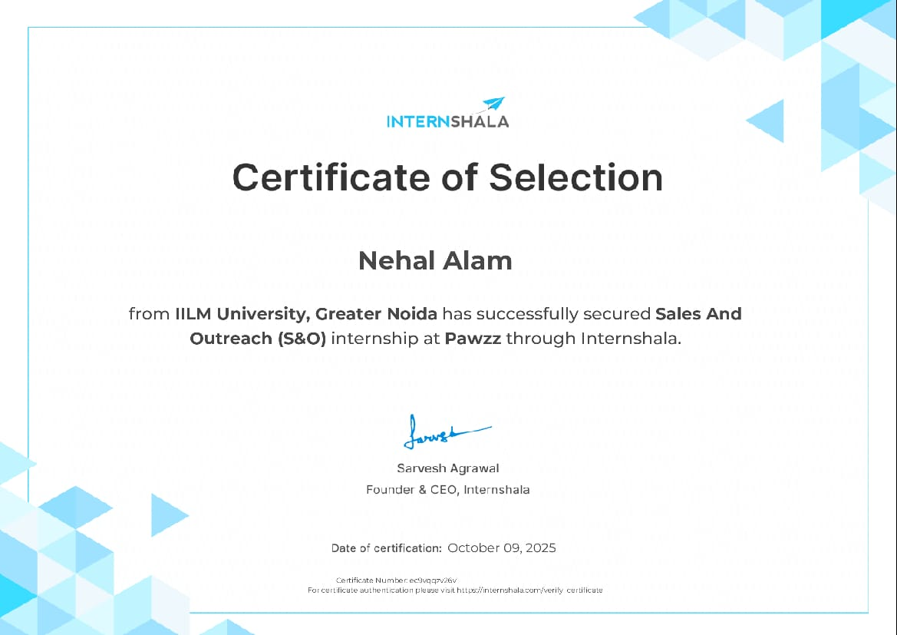

5. BIBLIOGRAPHY / REFERENCES
1. Internshala. “Sales and Outreach Internship at Pawzz Foundation.” internshala.com.
2. Internshala. “Pawzz Foundation — Company Overview.” internshala.com.
3. Certificate of Selection, Internshala, issued to Nehal Alam, October 9, 2025.

