What is NodeJS?

It is an enjoinment to run JavaScript outside the browser

It is built on V8 JS engine which is of chrome

With the help of this we can create full stack web app

Difference between Browser JavaScript and NodeJS?

|  |  |
| --- | --- |
| Browser JavaScript | Node JavaScript |
| Complete access to Document Object Model | No access to Browser API no DOM |
| We build interactive app | We build server side app it only consist of logic |
| It has no file system | We use file system in node info about Operating System and Networking etc |
| Fragments | It is based on version not on user browser. |
| We use es6 module which is by option | NodeJS use common JS library that is es6 with different syntax |
|  |  |

How to start with Code?

Using Command Prompt

By typing node in the command prompt and start

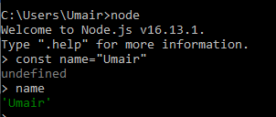

By using CLI

Crate a folder the create a file with type JavaScript

Write your code and then write node filename.js

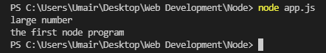

What is Global Variables in NodeJS?  
The Variables that we can access anywhere in our application no matter how complex our application gets

Some of the Global Variables are

|  |  |
| --- | --- |
| __dirname | Path to current directory  Example  C:\Users\Umair\Desktop\Web Development\Node |
| __filename | File name  Example  C:\Users\Umair\Desktop\Web Development\Node\app.js |
| require | Function to use module(CommonJS) |
| module | Info about current module(file) |
| process | Info about environment where the program is being executed |

Npm enables us to

Used our own code in different projects

Used code in our project by different developers

It is hosted at <https://www.npmjs.com/>